Physical Development Gross Motor:  - I can use lots of different ways of moving with increasing fluency and control  - I can climb over, under and through obstacles Fine Motor:  - I can show good pencil control when mark making and drawing ● I can use cutlery and other one handed equipment e.g.  paintbrushes/scissors  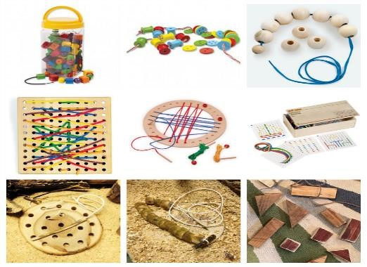  Personal, Social and Emotional Development Self-Regulation:  - I can identify my own different feelings and those of others  - I can keep on trying when I find something difficult  - I am starting to sit and listen more consistently during adult focus time  - I can follow simple instructions Managing Self:  - I can try new activities  - I can tell others about my work and play  - I can dress and undress for PE/ Forest School etc.  - I am starting to know ways to stay healthy including food and exercise  Building Relationships:  - I can share and co-operate with my friends  - I can work with a small group of children, sharing ideas ● I am starting to form good relationships with the familiar adults in my class  - I can express and identify my feelings  - I can express my basic needs to familiar adults e.g. ask to go to the toilet, etc. | 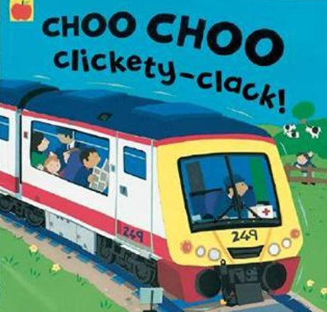Reception - Autumn 2  Meet me in Manchester (Transport)  RE: The Way, the Truth & the Life - God’s Family  - I Know that the angel Gabriel asked Mary to be the mother of God’s son.  - I can reflect on Mary’s reply to the angel.  - I know that Advent is a preparation for Christmas.  - I can think of ways to prepare for it.  - I know the story of the birth of Jesus.  - I can reflect on how important this is for us.  - I know that shepherds were the first to hear about the birth of Jesus.  - I can reflect on the good news they received. | Communication and Language  Listening Attention and Understanding:  - I can demonstrate good listening behaviours  - I can follow simple instructions (with two or more parts) reliably ● I engage in story times  - I like to join in with familiar songs and rhymes (repeated refrains and sings by heart)  - I can wait and take turns in conversation Speaking:  - I am starting to share my ideas with familiar adults  - I can talk to others (adults and children)  - I use talk to organise my thoughts  - I can listen to and talk about stories, rhymes and non-fiction  - I can learn new vocabulary  - I can share my ideas using talk as a tool  - I can say how I feel using talk as a tool  Literacy  Comprehension:  - I can retell the key events in stories  - I am starting to recall facts from non-fiction  - I can understand new vocabulary  - I can talk about what has happened in the story so far and anticipate what might happen next  - I can listen carefully to stories, rhymes, non-fiction and songs Word Reading:  - I can match most of the phase 2 letters and sounds  - I can say the phase 2 sounds in CVC words  - I can start to blend the sounds together  - I can segment and blend CVC words  - I can read most of the phase 2 tricky words  - I am starting to read simple phrases and sentences e.g. the cat and the dog Writing:  - I can write some lower case letters correctly  - I can write some upper case letters that I know (e.g. name, Mum, Dad, sibling name, etc)  - I can identify known letters to match initial sounds (phase 2)  - I can match most phase 2 letters and sounds  - I can write CVC words and labels e.g. c-a-t  - I can write simple labels using phonic knowledge.  - I can begin to write simple captions  - I can say a simple sentence for writing (oral and count words)
Understanding the World  - I can talk about my family and people in the community and their roles.  - I can talk about the area I live in, including the weather etc.  - I can talk about forces I feel e.g. push, pull etc.  - I can talk about the differences in materials  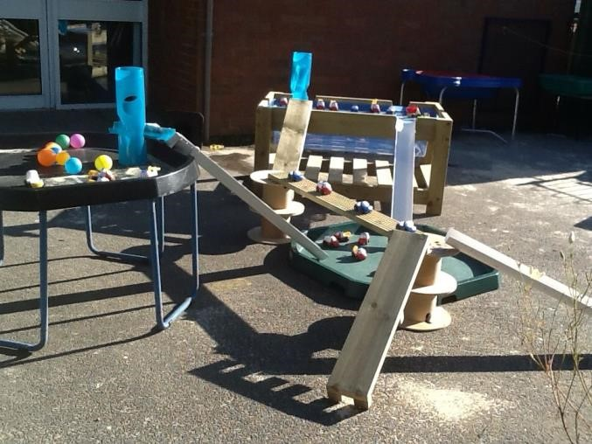 | Expressive Arts and Design Creating with Materials:  - I can use various tools for artwork and design e.g. playdough tools  - I can select my own art and design materials to create with  - I can tell others what my artwork is and signal key parts e.g. this is mummy, this is her hair.  - I can recreate familiar stories with small world and roleplay (with adult support)  Being Imaginative and Expressive:  - I can recount and retell familiar stories with my friends and adults (small world/ role play)  - I can role play imaginary scenarios linked to experiences  - I know some popular songs and can sing them supported by an adult  - I can listen and respond to instruments and music ● I can sing my own songs and with others and (supported by an adult) | 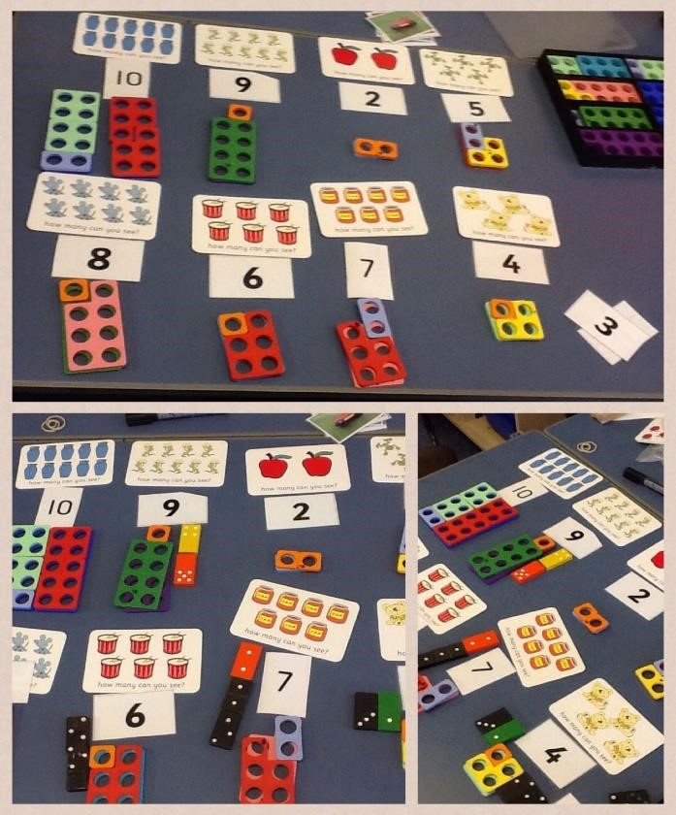  Mathematical Development Number  - I can count objects, claps, movements up to 10  - I can link numerals with cardinal value – last number said ● I can start to show how numbers can be made up – composition on 2,3,4 and 5  e.g. 1 and 3 is 4 and know there is more than one way of doing this  Numerical Patterns (and Shape)  - I can count to 10 by rote  - I can compare manipulatives (e.g. saying when one tower is bigger/smaller)  - I can find one more/ one less using concrete resources  - I can continue and copy patterns including shape patterns  (1,2/1,2 1,2,3/1,2,3)  - I can create my own patterns.  - I can select, rotate and manipulate shapes to solve puzzles and problems e.g. through a range of jigsaws  - I can talk about and name 2D & 3D shapes using some mathematical language.

