Year 5 Home Learning |  | This document outlines the activities/lessons your child to complete at home during the bubble closure. Each activity is explained in detail here, including where to find the activities. There is a Maths and English lesson to complete each day, then a range of activities provided for additional subjects which can be completed at any time. WALT stands for We Are Learning To, which will give you a clear indication of the lesson objective. There will be different levels of challenge for the children to complete for most lessons (*** being the hardest level). The children do not need to complete all three levels. The children can work directly into their home learning book they have been given. Please feel free to email any work or pictures of the work and do not hesitate to email me on year5@st-pauls-hyde.tameside.sch.uk if you require any assistance. Thank you, Mr Titterington.
Week 7 (Spring 2 half term – Week 1)
Maths |  |  | English
Look in the table below to find the information about the lesson, which you need to complete. Once you have read the table, scroll down to the bottom of the document to find the tasks and questions, which you need to complete for each lesson. This week will be focussing on Fractions. It is important that you follow this plan carefully, as this is new learning for us, and is not a recap of learning which we have completed in school.  I will be uploading PowerPoints with videos included which explain the methods which you will need to use. |  |  | The Saga of Ragnar – Historical Narrative  We have now finished our Non-Chronological report unit on tigers, and are moving onto our narrative unit. We will be beginning to look at the Vikings over the next couple of weeks, and with that our new narrative The Saga of Ragnar.  Our English lessons will be based on this short narrative during this week. In addition to this, beginning later this week, I will be uploading videos of an additional story, Beowulf, which will help you to generate even more ideas for your writing.  I’m looking forward to reading your stories and seeing your imaginative writing in action!
1) | Maths Lesson 31 – Compare fractions greater than 1  WALT: Compare fractions which are greater than 1 (including both improper and mixed fractions)  In the final lessons before half term, we thought about and compared different fractions which were less than 1. To do this, we found equivalent fractions by using bar models and also by finding the lowest common denominator.  Over the next two lessons, we will be given fractions which are either improper fractions or mixed fractions, and asked to compare which is the largest and smallest. We should remember that all improper fractions have a larger numerator than denominator, and a therefore larger than the number 1. We should remember that mixed fractions have whole numbers, which again means that they are larger than the number 1.  To compare these different fractions which are larger than 1, we can use two different methods.  The first is by using bar models. This is where we draw or shade accurately two different bar charts to represent different fractions. We can see when the bar models are placed together, which of the fractions is larger. An example of this method can be seen here:  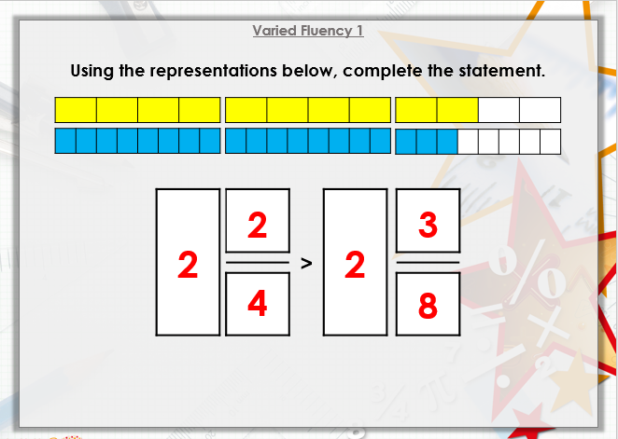  Alternatively, we can use our knowledge of finding the lowest common denominator to compare different fractions. Before half term, we did this with fractions smaller than 1, however, we can also do this for fractions larger than 1 to decide which is larger and which is smaller. An example of this method can be found here:  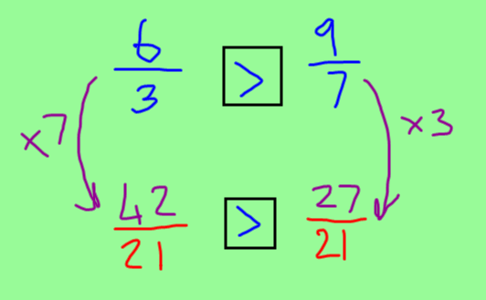  On Google Classroom, I have provided a video which explains both of these methods in detail, including a reminder of how to find the lowest common denominator (In case you have forgotten this method from before half term!)  Most of you should try to complete the 2 star challenge for this lesson.  Challenge Levels:  1 Star – Use the bar model method to compare different fractions which are larger than 1.  2 Star – Use the bar model and common denominator method for questions 1 and 2 of the worksheet.  3 Star – Use the bar model and common denominator methods for questions 1-4 of the worksheet. |  | 1) | English Lesson 31 – Planning a historical narrative  WALT: Write a plan for a historical narrative.  Last half term, we thought about historical narratives as we read The Saga of Ragnar, learning about his adventures and challenges when fighting the behemoth.  During this week, we will be writing our own hot tasks, for a story about the Vikings of our own choice. Your story needs to still be a historical narrative set during the Anglo-Saxon and Viking period. You can change the characters, and the settings, but there still needs to be a problem which is related to the Vikings.  In this lesson, I would like you to plan your story. We will be using the same planning template as our box up plan, so you may wish to go back to that lesson on Google Classroom, or look on your Google Drive to find your Ragnar plan to inspire you.  On Google Classroom, I have uploaded a video of my plan for The Saga of Bjorn, the Son of Ragnar. You could use this video to help you to change your story for your hot task.  Challenge Levels  1 Star – Complete the first column of the planning format  2 Star – Complete the first column of the planning format and also identify which steps to success have been used in each part of the story – e.g. subordinate conjunction – As  3 Star – Complete the plan, identifying which steps to success have been used in each part of the story, and an example of where they used it. E.g. Subordinate conjunction, After many days of battling….
2) | Maths Lesson 32 – Fractions Greater than 1 Lesson 2  WALT: Compare fractions which are greater than 1 – finding common denominators and numerators.  Yesterday, we looked at using the bar model method to compare different fractions which were greater than 1 (such as improper and mixed fractions). We also thought about how we could find common denominators, and that if the denominators were the same, then the fraction with the largest numerator would be the largest fraction.  Today we will think about finding either common denominators, or common numerators. We did not look at common numerators yesterday, and this will be new today.  The two key rules for this lesson are:  - When the numerators are the same, the greater the denominator, the smaller the fraction.  - When the denominators are the same, the greater the numerator, the greater the fraction.  An example of finding the common numerator can be found below. It is difficult to find a common denominator for 4 and 15, so finding a common numerator for 6 and 12 is easier, as we can multiply the first fraction by 2 to make both of the numerators 2.  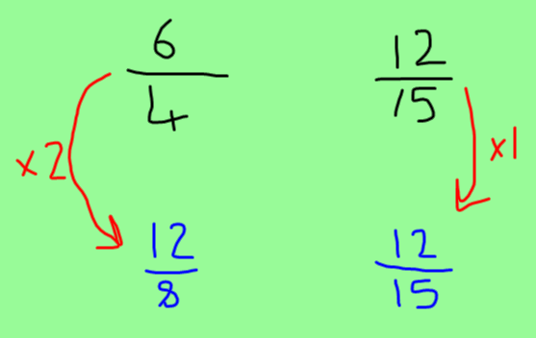  On Google Classroom, I have uploaded a video explaining how to find both the common denominator and the common numerator. If you did not complete the 2 star challenge yesterday, then you should complete the 1 star challenge today. If you completed the 2 star challenge yesterday, you should complete the 2 star challenge today (because we will be continuing the worksheet from yesterday).  Challenge Levels  1 Star – Complete questions 1-6 of the worksheet.  2 Star – Complete questions 5 – 8 on the worksheet  3 Star – Complete the 2 star challenge and then the problem solving sheet. |  | 2) | English Lesson 32- Writing the opening of our hot tasks  WALT: Write a historical narrative opening.  In this lesson, we will be beginning to write our hot tasks for our historical narrative. You will need to write your opening, which should include an original setting description and a character description.  In this setting and character description, you are writing your own independent version of the story of Ragnar. This means, that like in your plan yesterday, you should think about your own original setting for the story. This may not be in Scandinavia for example, perhaps it is a Viking who was in Britain. For your character description, you should try to think of your own Viking warrior, different to Ragnar. Perhaps it could be a female warrior, or a male warrior with a different name. Your opening needs to be interesting and creative, and should focus on descriptive grammar features such as expanded noun phrases, fronted adverbials and relative clauses.  On Google Classroom, I have recorded a video explaining the opening, and an example of the beginning of an opening which you could use to inspire your writing.  Challenge Levels  1 Star – Write a setting and character description, changing these to your own ideas.  2 Star – Write a setting and character description, changing these to your own ideas, and using a range of expanded noun phrases, fronted adverbials and relative clauses.  3 Star – Write a setting and character description, changing these to your own ideas, and using a range of expanded noun phrases, fronted adverbials, relative clauses and parenthesis.
3) | Maths Lesson 33 – Add and subtract fractions  WALT: Add and subtract fractions with the same denominators.  So far in our fraction unit, we have been looking at comparing and finding equivalent fractions. For the rest of this unit, we will be learning about adding, subtracting, multiplying and dividing fractions. You started this learning in Year 4, when you learnt how to add fractions which had the same denominators. In today’s lesson, we will be recapping how to add and subtract fractions with the same denominators.  We should remember from our Year 4 learning that when we add or subtract fractions with the same denominators, we only add/subtract the numerators and the denominators stay the same.  Examples of these types of questions can be seen below:  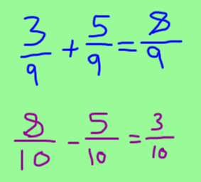  However, the different between Year 4 addition of fractions, and Year 5 addition of fractions, is that our answer may be an improper fraction. We know now (because we learnt before half term) how to change improper fractions into mixed numbers, as our answer should not be left as an improper fraction. An example of this method can be seen below:  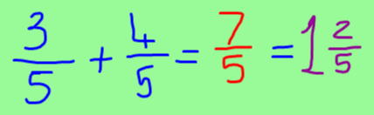  On Google Classroom, I have uploaded a video explaining this method in more detail, including a recap on how to change improper fractions into a mixed fraction.  Challenge Levels  1 Star - Answer questions 1-5 of the worksheet.  2 Star – Answer questions 1-8 of the worksheet  3 Star – Complete the 2 star challenge and then complete the problem solving activity. |  | 3) | English Lesson 33 – Writing a build up  WALT: Write a historical narrative build up.  In this lesson, you may wish to continue your writing on the same Google Doc or piece of paper as yesterday’s writing. Today, we will be writing the build-up for our story. This part of the story in The Saga of Ragnar, was the description of Ragnar defeating the other warrior and throwing his opponent off the cliff. For your build up, you could change the location and build-up towards the problem. For example, could you write a battle which your character is having with a different opponent, in a different location? Perhaps your warrior is part of a larger battle or Viking war, but still wants to find a tougher opponent. Your build-up should end with your character beginning their search for their opponent who will help them to reach their goal (such as getting to Valhalla).  Challenge Levels  1 Star – Write a build-up which uses 3 of the steps to success which you have been given.  2 Star – Write a build-up which uses 5 of the steps to success which you have been given.  3 Star – Write a build-up which uses all of the steps to success which you have been given.
4) | Maths Lesson 34 – Add and subtract fractions within 1  WALT: Add and subtract fractions with different denominators within 1.  Yesterday, we thought about adding and subtracting fractions which had the same denominators, then converting the improper fraction answers into mixed numbers. Today, we will be adding fractions which are smaller than 1, but have different denominators.  We have learnt already how to find common denominators, and should be able to apply this in this lesson.  Unlike which fractions have the same denominator, we cannot add or subtract fractions which have different denominators!  Because of this, we must find the lowest common denominator of the two fractions first, before we can add them.  An example of this method can be seen below, where I have changed the fractions to have the lowest common denominator of 12, before adding them:  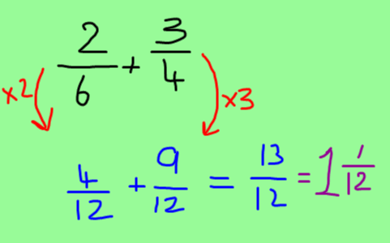  On Google Classroom, I have uploaded a video explaining this method. Most children should complete the 2 star challenge for this lesson.  Challenge Levels  1 Star – Complete the fractions with different denominators addition sheet.  2 Star – Complete the addition worksheet questions 1- 5 (Most of you should attempt this challenge)  3 Star – Complete the addition and subtraction worksheet questions 1-7  4 Star Bonus – Complete the 3 star challenge and the problem solving extension. |  | 4) | English Lesson 34 – Writing a problem  WALT: Write a problem for a historical narrative.  So far this week, we have written both the opening and build-up. The aim for this lesson is to write your own problem. In the story of Ragnar, the problem was when the behemoth attacked the town, and the people who lived there had to leave their homes. For your hot task, you should try to change the location of the problem, and the monstrous creature. You may wish to draw your creature to help you to think of some ideas. The location of your problem could be: in a forest, in a town, on a battlefield, in a mead-hall or at a harbour where the Vikings had left their boats. In the problem, your main character (Ragnar) should not have arrived yet. This will happen in the resolution.  On Google Classroom, I have recorded a video explaining how you may be able to change your problem, and have written my example.  Challenge Levels  1 Star – Write a problem which uses 3 of the steps to success which you have been given.  2 Star – Write a problem which uses 5 of the steps to success which you have been given.  3 Star – Write a problem which uses all of the steps to success which you have been given.
5) | Maths Lesson 35 – Add 3 or more fractions  WALT: Add 3 or more fractions including finding the common denominator.  Last lesson, we learnt how to add and subtract fractions when they had different denominators by finding the lowest common denominator. Today we will expand this knowledge by adding 3 different fractions with 3 different denominators.  The method to calculate these will be the same as yesterday, however this time, we will need to find a common denominator for all of the fractions. An example of this method can be seen here:  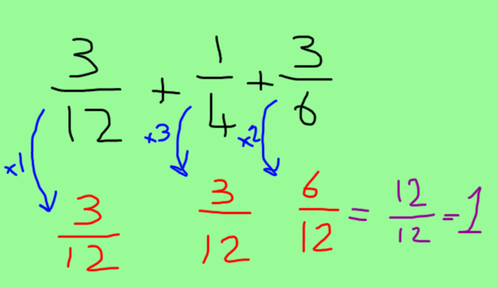  On Google Classroom, I have uploaded a video explaining how to complete this method.  Challenge Levels:  1 Star – Complete the adding 3 fractions question sheet.  2 Star – Complete questions 1-4 of the worksheet.  3 Star – Complete question 1-6 of the worksheet. |  | 5) | English Lesson 35 – Write a resolution and ending  WALT: Write a resolution and ending for a historical narrative  During this week, we have been writing our resolution and ending for our historical narrative inspired by The Saga of Ragnar. Yesterday, we wrote our problem, where the behemoth (or your monstrous creature) had attacked the town (or your own location). Today, your resolution needs to tell the story of your warrior or hero saving the town from the monstrous creature. During the resolution, you should describe your warrior arriving in the town, and then describe the battle which takes place between the two characters.  You should then move on to your ending, where one of the characters, either the warrior or the monstrous creature, is defeated. The end of your story should detail how the warrior reaches his final goal, for example Valhalla or being the most experienced warrior in the country.  Once you have finished your writing, you need to ensure that you proof read your writing, making edits to spelling mistakes, missing punctuation or to uplevel your writing, to add grammar features, descriptions, or ideas that you missed in your story.  On Google Classroom, I have uploaded a video explaining how to write your resolution and ending.  Challenge Levels  1 Star – Write a resolution and ending which uses 3 of the steps to success which you have been given.  2 Star – Write a resolution and ending which uses 5 of the steps to success which you have been given.  3 Star – Write a resolution and ending which uses all of the steps to success which you have been given.

Additional Subjects- To be completed anytime over next week
Science | Topic
Properties of Materials – Lesson 4  WALT: Use different processes to separate mixtures of different materials  In the last science lesson, we learnt about dissolving, and how, sometimes, when we mix a solid into a liquid, it can create a new liquid called a solution.  A local supermarket has had a disaster!  Lots of their goods have got mixed up after a delivery truck was loaded up incorrectly.  The manager of the supermarket has asked for your help in separating all the items so that they can be put out on the shelves.  Have a look at the jumbled up materials and think about how they have been mixed together  The mixtures which have been made are:  - Salt and water  - Flour and raisins  - Sand and water  - Rice and metal paper clips  If you have some of these materials at home, you may be able to carry out the experiment/investigation at home. If you do not, then you could think about what you could do, and write your ideas. Or, I will upload pictures of our investigation in school to Google Classroom, which you could use to complete your task.  In this lesson, we will be learning about the processes of filtering, evaporating, sieving and magnetic attraction. I would like you to choose one of these processes which could be used to separate each of the different material mixtures, and use the processes to explain your choices.  On Google Classroom, I have uploaded a video explaining each of the different mixtures, processes and the investigation which we will be completing for the lesson.  Challenge levels  1 Star – If you have the materials available, carry out the investigation to separate some of the mixtures. If you don’t have the materials, you could choose different materials which are similar and may need the processes to be separated.  2 Star – Think about the different processes above, either with or without completing the investigation yourself, explain which of the processes you would use to separate each of the different mixtures which have been made.  3 Star – Think about the different processes above, either with or without completing the investigation yourself, explain which of the processes you would use to separate each of the different mixtures which have been made – can you draw a picture/diagram of the different processes taking place? | Topic – Viking Lesson 4 - Danegeld  WALT: Understand the significance of the Danegeld and how this changed Britain.  In this lesson, we will learn about the Danegeld, which was created to prevent the Vikings from invading Britain. We will learn about King Ethelred II, who was commonly known as Ethelred the Unready, because of the poor decisions which he made, and also because he was also only 7 years old when he became king.  King Ethelred II created good relationships with the French in Normandy to improve his protection. However, King Ethelred II was most often known for his decision to create the Danegeld, which was basically a strategy where the Anglo-Saxons paid the Vikings money to make them stay away from England. However, the Vikings soon realised that they could keep raiding England, and then get paid even more money to stay away. The people of England did not like the King’s decision, because they felt that it was encouraging the Vikings to raid the country even more.  In the future, a poet and writer named Rudyard Kipling (who also wrote the Jungle Book) created a poem to describe the Dangeld.  For your main task, I would like you to write your own poem to describe the Dangeld. Think about the actions of King Ethelred II, the thoughts of the Vikings, and the consequences for England.  On Google Classroom, there is a video explaining the events which took place for the Danegeld to happen.  Challenge Levels:  1 Star Challenge – Write a poem to describe the Dangeld.  2 Star Challenge – Write a poem to describe the Dangeld and create a role play (freeze frames) for the different events that took place.  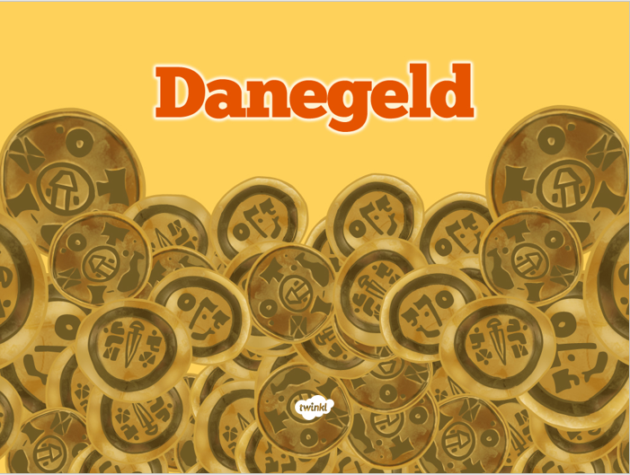
Art & PSHE | Computing
Diego Rivera  In this lesson, we will be continuing to learn about our South American art unit by learning about the artist Diego Rivera.  Diego Rivera was famous for making murals (painting on the wall).  His parents caught him drawing on the wall at a very young age. Rather than telling him off, they hung chalkboards and canvases on the walls for him to draw on.  The artists he particularly loved were Gauguin and Matisse.  His interest in murals came from a trip to Italy where he saw many frescoes painted on the walls there. He also thought that artwork was better if it was painted in public spaces because it would be seen by lots of ordinary people.  His style was big, bold and colourful. He was influenced by The Aztecs. Many of his murals show large groups of people. His artwork caused lots of disagreements in the USA because many people disliked the messages in his work.  His murals were so big and powerful that mural painting became viewed as a form of Art because of people like Diego Rivera.  Your job today is to make a picture of somebody that you think is amazing. All of the pictures will be arranged together to make a class mural.  Your important person could be…  …someone in your family  …a scientist  …a singer  …a person in history  …someone else that you think is amazing  You need to be able to explain why your person is so amazing.  (Just make sure that you are creative, but do not draw on your walls!)  Alternatively, you could create a mural style piece of artwork linked to the Vikings! It has been brilliant to see some of the combinations of South American art and Vikings, especially those which have been on the newsletter and our school Twitter page!  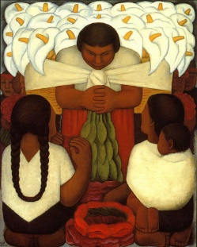 | Computing – Spreadsheets Lesson 4  WALT: Use a spreadsheet to convert between different units of measurement  So far in this unit of computing, we have thought about different ways that we can use formulas to solve problems. Today, we will create a spreadsheet to help with the real life situation of converting between different units of measurement. This could be converting Centimetres to Metres, or miles into kilometres.  On Google Classroom, I have uploaded a video explaining how you can use a spreadsheet to perform these calculations effectively. Once you have watched the video, you should log on to Purple Mash and find the 2Do named Spreadsheets Lesson 4 – Converting Measurements.
RE | Music
R.E. – Reconciliation – Lesson 1  WALT: Have the opportunity to know that actions have consequences and reflect upon these.  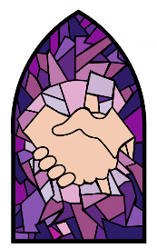  This half term, we will be beginning our new unit of Reconciliation. This is an important topic for us, because it helps us to reflect upon our actions, and to think about how we can be the best person we can be.  In this unit, we will be thinking about people who reflect on their actions, and also those who are in need of forgiveness.  In this lesson, we will learn about the actions of two different, inspirational people, whose beliefs and actions inspired different consequences. To begin, we will think about “The Ripple Effect”: Every act of kindness has a ripple effect. It improves our health, feelings, work, relationships and friendships. We will read the stories of Mary Ann long and Mother Antonia Brenner, and think about how both of their stories are linked to this Ripple Effect. The stories of both of these women can be found later in this document and also on Google Classroom.  Once you have read the two stories, I would like you to complete the main task. It is important that when you complete this task today, you include as much detail as possible so that we can achieve a higher level in R.E. Most children should choose the two star challenge activity for this lesson.  On Google Classroom, I have uploaded a video explaining this lesson in more detail.  Challenge levels:  1 Star Main Task – Think about some of the problems which the two women faced in their stories. Try to think of as many problems as you can. Think about the actions which they chose to react to these problems with. Then think about the consequences of their actions. On Google Classroom, there is a table for you to write in. You could write in different colours for each of the different women, or create two different tables, one for each person.  Problems Actions Consequences  2 Star Main Task - Think about some of the problems which the two women faced in their stories. Try to think of as many problems the women faced and the beliefs which they had. Think about the actions which they chose to react to these problems with. Then think about the consequences of their actions. On Google Classroom, there is a table for you to write in. You could write in different colours for each of the different women, or create two different tables, one for each person.  Problems & Beliefs Actions Consequences  3 Star Main Task - Think about some of the problems which the two women faced in their stories. Try to think of as many problems the women faced and the beliefs which they had. Think about the actions which they chose to react to these problems with. Then think about the consequences of their actions. On Google Classroom, there is a table for you to write in. You could write in different colours for each of the different women, or create two different tables, one for each person.  Problems & Beliefs Actions Consequences  As an extension can you: explain how Mother Antonia’s beliefs shaped her behaviours. Who did she learn from? Who was she similar to? Can they make links to any stories which they know from the last unit or from the Bible which might have inspired their actions? | Music - Pots and Pans Percussion  The Tameside Music service have been providing some videos which may help with learning music at home. Mr Blackwell, who has often visited our school to teach music, has provided a video for percussion using Pots and Pans. This would be a great activity to try at home! Just try not to make too much noise whilst mum, dad or carers are working!! You might want to upload a video of your own attempts to Google Classroom!  The link for Mr Blackwell’s video can be found here: https://www.youtube.com/watch?app=desktop&v=-nXX24vqLns  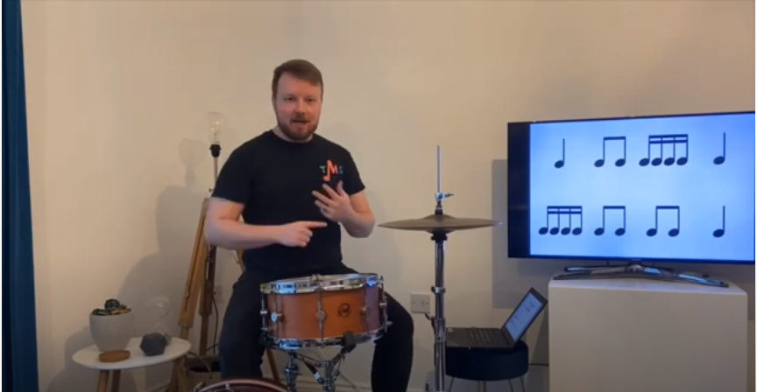
 | Health and Wellbeing
P.E. & Dance
Mr Allen has started to upload P.E. and dance sessions with videos onto our Google Classroom page. See if you can join in with his activities, and remember to leave a comment if you do! It is important to continue to exercise at home, especially during extended time inside. Mr T might even make a guest appearance!!
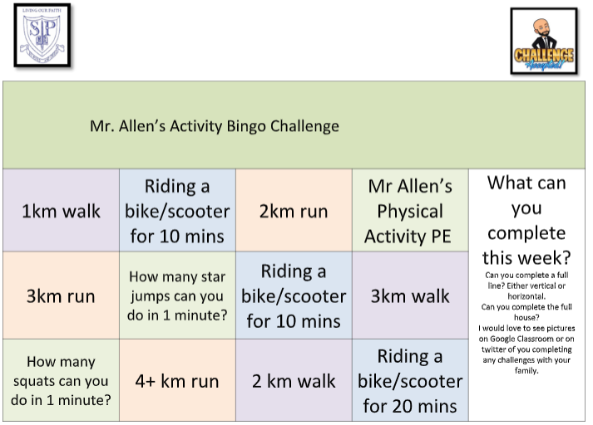

PSHE – Wellbeing Journal
For this week’s PSHE activity, I have provided wellbeing journal. This journal will help you to reflect on your day, to think about what you are proud of, what has worried you, or things we are grateful for. You may wish to just complete this once, for one day, or you could complete the journal each day for the whole week.
Let me know in your comments how you feel about this activity, and we may be able to repeat it next week!

Monday – Maths Lesson 31 Resources – 1 Star Challenge
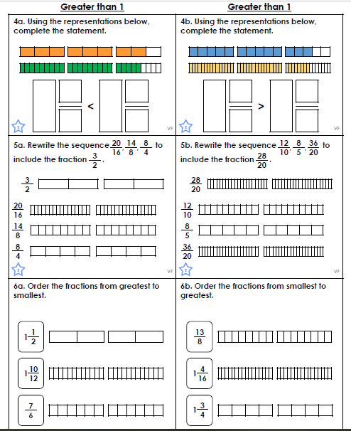

Monday – Maths Lesson 31 Resources – 2 and 3 Star Challenge
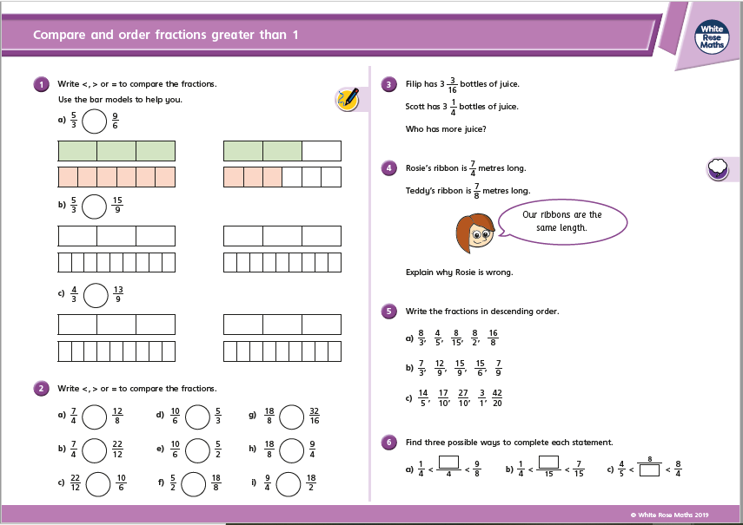

Tuesday – Maths Lesson 32 - Resources – 1 and 2 Star Activity – Question Sheet
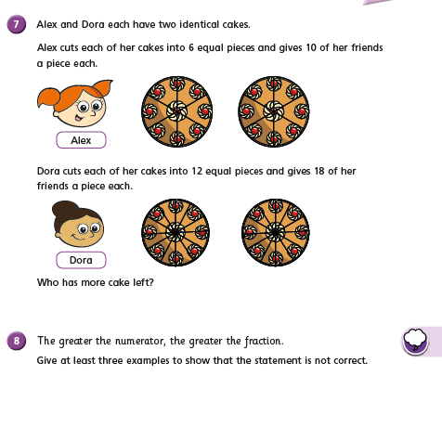

Tuesday – Maths Lesson 32 – 3 Star Reasoning and Problem Solving Sheet
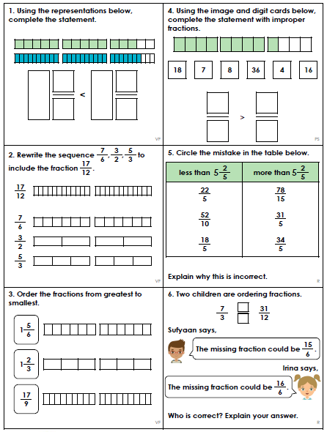

Wednesday – Maths Lesson 33 Resources – 1 and 2 Star Activity Sheet
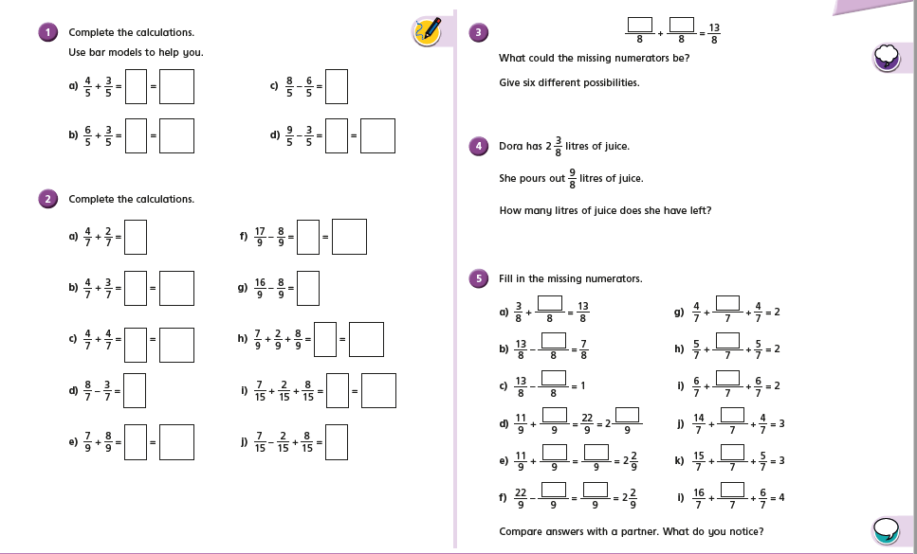
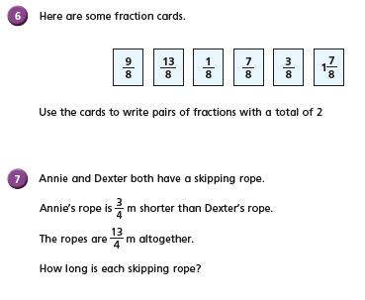
Wednesday – Maths Lesson 33 Resources – 3 Star Activity
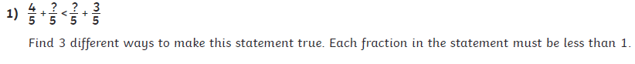
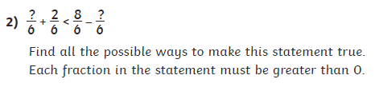

Thursday – Maths Lesson 34 Resources - 1 Star Activity
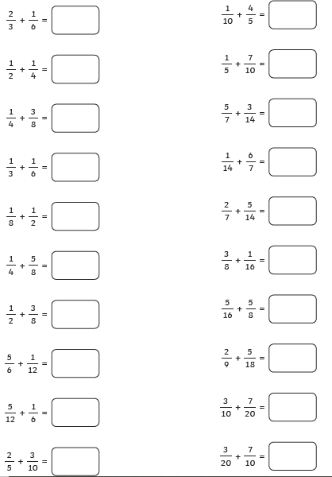

Thursday – Maths Lesson 33 – 2 and 3 Star Challenge
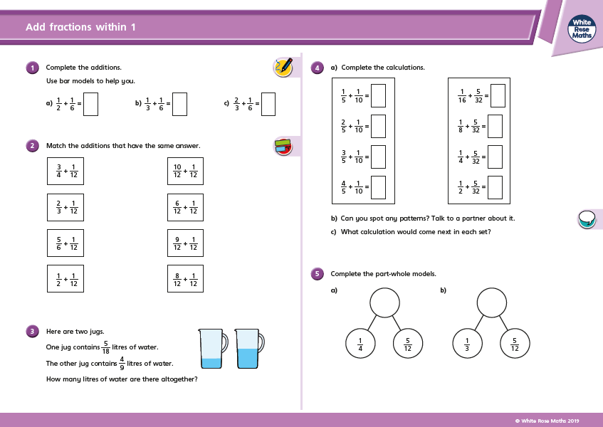
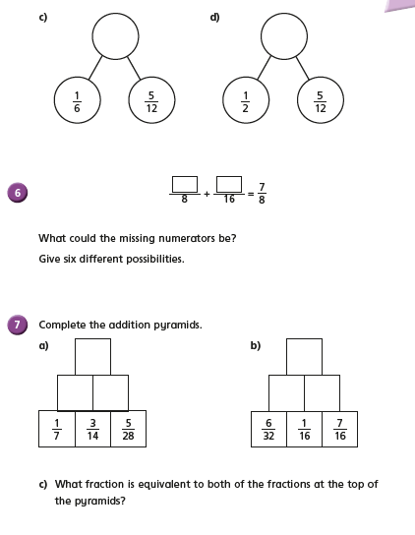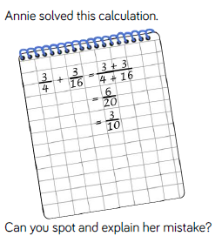
Friday – Maths Lesson 35 Resources – Adding 3 Fractions - 1 Star Activity
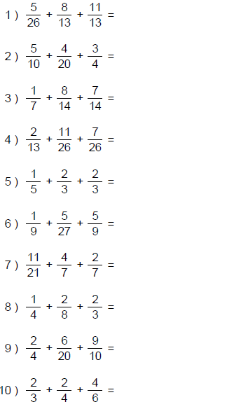

Friday – Maths Lesson 35 Resources – Adding 3 Fractions – 2 and 3 Star Activity
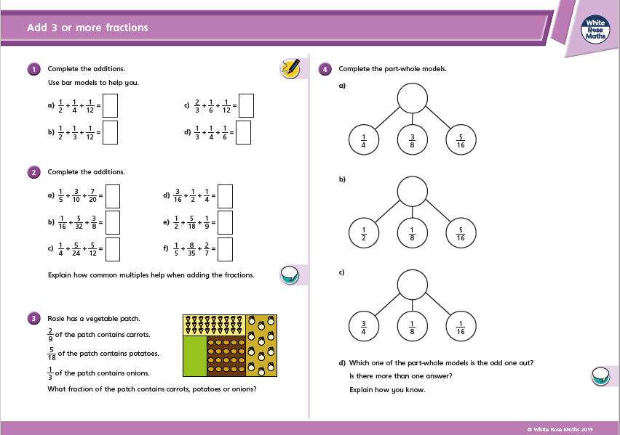
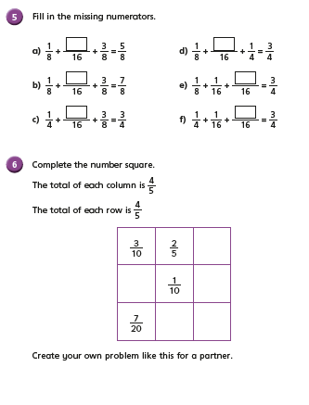

Monday –English Lesson 31 Resources – Planning the Hot Task
Hot Task Plan
WALT: box up the narrative of The Saga of Ragnar
Title: ____________________________________________
 | What happens? | Steps to success I will use
Setting Description

Character Description

Build up –

Problem –

Resolution –
Ending –

Tuesday – English Lesson 32-35 – Hot Task Steps to Success
Me | Our Steps to Success |  | My teacher
 | Simple Past Tense Examples
 | Past Progressive Tense Examples
 | Subordinate Clauses with commas
 | Relative Clauses
 | Parenthesis
 | Commas to clarify meaning
 | Expanded noun phrases
 | Fronted adverbials

Monday – R.E. Resources – Reconciliation – Mary Ann Long and Mother Antonia Brenner
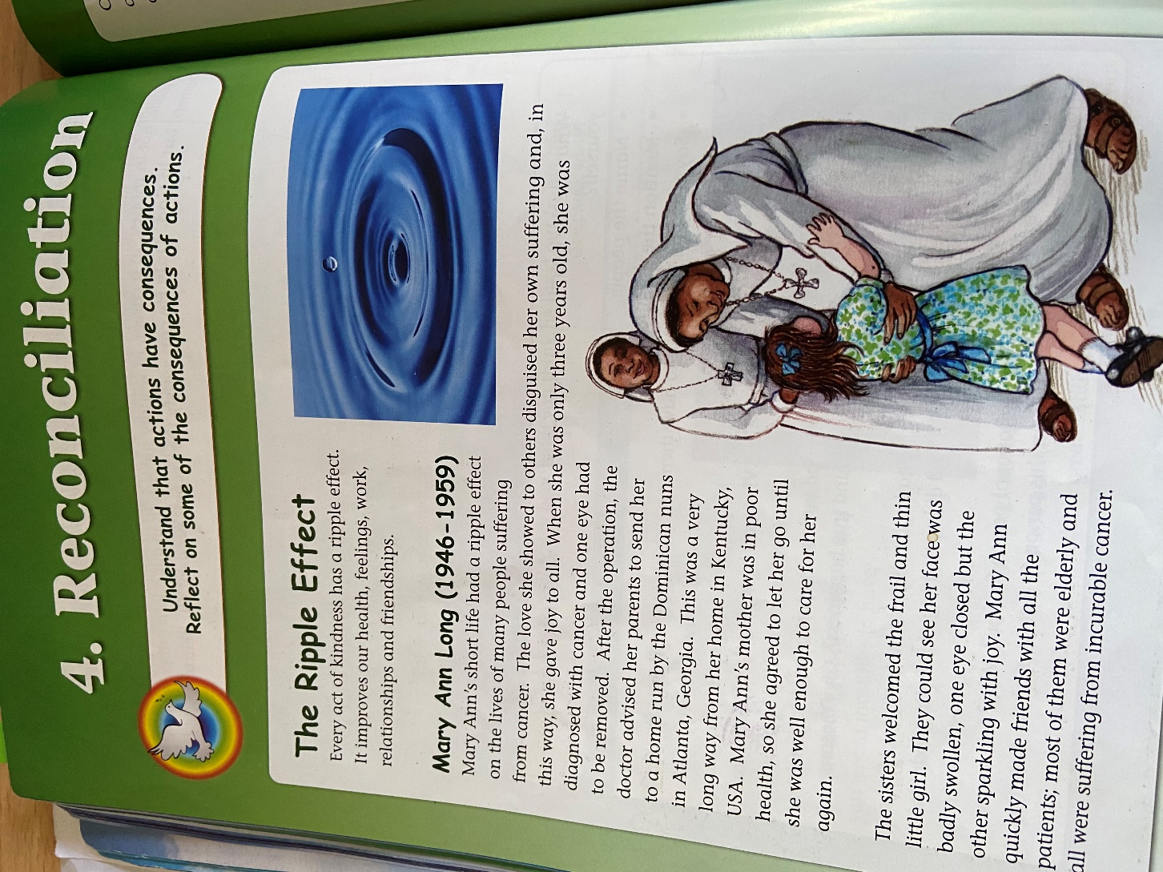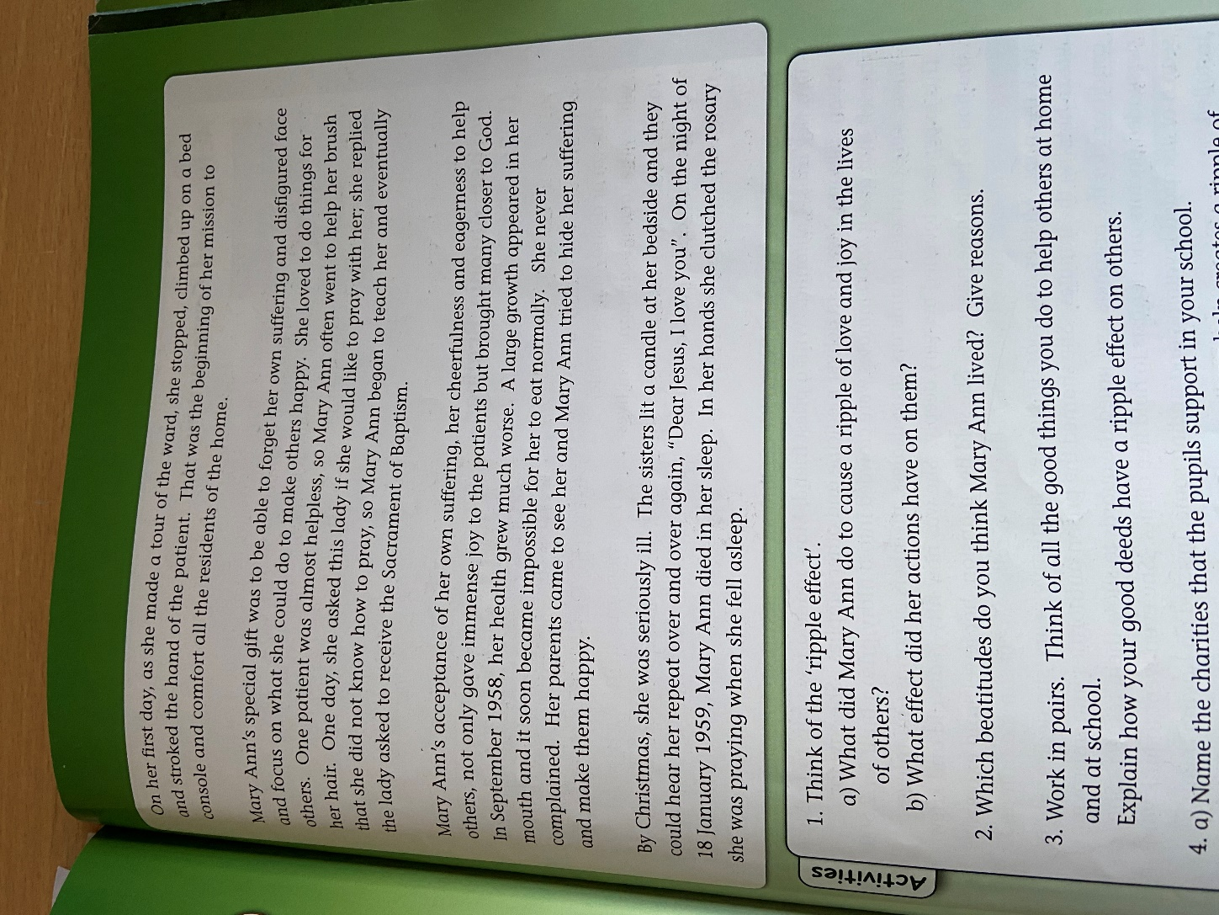
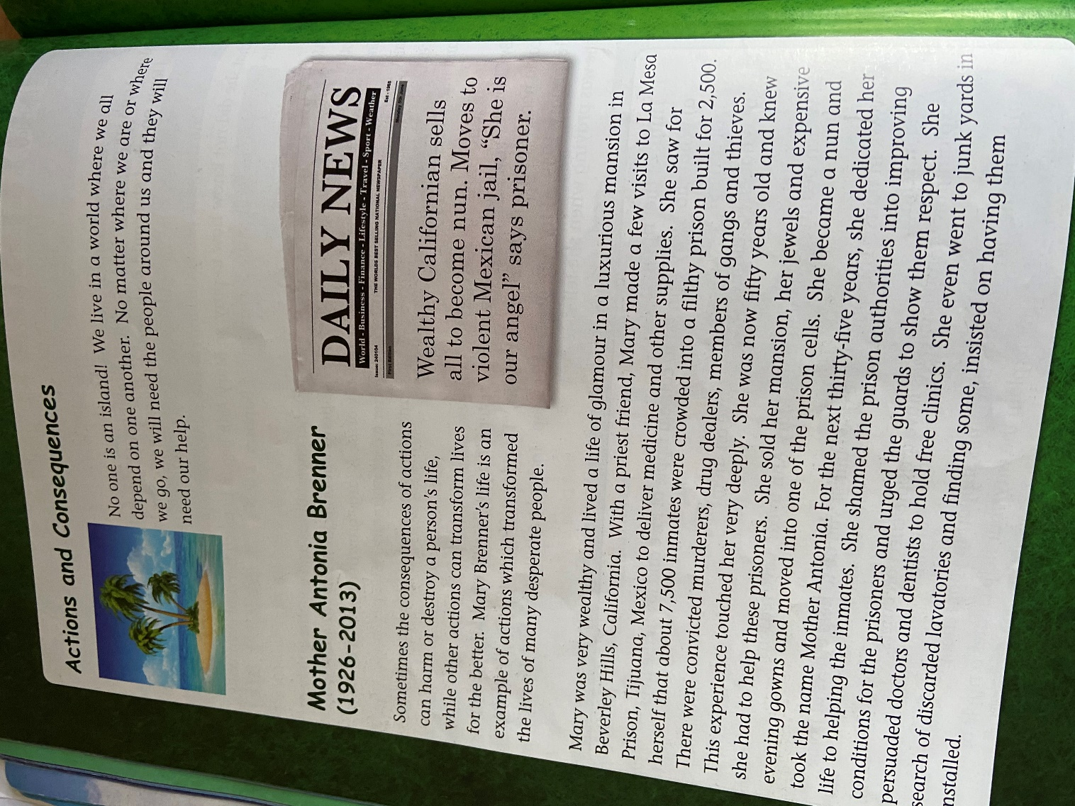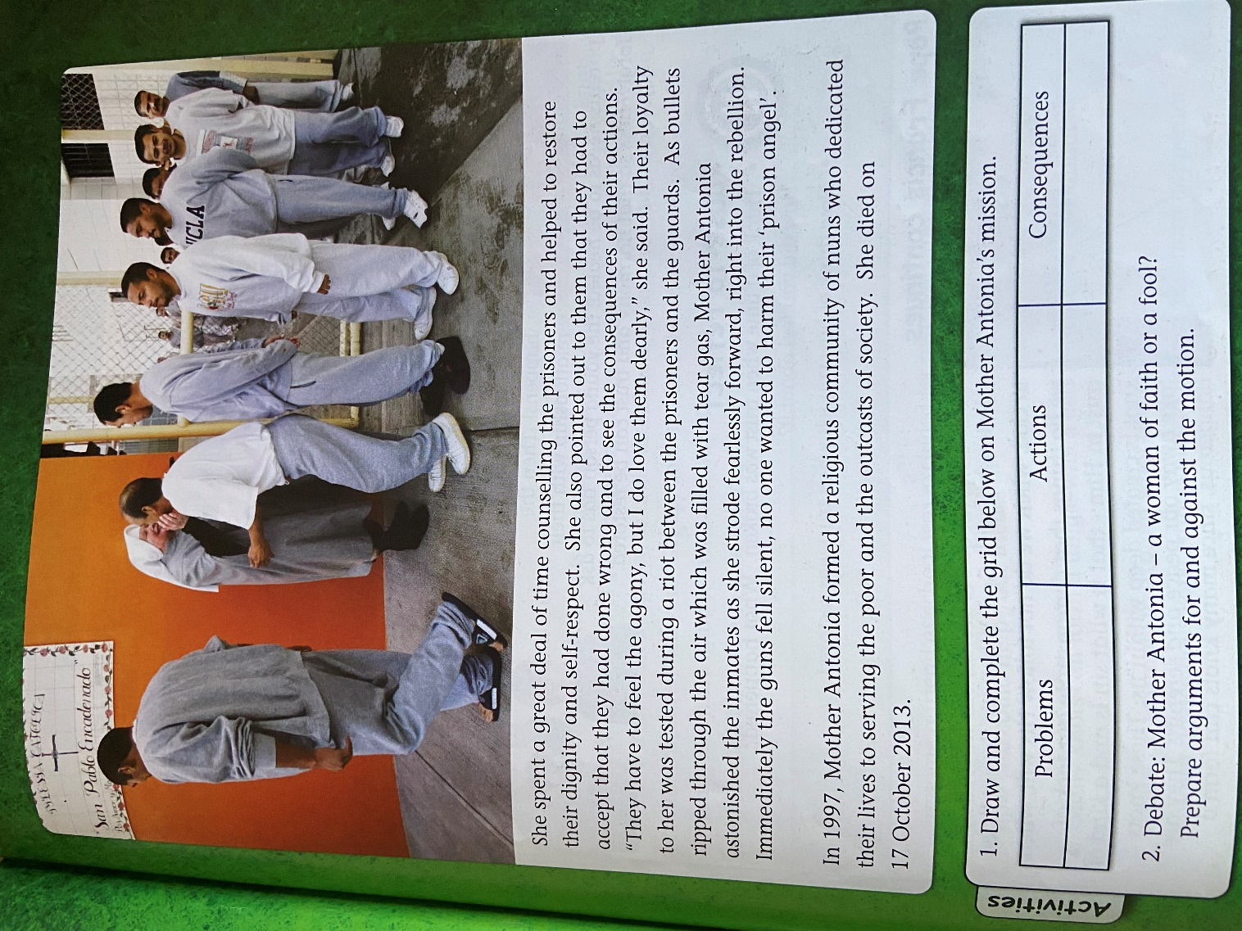

Problems | Beliefs | Actions | Consequences

Mother Antonia – A woman of faith or a fool?

PSHE Resources
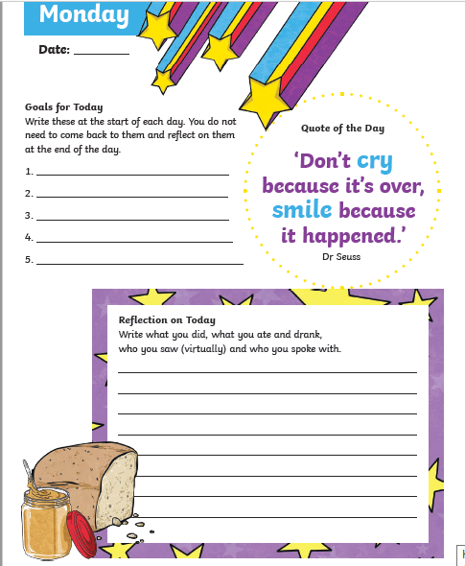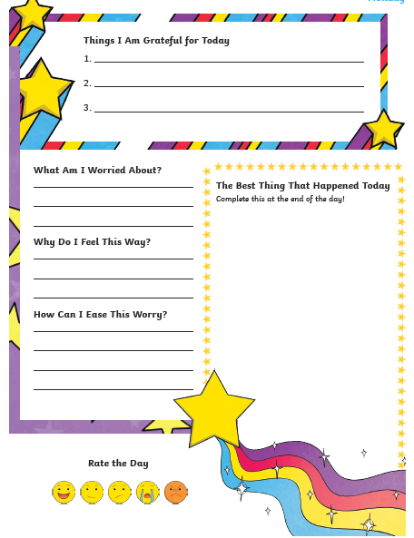

Topic resources – The Danegeld
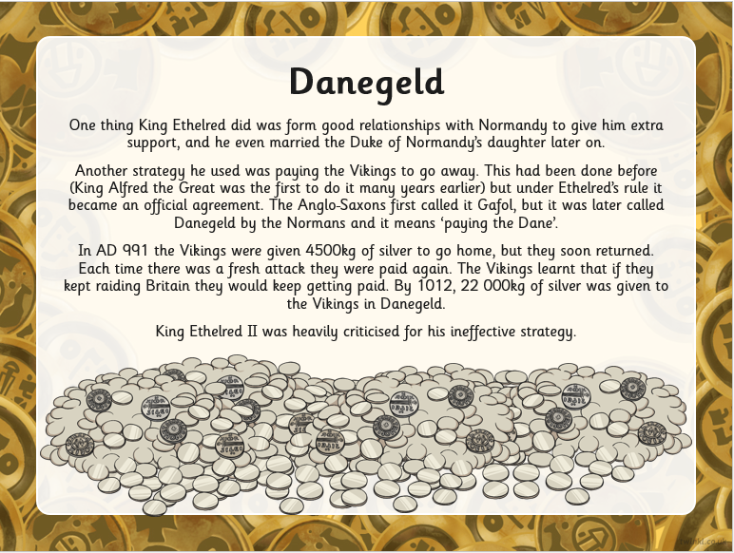
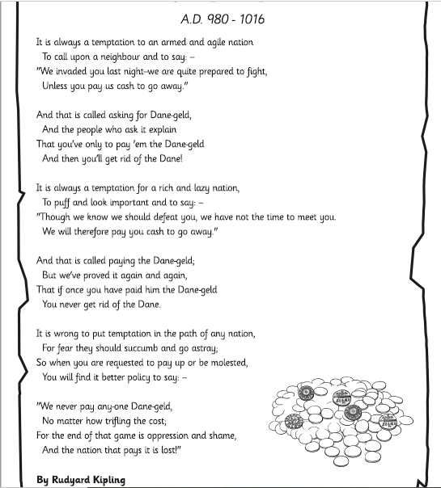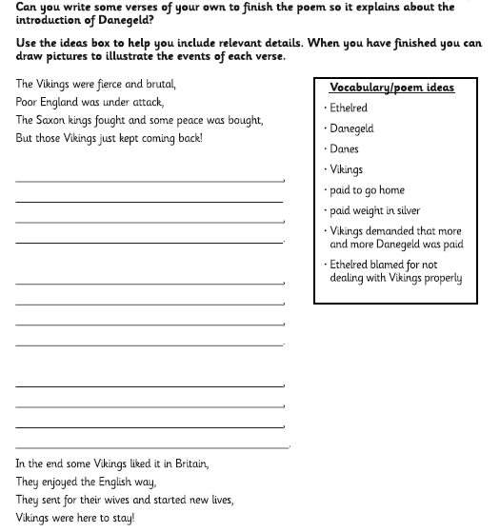
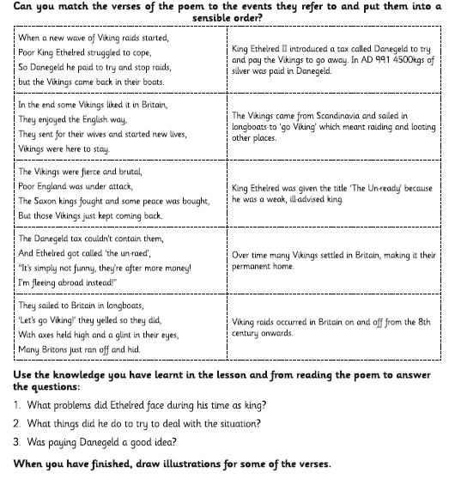

Science Resources
