Year 1 Home learning menu- Spring 2 week 1
See daily videos and worksheets on our Google Classroom to support this plan
The Rainbow Fish  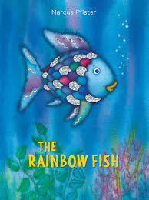 | Conjunctions.  joining sentences together using the conjunction because.  Listen to the first part of the story.  What should The Rainbow Fish do?  Write a sentence explaining what you think he should do using the conjunction because. | Write a brief synopsis and review of the story.  Listen to the whole story.  Did you enjoy it?  What was your favourite part?  Complete the worksheet, showing what you know about the story. |  | Listen to the simplified version of the story and create a story map.  You can use the example on the video to magpie from. |  | Create actions to learn the text.  Using the story map you created yesterday, create your own actions to help you remember the story. |  | Describe the main character.  Think about the main character in the story. Create a mind map of words to describe the rainbow fish. Choose a few words and write two sentences to describe the rainbow fish.
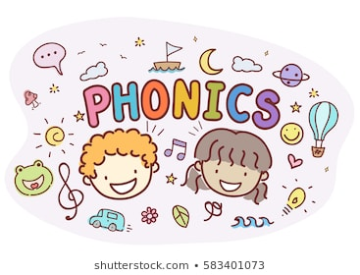 | Read sentences and find the words with the /igh/ phoneme.  Read the sentences in the phoneme spotter and recognise which words have the /igh/ phoneme. How is that phoneme made? | Sort the ways to make the /igh/ phoneme.  Read all the words and sort them according to how the /igh/ phoneme is made. |  | Read sentences and find the words with the /igh/ phoneme.  Read the sentences and recognise which words have the /igh/ phoneme. How is that phoneme made? |  | Read sentences and find the words with the alternative spellings for the /f/ phonemes.  Read the sentences and recognise which words have the /f/ phoneme. How is that phoneme made? |  | Read sentences and find the words with the /igh/ phonemes.  Read the sentences and recognise which words have the /igh/ phoneme. How is that phoneme made?
RE  Families and celebrations | WALT- Have the opportunity to hear how Jesus chose some of the first disciples and consider how we choose friends.  Watch the video on our Google classroom.  Jesus had many friends and followers throughout his life. Can you remember the names of His 12 disciples.  As Catholics, we are followers of Jesus.  What characteristics do you think Jesus looked for in His disciples?  What do you look for in a friend?  Complete the picture with ideas of what makes a good friend.  Are you a good friend?
 | WALT- Count in 2s  Learn how to count up in 2s using our fingers and the whisper shout game!  Colour a number chart counting in 2s. Can you see a pattern? |  | WALT- Count in 2s  Count object in 2s. |  | WALT- Count in 5s  Learn to count in 5s.  Colour the number chart in 5s.  Can you see a pattern? |  | WALT- Count 5s  Count object in 5s. |  | WALT- Count in 2s and 5s.  Count object in 2 and 5s.
Under the Sea  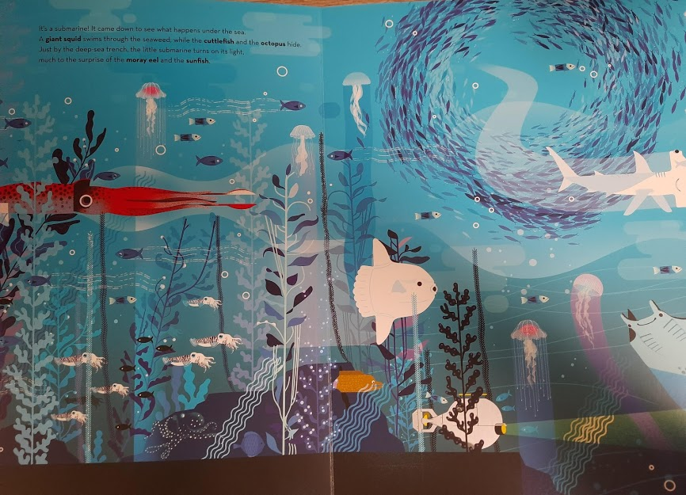 | Challenge 1:  Initial thinking- what do you already know?  Before we start a new topic, can you draw a picture showing everything you know about the seas and oceans.  Try to include things you would see and the names of animals or anything else you include.  Challenge 2:  Compare the characteristics of a fish and people.  Label a picture of a fish with the different body parts.  What is the same as us and what is different?  Challenge 3:  Create your own fish out of leftover things at home.  Look at the pictures on our google classroom video to help me.  Challenge 4:  Listen to some facts about different under sea creatures and create you own fact file about one of the animals.

