Year 5 Home Learning  E-Safety Week |  | This document outlines the activities/lessons your child to complete at home during the bubble closure. Each activity is explained in detail here, including where to find the activities. There is a Maths and English lesson to complete each day, then a range of activities provided for additional subjects which can be completed at any time. WALT stands for We Are Learning To, which will give you a clear indication of the lesson objective. There will be different levels of challenge for the children to complete for most lessons (*** being the hardest level). The children do not need to complete all three levels. The children can work directly into their home learning book they have been given. Please feel free to email any work or pictures of the work and do not hesitate to email me on year5@st-pauls-hyde.tameside.sch.uk if you require any assistance. Thank you, Mr Titterington.  E-SAFETY WEEK – This week is national E-Safety week. This year it is particularly important as we are all using online learning and resources for education and entertainment! Please ensure that you complete these activities.  The BBC are also providing a live lesson on Tuesday 9th February 2021 at 11am. Please join in with this helpful lesson, and share your activities with me!  The lesson can be found here and can also be viewed on the CBBC channel at the same time: https://www.bbc.co.uk/teach/live-lessons/safer-internet-day-live-lesson/zdh2wnb
Week 6
Maths |  |  | English
Look in the table below to find the information about the lesson, which you need to complete. Once you have read the table, scroll down to the bottom of the document to find the tasks and questions, which you need to complete for each lesson. This week will be focussing on Fractions. It is important that you follow this plan carefully, as this is new learning for us, and is not a recap of learning which we have completed in school.  I will be uploading PowerPoints with videos included which explain the methods which you will need to use. |  |  | The Saga of Ragnar – Historical Narrative  We have now finished our Non-Chronological report unit on tigers, and are moving onto our narrative unit. We will be beginning to look at the Vikings over the next couple of weeks, and with that our new narrative The Saga of Ragnar.  Our English lessons will be based on this short narrative during this week. In addition to this, beginning later this week, I will be uploading videos of an additional story, Beowulf, which will help you to generate even more ideas for your writing.  I’m looking forward to reading your stories and seeing your imaginative writing in action!
1) | Maths Lesson 26 - Converting Improper Fractions to Mixed Numbers  In continuing with our fraction work, we will be starting the week with another new Year 5 topic, which is convert improper fractions into mixed numbers.  Last week, we learnt that:  Improper Fractions = Fractions larger than 1, where the numerator is larger than the denominator. $\frac{7}{3}$  Mixed Numbers = Fractions larger than 1, which are a mix of both whole numbers and fractions. 4$\frac{3}{4}$  Converting between improper and mixed fractions is important for a variety of methods, and the concept is a fundamental part of addition and subtraction of fractions in Year 5.  In this lesson, we will learn two different methods. Firstly, how we can convert improper fractions into mixed numbers by drawing or using cubes. Secondly, how we can use our knowledge of mental division to mentally complete this conversion.  An example of the cube method is shown below, when, converting $\frac{15}{6}$ to a mixed number. You would need to collected 15 cubes, and order them into rows of 6. When you have done this, you should find that you have 2, whole rows of 6, and one row of 3. This shows that you have 2 whole and 3 sixths, which can be written as: 2$\frac{3}{6}$  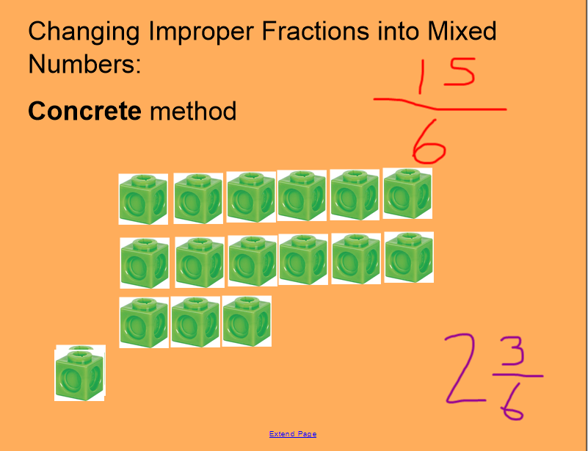  To calculate this mentally, you would need to divide the numerator by the denominator, in the above example this would be 15 ÷ 6. You can fit 2 whole 6’s into 15, which would give you 3 remaining. This would also give you the answer: 2$\frac{3}{6}$  On Google Classroom, the children will find a video explaining both of these methods in detail.  An additional video explaining this method can be found here: https://whiterosemaths.com/homelearning/year-5/spring-week-3-number-multiplication-and-division-2/  Challenge Levels  1 Star – Complete section 1 and 2 of the 1 Star worksheet.  2 Star – Complete section 1, 2 and 3 of the 1 Star worksheet.  3 Star – Complete the 1 Star Worksheet and the reasoning problems. |  | 1) | English Lesson 26  WALT: Understand the difference between simple tense and progressive tense.  When we are writing, we often think about, and use the present and the past tense. By year 5, we should know that we can write in both the present and te past tense. Writing in the past tense, is writing about something which has already happened. Writing in the present tense, is writing about some which is currently happening. It is important that different text types use the correct tense, to help them to make sense.  However, there are different types of present and different types of past tense.  We can use: Simple present tense, Simple past tense, Present Progressive Tense and Past Progressive Tense.  There are rules for each of these to help you to tell which one is which.  Simple tense does not tell you whether the verb has been completed or is ongoing. Here is the rule for simply tense, with an example:  - Simple present tense is when the verb ends with an s or an es, such as: Mr T watches ice hockey.  The boy walks to the bus to get to school.  - Simple past tense is when the verb ends with ed, such as: Mr T watched ice hockey.  The boy walked to the bus to get to school.  We can also use present and past progressive tense. Progressive tense is used to show that the verb is still on going. Here are the rules for progressive tense with an example:  Present progressive tense usually has the word is or are followed by a verb ending with ing, for example: Mr T is watching ice hockey.  The boys are walking to the bus to get to school.  Past progressive tense usually has the words was or were followed by the verb ending with ing, for example: Mr T was watching ice hockey.  The boys were walking to the bus to get to school.  On Google Classroom, I have uploaded a video explaining how to choose the correct tense in your writing. I have also filmed a quiz which you can join in with, picking the correct tense and verb.  Later in this task, you will also find posters which explain these two types of tense clearly.  For this lesson, there are only two challenges. Firstly, I would like you to complete the quiz on Google Classroom, by following the video and writing down your answers, either on paper or in the Google Doc I have made.  The complete these tasks:  Challenge level  1 Star – Write 10 expanded noun phrases with a mixture of simple and progressive, past and present tense.  2 Star – Write a new paragraph for the story, The Sage of Ragnar and highlight the verbs in different colours to show the past and present tense.
2) | Maths Lesson 27 – Converting Mixed Numbers to Improper Fractions  WALT: Convert Mixed Fractions to Improper Fractions  Building on from yesterday’s lesson, we will now be going in the opposite direction, changing mixed numbers back to improper fractions. Yesterday, we were dividing, and sorting into groups to complete the conversion. Today, because we are going the opposite way, we will need to multiply. Again, we can complete this conversion using both cubes and mental methods.  Cube Method  To complete the cube method for the example of below, you would need to create two whole groups of 5 counters. You would then need one final group of 3 counters out of 5. Once you have created these groups, you need to counter the amount of cubes you have used to find the numerator for your improper fraction. Here is an example: 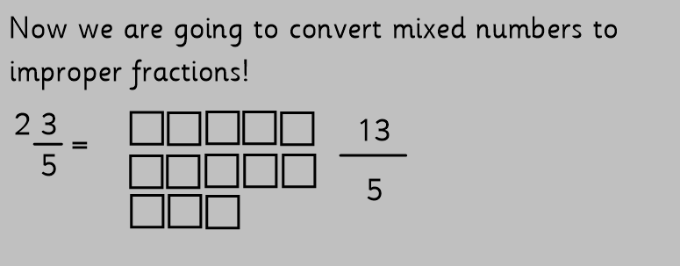  Mental Conversion  To solve the above question mentally, you would need to multiply the whole number by the denominator 2 x 5 = 10. Then, you would add the numerator 10 + 3 = 13, this answer provides your numerator, giving the answer 13/5.  On Google Classroom, I have provided a video which explains both of these methods in detail.  An additional video for this method can be found here: https://whiterosemaths.com/homelearning/year-5/spring-week-5-number-fractions/  Challenge Levels  1 Star – Complete Questions 1-5 of the Activity Sheet  2 Star – Complete Questions 1-6 of the Activity Sheet  3 Star – Complete the problem solving challenge to convert improper fractions and then compare two fractions to see which is larger. |  | 2) | English Lesson 27 - Town Members diary entry  WALT: Write a diary entry with a mixture of simple and progressive past tense.  Building on from yesterday’s lesson on simple and progressive tense, I would like you to build on the knowledge you gathered yesterday, using examples of past simple and progressive tense to write a diary entry.  The diary entry should be written from the point of view of one of the families who lived in the town when the Behemoth arrived. You may wish to write the diary entry from the point when the behemoth arrived, to the point when Ragnar arrives for the challenge.  You should try to think about:  - Using a mix of simple past tense and progressive past tense verbs  - What the atmosphere in the town was like before the monstrous creature arrived  - What happened when the monstrous creature arrived? What did it do?  - What did the monster and the families once it was inside of the town?  Think also about all of the different grammar features which we learnt last week, and how you could use these to improve your writing.  It would be good if you could highlight verbs in different colours which use simple past tense and past progressive tense.  Remember that a diary entry should be written in first person.  Challenge Levels  1 Star – Write a diary entry for a town’s person, using a mixture of simple past tense and past progressive tense verbs.  2 Star – Write a diary entry for a town’s person, using a mixture of simple past tense and past progressive tense verbs, and subordinate clauses.  3 Star - Write a diary entry for a town’s person, using a mixture of simple past tense and past progressive tense verbs, subordinate clauses, relative clauses and parenthesis.
3) | Maths Lesson 28 – Fraction Number Sequences  WALT: Compare, order and complete number sentences using fractions  You should have now used the activities from last week and this week to develop a good understanding of finding equivalent fractions and conversions between mixed numbers and improper fractions. You will need to use this knowledge to place fractions into sequences and in order.  If fractions have different denominators, you will need to convert them to the same denominator by using equivalent fractions. If there is a mix of improper and mixed fractions, you will need to convert some so that they are both the same.  A detailed explanation of this method can be found on the video I have uploaded to Google Classroom, as this can be difficult to explain through written text.  An additional video which explains this method can be found here, titled: Number Sequences : https://whiterosemaths.com/homelearning/year-5/spring-week-5-number-fractions/  Challenge Levels  1 Star – Complete Questions 1-4 of the activity sheet  2 Star – Complete questions 1-6 of the activity sheet.  3 Star – Complete the 2 star challenge and the 3 star problem solving sheet |  | 3) | English Lesson 28 – Setting Description  WALT: Write a setting description for a location of my choice in The Sage of Ragnar  In this lesson, I would like you to show me everything that you have learnt over the last few weeks. I would like you to write a setting description for a location of your choice from The Sage of Ragnar. This could be a description of:  - Ragnar’s home  - The Scandinavian landscape  - The town  - A different location of your choice which might not be in the story we have read, but could fit in.  In your setting description, you should try to use each of the grammar features which we have learnt to show me what you have learnt.  On google classroom, I have uploaded a video explaining this task in more detail.  Challenge levels  1 Star – Write a setting description, using a mixture of simple past tense and past progressive tense verbs.  2 Star – Write a setting description, using a mixture of simple past tense and past progressive tense verbs, and subordinate clauses.  3 Star - Write a setting description, using a mixture of simple past tense and past progressive tense verbs, subordinate clauses, relative clauses and parenthesis.
4) | Maths Lesson 29 – Compare and order fractions less than 1  WALT: Compare and order fractions less than 1  In this lesson, we will need to use our knowledge of equivalent fractions.  We will be given two different fractions, for example ¼ and ½ These fractions have different denominators, however we should be able to use our knowledge of equivalent fractions to find the lowest common denominator. By changing the fractions so that they have the same denominator, we are able to compare which of the fractions is larger without using or needing to draw diagram.  We can compare fractions by using diagrams. This helps to give us a visual representation and clearly shows which fraction is larger and smaller. However, using this method can be difficult as when drawing the bar models, it is essential that each part/section of the bar are equal, meaning they must be measured accurately when they are being drawn. An example is here: 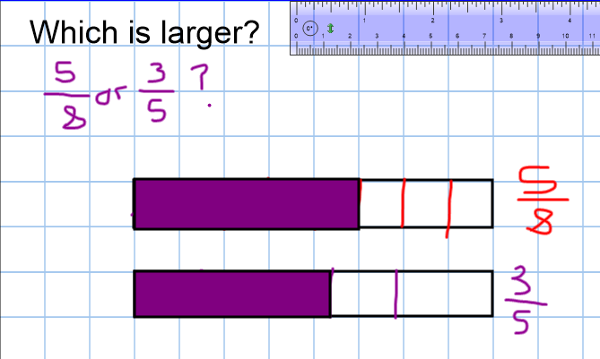  Once you have mastered this method, you should be able to use your knowledge of equivalent fractions to find the lowest common denominator.  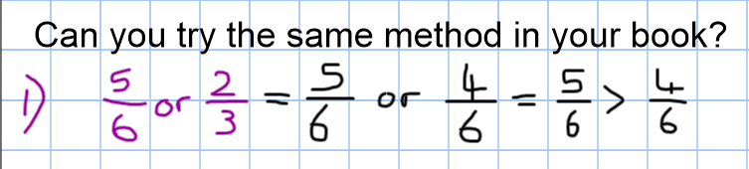  On Google Classroom, I have uploaded a detailed method explaining both of the methods. If you cannot access Google Classroom, a helpful guide can be found here: https://www.bbc.co.uk/bitesize/articles/znk4kmn  An additional guide can be found here: https://whiterosemaths.com/homelearning/year-5/spring-week-5-number-fractions/  Challenge Levels  Each of the activities today are very similar, but the times tables you will need are more challenging as you go higher.  1 Star – Complete the 1 Star Level Fraction Sheet.  2 Star – Complete the 2 Star Level Fraction Sheet.  3 Star – Complete the 3 Star Level Fraction Sheet.  4 Star – Complete the bonus challenge level. |  | 4) | English Lesson 29 – Innovate the opening and build up  WALT: Innovate the opening and build-up of The Saga of Ragnar.  Innovation writing in English is when write a story in our own words, following the same structure. Over the next two lessons, we will be writing our own version of the story of Ragnar, again using all of the grammar features which we have learnt over the last two weeks. In this writing, you should use the same characters and the same story as The Saga of Ragnar, but add more detail, and write some of your own ideas.  In this lesson, you should write the opening, and build up. This should include: a character description, a setting description and the part of the story where Ragnar is fighting an opponent on a cliff edge.  On Google classroom, I have uploaded a video explaining this lesson in more detail.  After half term, we will be writing our hot task, where we can change the story to our own ideas, using different characters and settings.  Challenge Levels  There are no challenge levels for this lesson. This challenge is to write the Opening and build up using a selection of the steps to success which have been provided.
5) | Comparing Fractions Lesson 2  WALT: Compare fractions less than 1 including problem solving  Today, we will be continuing with our objective to compare different fractions which are less than 1. We will be using the same methods as yesterday, however taking it one step further where I would like you to choose your own challenge level, depending on how confident you were in yesterday’s lesson.  On Google Classroom, I have recorded a video which again explains the method, and also introduces the different tasks which you can choose to complete. Again an example of this method is shown on the two videos on this website: https://whiterosemaths.com/homelearning/year-5/spring-week-5-number-fractions/  Here are the activity levels which you may choose for this lesson:  1st Activity – Complete the white rose hub activities to improve your knowledge.  2nd Activity – Complete the picture maths activity, answering the different questions about the pictures. (We have done these in school before!)  3rd Activity – Complete the 6 problem solving questions. |  | 5) | English Lesson 30 – Problem, resolution and Ending  WALT: Innovate the problem, resolution and ending of The Saga of Ragnar.  In this lesson, we will be continuing our innovation stories from yesterday, writing the problem, resolution and ending. Innovation writing in English is when write a story in our own words, following the same structure. Over the last two lessons, we have been writing our own version of the story of Ragnar, again using all of the grammar features which we have learnt over the last two weeks. In this writing, you should use the same characters and the same story as The Saga of Ragnar, but add more detail, and write some of your own ideas.  In this lesson, you should write the problem, resolution and ending. This should include: The behemoth attacking the town, Ragnar facing the monstrous creature, and Ragnar reaching Valhalla.  On Google classroom, I have uploaded a video explaining this lesson in more detail.  Challenge Levels  There are no challenge levels for this lesson. This challenge is to write the Opening and build up using a selection of the steps to success which have been provided.

Additional Subjects- To be completed anytime over next week
Science | Topic
Properties of Materials – Lesson 3  WALT: Investigate materials which will dissolve.  Warning: You will need adult supervision for this lesson. Please do not complete this lesson if you do not have an adult to help you.  In this lesson, we will have two different investigations which you can choose from. You may wish to choose to just complete one investigation, or you could include both investigations.  On Google Classroom, I have uploaded a video explaining what dissolving is, and also how to complete each of the different investigations.  Investigation 1: I would like you to investigate which items are soluble and insoluble. Soluble items are those which will dissolve in a liquid (this is when a solid, mixes with a liquid to make a new liquid called a solution). Insoluble items are those solids which will not dissolve into a liquid to create a new solution. In this experiment, I have given you a list of different materials and solids, such as rice, salt or sand. You may or may not own these different items at home, if you do not own a specific item, you may change it to a different item. Mix these solids into warm water with adult’s supervision. Then write down whether these solids have dissolved into the water. You will know if this has happened if the solid is no longer visible.  Investigation 2: Using either sugar or salt, with an adult’s supervision, prepare three different cups of water, one cold cup, one warm cup, and one hot cup of water. Do not use hot water without a parent’s permission. Put the salt into each of the different cups and time how long it takes for the salt or sugar to dissolve into each of the different liquids. | Topic – Vikings Lesson 3  WALT: Use The internet to research and identify the importance of different Anglo-Saxon kings during the Viking period.  Last week, we thought about some of the key events which happened during the Anglo-Saxon and Viking Eras, and ordered them chronologically in a timeline. We learnt about the number of different kings which were in control of parts of England during this period of hundreds of years.  In this lesson, I would like you to learn about, and use the internet to research in more detail, the importance of the Anglo-Saxon kings Alfred the Great and King Athelstan.  Before completing your main task, I would like you to use the internet, with a safe search engine sure as www.kiddle.co to research and find 5 interesting facts for each king which prove why they each were an importance king.  Once you have found your 5 facts for each of the kings, log onto Google Classroom and write a short discussion text to summarise your ideas. You should set out your writing like this:  Introduction – Who were the two different kings, when were they in power, general facts such as their age and location they were king.  Main Paragraph 1 – Why was King Alfred the Great an important king?  Main Paragraph 2 – Why was King Athelstan an important king?  Conclusion – In your opinion, which was the most important king and why?  On Google Classroom, I have recorded a video which gives you some facts about the two different kings, and to explain your activity in more detail.  Later in this document, I have also included an information sheet for each of the kings.  Try to use some of the English Grammar features from our Ragnar and non-chronological report work in your writing.  Challenge levels  1 Star – Write a discussion text using facts from the video on Google Classroom.  2 Star – Write a discussion text using facts from the video on Google Classroom and your own research using the internet.  3 Star – Complete the two star challenge and write a 3rd main paragraph for your own, different Anglo-Saxon king.
Art & PSHE | Computing
Leonora Carrington  This week, we will learn about the artist named Leonora Carrington who was a British artist who spent most of her life in Mexico.  Much of Leonora’s artwork is unique, and is often said to be dream like.  Dream Catchers are common in Native American culture. They are usually circular and have a web or net in which to ‘catch you dream’.  Feathers and beads are often used to decorate them because they are special items in their culture. They were used to filter bad dreams so that only the good dreams could get through to the mind.  This week, I would like you to make your own dream catcher. If you don’t have any resources to create a dream catcher, you can draw one instead.  I would like to link this to our PSHE activity, by thinking about your own dreams, these could be aspirations you have for your own life.  I can’t wait to see your creative designs!  On Google Classroom, I have uploaded a video explaining this task in more detail.  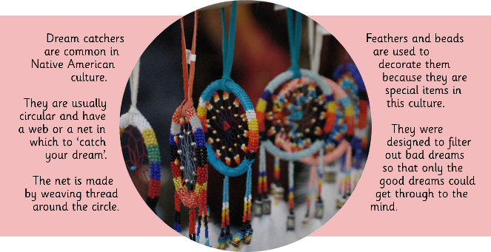 | Computing Lesson 1 – E-Safety Week  This week there will be two computing lessons, our normal lesson on spreadsheets on Friday, and an E-Safety lesson to replace our PSHE lesson.  This week is E-Safety week, and in this lesson there will be 3 different activities. I would like you to complete all 3.  Starter  As a starter activity, I have upload a video that I recorded at the beginning of the week. I have been wondering whether I should or should not upload this video online? Could you give me some tips about which parts of the video I may need to change. The video is available on Google Classrooms, along with a Google Doc for you to write your ideas in.  Main Activity 1  I have uploaded some different conversations which some children have had with strangers online. These could be through social media sites or even through gaming, such as with a headset or console messaging. I would like you to think about which ideas the children should and should not have spoken about. Underneath each of the conversations in the Google Doc on Google Classrooms, can you write down what the children should and should not have talked about.  Main Activity 2  On Google Classroom, I have uploaded a video talking through some of the different rules and ideas which you should be mindful of when using the internet. I would like you to watch the video and then think of a set of rules which people should follow when using the internet. I would like you to make a E-Safety Poster, explaining to other children what you should and should not do on the internet. You could create this poster digitally in a Google Doc, by hand and take a picture, or create an E-Safety poster using Purple Mash.  Computing Lesson 2 – Spreadsheets Lesson 3  So far, we have learnt how to use formulas and mathematical symbols to solve different calculations using spreadsheets on Purple Mash. Both myself and Miss Quinn have been very impressed with the spreadsheets you have created!  In this lesson, I would like you to use a spreadsheet to solve perimeter and area problems! To work out how to do this, watch my video on Google Classroom and then complete the activity on Purple Mash.
RE
Inspirational People – Lesson 6
WALT: Know why Jesus blessed the pure in heart and the poor in spirit
Over the last few weeks, we have learnt about the beatitudes and the different people who displayed them and followed them in their own lives.
In this lesson, we will particularly focus on the beatitudes for the Pure in heart and the Poor in Spirit.

I would like you to read the stories of Edith Stein and Father Pedro Arrupe. Both of these inspirational people followed or showed actions which represented the beatitudes. One you have read each of the stories, I would like you to look once more through the beatitudes.

I would like you to create your own Similarities and Differences table to compare Edith Stein and Pedro Arrupe. In the table, I would like you to compare how they were similar or different in the ways that they followed Jesus’ example. You might even be able to think of a beatitude which is linked to both of the people, or different beatitudes, which are linked to only one off these people.
On Google Classroom, I have recorded a video reading the stories for both of these people, and also explained this task in more detail. You will also find a Google Doc with a table made for you to complete.

Challenge Levels
1 Star – Create a similarities and difference table to tell me how they both followed Jesus’ examples in similar and different ways.
2 Star – Create a similarities and difference table to tell me how they both followed Jesus’ examples and the beatitudes in similar and different ways.
3 Star – Write one of two sentences after completing the 2 star challenge to tell me how you could learn from these two inspirational people.

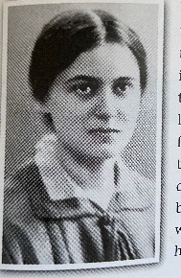
 | Health and Wellbeing
P.E.
Mr Allen has started to upload P.E. sessions with videos onto our Google Classroom page. See if you can join in with his activities, and remember to leave a comment if you do! It is important to continue to exercise at home, especially during extended time inside. Mr T might even make a guest appearance!!
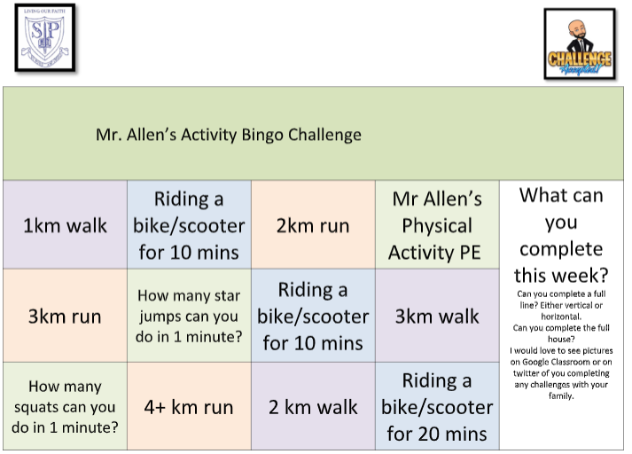
Monday – Maths Lesson 26 Resources – 1 Star Challenge
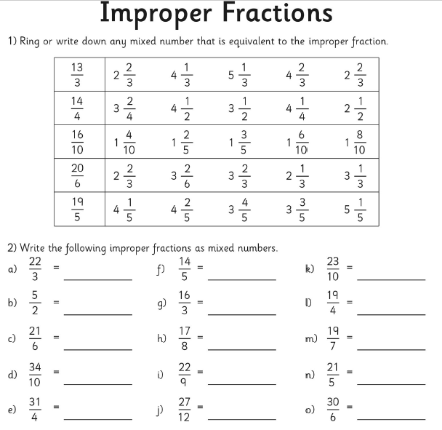
Monday – Maths Lesson 26 Resources – 2 Star Challenge
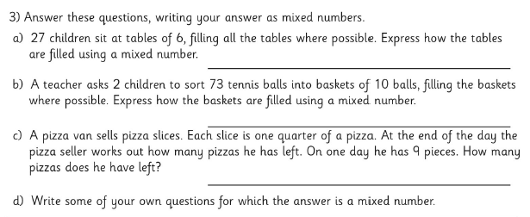
Monday – Maths Lesson 26 – 3 Star Reasoning Challenge
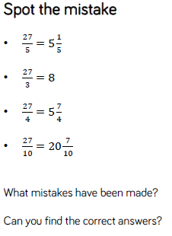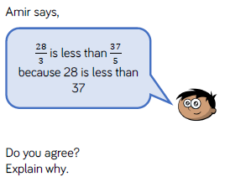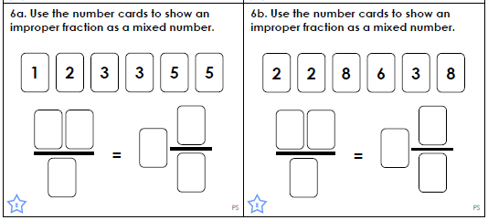

Tuesday – Maths Lesson 27 - Resources – 1 and 2 Star Activity – Question Sheet
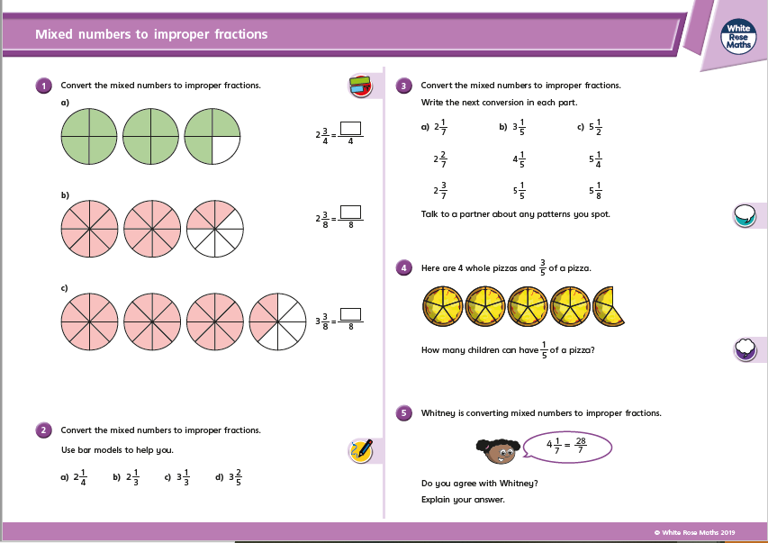
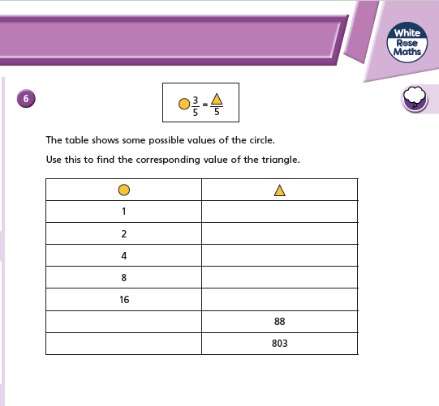

Tuesday – Maths Lesson 27 – 3 Star Reasoning and Problem Solving Sheet
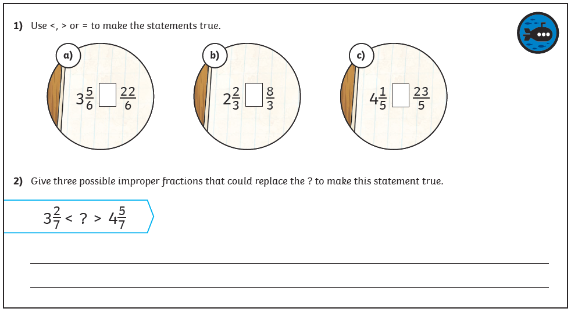

Wednesday – Maths Lesson 23 Resources – 1 and 2 Star Activity Sheet
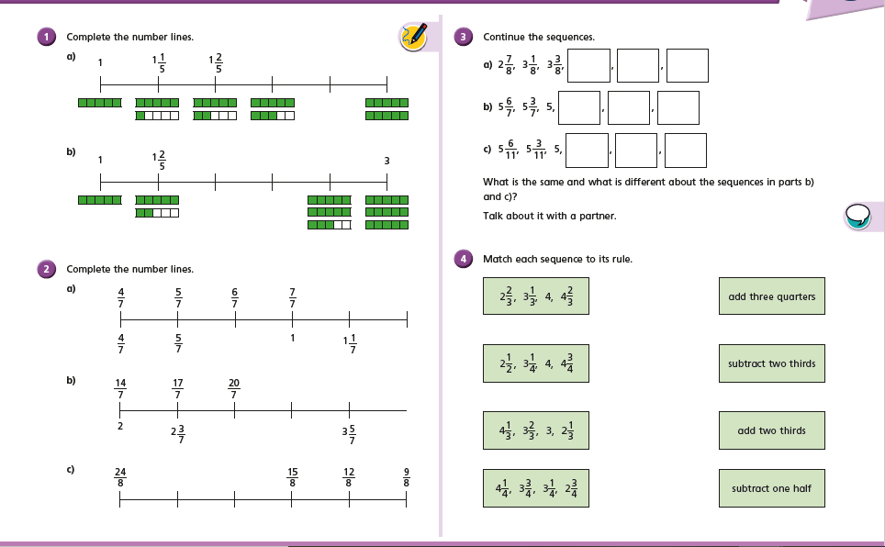

Maths Lesson 28 – 3 Star Problem Solving Activity

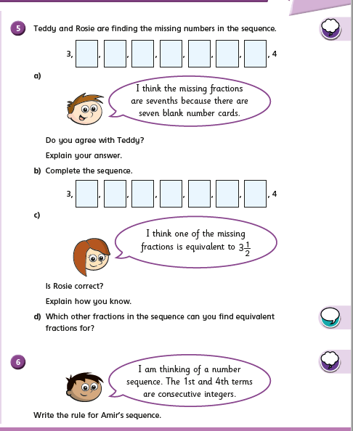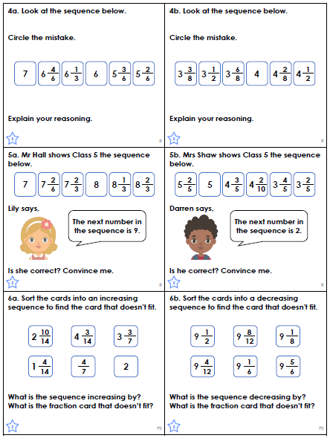

Thursday – Maths Lesson 29 Resources - Comparing Fractions Lesson 1
1 Star Activity 2 Star Activity
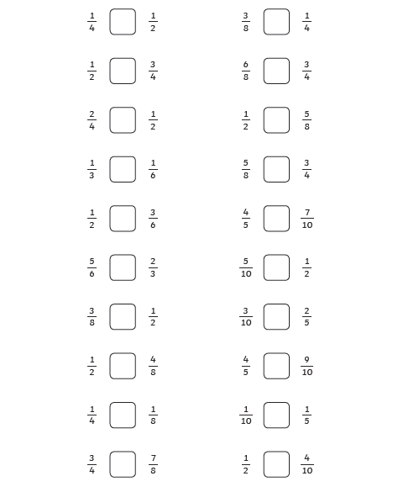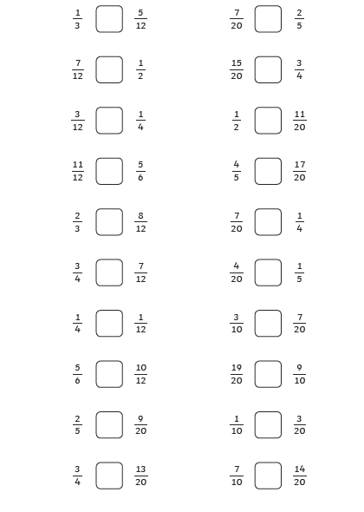

3 Star Activity 4 Star Problem Solving Challenge
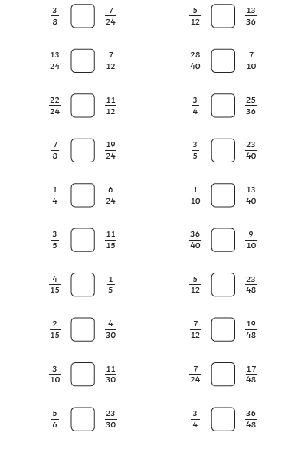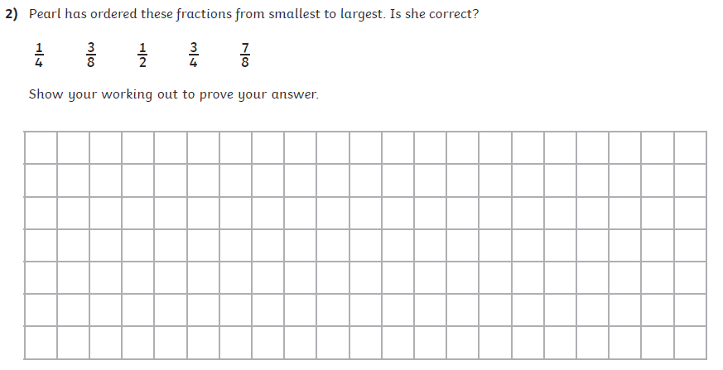

Friday – Maths Lesson 30 Resources – Comparing Fractions Lesson 2
1st Activity Option
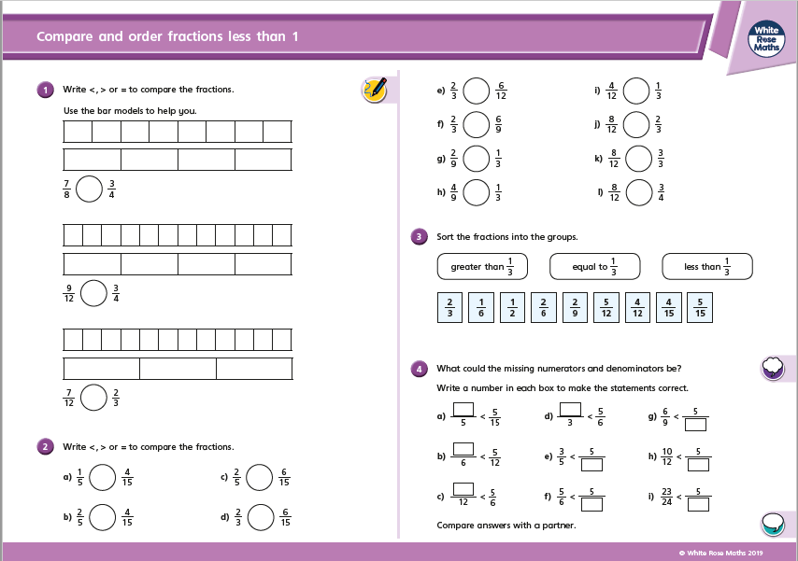
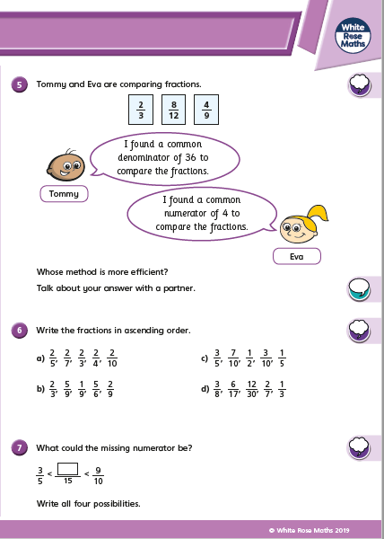

2nd Activity Option
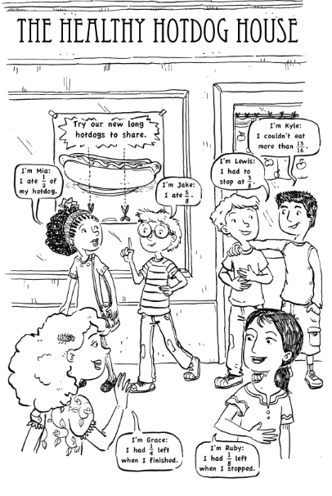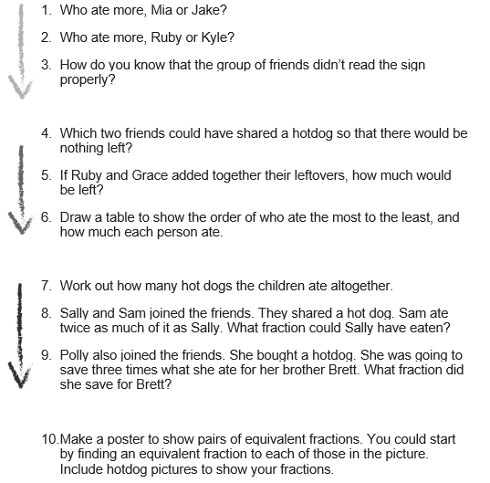

3rd Activity Option
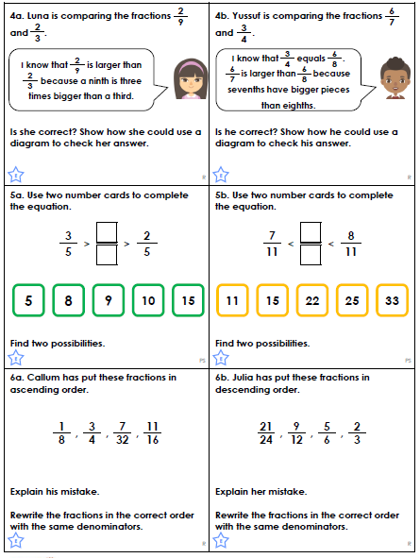

Monday –English Lesson 26 Resources – Simple and Progressive Tense
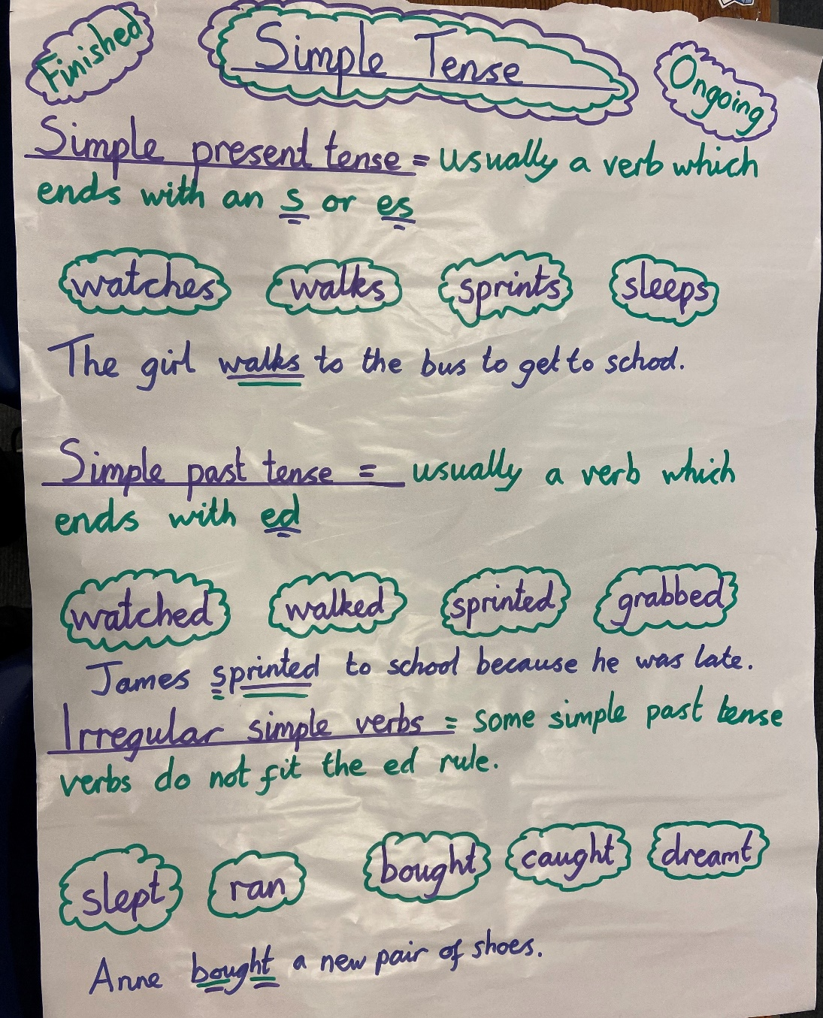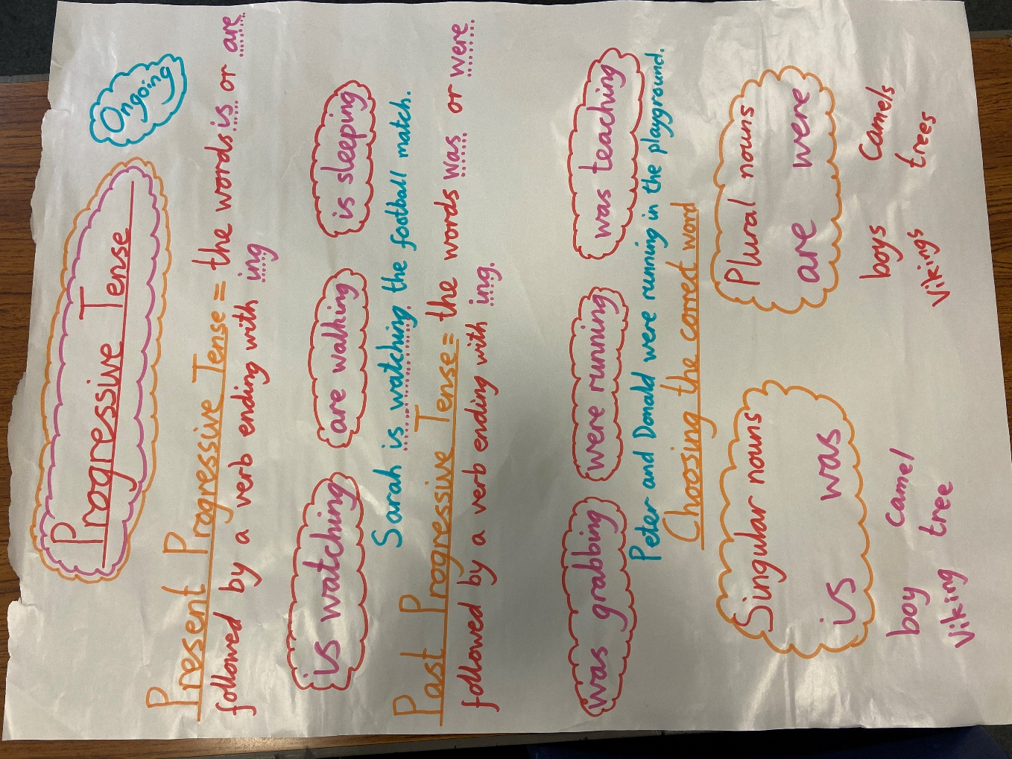
Tuesday – English Lesson 27 – Diary Entry
Me | Our Steps to Success |  | My teacher
 | Simple Past Tense Examples
 | Past Progressive Tense Examples
 | Subordinate Clauses with commas
 | Relative Clauses
 | Parenthesis

Wednesday, Thursday and Friday English - Steps to success
Me | Our Steps to Success |  | My teacher
 | Simple Past Tense Examples
 | Past Progressive Tense Examples
 | Subordinate Clauses with commas
 | Relative Clauses
 | Parenthesis
 | Commas to clarify meaning
 | Expanded noun phrases
 | Fronted adverbials

Monday – R.E. Resources – The Beatitudes, St Edith Stein & Father Pedro Arrupe
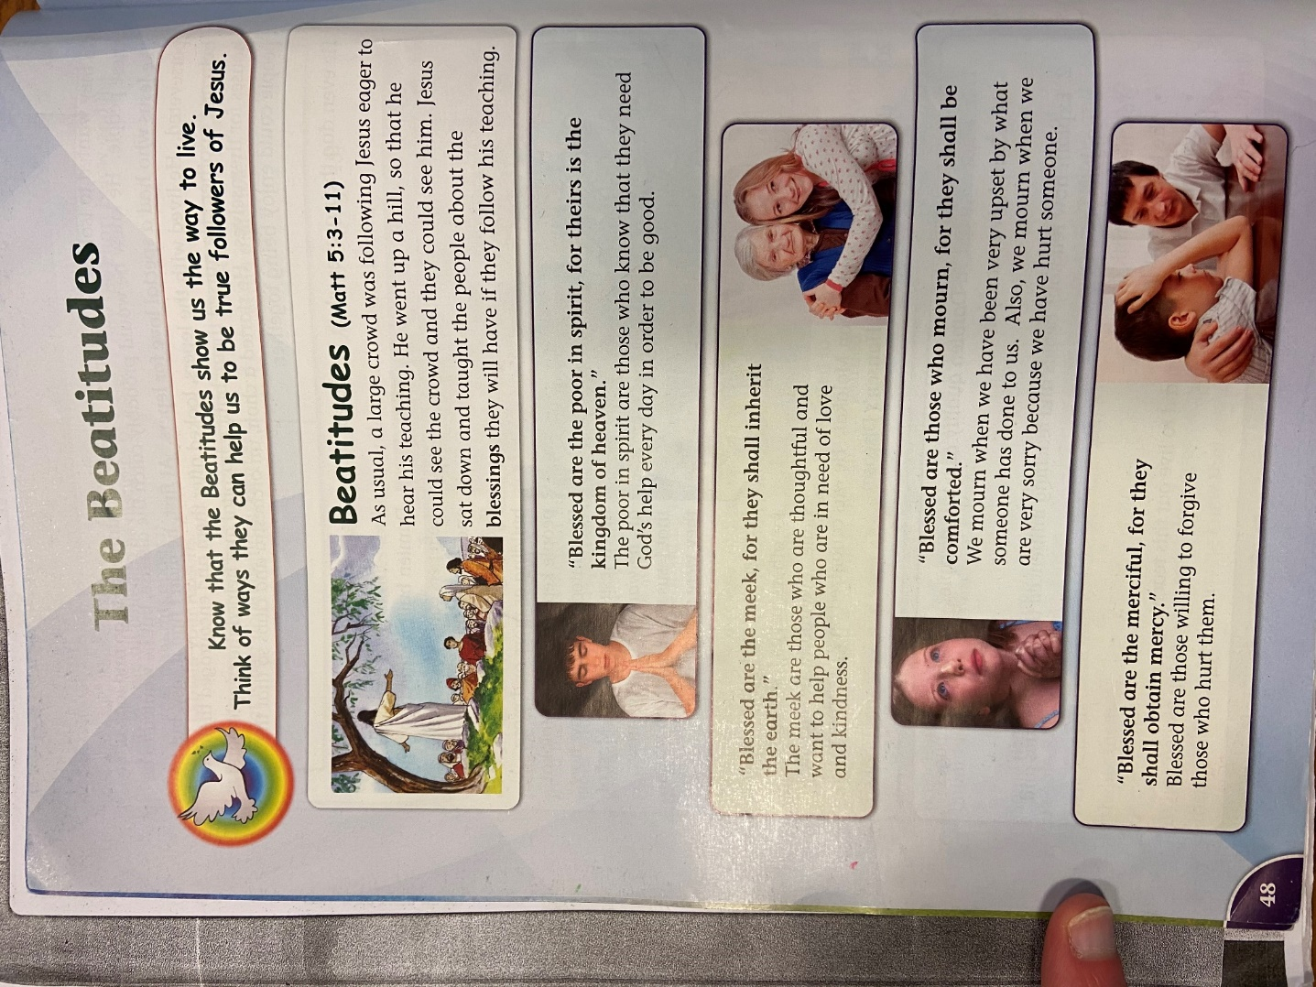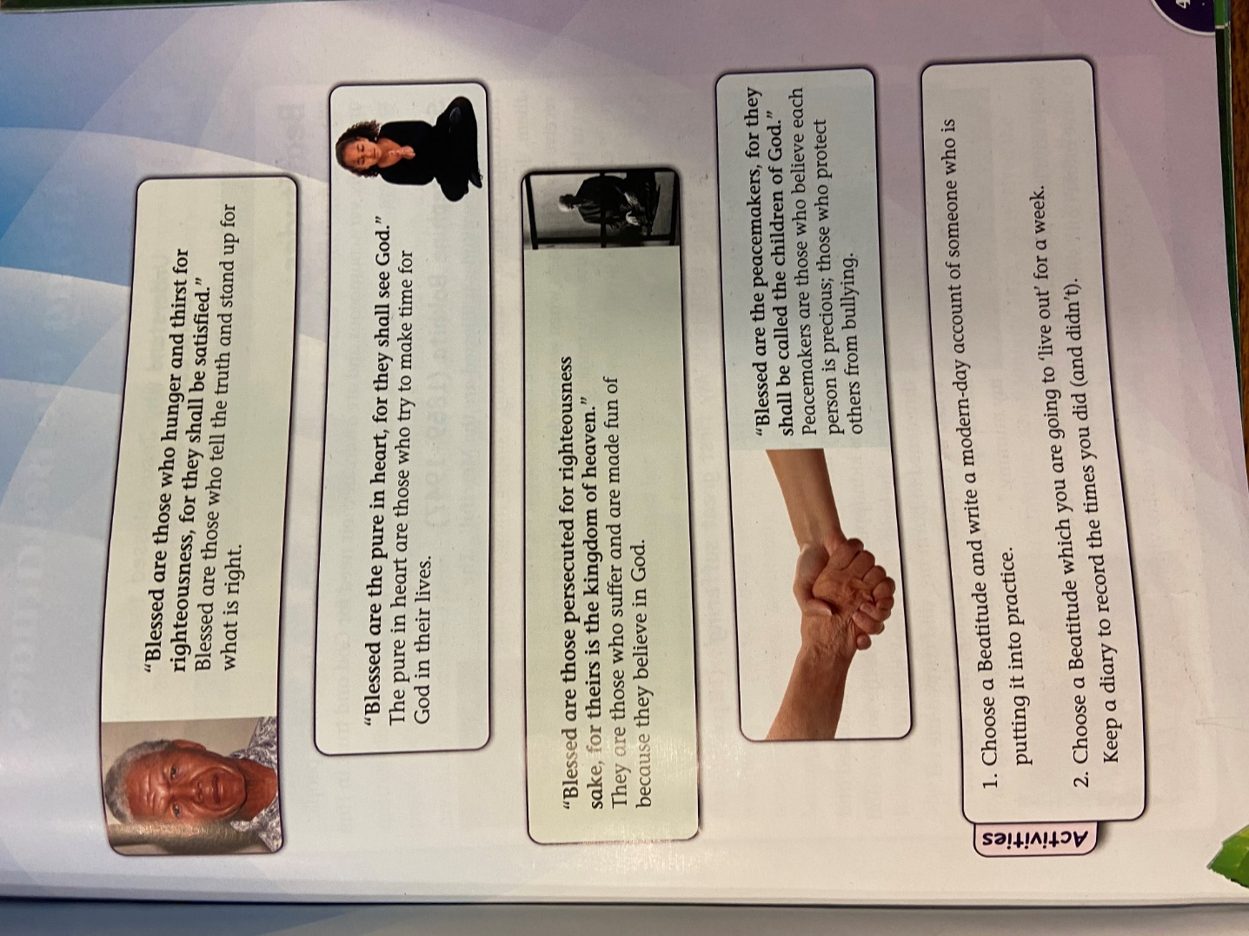
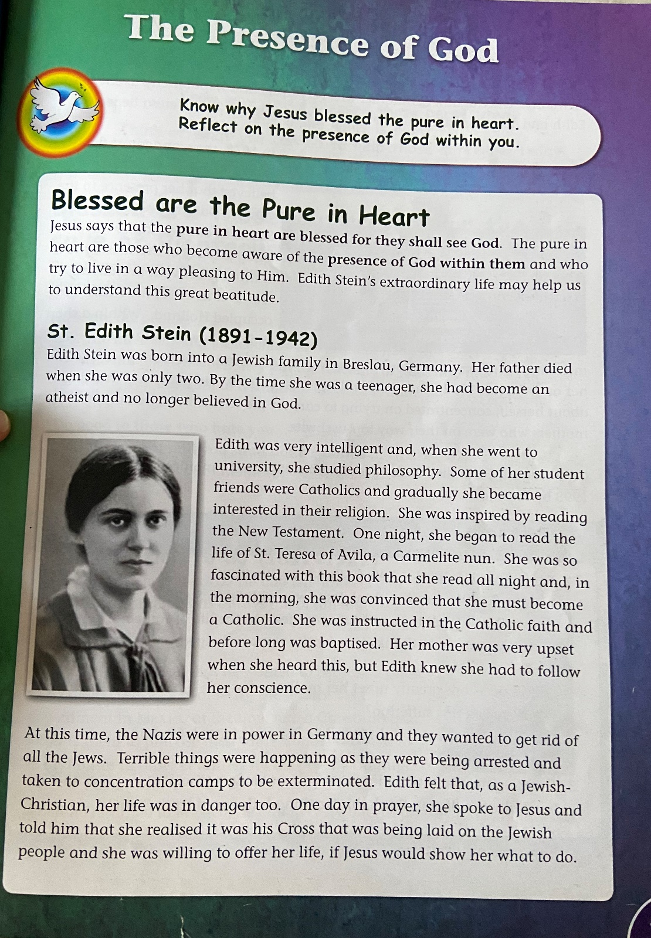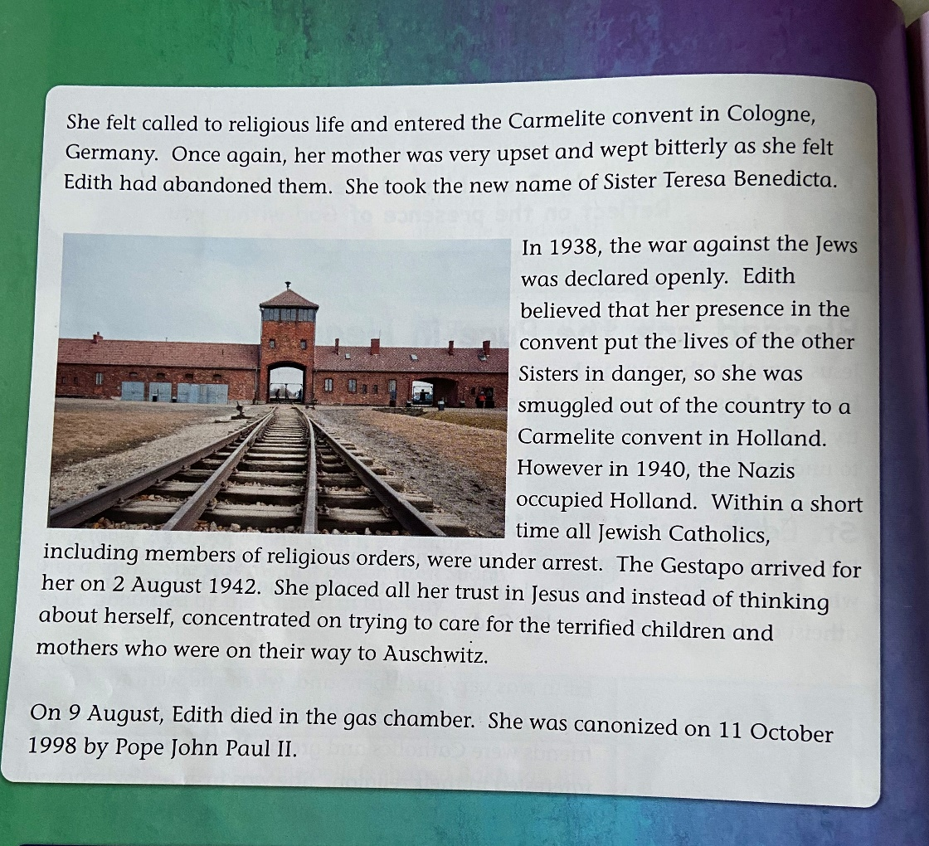
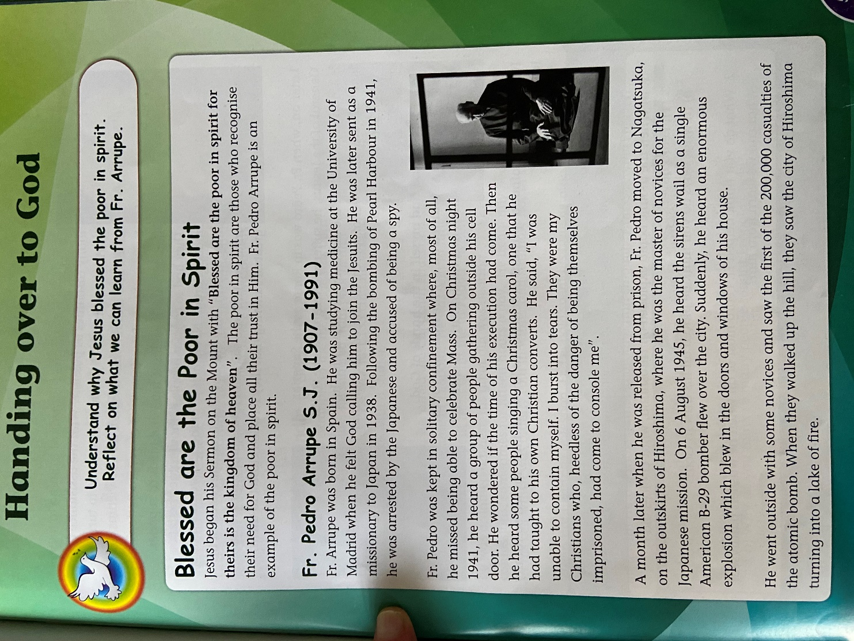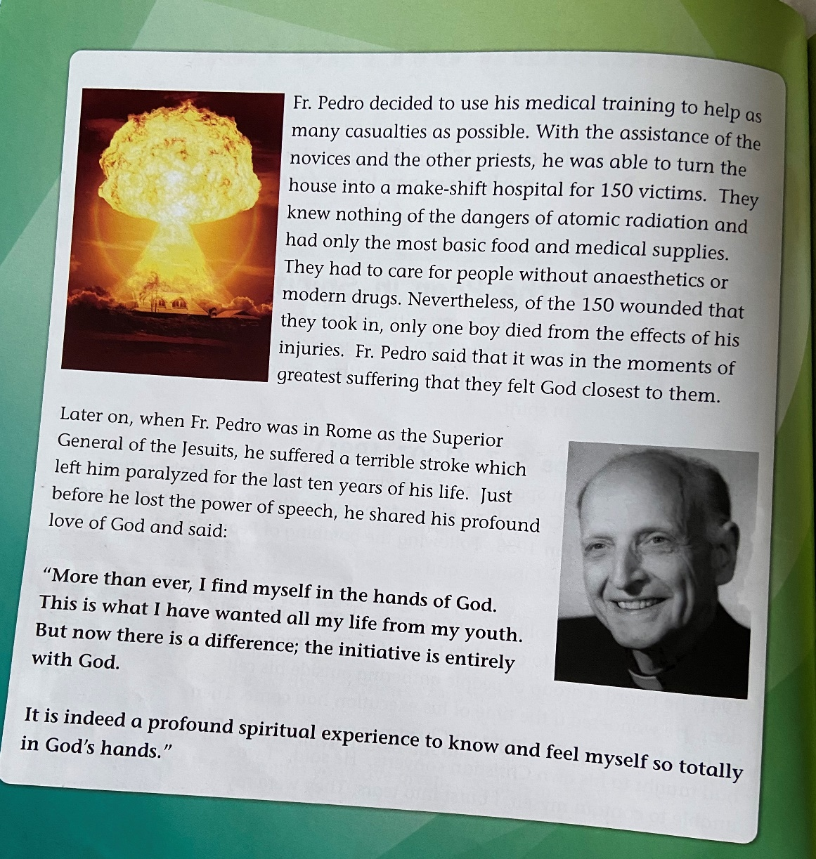

Art And PSHE Resources
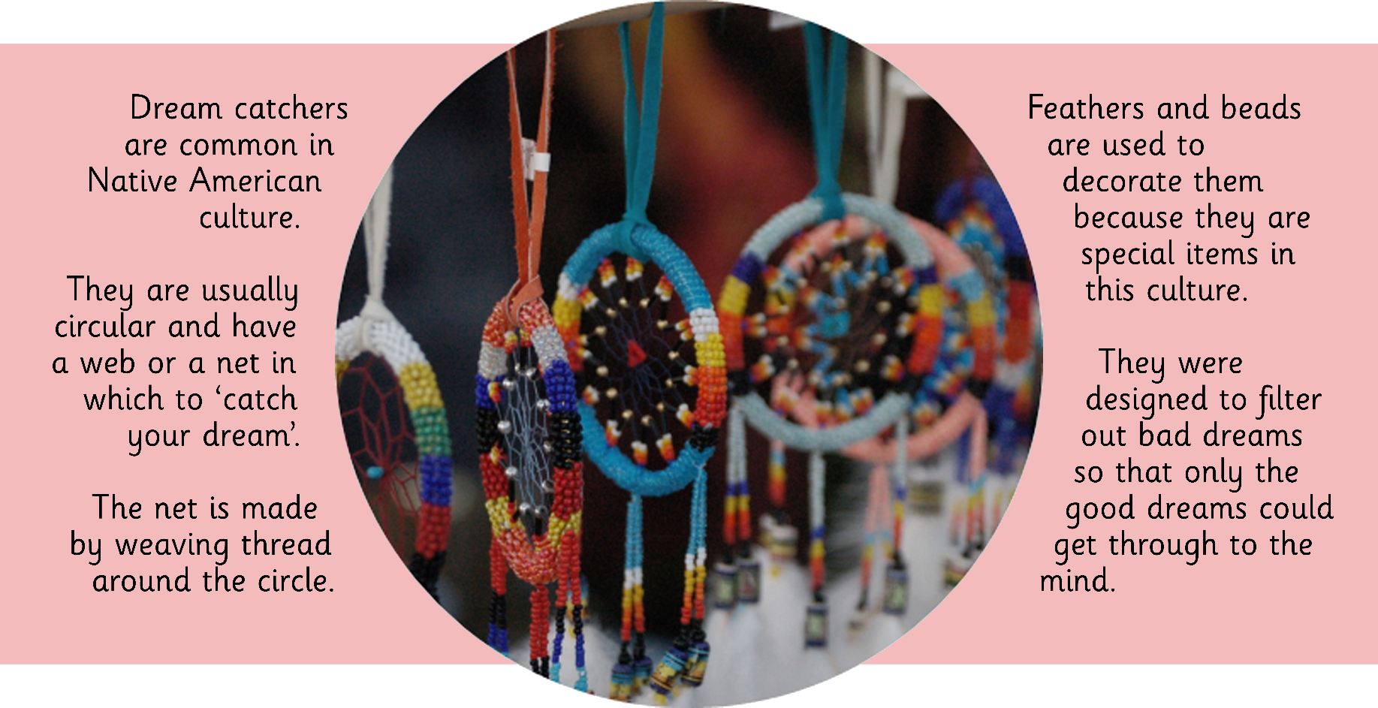
E-Safety Resources
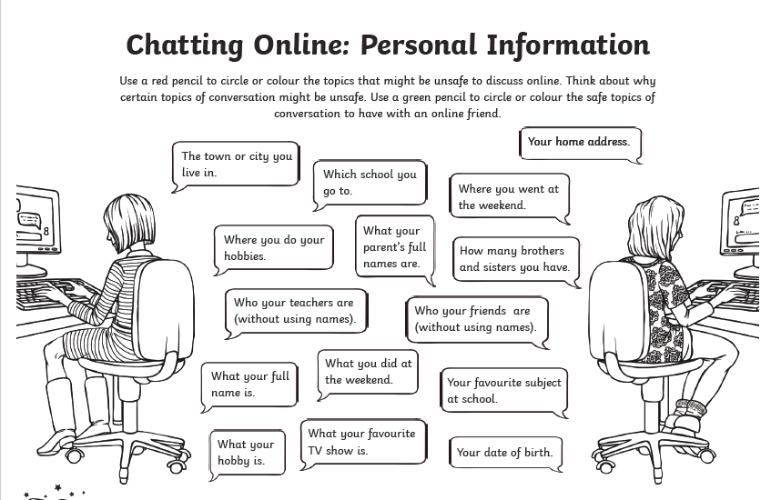
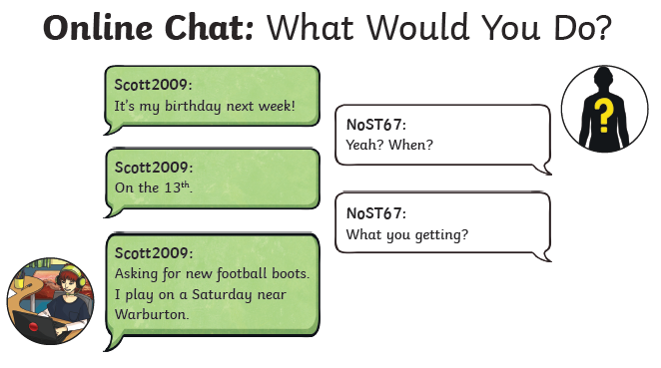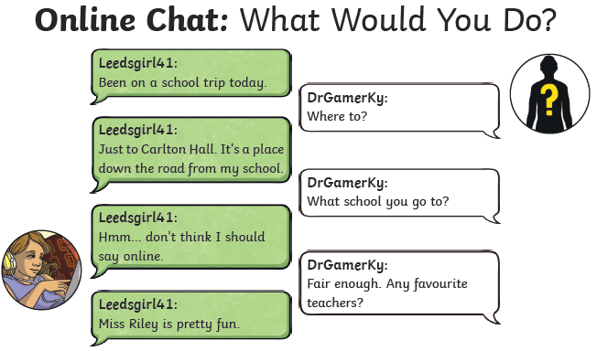
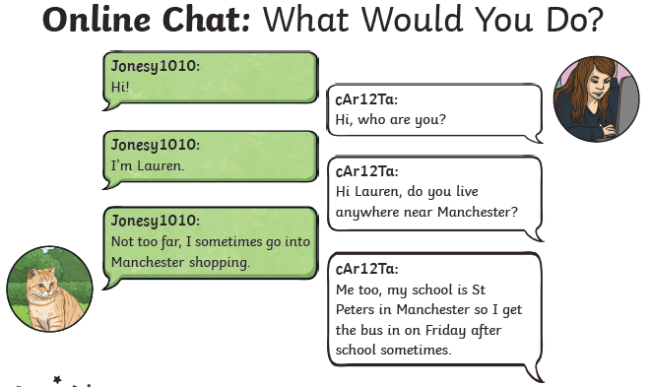

Topic resources – Anglo-Saxon King Information Sheet
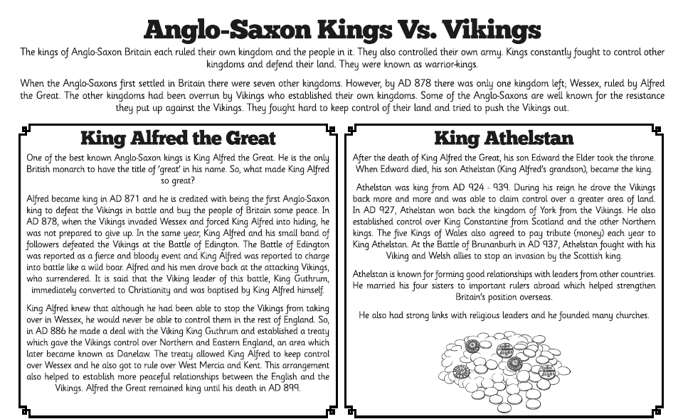
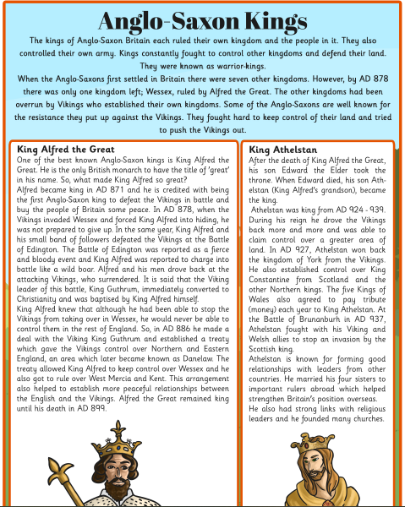

P.E. Resources
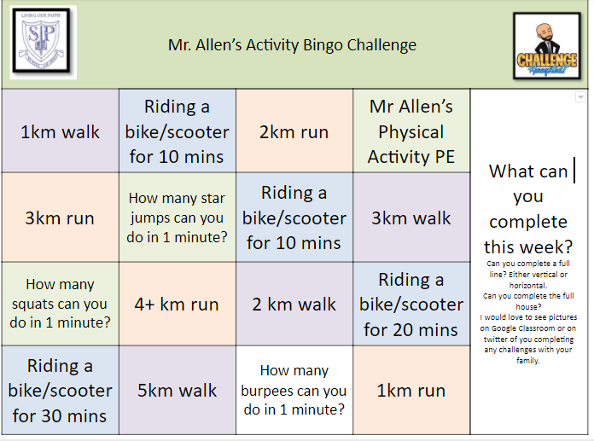

Science Resources
