Year 1 Home learning menu- week 6
See daily videos and worksheets on our Google Classroom to support this plan
Snail and the Whale  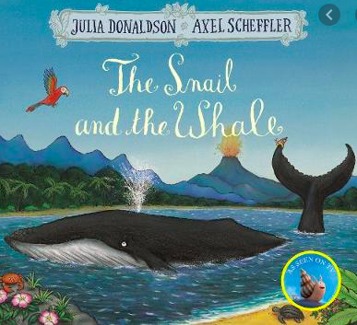 | Conjunctions.  joining sentences together using the correct conjunction.  Watch the PowerPoint and see if you can choose the correct conjunction between ‘and’ or ‘because’ and turn 2 sentences into 1. | Writing a sentence with conjunction ‘and’ or ‘because’.  Watch the PowerPoint and see if you can answer the questions about whales and use a conjunction in your answer. All the answers are in the whale text. |  | Can you write a sentence about a whale using an expanded noun.  Watch the PowerPoint and spot the expanded nouns. Then can you write your own sentence with an expanded noun using the suggestions on the PP. |  |  | Plan your own informative text.  Using the template, listen to the PowerPoint and see if you can write a plan for your own informative text about whales. |  |  | Can you write your own informative text?  Using your plan from yesterday, can you now fill in the informative text template to create your own. Try to include a conjunction and an expanded noun.
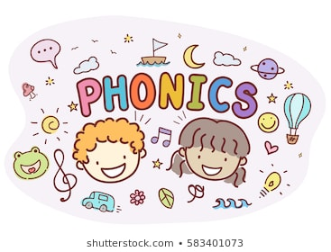 | Revise the /ai/ phoneme.  Read sentences and find the words with the /ai/ phoneme.  Read the sentences and recognise which words have the /ai/ phoneme. How is that phoneme made? | Read and write tricky words.  Look at this weeks tricky words- what is tricky about them?  Play sneaky peak.  How many words can you recognise? |  | Read sentences and find the words with the /ee/ phoneme.  Read the sentences and recognise which words have the /ee/ phoneme. How is that phoneme made? |  |  | Read sentences and find the words with the alternative spellings for /c/ and /ch/ phonemes.  Read the sentences and recognise which words have the /c/ and /ch/ phoneme. How is that phoneme made? |  |  | Read sentences and find the words with the /ee/ and /ai/ phonemes.  Read the sentences and recognise which words have the /ee/ and /ai/ phoneme. How is that phoneme made?
RE  Families and celebrations | WALT- Have the opportunity to hear how Jesus’ family took him to the Temple and think about why this was a special celebration.  Watch the video on our Google classroom.  Have you ever got lost?  How did you feel?  How did your parents feel when you were lost?  Look at the picture in the video: what can you see in the picture? What is Jesus doing? Who is he with? How do you think Mary and Joseph felt when he was lost? How do you think they feel now?  Listen to the story.  Why do you think Jesus was surprised they had been searching for him?  Using the worksheet, write in the speech bubbles what Jesus and Mary said when Jesus was found in the temple.
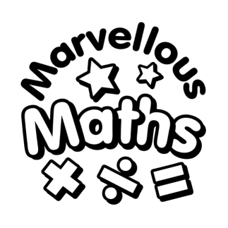 | WALT- find one more and one less of numbers to 50.  Using our knowledge of tens and ones. Calculate the number, then add one more or take one away. |  | WALT- find one more and one less of numbers to 50.  Today we will look for patterns in numbers when we add one more or take one away- particularly when bridging 10. |  | WALT- Compare objects within 50.  Using the appropriate mathematical language and signs compare pictures of objects. |  |  | WALT- Compare numbers within 50.  Using the appropriate mathematical language and signs compare numbers. |  |  | WALT- Order numbers within 50.  Using the appropriate mathematical language and signs order numbers and/or representations.
Asia | Make a Chinese Dragon  In preparation for Chinese New Year this Friday, we’ll be making our own dancing dragons. Watch the PowerPoint to learn about China and find the templates attached. | Make a lucky card with a traditional red envelope to celebrate Chinese New Year.  Let’s follow this Chinese tradition for New Year and make someone in your house a lucky card. Usually, money is placed inside as a gift but I want you to give a different gift. I want you to write a promise in your card to help someone, this could be you promise to tidy your toys or help bring the shopping in etc. Then make or colour in an envelope red and give it to your person on Friday. |  | Can you learn to count to 10 to mandarin for the NY countdown?  Watch the PowerPoint and come learn mandarin for some fun. It is a tricky language so if you learn any numbers you did a great job! Let’s see if we can even count backwards just like the New Year countdown! |  | Let’s make some Chinese New Year decorations.  Let’s make some traditional red lanterns to bring us some luck for the New Year and decorate our homes.  Listen to the PowerPoint for some inspiration. |  |  | Happy Chinese New Year!  Let’s celebrate the New Year and give out your lucky cards you made earlier.  Then see if you can play some traditional Chinese games. Look at the PowerPoint for how to play!

