Year 1 Home learning menu- week 5
See daily videos and worksheets on our Google Classroom to support this plan
Snail and the Whale  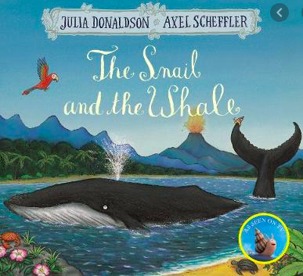 | Read a non-fiction informative text about whales.  Go through the text and highlight any proper nouns or conjunction words such as ‘because’ ‘and’ or ‘if’.  Then answer the following questions.  Is it interesting?  What else will it tell you?  Can you predict other headings?  What type of genre is it?  How do you know? | What are the key features of informative text?  Listen to the PowerPoint to help you find all the key features in the text.  Print out the text sheet if possible and highlight the features mentioned at the end. |  | Create a text map for our whale text.  Can you draw pictures under each heading to explain what is being said in the text. Watch the PowerPoint for an example. |  | Make a Whale fact file.  Can you use all the new information you’ve learnt this week to help make your own fact file!  You can use either template to create this, one has the headings for you and one lets you make your own. Use previous work this week to help you. |  | Write a riddle  Now you know so much about whales can you write a riddle for someone in your house?  So you can’t say what animal you are talking about but you can give them lots of facts about it to give them a clue.  Watch the PowerPoint for some riddles for you to guess and help doing your own.
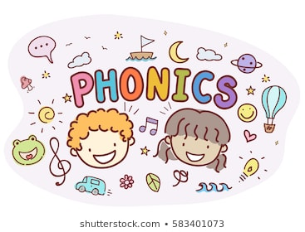 | Investigate the phoneme /ee/  Using the phoneme spotter, read together and find and write/highlight any words containing the /ee/ phoneme | Sort words with the /ee/ phoneme  Read words with the different graphemes for the /ee/ phoneme. Sort them according to how the phoneme is made. |  | Read sentences and find the words with the /ee/ phoneme.  Read the sentences and recognise which words have the /ee/ phoneme. How is that phoneme made? |  | Read sentences and find the words with the /ch/ phoneme.  Read the sentences and recognise which words have the /ch/ phoneme. How is that phoneme made? |  | Read sentences and find the words with the /ee/ phoneme.  Read the sentences and recognise which words have the /ee/ phoneme. How is that phoneme made?
RE  Families and celebrations | WALT- Have the opportunity to know that God is our Father in heaven and think about why it is important.  Watch the video on our Google classroom.  Ask the chn what they think Jesus was like when he was little?  What do you think Jesus did when he was with his family?  Chn think, pair, share: What are some of the things you do with your family?  Look at the picture in the video: what can you see in this picture? What are they doing? Name some of the things you can see in the picture? How do you think Jesus helped Joseph in the workshop?  Draw a picture of what Jesus would have done as a child and what you enjoy doing.
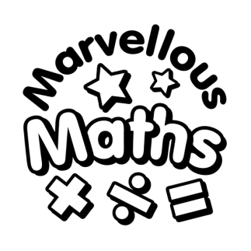 | WALT- Counting to 50 by making 10s.  Counting up to 50 and writing the numbers. An introductions to partitioning into 10s and 1s.  Make a chart to 50 with 10 in each row. |  | WALT- Numbers to 50.  Finding totals by counting on from the last multiple of 10. Complete the sheet on google classroom or make your own amounts in 10s and 1s. |  | WALT- Counting forwards and backwards within 50.  Lots of counting, forwards and backwards, starting from different numbers. Work out how we know whether we are counting forwards or backwards. |  | WALT- Tens and ones.  Continue with our work, finding totals up to 50 by partitioning into 10s and 1s.  Looking for patterns in numbers to 50. |  | WALT- Represent number to 50.  Draw tens and ones or make tens and ones to make numbers to 50.  How many 10s?  How many one?
Antartica  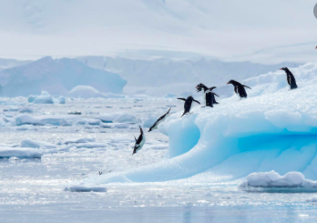 | Lost and Found SMSC lesson  Listen to the Lost and Found story PowerPoint and pause the video when a question appears. Discuss this with an adult and then write down your answer. | Make a penguin  Know you’ve learnt about penguins this week can you create one? Using what materials you have available create your own penguin! |  | Ice experiment! Brrr  So after learning about icebergs can you do this home experiment with ice?  You will need 5 ice cubes and place them in different places around your house as instructed on the PowerPoint. You will need to record your results of which melted first on the sheet provided. |  | Build an igloo!  Using what materials you have available can you build your own igloo! You can use card, marshmallows, cotton wool.. See the PowerPoint for some help and suggestions and some igloo knowledge! |  | You’re off to Antarctica!  You’re being sent on a year long trip to Antarctic as a scientist, to study the animals there. Can you write a list of all the things you would need to take with you? Think about what you will need to build an igloo? What would you need to survive and keep warm? What would you need to help study the animals?

