Year 5 Home Learning |  | This document outlines the activities/lessons your child to complete at home during the bubble closure. Each activity is explained in detail here, including where to find the activities. There is a Maths and English lesson to complete each day, then a range of activities provided for additional subjects which can be completed at any time. WALT stands for We Are Learning To, which will give you a clear indication of the lesson objective. There will be different levels of challenge for the children to complete for most lessons (*** being the hardest level). The children do not need to complete all three levels. The children can work directly into their home learning book they have been given. Please feel free to email any work or pictures of the work and do not hesitate to email me on year5@st-pauls-hyde.tameside.sch.uk if you require any assistance. Thank you, Mr Titterington.  All of this week’s tasks have now also been uploaded onto Google Classroom, along with video links. You can complete your work using Google Classroom, and send your work back to me so that I can provide you with some feedback.
Week 5
Maths |  |  | English
Look in the table below to find the information about the lesson, which you need to complete. Once you have read the table, scroll down to the bottom of the document to find the tasks and questions, which you need to complete for each lesson. This week will be focussing on Division and Fractions. It is important that you follow this plan carefully, as this is new learning for us, and is not a recap of learning which we have completed in school.  I will be uploading PowerPoints with videos included which explain the methods which you will need to use. |  |  | The Saga of Ragnar – Historical Narrative  We have now finished our Non-Chronological report unit on tigers, and are moving onto our narrative unit. We will be beginning to look at the Vikings over the next couple of weeks, and with that our new narrative The Saga of Ragnar.  Our English lessons will be based on this short narrative during this week. In addition to this, beginning later this week, I will be uploading videos of an additional story, Beowulf, which will help you to generate even more ideas for your writing.  I’m looking forward to reading your stories and seeing your imaginative writing in action!
1) | Maths Lesson 21  WALT: Solve 4 by 1 digit divisions with remainders.  Last week, we thought about how we could divide numbers using both counters and written short division (bus stop method).  We have talked a little bit about remainders, and how numbers may need to be altered in different columns because of remainders moving between them.  In today’s lesson, we will think about what may happen if we are using a division method and reach the ones column, but then still have remainders. We will learn how to write these remainders at a Year 5 level, and then attempt to answer some questions based on this.  We can solve these questions with both counters and the short division method. On Google Classroom, I have included a video which will explain both of these methods, which I recommend you watch before attempting the activities.  An example of these methods are shown here:  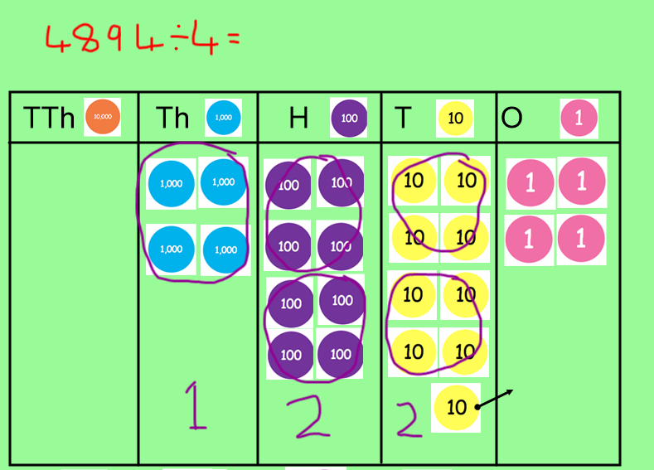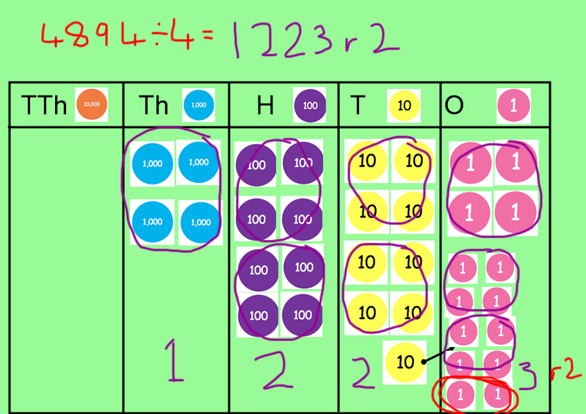  Formal Written method:  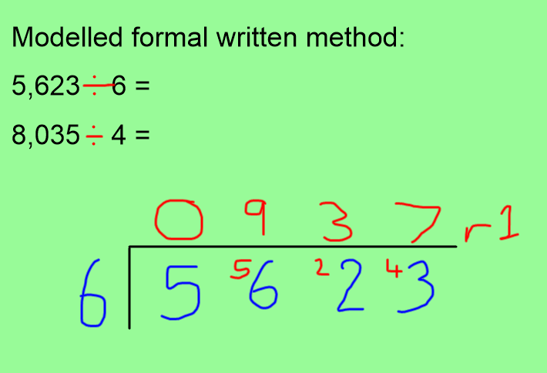  Challenge Levels:  1 Star – Complete the division with remainder questions. 1-16.  2 Star – Complete the reasoning activity, predicting whether the question will give a remainder or not. The activity is later in this document.  3 Star – Complete the consecutive number problem solving activity, for division with remainders. |  | 1) | English Lesson 21  WALT: Use Commas to clarify meaning (commas to avoid ambiguity)  This lesson’s WALT may seem a little complicated, because of tricky words such as ambiguity. Commas can be very important because they can change the meaning of a whole sentence. Often, we need commas to clarify what we mean when we are writing.  Here is a very easy example to understand, and helps us to recognise why the commas is so important:  - Let’s eat Grandma.  - Let’s eat, Grandma.  Although both of the sentences above have the same words, they have VERY different meanings. The first sentence (without a comma) shows that I am talking about Grandma. Basically, the first sentence would be me telling someone that I want to eat my Grandma!! The second sentence has a VERY important comma. The second sentence means that I am talking to Grandma, meaning, I am telling Grandma that it is time to eat her food with me. As you can see, these sentences are very different, and it is important we recognise the meaning of each one.  Another example comes from our SPAG test before Christmas:  - Shall we go visit Sam?  - Shall we go visit, Sam?  Again, these two sentences have very different meanings. The first sentence, is when I ask someone if they want to go and visit Sam. The second sentence, is when I ask Sam if he wants to go to visit somewhere. By adding a simple comma, we can clarify (make clear) what we mean, and change the meaning of the sentence entirely to avoid ambiguity (confusion)!  A helpful video which also explains this can be found here: https://www.youtube.com/watch?v=mjv5Vp7tHsU  On Google Classroom, you will find a video where I have explained this lesson in more detail. I would encourage you to watch this, as we have not learnt this grammar feature yet this year, and it is a new one which I would like you to try and include.  Main activity: On Google Classroom, and later in this document, you will find a variety of sentences which need a comma to clarify their meaning, but the comma is missing. Can you see if you can edit the sentences by adding the comma (or commas) in the correct places?  Extra challenge: I wonder whether you could write some of your own sentences which use a comma to clarify meaning. Write some extra sentences at the bottom of the Google Doc on Classrooms. They could be about our story of Ragnar or they could be for a topic of your choice in this lesson.
2) | Maths Lesson 22  WALT: What is a fraction?  Today, we will be beginning our new topic of fractions. In Year 4 with Miss Holland, you completed your fraction topic, and you should have some knowledge about Fractions already. Because of lockdown, we will be recapping some of those lessons, and also completing new lessons from Year 5.  Today, we will be thinking about what a fraction is and how they can be represented. We should remember that fractions have a numerator and a denominator, and show a part of something, or a number of parts of something.  On Google Classroom, you will find a video which explains how we can identify and represent different fractions. Once you have watched this video, you should attempt to complete the main activity and the problem solving activity for this lesson.  You can also find a video from White Rose Hub who explain the activities for today’s lesson here: https://whiterosemaths.com/homelearning/year-5/spring-week-3-number-multiplication-and-division-2/  Challenge Levels  1 Star – Complete the 1 Star Activity Sheet.  2 Star – Complete the 1 Star Activity Sheet and 2 Star problem Solving Activity Sheet  3 Star – Complete the 1 Star Activity Sheet and the 3 Star Problem Solving Activity Sheet |  | 2) | English Lesson 22  WALT: Use subject specific language to create interesting expanded noun phrases with prepositions  One of the most important features of a narrative are expanded noun phrases. Expanded noun phrases provide interesting descriptions, which interest the reader and make them want to carry on reading. We have learnt lots about expanded noun phrases this year, however in this lesson, I would like you to think carefully about the adjectives which you use; making sure that they are not boring, and that they are interesting for the Viking topic.  Later in this document, and on Google Classroom, you will find a vocabulary poster which will give you some ideas for nouns which you could expand using adjectives, to add additional information to.  On Google Classroom, there is also a set of word cards, a video explaining how to create an expanded noun phrase, and some examples of Viking expanded noun phrases.  You should also try to include prepositions in your expanded noun phrases to extend your sentences further and to make them more interesting.  To create an expanded noun phrase you need to:  Begin with a noun Viking  Add a determiner to the beginning of the sentence The Viking  Add one or two interesting adjectives in between the determiner and the noun The fearsome, blood-thirsty Viking  Add a verb to describe what the noun is doing The fearsome, blood-thirsty Viking thundered  Add a preposition (a preposition is word which describes the position of something or where something is) The fearsome, blood-thirsty Viking thundered towards  Add a prepositional phrases (this basically means adding extra information) The fearsome, blood-thirsty Viking thundered towards the blazing fire whilst resident darted in the opposite direction, clutching their belongings.  For your task, can you write at least 10 of your own expanded noun phrase sentences to describe some nouns which might have been in The Saga of Ragnar? These could be nouns which were already in the story, or your own Viking nouns which could be used to expand the story even further.  For your challenge, could you try to include a different grammar feature we have learnt inside your expanded noun phrase sentence, this could be parenthesis or a relative clause, for example.
3) | Maths Lesson 23  WALT: Use fraction walls to find equivalent fractions.  In today’s lesson, we will be thinking about equivalent fractions. Equivalent fractions are two or more different fractions which have the same value, even though they may look different. For example, they may have different denominators.  A short and helpful video which clearly shows equivalent fractions can be found on BBC Bitesize by clicking here.  A fraction wall can be useful for finding equivalent fractions as they place fractions clearly next to one another, representing their values. A fraction wall looks like this:  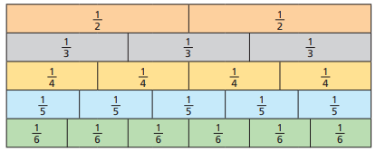  For example, in the fraction wall above, $\frac{2}{3}$ = $\frac{4}{6}$  On Google Classroom, the children will find a video with instructions and examples for how we can use a fraction wall to find equivalent fractions.  When completing their work on Google Classroom, the children are likely not to be able to write fractions in this format : $\frac{4}{5}$ Instead, they can write their fraction like this: 4/5  Another helpful video is provided by White Rose Hub here: https://whiterosemaths.com/homelearning/year-5/spring-week-3-number-multiplication-and-division-2/  Challenge Levels  1 Star – Complete questions 1-4 on the main activity page.  2 Star – Complete questions 1-5 on the main activity page.  3 Star – Complete the 2 Star challenge (main activity 1) and the problem solving activity. |  | 3) | English Lesson 23  WALT: Create complex sentences with accurate punctuation using subordinating conjunctions.  So far this year, one of the topics from Year 4 which we have struggled to recap is the use of subordinating conjunctions at the beginning of a sentence, and using a comma in the correct place.  In this lesson, I would like you to practice using a comma in the correct place in a subordinating conjunction sentence.  How to use a subordinating conjunction  - Use a subordinating conjunction to begin your sentence. (A subordinating conjunction sheet can be found on Google Classroom and at the bottom of this document).  - Use a comma after the subordinate clause. A clause is a phrase which contains a verb. A subordinate clause does not make sense on its own.  - After the comma, write your main clause which does make sense on its own.  For example: Although he was one of the bravest warriors in the country, Ragnar was still fearful of the evil Behemoth terrorising the town.  In the example above, the purple underlined word is a subordinating conjunction. The red, bold phrase is the subordinating clause and contains the conjunction, the clause does not make sense on its own and is dependent on the rest of the sentence. The subordinate clause must be followed by a comma. The blue part of the sentence, which is not underlined or bold, is the main clause. This main clause does make sense on its own if the subordinate clause is taken away. This creates a complex sentence.  On Google Classroom, you will find a video which explains how to write a complex sentence, using a subordinating clause.  Main Task: For your main task, I would like you to write at least 10 of your own complex sentences using a subordinate clause, using a comma in the correct position in the sentence. Your sentences should be based on the story of The Saga of Ragnar.  Challenge Levels  1 Star – Write 10 of your own sentences using the subordinating conjunctions When, As, After, Because, Before  2 Star – Write 10 of your own sentences using a mixture of all of the subordinating conjunctions from the subordinate conjunctions sheet.  3 Star – Write your own paragraph to tell the story of the battle between Ragnar and the Behemoth, using at least two complex sentences using subordinate conjunctions, and at least one other grammar feature we have learnt.
4) | Maths Lesson 24  WALT: Calculating equivalent fractions.  As we learnt last lesson, equivalent fractions are two or more fractions which have the same value, but may look different. Yesterday, we used a fraction wall to find these equivalent fractions, whereas today, we will be calculating them without using these diagrams.  When we are calculating equivalent fractions, whatever you multiply the numerator by, you must multiply the denominator by the same amount, to ensure that the new fraction is equivalent. Here is an example:  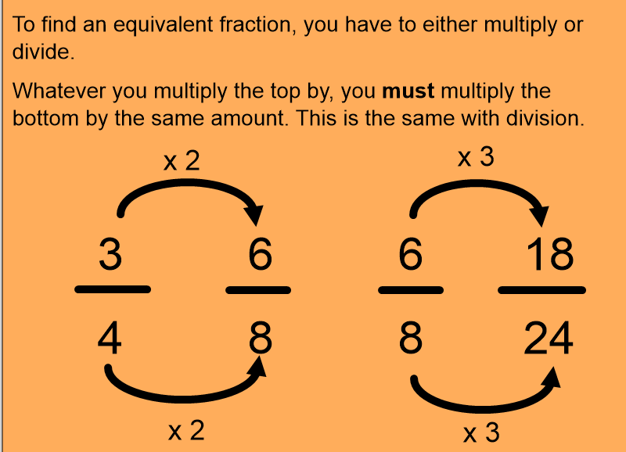  If one of the numerators or denominators are missing, then we can use this method to find the missing number. For example:  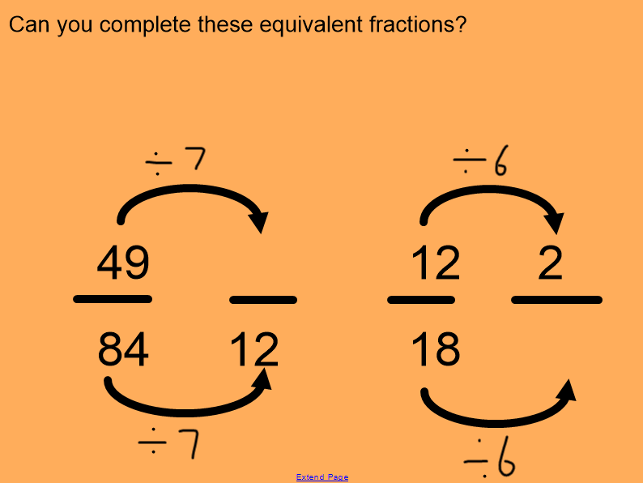  On Google Classroom, there is a video for the children which explains how to find and calculate equivalent fractions.  Another helpful video is provided by White Rose Hub here: https://whiterosemaths.com/homelearning/year-5/spring-week-3-number-multiplication-and-division-2/  Challenge Levels  1 Star – Answer questions 1-6  2 Star – Answer questions 1 – 9  3 Star – Answer questions 1 – 9 and then complete the extension reasoning challenge. |  | 4) | English Lesson 24  WALT: Write a character description for the hero Ragnar.  During the last few lessons, we have learnt about and recapped: relative clauses, parenthesis, subordinating conjunctions, expanded noun phrases and commas to clarify meaning. Today, you will be applying this knowledge to a piece of writing.  For your main task, you should try to write a character description for the hero Beowulf. During this year, some of our character descriptions for stories have not been very detailed and could be written to create more interest.  When describing Ragnar, we could think about:  - What he was wearing  - Which belongings did he have  - What was his personality like  Think carefully about the difference between the character description which you would write for a Viking warrior, and the ones we wrote for a boy such as Luca in The Curse of Cogston House.  Challenge Levels  1 Star – Write a character description which includes information for the 3 bullet points above.  2 Star – Write a character description which uses 4/6 of the Steps to Success  3 Star – Write a character description which uses 6/6 of the Steps to Success.  Think carefully about the amount of writing you complete for your character description, and remember that it needs to be a good amount for a Year 5 pupil. With an average side font, it should be no less than 6 lines.  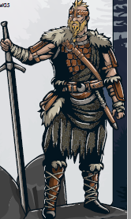
5) | Maths Lesson 25  WALT: Identify fractions greater than 1 whole, recognising improper fractions and mixed numbers.  In today’s maths lesson, we will be using diagrams to recognise when fractions have a greater value than 1. We have been thinking this week about how fractions are a part of a number. However, when the numerator (the top of the fraction) is larger than the denominator (the bottom of the fraction), the fraction will have a value greater than 1.  Proper fraction = When the numbers is smaller than the fraction’s denominator. For example: $\frac{2}{4}$  Improper fraction = When the numerator of a fraction is larger than the fraction’s denominator. For example: $\frac{6}{4}$  Mixed number = When a whole number is combined with a proper fraction. For example: 2$\frac{2}{4}$  Today, we will be building upon our knowledge of the first 3 lessons to think about the relationship between improper fractions and mixed numbers. We will use diagrams to recognise how many WHOLES are in an improper fractions. Here is an example:  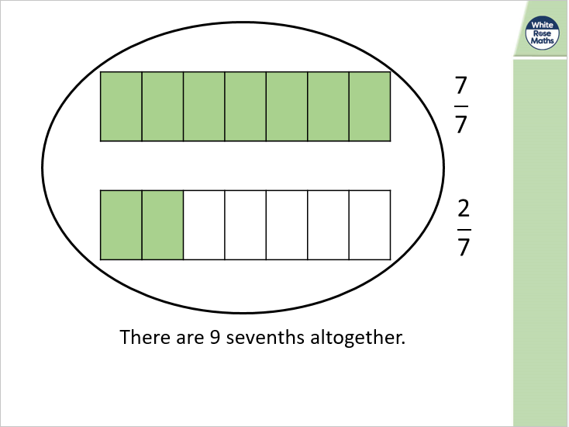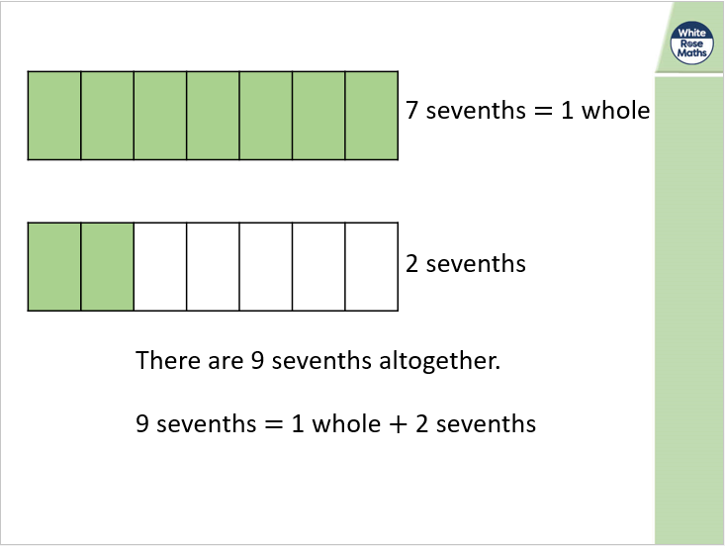  On Google Classroom, the children will find a video which explains how we can recognise the relationship between improper and mixed fractions, using both diagrams and mental calculations.  Challenge Levels  1 Star – Complete the main activity sheet, questions 1-4  2 Star – Complete the main activity sheet, questions 1-6  3 Star – Complete the main activity sheet, questions 1-6 and the problem solving and reasoning challenge. |  | 5) | English Lesson 25  WALT: Write a character description for the villain – The Behemoth  Yesterday, we wrote a character description for Ragnar. Today, we will be writing a new character description and improving our use of the steps to success which we may or may not have used.  Today, I would like you to write a character description for the Behemoth described in the story.  A behemoth is typically described as a huge or monstrous creature. Before beginning to write your character description for the Behemoth, I would like you to draw a picture of what you think this monstrous creature may have looked like. I would like you to use your imagination, and creativity. Think about the size of the beast, the colour, the clothes it wore, what made it different from people, and why it was so inhuman?  There is no correct answer for the appearance of the monstrous creature, as it is not described fully in the story. Think about stories you have read in the past with monsters and creatures, and how you can use those ideas for your drawing and writing.  Later in this document, you will find a Steps to Success and a drawing template.  On Google Classroom, there is a short video guide for this lesson, where I have written my ideas for the behemoth.  Challenge Levels  1 Star – Write a character description which includes information for the 3 bullet points above.  2 Star – Write a character description which uses 4/6 of the Steps to Success  3 Star – Write a character description which uses 6/6 of the Steps to Success.

Additional Subjects- To be completed anytime over next week
Science | Topic
Properties of Materials - Lesson 2  WALT: Investigate thermal conductors and insulators.  In this lesson, we will be investigating the different thermal conductors and insulators.  A thermal conductor is a type of material which allows heat to pass through it, for example a radiator.  A thermal insulator is a material which does not let heat pass through it.  In this activity, The Brilliant Bags Company want to make a new lunch box for children to bring their packed lunches to school in. Food will be stored in the lunch box for quite a long time – probably all morning. They want to make sure the lunch box keeps the children’s lunches cool and fresh, so they need to think about the best material to use to make the inner lining of the lunch box.  You will need to find the best thermal insulator for the inner lining of the lunch box. Thermal conductors will let heat through and make the food warm up quickly.  Main Activity/ Investigation: To complete this, you will need between 3 and 5 different materials and an ice cube for each material. To find the best insulator, you will need to wrap the ice cube inside each of the materials, and time how long each ice cube takes to melt. The ice could take some time to melt, so it may be better to begin the experiment for each material at the same time. The ice cube which melts the fastest is the worst insulator, as the heat will have passed through the material to melt the ice cube. The slowest to melt will be the best insulator, because the heat will have taken longer to pass through the material.  Example materials could be: tin foil, fabric or cling film. You should complete the activity sheets found later in this document, or on Google Classrooms to summarise the results from your investigation.  If you have a thermometer at home, you may wish to check the temperature of the ice cubes at different times during the experiment.  If you do not have the resources for this lesson, we will be completing the lesson in school on Thursday, when I will video/film our investigation. This video will be uploaded onto Google Classroom on Thursday evening, meaning you can watch the video and then write your answers for the investigation.  Challenge Levels  1 Star – Complete the investigation and write down your time results.  2 Star – Complete the investigation and the 2 star questions to predict your results.  3 Star – Complete the 2 star activity, then write a summary of your science investigation, explaining the results and why slowest material is the best insulator. | Viking Lesson 2  WALT: Understand the importance of chronological order to create a timeline.  In this lesson, we will be thinking about why using chronological order can be important, particularly when learning about History. Chronological order means ordering dates in the correct way, from the earliest event to the most recent event.  Last half term, we learnt about the Anglo-Saxon invasion of England after the Romans had left Britannia. However, last lesson we learnt about the invasion of the Vikings which then followed a few hundred years later.  Today, I would like you to create your own timeline for the Anglo-Saxons and the Vikings. The reason why these are mixed together is because the Anglo-Saxons were still in England during the Viking invasions, and their timelines are mixed together.  Ideally, I would like you to draw your own timeline for the Anglo-Saxons and Vikings using the information I have given you, a picture of a good example can be found on Google Classroom.  On Google Classroom, I have uploaded a video explaining the timeline of the two civilisations. The timeline dates are only available on Google classroom, and I would like you to use both sheets to order the dates.  Extension activity: at the end of the video, there is a Viking interview activity, which you could try with your family!  Challenge level  1 Star – Print out the time line sheets, which can then be cut out and placed in the correct order.  2 Star – Use all of the dates on the different sheets provided to draw your own timeline with the dates in order.  3 Star - Use all of the dates on the different sheets provided to draw your own timeline with the dates in order, and also research and add in some of your own dates.  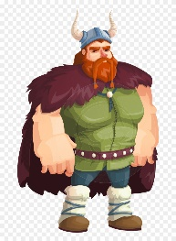
Art | Computing
Combining the work of Joaquin Torres Garcia and the Vikings  In this lesson, I would like to combine our learning from The Americas and our learning from the Vikings.  Joaquin Torres Garcia was a South American artist who created art puzzles within his work. An example of his artwork can be seen in the picture below. He used symbols to create his artwork. For this work, I would like you to think of some important Anglo-Saxon and Viking symbols, and then use these to create a piece of artwork similar to that of Joaquin Torres Garcia.  On Google Classroom, you will find a more detail instruction video to explain this task.  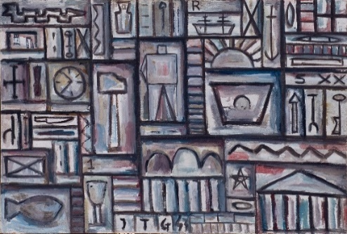 | Spreadsheet Lesson 2  WALT: Create a times table machine using formulas.  In this lesson, we will be building on our knowledge of spreadsheets by creating a times table machine. Today, we will be using formulas. Formulas are helpful in spreadsheets because they reduce the amount of work which you may have to do.  Log on to Google Classroom, and watch the video guide for our lesson. You will need to have both Google Classroom and Purple Mash open for this lesson.  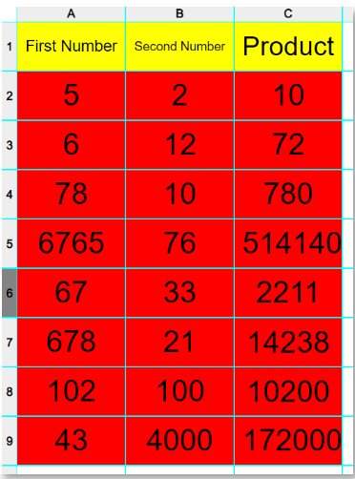
RE
R.E. Lesson 5 - Inspirational People
WALT: Understand why Jesus blessed the merciful
So far in this unit, we have been reading about inspirational people such as Father Damien and Jesus, and the actions which they showed which showed why they were an inspiration.
Last week, we looked at the Beatitudes, the blessings which Jesus gave, for those who followed his message. Today, we will be revisiting these blessings, thinking about another individual who represented Jesus’ message in an important way.

Later in this document, and on Google Classroom, you will find the story of St Josephine Bakhita. St Josephine was an inspirational person, who, throughout her life, worked to be a peacemaker and help others. For this lesson, I would like you to read the story of St Josephine’s life, and think about why her actions were important.
On Google Classroom, I have uploaded a video where I have read the story to you, and also where I have explained the different tasks and challenge levels which have been set.

I have been really proud of you over the last two weeks for choosing some of the harder challenges, instead of choosing the easy option! Well done Year 5!

Challenge Levels
1 Star – Can you explain why St Josephine Bakhita was a peacemaker and how she followed the beatitudes? What did she do that showed that she was a forgiving person?
2 Star – Can you look can at the beatitudes which we learnt about last week… can you choose 3 of the beatitudes that we learnt about, and tell me what St Josephine did that showed that she followed the beatitudes and messages that Jesus gave? See if you can tell me specific parts of the story or actions which show that she followed the beatitudes well.
3 Star – Complete the 2 star challenge writing a short, meaningful paragraph for each of the 3 beatitudes you have chosen.

 | Health and Wellbeing
P.E.
Mr Allen has started to upload P.E. sessions with videos onto our Google Classroom page. See if you can join in with his activities, and remember to leave a comment if you do! It is important to continue to exercise at home, especially during extended time inside. Mr T might even make a guest appearance!!

PSHE

Can you design a positive thinking cap?
Using the outline below, design a cap with colourful messages about positive thinking. You might want to try different kinds of writing, or use symbols and illustrations. Just remember to keep it positive!
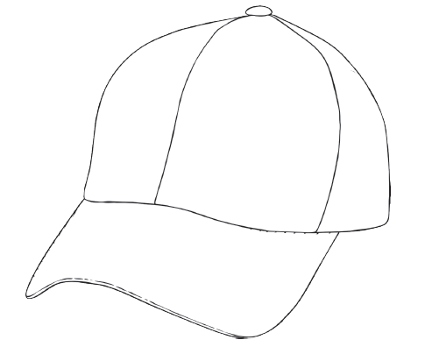
Monday – Maths Lesson 21 Resources – 1 Star Challenge
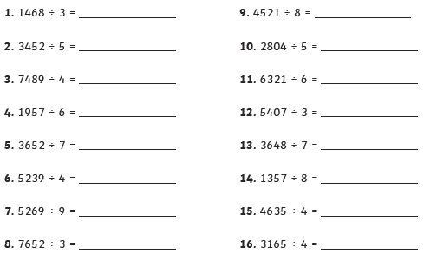
Monday – Maths Lesson 21 Resources – 2 Star Challenge Monday – Maths Lesson 21 Resources – 3 Star Challenge
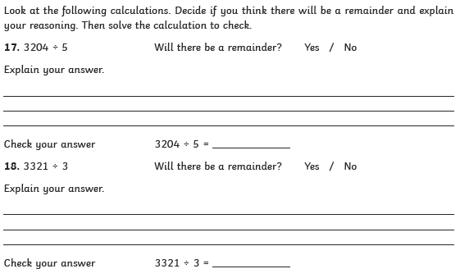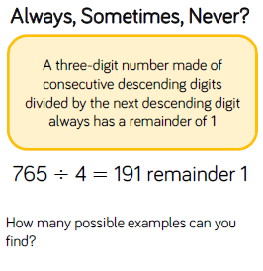
Tuesday – Maths Lesson 22 - Resources – 1 Star Activity – Question Sheet
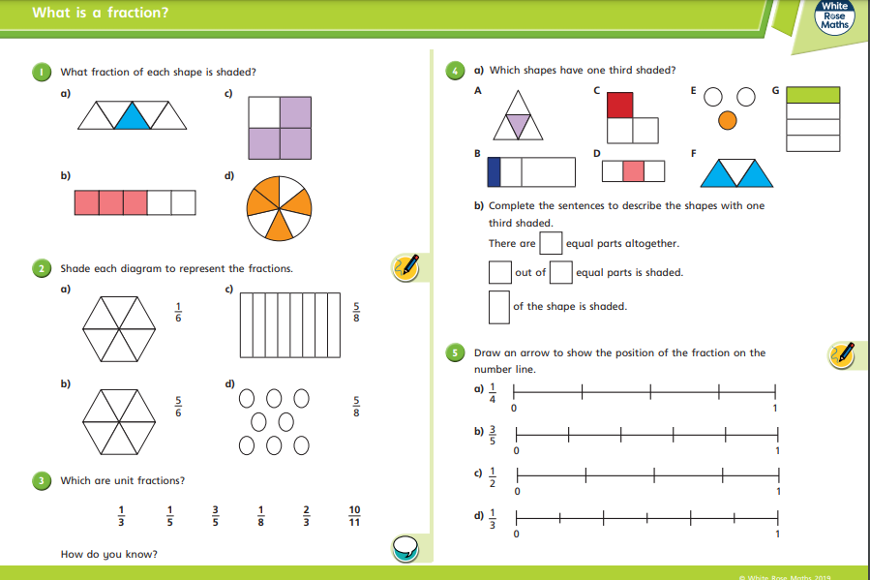
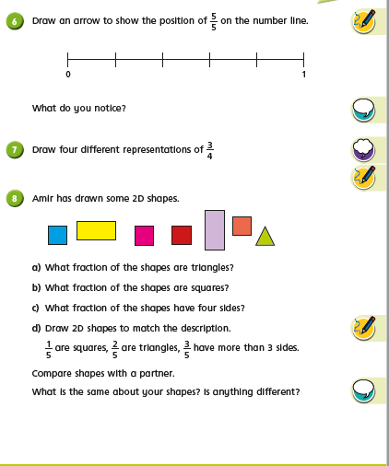

Tuesday – Maths Lesson 22 – 2 and 3 Star Reasoning and Problem Solving Sheet
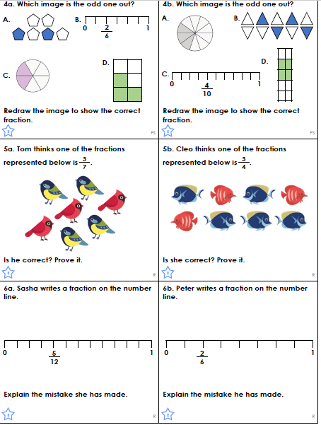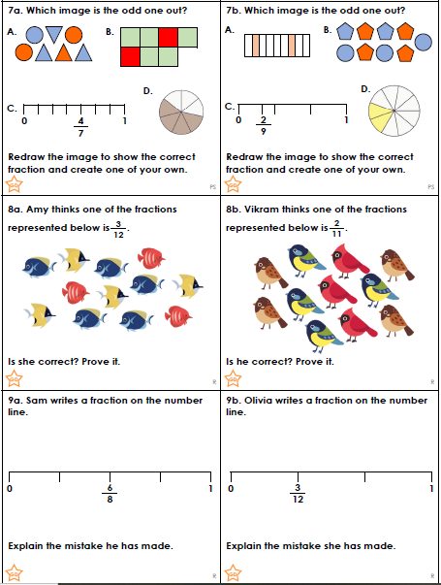

Wednesday – Maths Lesson 23 Resources – 1 and 2 Star Activity Sheet
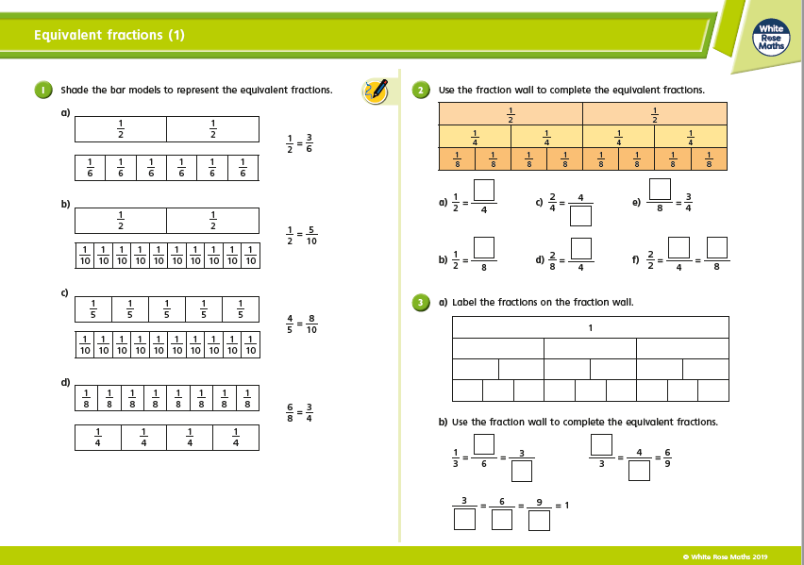

Maths Lesson 22 – 3 Star Problem Solving Activity
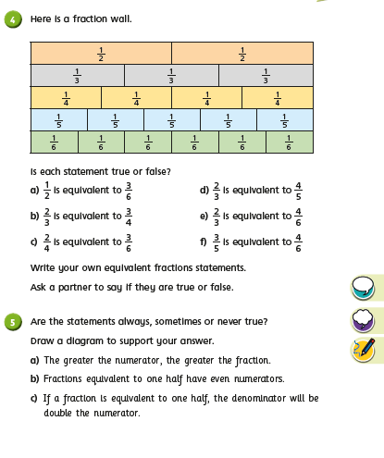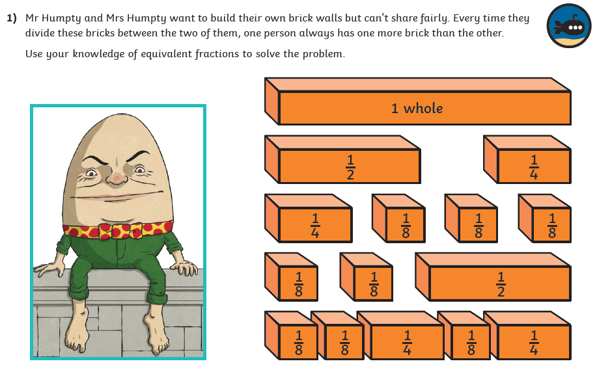

Wednesday – Maths Lesson 18
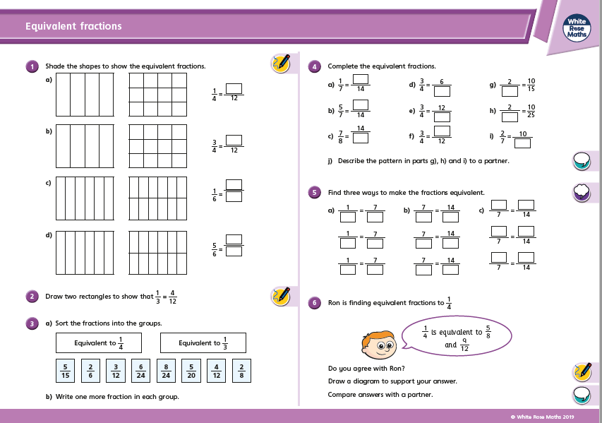

2 Star Challenge 3 Star Challenge
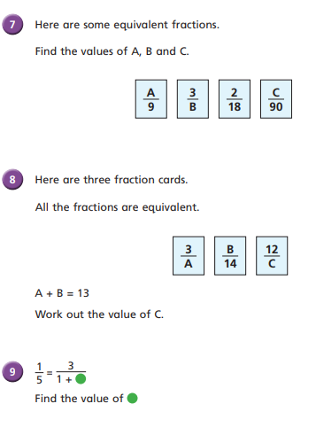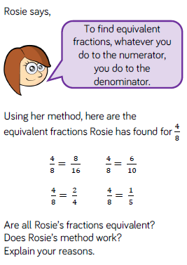

Thursday – Maths Lesson 19 Resources - 3 by 1 digit division questions
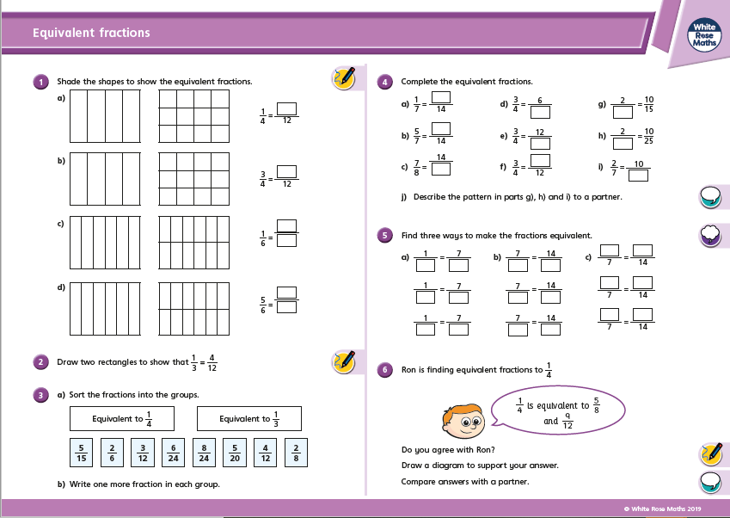

Problem Solving Activity - Thursday
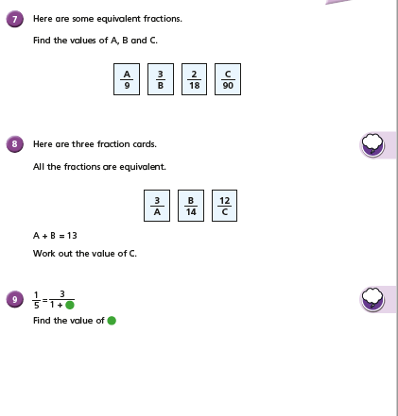

Friday – Maths Lesson 25 Resources – Fractions Greater than 1 Main activity sheet
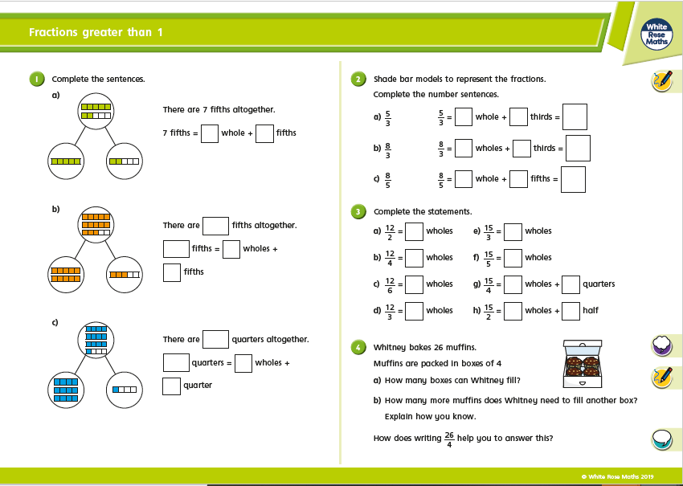

Friday – Maths Problem Solving Activity
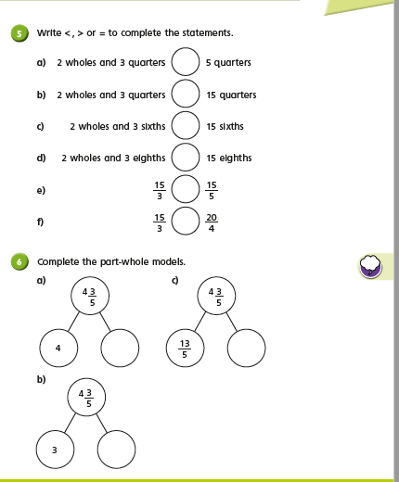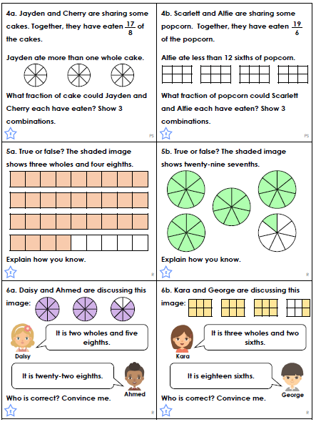

Monday –English Lesson 21 Resources
- Let’s eat Ragnar.
- Boromir enjoyed eating drinking and laughing.
- The behemoth who was the hater of happiness lived in the depths of darkness.
- As the warriors sat around the fire eating the Behemoth hid in the woods.
- As the sun shone bright yellow warriors moved into the shade.
- Ragnar enjoyed fighting friends and his family.
- The Behemoth was a wicked repulsive beast.
- The gods said welcome Ragnar to the land of Valhalla.
- The town which had a magnificent mead-hall was the home of Hrothgar and his queen.
- The warriors said we cannot leave a man.
- Ragnar was chasing the behemoth carrying a long sword.

Can you write between 3 and 5 sentences of your own which uses a comma to clarify meaning and avoid ambiguity?

Tuesday – Expanded Noun Phrase Help
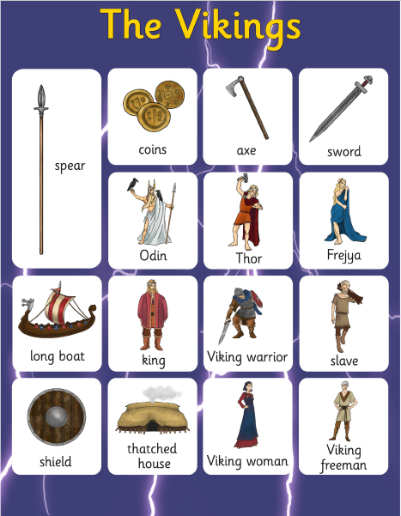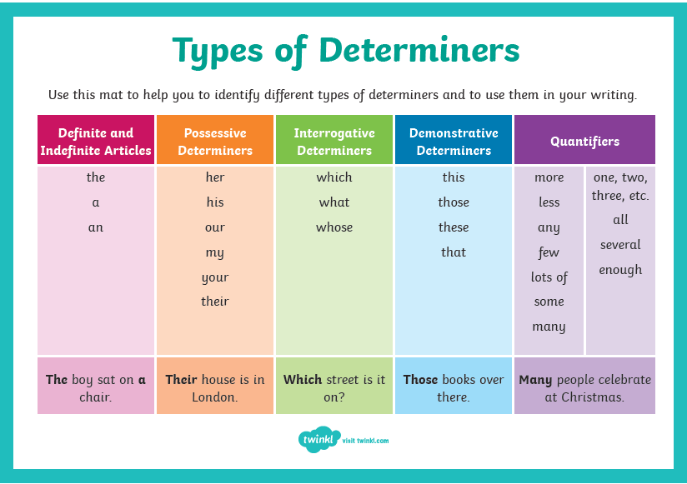

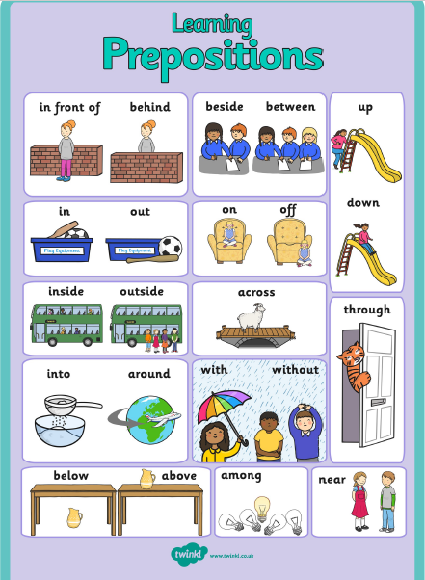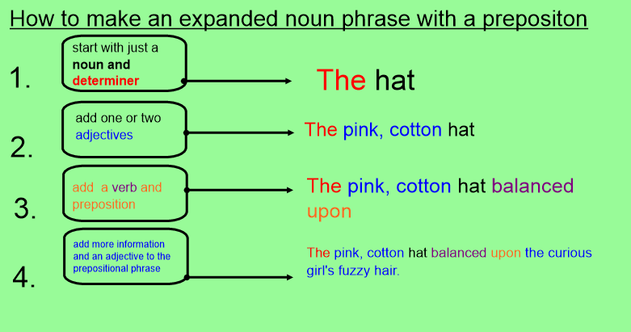

Wednesday – Subordinating Conjunctions
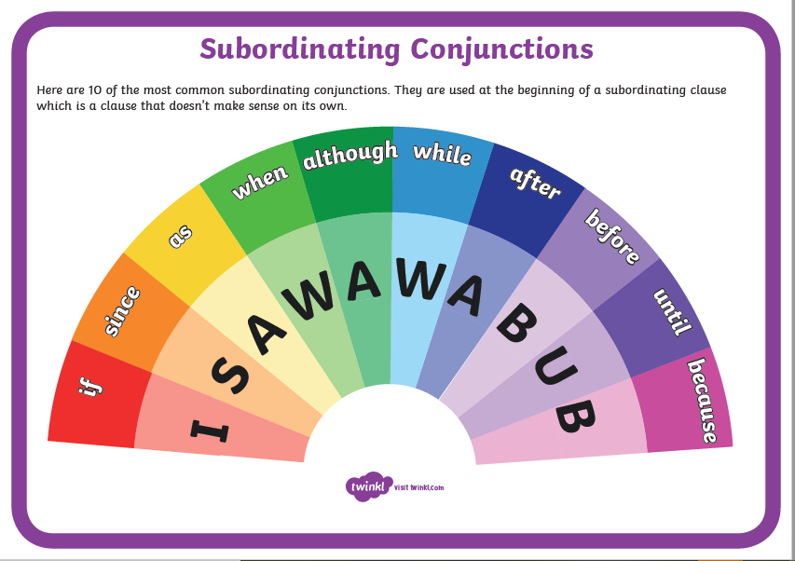

Thursday & Friday – English – Ragnar and Monstrous Creature Character Description
Me | Our Steps to Success |  | My teacher
 | Expanded noun phrases
 | Fronted Adverbials
 | Subordinate conjunctions to create complex sentences
 | Relative Clause
 | Parenthesis
 | Comma to clarify meaning

My Monstrous Creature

Monday – R.E. Resources – The Beatitudes & St Josephine Bakhita
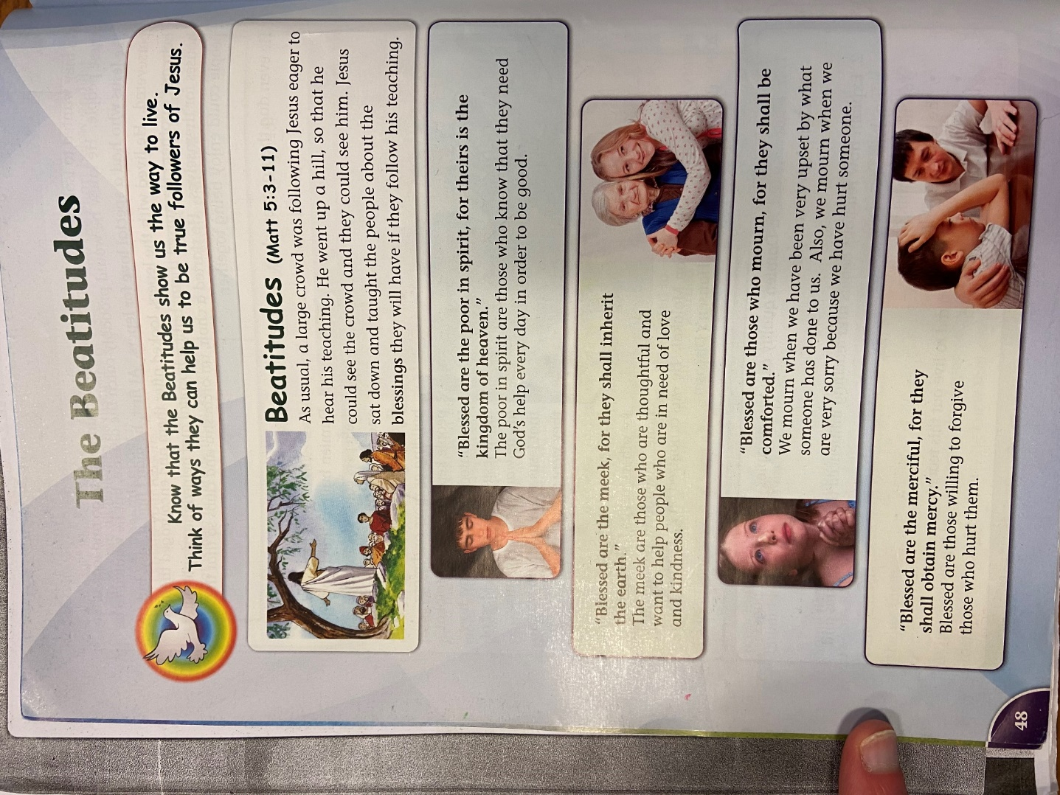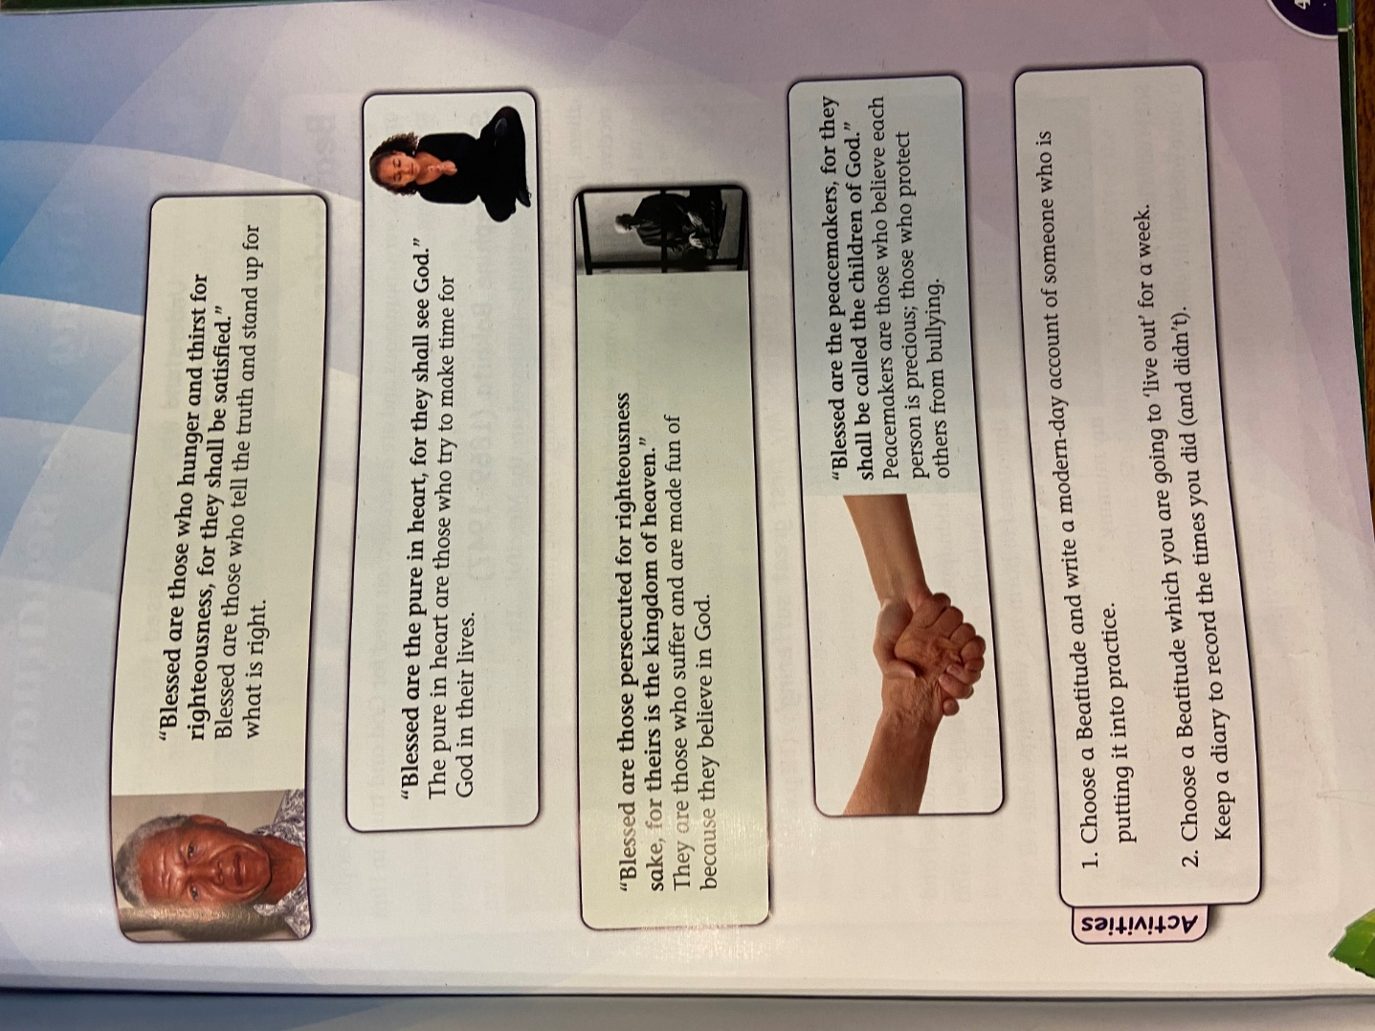

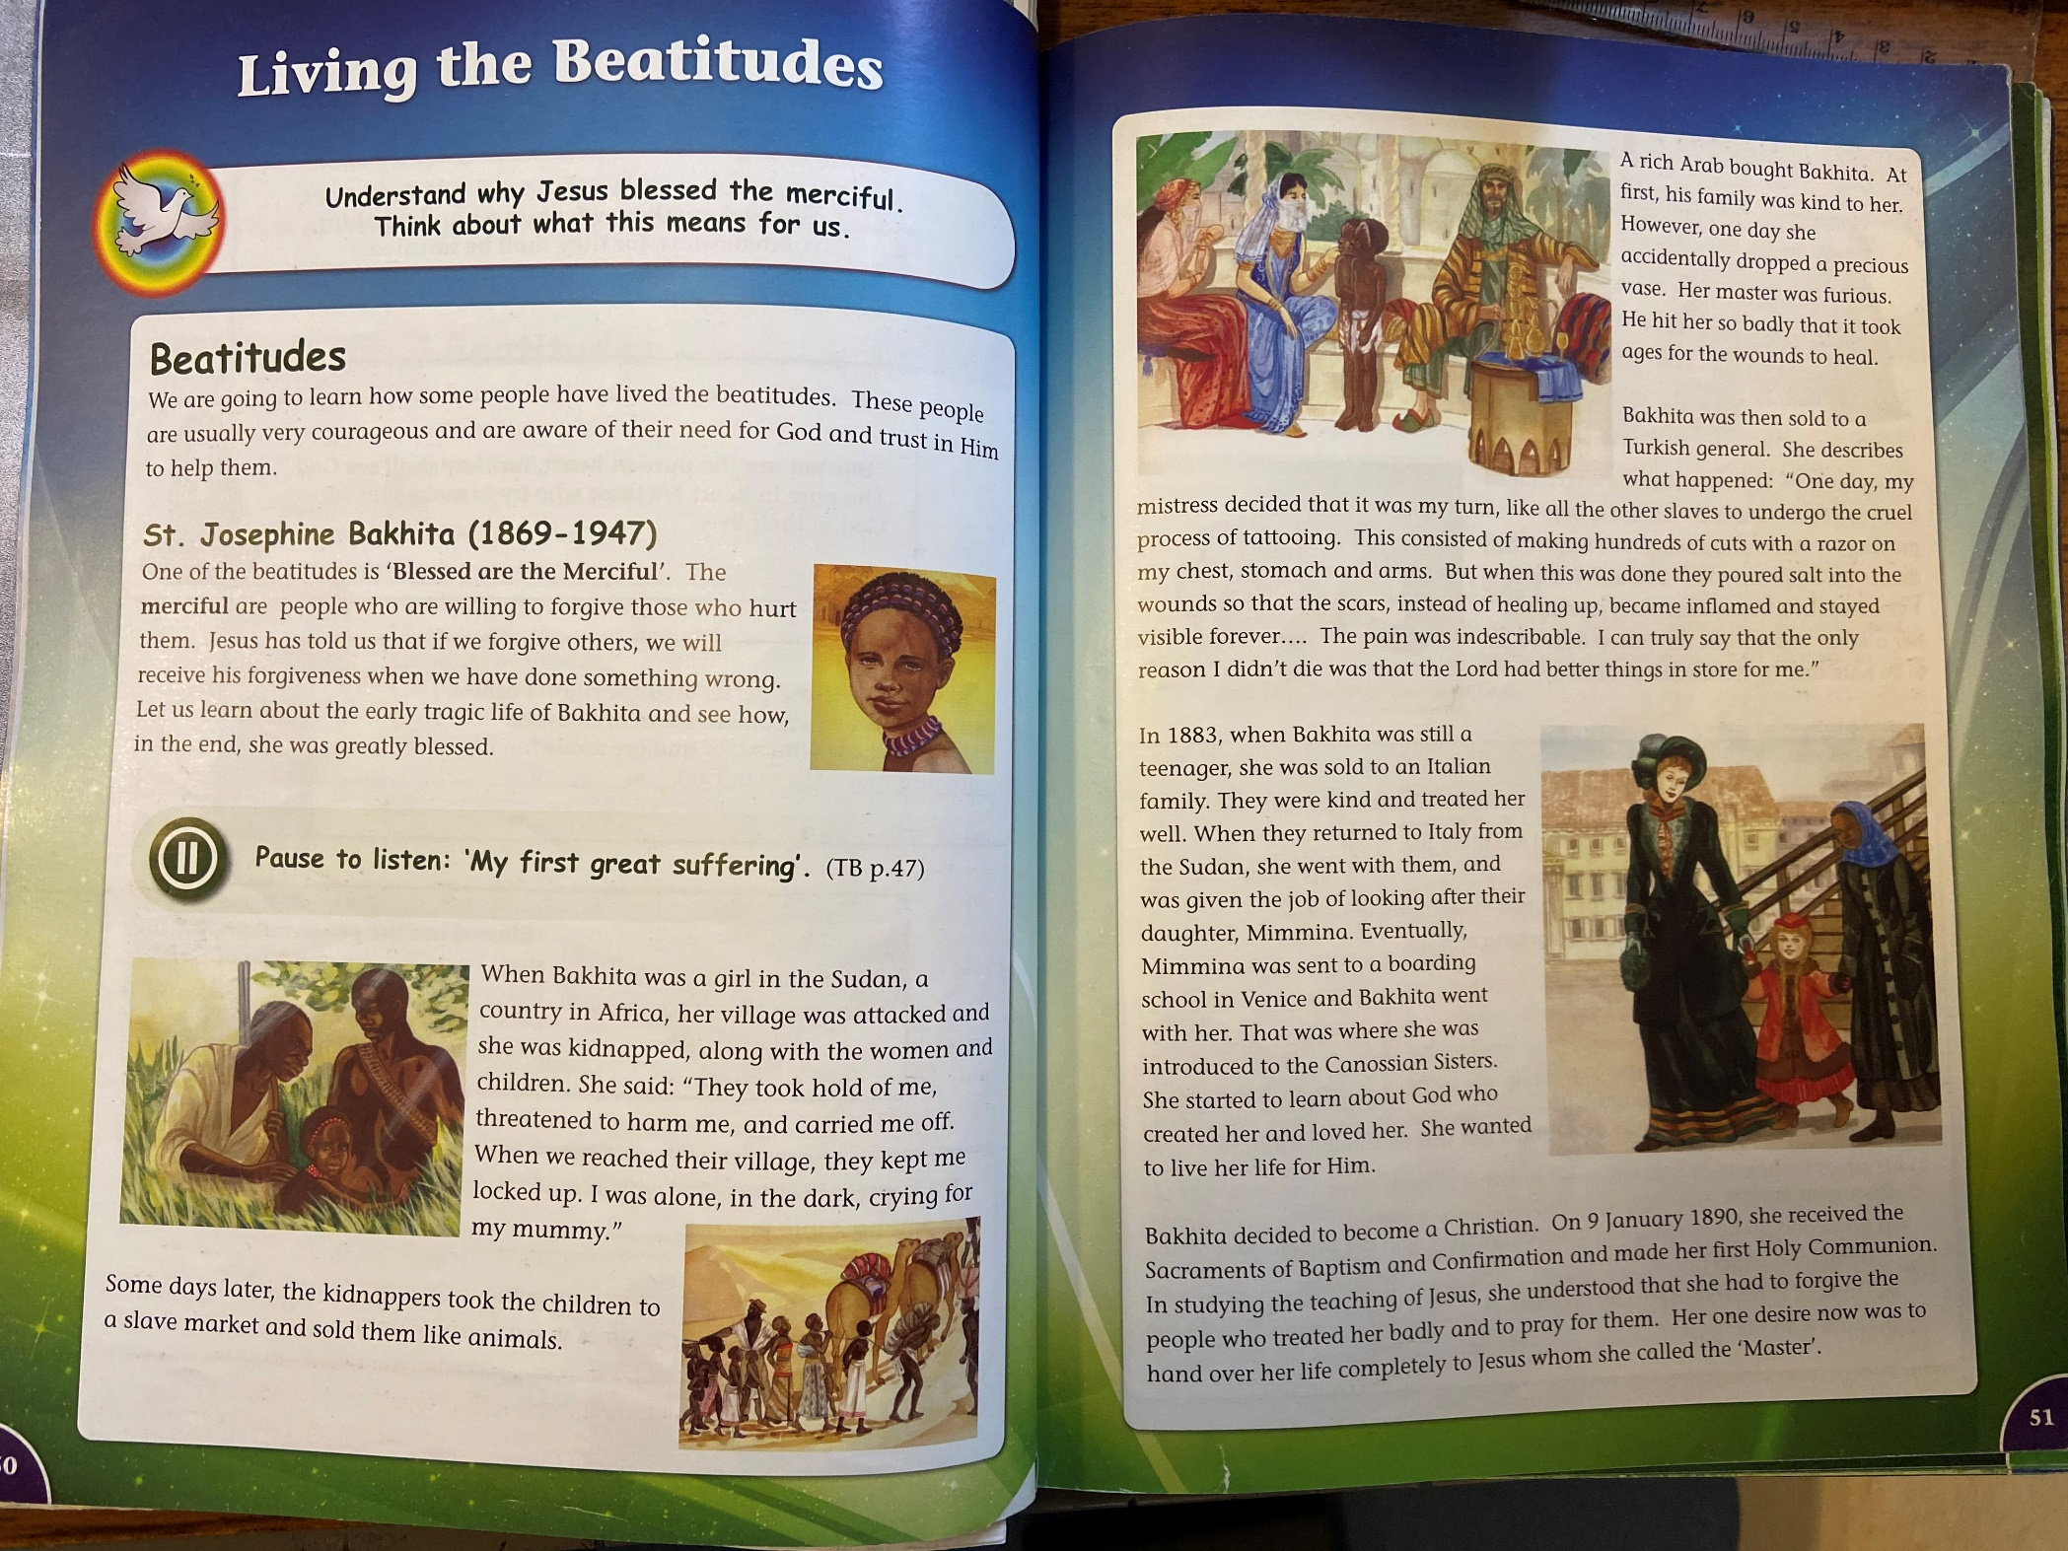
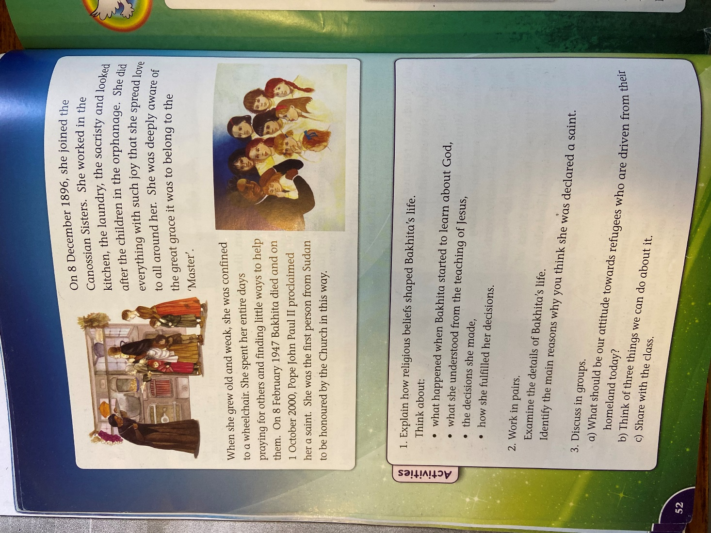

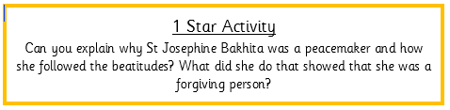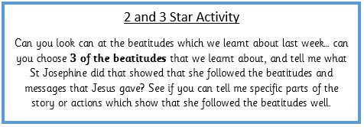
PSHE Resources
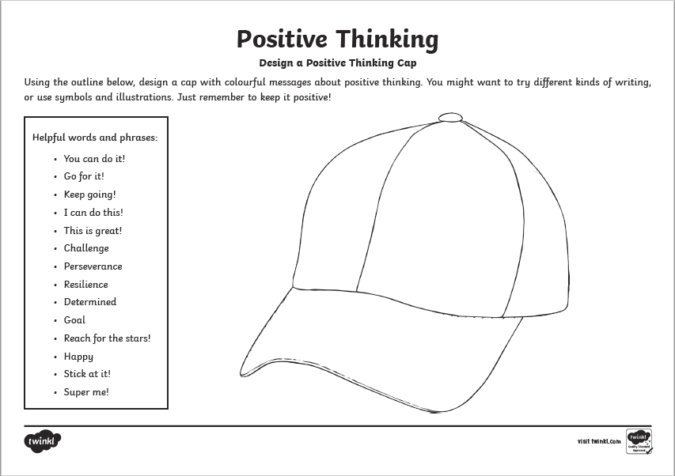

Science Resources
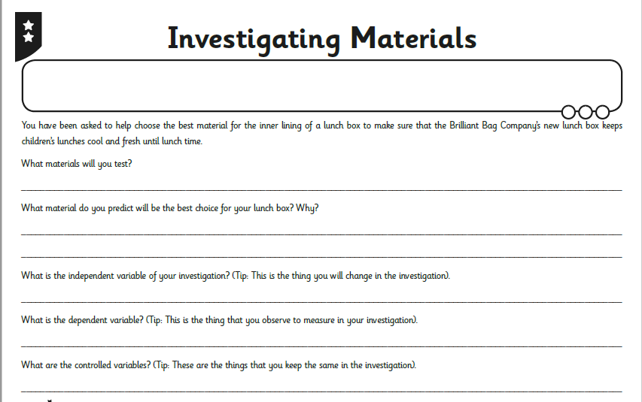
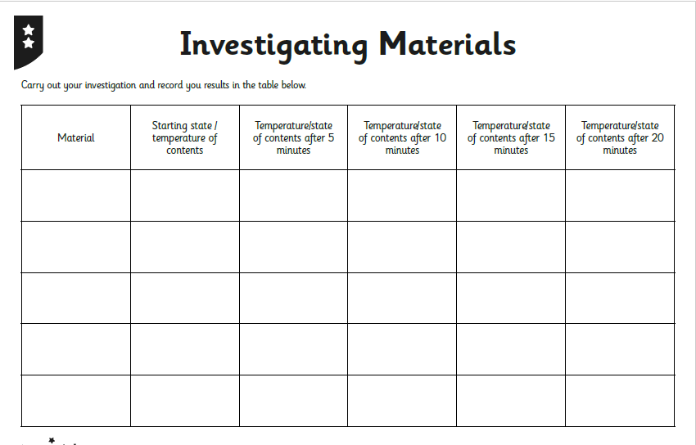

Material | Time Taken to Melt

