|  |  |  |  |  |
| --- | --- | --- | --- | --- |
| logoYear 5 Home Learning | | This document outlines the activities/lessons your child to complete at home during the bubble closure. Each activity is explained in detail here, including where to find the activities. There is a Maths and English lesson to complete each day, then a range of activities provided for additional subjects which can be completed at any time. WALT stands for We Are Learning To, which will give you a clear indication of the lesson objective. There will be different levels of challenge for the children to complete for most lessons (\*\*\* being the hardest level). The children do not need to complete all three levels. The children can work directly into their home learning book they have been given. Please feel free to email any work or pictures of the work and do not hesitate to email me on [year5@st-pauls-hyde.tameside.sch.uk](mailto:year5@st-pauls-hyde.tameside.sch.uk) if you require any assistance. Thank you, Mr Titterington.  **All of this week’s tasks have now also been uploaded onto Google Classroom, along with video links. You can complete your work using Google Classroom, and send your work back to me so that I can provide you with some feedback.** | | |
| **Week 4** | | | | |
| **Maths** | | | **English** | |
| Look in the table below to find the information about the lesson, which you need to complete. Once you have read the table, scroll down to the bottom of the document to find the tasks and questions, which you need to complete for each lesson. **This week will be focussing on Multiplication and division. It is important that you follow this plan carefully, as this is new learning for us, and is not a recap of learning which we have completed in school.**  **I will be uploading PowerPoints with videos included which explain the methods which you will need to use.** | | | **The Saga of Ragnar – Historical Narrative**  We have now finished our Non-Chronological report unit on tigers, and are moving onto our narrative unit. We will be beginning to look at the Vikings over the next couple of weeks, and with that our new narrative The Saga of Ragnar.  Our English lessons will be based on this short narrative during this week. In addition to this, beginning later this week, I will be uploading videos of an additional story, Beowulf, which will help you to generate even more ideas for your writing.  I’m looking forward to reading your stories and seeing your imaginative writing in action! | |
| 1) | Maths Lesson 16  WALT: Practice multiplying 4 digit by 2 digit numbers – basic practice.  Last week, we developed our knowledge of column multiplication. Today and tomorrow’s lesson will be our final lessons looking at this method, as we have reached the most challenging stage. We will be multiplying 4 digit numbers, by 2 digit numbers. For example, 6273 x 54.  A helpful video for this method can be found on **Google Classroom.** During this lesson, we will be practising answering questions with these digits. Tomorrow’s lesson will move on to problem solving.  An example of this method is here:    Below you will find a worksheet to try and apply this method.  Challenge levels:  1 Star – Complete questions 1 and 2 of the worksheet  2 Star Complete questions 1-4 on the worksheet  3 Star – Complete questions 1-6 on the worksheet. | | 1) | English Lesson 16 – Cold Task  WALT: Write a historical narrative inspired by the opening paragraph of The Saga of Ragnar.  As usual with our English units, we will be beginning this English unit by writing a cold task using the beginning of our story, The Saga of Ragnar. A cold task is an opportunity for you to show me what you think a historical narrative based on the Vikings might be, using all of your learning so far in our English and Topic lessons this year.  The Vikings invaded England whilst the Anglo-Saxons were still here. They are very similar to the Anglo-Saxons who we have learning about this year!  Later in this document, **and on Google Classrooms,** you will find the first paragraph of the story: The Saga of Ragnar. I would like you to write the rest of the story, using all of the grammar features which we have learnt this year, and especially those we used in the Non-chronological reports.  Here is a possible Steps to Success you could follow:  Steps to Success   * Subordinate clause sentences (Complex Sentences) * Expanded noun phrases with prepositions * Fronted Adverbials * Subject specific vocabulary (Viking vocabulary) * Relative Clauses * Parenthesis * Modal Verbs |
| 2) | Maths Lesson 17  WALT: Problem solving when multiplying 4 by 2 digit numbers. (Including recap)  Everyone has been working exceptionally hard with the new multiplication methods which we have covered. I know that this has been difficult, particularly when we have been learning this through online learning! However, you have all worked so hard with this method, and the more practice you can have, the better!  In this lesson, I would like you to apply the column multiplication method which we have been practicing with problem solving questions. **If you are not feeling confident with the column multiplication method, I would recommend that you repeat either Maths Lesson 14,15 or 16. The more practice you have with these methods, the confident you will be. If you have already answered all of those questions, ask someone at home to give you some new questions, such as: 64 x 73 or 274 x 65.**  On Google Classroom, you will find some problem solving tasks which have different levels of challenge. I have also included links to the white rose hub website, which provides helpful videos if you would like a recap on how to use the column multiplication method.  These videos can be found here: <https://whiterosemaths.com/homelearning/year-5/spring-week-2-number-multiplication-division/>  Challenge levels:  1 Star – Create and answer your own multiplication questions to practice using the column multiplication method.  2 Star – Complete problem solving page 1.  3 Star – Complete problem solving page 2. | | 2) | English Lesson 18  WALT: Create a text map for The Saga of Ragnar  In this lesson, we will read the full, short story of The Saga of Ragnar. You can find this story later in this document. You can also listen to me reading the story **on Google Classrooms.** I will also be explaining the main activity which you will need to complete on Google Classrooms.  Once you have read the story, I would like you to create your own text map for The Story of Ragnar. A text map is a series of pictures which help you to retell the story. On Google Classrooms, I will show you how to summarise a paragraph into shorter sentences, which you can then use to create pictures to help you to retell the story word for word.  By the end of this lesson, I would like you to have created your own text map for the story. You can do this in one of two ways. First, you could create a real drawing of the text map using paper and pencils. You can then take a picture of this and upload it to Google Classrooms. Secondly, you can use the Google Drawing document which I have set on **Google Classrooms** to create your text map digitally.  Challenge Levels  1 Star – Create a text map for The Saga of Ragnar  2 Star – Create a text map for The Saga of Ragnar, and add in some of your own adjectives.  3 Star – Create a text map for The Saga of Ragnar, and add some of your own sentences to the text map. |
| 3) | Maths Lesson 18  WALT: Divide 2 digit numbers by 1 digit numbers.  For the remainder of this week, we will be moving onto calculations for division. Today, we will start with 2 by 1 digit divisions, which we can calculate with both counters, and a formal written method. An example of both methods are shown here for 56 ÷ 4:    When using the counter method, we can create the largest number (in this case 56) using or drawing counters. Then we begin on the left side of the number, and circle the counters in groups of 4. If we have any tens left over not in the group of 4, we need to exchange these for Ones, meaning we can then circle the ones into groups of 4. The number of groups of 4 that we have in each column, gives you the final answer.    For the formal method, we first divide 5 by 4, which is 1 with **1** ten left over. We then carry the ten over to the one column and divide 16 by 4, which equals **4**. This means our answer is **14.**  **On Google Classroom,** the children will find a video which explains both of these methods in more detail. There will also be a link to the white rose hub website which can be found here: <https://whiterosemaths.com/homelearning/year-5/spring-week-2-number-multiplication-division/>  It would be great to see you completing both the questions, and a problem solving and reasoning challenge today. You can use either the counter method, or the written method today, whichever you feel most confident with.  Challenge Levels:  1 Star – Complete the 2 by 1 digit division questions.  2 Star – Complete the 1 star challenge and questions 1-3 of the problem solving sheet.  3 Star – Complete the 1 star challenge and questions 1-6 of the problem solving sheet. | | 3) | English Lesson 18  WALT: Imitate a text map for The Saga of Ragnar  Last lesson, we drew a text map for The Saga of Ragnar. You should have used this text map to help you to remember the words which are in the story, to help you to retell it out loud.  In this lesson, just like we have done in school, I would like you to create some actions for your text map. You should practice these at home, perhaps you could show someone your actions, perhaps you could try to teach someone else at home.  **On Google Classrooms,** I have uploaded a video explaining this task.  Once you have practiced your actions, you may wish to record a video of your text map actions and upload this to Google Classrooms. If you cannot record a video, then you could take some pictures of your actions.  Challenge levels:  You can decide your own challenge for this lesson, you could either create actions for the first two paragraphs, or create actions for the whole text. |
| 4) | Maths Lesson 19  WALT: Divide 3 digit numbers by a 1 digit number using a formal written method.  Yesterday, we learnt how to divide a 2 digit number by a 1 digit number, today, we will be moving onto the next challenge of dividing a 3 digit number by a 1 digit number. We will be using the same methods as yesterday’s lesson (counters and the written method), however, if you used the counter method yesterday, I would like you to challenge yourself to use the written method. This is also important because of the LARGE amount of counters which these questions will require. An example of each method can be seen here for the question 114 ÷ 6:    Formal written method:    **On Google Classroom,** the children will find a video which explains both of the methods which are shown above. They should then try to complete the activities. Again, it would be great to see the children both answering the questions and problem solving questions.  Challenge Levels:  1 Star – Complete the 3 by 1 digit division questions.  2 Star – Complete the 1 star challenge and question 4a and 4b from problem solving.  3 Star – Complete the 1 and 2 star challenge and questions 7a and 7b from problem solving. | | 4) | English Lesson 19  WALT: Box-up the narrative of The Saga of Ragnar.  Usually in school, once we have created and rehearsed the text map for the focus story of our unit, we box up the text map. This means that we are writing the story of The Saga of Ragnar inside a plan. **We are not planning our own story.**  Boxing up the story is like working backwards. We know what happens in the story (because we have read it) but we now need to put each part of the story into the correct sections of the plan, and shorten each paragraph into a couple of sentences or points. It is like we are working backwards from the story to the original plan, working out how the author might have planned their text.  We will need to think about:   * Which part of the story is the opening * Which part of the story is the build up * Which part of the story in the problem * Which part of the story is the resolution * Which part of the story is the ending   For your task for today’s lesson, I would like you to use the planning format which I have uploaded **onto Google Classrooms** and fill in the blank spaces of the boxing up plan, using the story. You should find both the story and the text map script on Google Classroom lesson 19.  If you cannot access Google classroom, a planning format has been included later in this document.  Challenge Levels:  1 Star – Complete the first column of the box-up planning format  2 Star – Complete the first column of the box-up planning format and also identify which steps to success have been used in each part of the story – e.g. subordinate conjunction – As  3 Star – Complete the box-up plan, identifying which steps to success have been used in each part of the story, and an example of where they used it. E.g. Subordinate conjunction, **After** many days of battling…. |
| 5) | Maths Lesson 20  WALT: Divide 4 digit numbers by 1 digit numbers using formal written methods.  This will be the final lesson this week using the division methods which we have learnt. By this lesson, you should now be confident with the written method for division. This will be the final practice with the method, before moving onto a remainder lesson on Monday, and then fraction work for the rest of the week.  Here is an example of the possible method. Counters can be used for these questions, although it may be difficult:    On Google Classroom, you will find a video which goes through this method in detail. Once you have watched the video, complete the activities for this lesson.  Challenge Levels:  1 Star – Answer the division questions for 4 by 1 digit division.  2 Star – Complete the 1 star challenge questions and the 2 star problem solving sheet  3 Star – Complete the 1 star challenge questions and the 3 star problem solving sheet | | 5) | English Lesson 20  WALT: Use relative clauses and parenthesis to describe Ragnar and the setting  During this year, we have learnt how to write sentences which use both relative clauses and parenthesis. We have learnt about how these two grammar features can add additional information to a sentence, and have also used a variety of punctuation including commas, brackets and dashes.  We have learnt about the difference between parenthesis and relative clauses being the use of a relative pronoun, such as: which, who, where, that  Examples:  Relative Clause = Ragnar**, who was the strongest warrior in Scandinavia,** was determined to defeat the fearsome beast.  Parenthesis = Ragnar **– a tall man with long brown hair –** was famous throughout all of the Viking lands.  In this lesson, I would like you to write 10 of your own relative clause and parenthesis sentences. You should try to write a mix of the two different types of sentences.  **On Google Classroom,** there is a video explaining this task, including a Google Document for you to write your sentences in.  Challenge levels:  1 Star – Write 5 relative clause sentences and 5 parenthesis sentences.  2 Star – Write 5 relative clause sentences and 5 parenthesis sentences with a mix of punctuation  3 Star - Write 5 relative clause sentences and 5 parenthesis sentences with a mix of punctuation, then write your own paragraph including one or two of these sentences, and other grammar features. |

|  |  |
| --- | --- |
| **Additional Subjects- To be completed anytime over next week** | |
| **Science** | **Topic** |
| Properties of materials – Lesson 1  WALT: Compare and group together everyday materials based on the basis of their properties.  In this lesson, we will be beginning our properties of materials unit. We will need to think about the knowledge which you gathered in year 4 to help with this. In this unit, we will talk about solids, liquids and gases.  In today’s lesson, I would like you to pick 5 different objects to test around your house(with your parents’ permission). These will need to be small objects, that are not valuable, so that you can test their properties. This will also need to be something that you don’t mind getting wet.  **Starter task:** Can you complete the properties definition sheet? See if you can match or find the definitions for these 10 properties: magnetic, reflective, absorbent, permeable, translucent, flexible, hard, flammable, insulating and transparent. When you have matched the words to their definition, check your answer.  **Main Task:** Now it is time to experiment with your 5 objects. Use the Testing Properties experiment sheet. Follow the instructions, and test the 5 materials/objects which you have chosen for: if they are magnetic (yes or no), if they are hard (rating out of 5), if they are transparent (yes or no), if they are flexible (rating out of 5) and finally, if they are permeable (yes or no). You may not have a magnet at home (a fridge magnet may help), so you may have to estimate with this one.  Once you have gathered your results, complete the table and send it back to me. | Vikings Lesson 1  WALT: Learn about the invasion of the Vikings.  In this lesson, we will learn about the Vikings, about how and when they invaded England. This is the first lesson in our Viking topic, and our understanding gained from these lessons, will help with our writing in English.  **On Google Classrooms,** there will be a video explaining our new topic, and the activities for this lesson.  **As a starter task,** I would like you to complete the sorting activity for British History. This will test your knowledge about some of the key events that you may have (or may not have yet) learnt about, occurred, and will help us to understand when the invasion of the Vikings took place. The sorting activity can be found later in this document or on **Google Classrooms.**  **Main Task 1:** For your first main task, I would like you to use an atlas or Google Earth to help you to show me how the Viking Invasion happened. Watch the video on Google Classroom to find the full instructions. Can you complete your own graph of Europe, (A copy can be found later in this document) by:  -separating Britain into Danelaw and Wessex  - separating the borders of England, Scotland and Wales?  - Identify Key European countries for the Vikings  - Locate Lindisfarne Priory  **Main Task 2:** After listening to the introduction to the Viking invasion, can you answer and summarise the key introduction question:  Why did the Vikings invade Britain? |
| **Art** | Computing |
| **Vikings – Longboats**  I wonder whether you could use the internet to research about Viking Longboats? Once you have done this, could you create your own piece of artwork inspired by their longboats. You could upload a picture of your artwork to Google Classroom.  Viking Art Ideas Ks2 - Creative Art | Spreadsheets Lesson 1  WALT: Understand the basic features of a spreadsheet.  For this lesson, you will need to open both Google Classroom and Purple Mash. On Purple Mash, you will have a 2Do which is a blank spreadsheet. On Google Classroom, there will be a video explaining this lesson, with examples of the task which you need to complete. |
| **RE** |
| Inspirational People – Lesson 3  WALT: Have the opportunity to know that the Beatitudes show us the way to live.  In this lesson, we will learn about the Beatitudes and why they were important. **On Google Classrooms,** you will find a video where I have introduced the different Beatitudes to you. The beatitudes can also be found later in this document.  **Starter task:** Can you order the beatitudes from the most important to the least important? To challenge yourself, see if you can explain why you have chosen the most and least important Beatitudes.  **Main Task:** Can you choose two different Beatitudes which you could write about. Can you present the two beatitudes which they have chosen in a symbolic way, using patterns and symbols which link to that beatitude.  Underneath/next to each of these symbols, can you use these beatitudes to:   1. Write a modern-day account of someone who is putting this into practice? The children should think about how these people would behave or act. 2. Explain how following these beatitudes help us to be true followers of Jesus.   The Beatitudes | Devotional Reading Plan | YouVersion Bible |
| **Health and Wellbeing** |
| **P.E.**  Mr Allen has started to upload P.E. sessions with videos onto our Google Classroom page. See if you can join in with his activities, and remember to leave a comment if you do! It is important to continue to exercise at home, especially during extended time inside. Mr T might even make a guest appearance!!  **PSHE**  Whilst completing learning at home, it is important that we are finding a healthy balance of all of our activities. To help with this, I wonder whether during this week you can complete the Happiness Activity Chart? Remember, you can save your work on Google Classroom and add new ideas to it each day. The happiness chart can also be found below. |

Monday – Maths Lesson 16 Resources

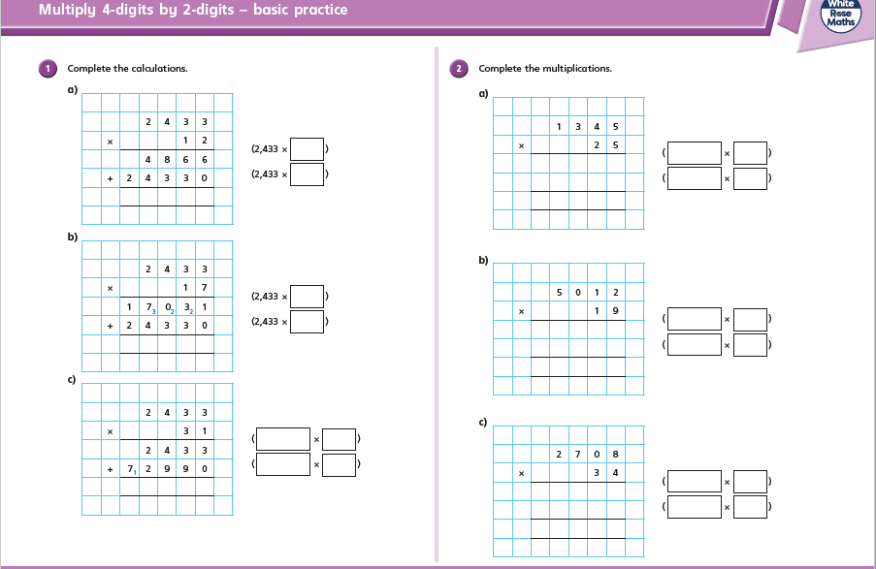

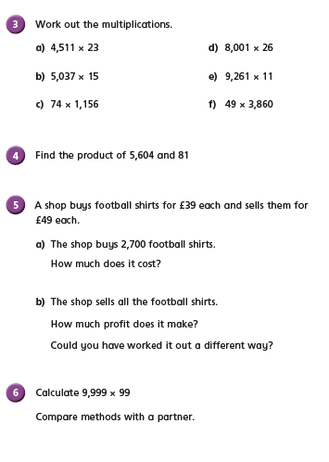

Tuesday – Maths Lesson 17 - Resources – Problem Solving Page 1

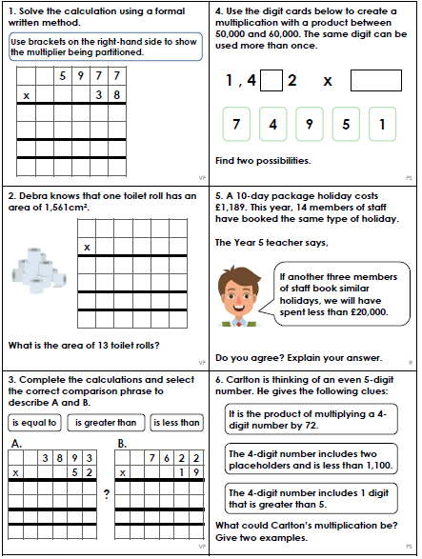

Tuesday – Maths Lesson 17 – Problem Solving Page 2

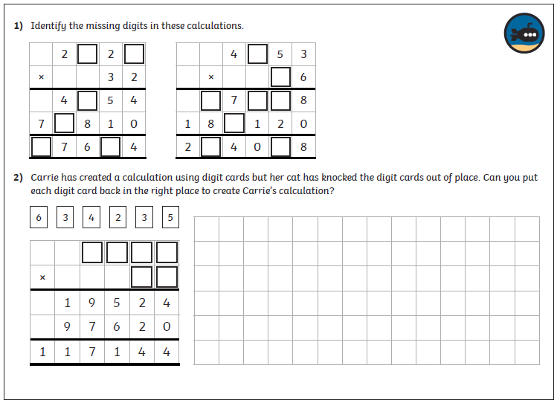

Wednesday – Maths Lesson 18 Resources – 2 by 1 digit division questions

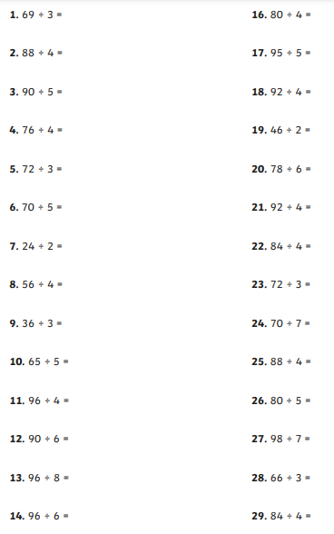

Wednesday – Maths Lesson 18 – Problem Solving Activity

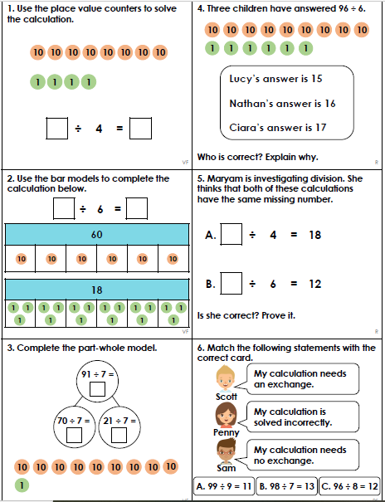

Thursday – Maths Lesson 19 Resources - 3 by 1 digit division questions

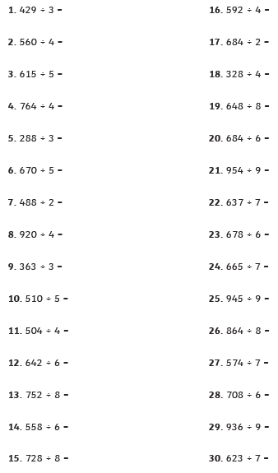

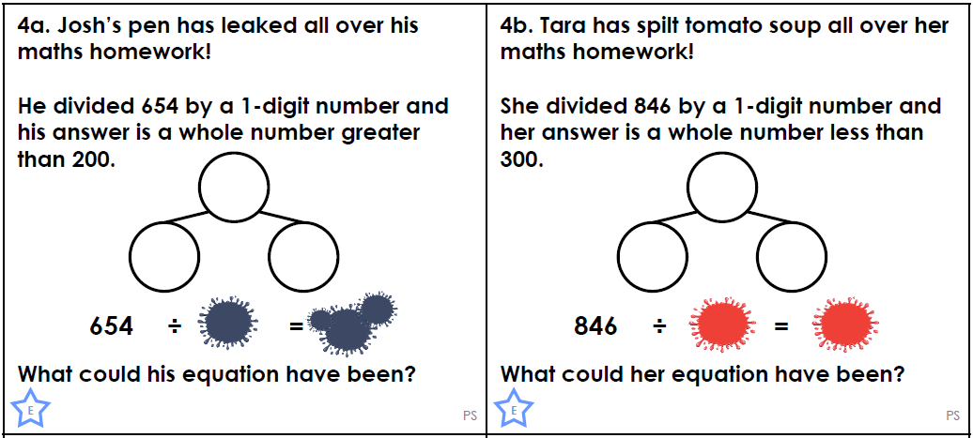

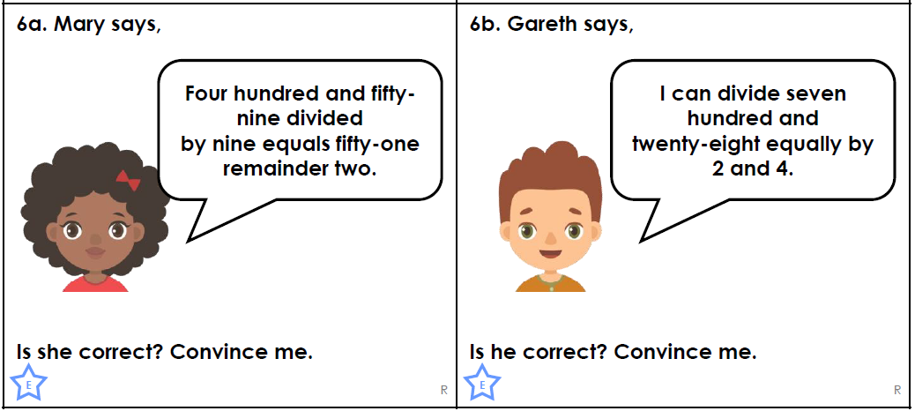

Friday – Maths Lesson 20 Resources – 4 by 1 digit division questions

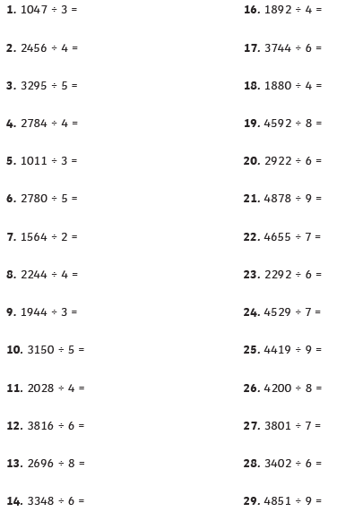

Friday Maths Lesson 20 – 2 Star Problem Solving

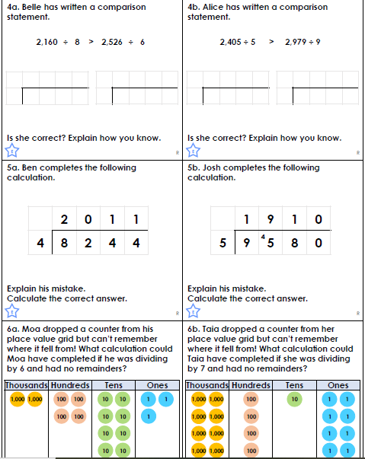

Friday – Maths Lesson 20 – 3 Star Problem Solving

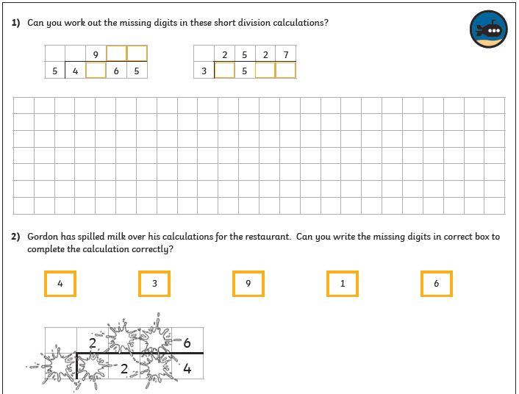

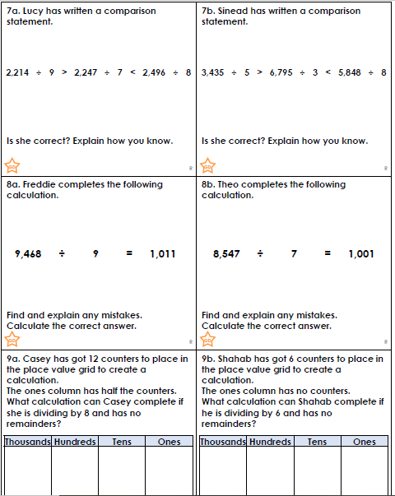

Monday –English Lesson 16 Resources

The Saga of Ragnar – First Paragraph

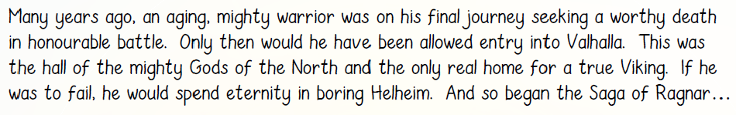

|  |  |  |  |
| --- | --- | --- | --- |
| **Me** | **Our Steps to Success** | | **My teacher** |
|  | Expanded Noun Phrases | |  |
|  | Fronted Adverbials | |  |
|  | Subordinate Clause Sentences | |  |
|  | Relative Clauses | |  |
|  | Parenthesis | |  |
|  | Modal Verbs | |  |
|  | Subject Specific Vocabulary (Vikings) | |  |
| C:\Users\colette keane\AppData\Local\Microsoft\Windows\Temporary Internet Files\Content.IE5\EMWP1N40\4240385850_34c6799b77_z[1].jpg | | C:\Users\colette keane\AppData\Local\Microsoft\Windows\Temporary Internet Files\Content.IE5\JO0R29RW\thumb-magic-wand-pictofigo-hi-013[1].png | |
| C:\Users\colette keane\AppData\Local\Microsoft\Windows\Temporary Internet Files\Content.IE5\EMWP1N40\4240385850_34c6799b77_z[1].jpg | | C:\Users\colette keane\AppData\Local\Microsoft\Windows\Temporary Internet Files\Content.IE5\JO0R29RW\thumb-magic-wand-pictofigo-hi-013[1].png | |

Tuesday & Wednesday – English lesson 17 & 18 Resources

Text Map Script:

The Saga of Ragnar

Many years ago, an aging, blood-thirsty warrior – who originated from Scandinavia - was on his final journey seeking a worthy death in honourable battle. Only then would he have been allowed entry into Valhalla. This was the hall of the mighty Gods of the North (such as the hero Beowulf) and the only real home for a true Viking. If he was to fail, he would spend eternity in boring Helheim. And so began the Saga of Ragnar…

He stood gripping the heavy, metal sword in his hand as he stared furiously at his opponent. He lifted the feeble man – who hadn’t provided a challenging opposition - high above his head and took a deep sigh, hurled him over the cliff edge and watched him plummet towards the white snow below. He rotated towards his peer Boromir, with a puzzled look on his face.

“Will I ever reach the gods in Valhalla?” Ragnar roared like a beast across the snow-capped mountains. “Why will no one challenge me?”

After many days of battling, winning and waiting, something caught the eye of the Viking warrior through a clearing in the distant mountains. Brightly, the flames from a fire stretched towards the sky. Smoke smothered the mountains’ high, rocky peaks like a dark spirit. He could hear the shrill screams of women and loud growls from something inhuman. Hurtling downwards, Ragnar and Boromir headed towards the village in search of the blood curdling noises. Before long, he reached the village but did he find the opponent he had been searching for all this time?

The blazing, scarlet flames, surrounding the innocent victims, continued to spread through the village as women frantically ran for their lives. Towering above the flames, was a colossal behemoth feasting on the women and children.

“Finally, a worthy opponent for me!” Ragnar bellowed through the flames.

Boromir demanded victoriously, “Let’s attack, Ragnar!”

Heading towards the danger, Ragnar confidently equipped his belongings: his rusted helmet, his shield and his essential longsword.

Courageously, he drew his sword (which was sharpened and undefeated) and began an epic battle with the behemoth. He was thrown around the village like a rag doll but continued to rise and fight. Ragnar knew that we needed to become victorious; however, he felt like he had nothing left to give. Although Ragnar was once as strong as an ox, he was now aging and tired. After hours of fighting, the evil beast brutally drilled a spear into the Viking’s heart and, as the silver snowflakes fell around him, Ragnar took his final breath. Just like he had wanted, our Norse hero lives on with the Gods of the North in the only real home for a true Viking, Valhalla.

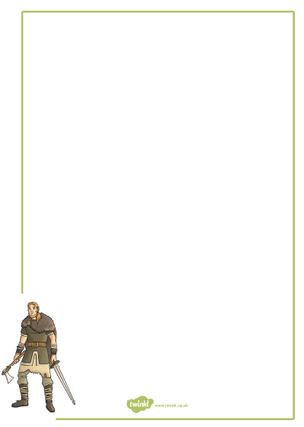

Thursday – English – Box up plan format

Box up Plan

WALT: box up the narrative of The Saga of Ragnar

Title: \_\_\_\_\_\_\_\_\_\_\_\_\_\_\_\_\_\_\_\_\_\_\_\_\_\_\_\_\_\_\_\_\_\_\_\_\_\_\_\_\_\_\_\_

|  |  |  |
| --- | --- | --- |
|  | What happens? | Steps to success I will use |
| Setting Description |  |  |
| Character Description |  |  |
| Build up – |  |  |
| Problem – |  |  |
| Resolution – |  |  |
| Ending – |  |  |

Monday – R.E. Resources – The Beatitudes

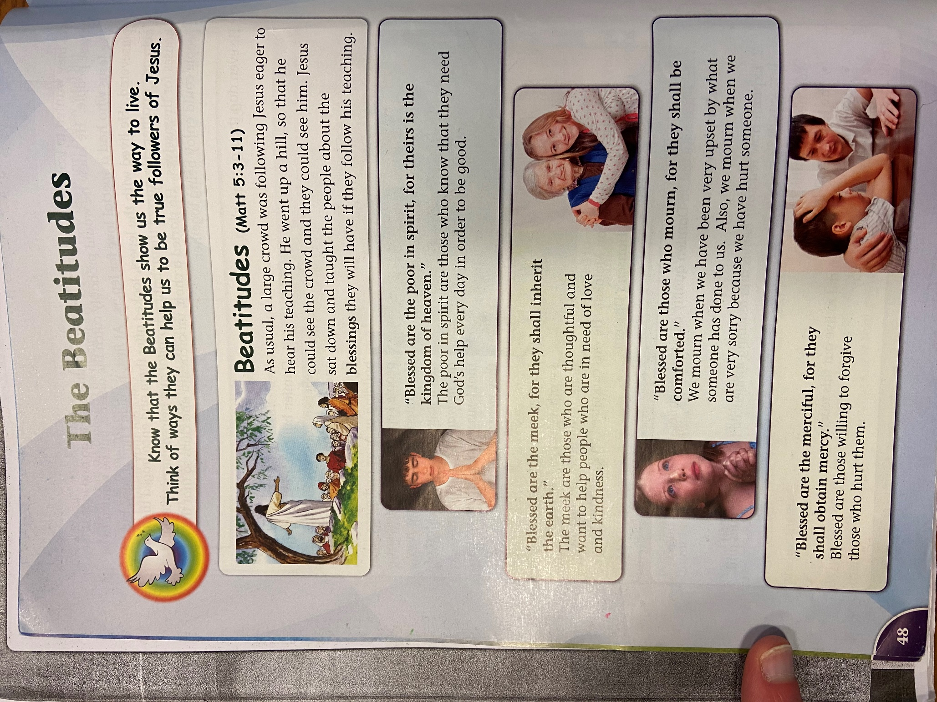

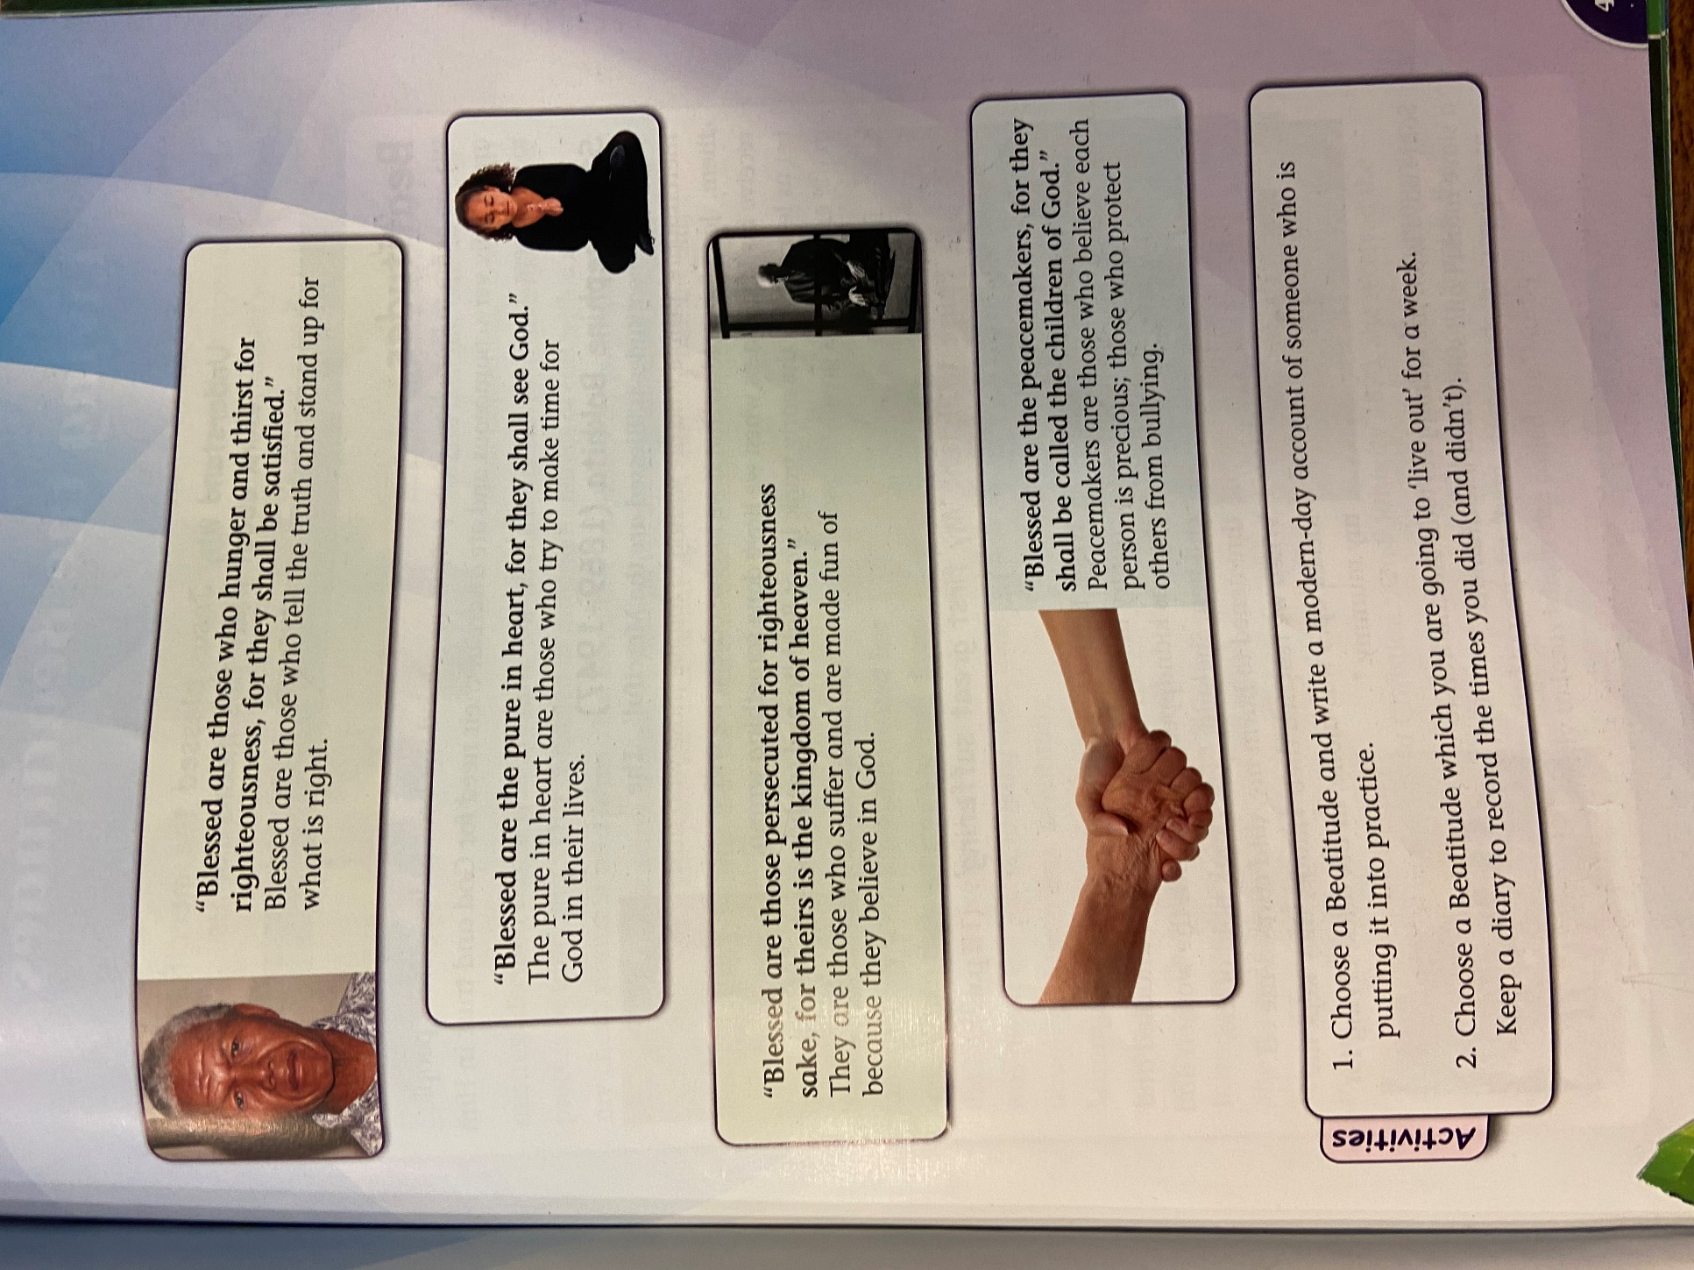

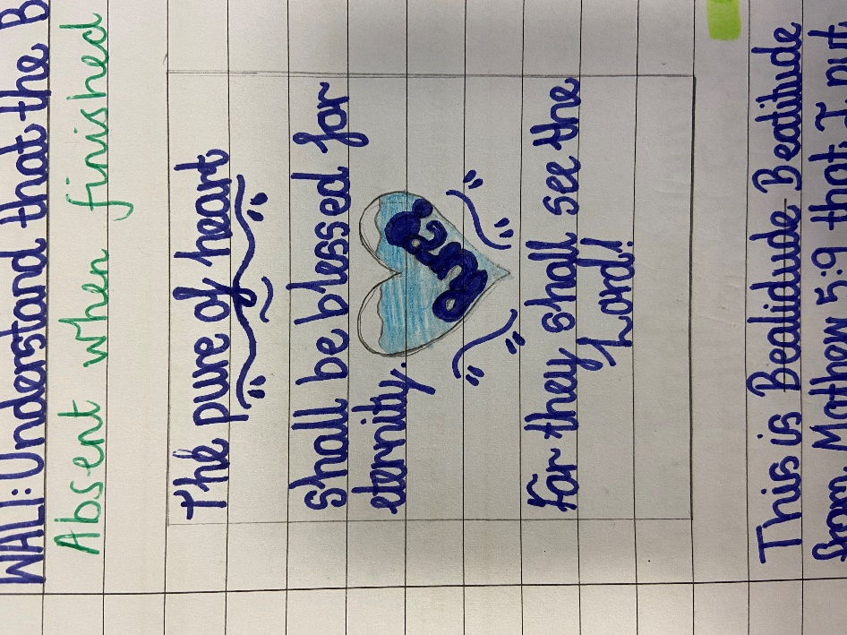 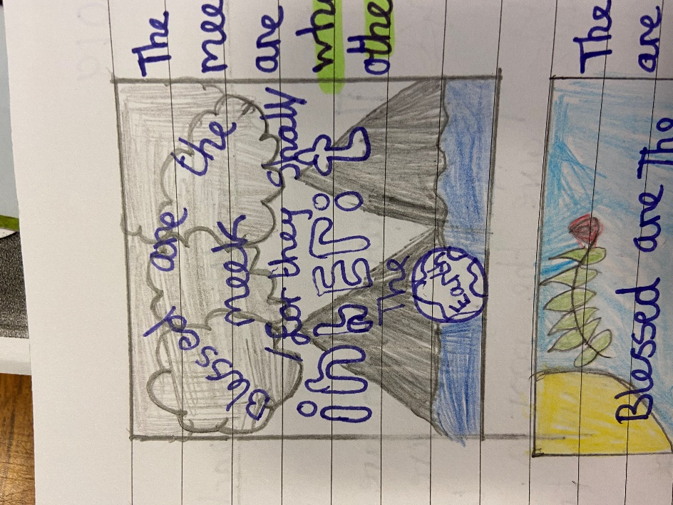 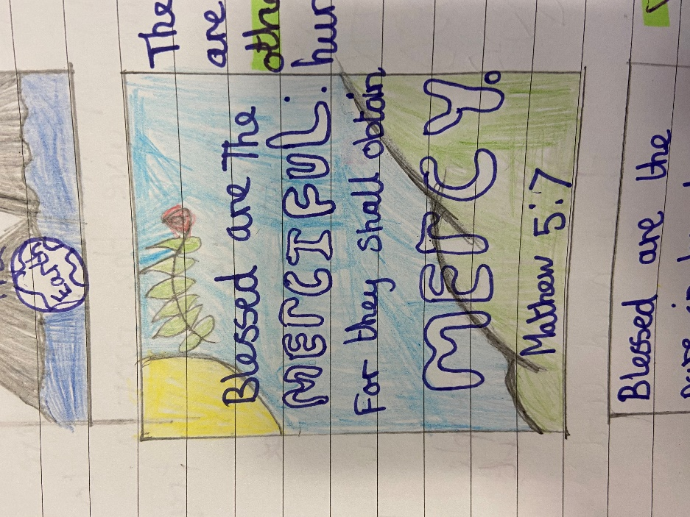

Wednesday – Viking/Topic Resources

British History Timeline

|  |  |  |  |  |
| --- | --- | --- | --- | --- |
| Roman Britain | Victorian Britain | Tudor Britain | Viking Britain | Georgian Britain |
| Modern Britain  Including World War 2 | Anglo-Saxon Britain | Pre-historic Britain | Medieval Britain  Normans | Stuart Britain |
| **BC** | **1714** | **793** | **1837** | **1485** |
| **450** | **1066** | **1603** | **1902+** | **43AD** |

**How well do you know your British History?**

**Do you know whether the Vikings or the Romans came first?**

**Try to put the events in order and have a go at the dates!**

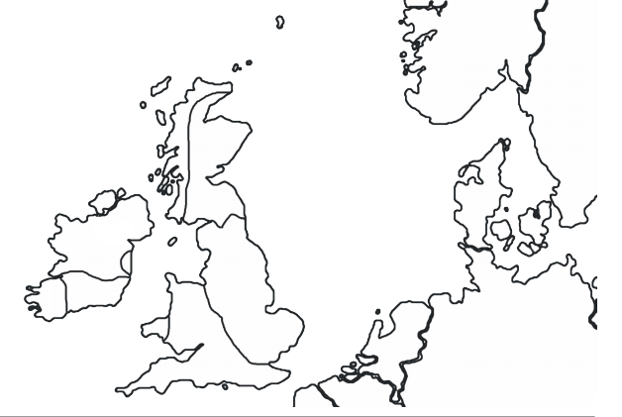

Thursday – Science Resources

PSHE Resources

Why did the Vikings invade Britain?

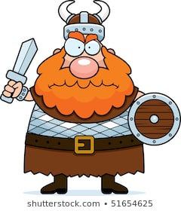

PSHE Resources

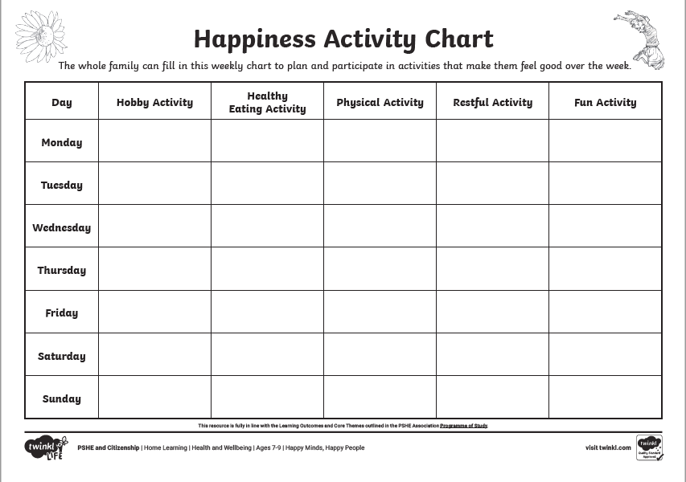

Science Resources

