Year 1 Home learning menu- week 4
See daily videos and worksheets on our Google Classroom to support this plan
Snail and the Whale  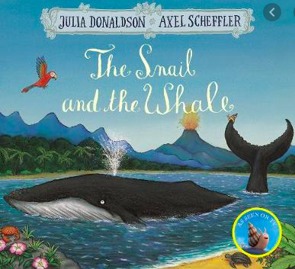 | Write a thank you note!  Pretend you are the Whale or the Snail from the story and write a thank you note to the people who helped save the whale. | Lets plan the next adventure!  Draw a map of where you think the whale and all the snails will go this time and show them returning home safely. | Write down the plan for the next adventure.  Using your picture map yesterday, write down the journey the snails and the whale will take this time. | Send a Postcard!  Choose your favourite place the snail and the whale visited and create a postcard. Draw a nice picture on the front of the postcard and write a message for someone on the back of your choice. | Where would you like to go with a whale and a snail?  Write a sentence and a draw a picture where you would like to go on an adventure!
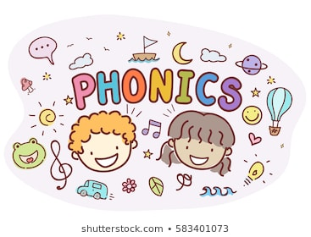 | Investigate the phoneme /ai/  Using the phoneme spotter, read together and find and write/highlight any words containing the /ai/ phoneme | Sort words with the /ai/ phoneme  Read words with the different graphemes for the /ai/ phoneme. Sort them according to how the phoneme is made. | Read sentences and find the words with the /ai/ phoneme.  Read the sentences and recognise which words have the /ai/ phoneme. How is that phoneme made? | Read sentences and find the words with the /c/ phoneme.  Read the sentences and recognise which words have the /c/ phoneme. How is that phoneme made? | Read sentences and find the words with the /ai/ phoneme.  Read the sentences and recognise which words have the /ai/ phoneme. How is that phoneme made?
RE  Families and celebrations | WALT- Have the opportunity to understand what it means to belong to the Church family.  Ask your child to think of a time when they were taken somewhere special with the family.  Watch the video in our google classroom- the story of when Mary and Joseph took Jesus to the temple.  Ask questions like:  Why did Mary and Joseph go to the temple?  What happened when they arrived?  How do you think Simeon was feeling? Why?  What did Simeon say?  What do you think Mary was thinking? Why?  What did Anna do after she had seen Jesus?  Draw a picture of Mary, Joseph and Simeon (or print the picture) and write speech bubbles for each of the people.
 | Subtraction- crossing through 10.  Using tens frames, complete subtractions by crossing out the correct amount.  Calculations taken from illustrations.  See below. | Subtraction- crossing through 10.  Using tens frames, complete subtractions by crossing out the correct amount.  Calculations taken from written problems.  See below. | Subtraction- crossing through 10.  Using tens frames, complete subtractions by crossing out the correct amount.  Today concentrating on how many to get back to 10 and how many more.  See below. | Subtraction- crossing through 10.  Solve written word problems for subtraction. Solve using a number line.  We will work through each question together on the video. | Subtraction- comparing numbers.  Looking at numbers, compare their size. Which is bigger and by how much. Write calculations to match these differences.  We will work through each question together on the video.
South America  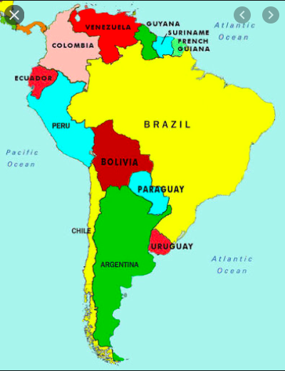 | South America!  Lets learn some facts about South America.  Let’s make a fun fact file together as a class. So you can either research facts about brazil and choose your favourite, most shocking or most funny fact and send it to us. The other option is find your favourite place in brazil and why you would like to visit it.  All this information will be put together and made into one fact file you can view. | Lets look at Brazil!  Looking at the world famous Rio Carnival, why the celebrate and how!  Lets make our carnival head pieces.  (You might need some feathers or other craft material) | Yummy tropical fruit skewers.  Looking at the Brazilian culture we will see what food they eat, can you make a fruit skewer using traditional Brazilian fruit?  You will need –  Papaya  Mango  Pineapple  You can also add Guava, however this is not always easy to find. You may wish to make a fruit salad bowl instead and add passion fruit!  Fill in the taste table about what you liked. | Amazon rainforest!  Lets learn some facts about the amazon rainforest and who lives there.  Make a save the amazon rainforest poster! | Brazilian Music  Brazil is famous for Zumba, Samba and many other dances. Listen to the music that inspires some of these dances. You may create your own Samba or Zumba dance if you would like and send us the video or just fill in the music feedback sheet about how the music made you feel and your opinion on each song.
Maths Day 1:
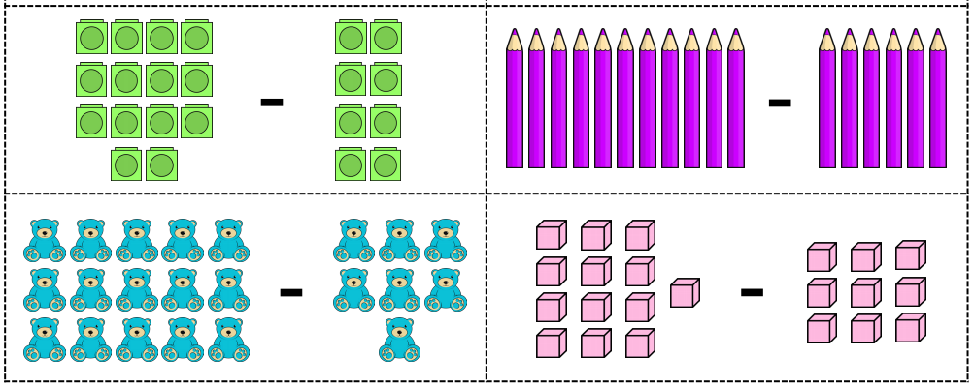
Maths Day 2:
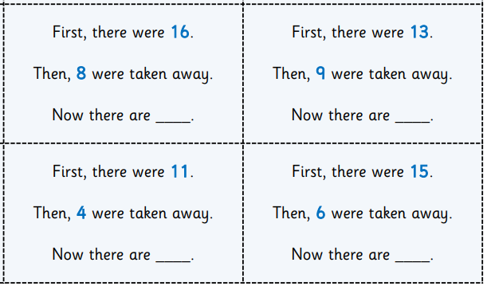

Maths Day 3:
