Year 5 Home Learning |  | This document outlines the activities/lessons your child to complete at home during the bubble closure. Each activity is explained in detail here, including where to find the activities. There is a Maths and English lesson to complete each day, then a range of activities provided for additional subjects which can be completed at any time. WALT stands for We Are Learning To, which will give you a clear indication of the lesson objective. There will be different levels of challenge for the children to complete for most lessons (*** being the hardest level). The children do not need to complete all three levels. The children can work directly into their home learning book they have been given. Please feel free to email any work or pictures of the work and do not hesitate to email me on year5@st-pauls-hyde.tameside.sch.uk if you require any assistance. Thank you, Mr Titterington.  All of this week’s tasks have now also been uploaded onto Google Classroom, along with video links. You can complete your work using Google Classroom, and send your work back to me so that I can provide you with some feedback.
Week 3
Maths |  |  | English
Look in the table below to find the information about the lesson, which you need to complete. Once you have read the table, scroll down to the bottom of the document to find the tasks and questions, which you need to complete for each lesson. This week will be focussing on Multiplication. It is important that you follow this plan carefully, as this is new learning for us, and is not a recap of learning which we have completed in school.  I will be uploading PowerPoints with videos included which explain the methods which you will need to use. |  |  | Our topic and focus for our time outside of school will be writing non-chronological reports. Our topic will be called “Wild Cats – Non Chronological Reports”.  Each lesson, I have provide a link for an individual lesson, which will teach you the different learning focuses for each lesson. The videos will provide you with activities to complete. There will also be alternative paper activities similar to the videos, in case you are not able to follow along.  All of the weeks videos and activities can be located here: https://classroom.thenational.academy/units/wild-cats-non-chronological-reports-702c
1) | Lesson 11 – WALT: Multiply 2 digit numbers by a 1 digit number.  During this week, we will be building up to reaching our target for multiplication in Year 5. We will be beginning with multiplying 2 digit numbers by a 1 digit number, and then building up to multiplying a 4 digit number by a 2 digit number.  In this lesson, we will learn the strategies for multiplying a 2 digit number by a 1 digit number using the expanded method. The expanded method helps you to break down the multiplication into smaller parts, and to recognise which numbers (and digits) are being multiplied together. Below is an example of the expanded method:  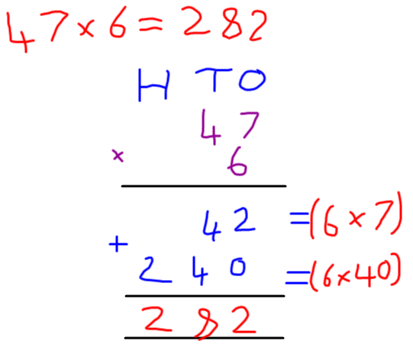  On Google Classroom, I have uploaded a PowerPoint which explains this method, including a video showing the children the strategies. This video will help them to complete their main task.  Below there are two different activities. The first activity includes a selection of questions to practice the expanded multiplication method. There are then also some problem solving questions which you can apply your knowledge to.  Challenge Levels  1 Star – Complete the first worksheet, answering multiplication questions using the expanded method which is shown in the PowerPoint.  2 Star – Complete the first worksheet and question 1 & 2 of the extension worksheet.  3 Star – Complete both the worksheets provided. |  | 1) | Lesson 11 – WALT: Edit a non-chronological report.  In Year 5, one of the main skills which we need to develop within our English work is to proof read and edit our work, making meaningful improvements to our writing. So far, you should have written your opening paragraph and appearance paragraph. If you haven’t yet done this, you should watch the videos for Lesson’s 9 and 10. You will need to look at your writing from last week. In this lesson, you will learn about the purpose of editing, an editing checklist and then edit your work. For your main task, you will need to use the editing checklist which you create, to edit your two main paragraph.  The video for today’s lesson can be found here: https://classroom.thenational.academy/lessons/to-edit-a-non-chronological-report-c9j3ac  To complete this, you may wish to use Google Classroom. On Google Classroom, you could open your work from the previous two lessons, copy and paste your writing into a new Google Doc by highlighting your text. You could then change the colour of your text to add in new information and to show the words which you have edited. A good colour to use could be Purple to show your Purple Pen.  Challenge levels  1 star – Help Mrs Smart to create an editing checklist, then edit your writing.  2 Star – Use your editing checklist to accurately fix all of the mistakes in spelling and punctuation in your writing.  3 Star – Complete the two star challenge, and up level your work using your own ideas, such as by adding relative clauses, parenthesis or another grammar feature which we have learnt in school so far this year.  Alternative Paper Task  If you cannot access Google Classroom, or the online video, later in this document I have included the checklist which Mrs Smart creates in the video. You should use the checklist to edit your writing from Lesson 9 and 10, which is your opening and appearance paragraphs.
2) | Lesson 12 – WALT: Multiply 3 digit numbers by a 1 digit number.  In this lesson, we will progress from using the expanded method to short multiplication. We will be looking at multiply 3 a digit number by a 1 digit number, however this method is quicker, and is the next step towards Year 5 multiplication.  An example of this method is below:  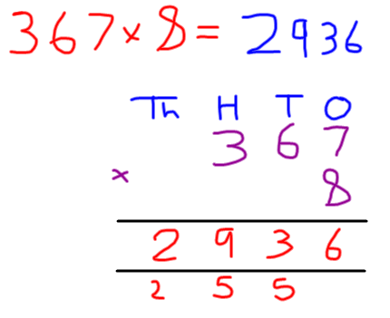  On Google Classroom, you will find a PowerPoint with a video explaining the short multiplication method. A short multiplication video can also be found on our school website. The link for the website can be found here: http://www.st-pauls-hyde.tameside.sch.uk/page/year-5/65277  Challenge Levels  1 Star – Complete the multiplication questions with 3 and 1 digit numbers using the short multiplication method.  2 Star – Complete the 1 star challenge and the problem solving activity.  3 Star – Complete the 1 and 2 star challenge. Then if you have a printer, complete the QR code hunt by hiding the questions around your house, and checking your answers why scanning the QR codes. |  | 2) | Lesson 12 – WALT: Learn about Tiger’s habitat and diet.  To prepare for the next paragraphs of our non-chronological report writing, in this lesson, we will be researching, gathering information about tiger’s habitat and diet. Mrs Smart will share with you a paragraph for both diet and habitat, for your first task, you will need to use the information she has given you to create a bullet point list of factual information which you may use in your writing.  For your main task, and to check that you have gathered enough information for your writing for the future lessons this week, you will need to answer the questions which Mrs Smart provides you with.  To complete this work, you could log on to Google Classroom and use the Google Doc to complete your note taking and write your answers for Mrs Smart’s questions.  The link for today’s video can be found here: https://classroom.thenational.academy/lessons/to-learn-about-tigers-diet-and-habitat-75j6ce  Challenge levels:  - Star - Make notes about a tiger’s diet and habitat using the bullet points above.  - Star – Answer the questions which Mrs Smart provides using the notes you have made about the tiger’s diet and habitat.  - Star - Complete the two star challenge. Then also carry out your own research to gain unique notes and information for your final report.  Alternative Paper Task  Below I have included the two pieces of information which Mrs Smart provided for diet and habitat, as well as the questions which she asks at the end of the lesson. Can you use these to create notes for your own report?
3) | Lesson 13 – WALT: Multiply 4 digit numbers by a 1 digit number.  In this lesson, we will be taking multiplication one step further once again. A year 5 requirement is that you should be able to multiply a thousand number by a 1 digit number. We will again be using the short multiplication method.  An example of this method is here:  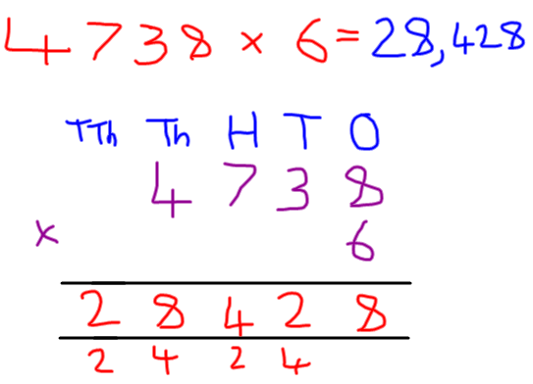  On Google Classroom, you will find a PowerPoint with a video explaining the short multiplication method. A short multiplication video can also be found on our school website. The link for the website can be found here: http://www.st-pauls-hyde.tameside.sch.uk/page/year-5/65277  Challenge Levels  1 Star – Complete the 4 by 1 digit multiplication questions  2 Star – Complete the 1 star challenge and the 1st Problem Solving Challenge  3 Star – Complete the 1 star challenge and the 2nd Problem Solving Challenge. |  | 3) | Lesson 13 – WALT: Write a diet paragraph for our non-chronological report.  In this lesson, we will be bringing together and applying all of the skills, which we have learnt over the last two weeks in preparing for our non-chronological reports about tigers. For this lesson you will need to look back at your notes from lesson 12. It is strongly recommended that you watch the video as this lesson, as Mrs Smart’s tips are useful. A reminder that you can access the video on mobiles, laptops and tablets by typing the link into the internet.  The link for this lessons video is here: https://classroom.thenational.academy/lessons/to-write-the-diet-paragraph-of-a-non-chronological-report-61k3ar  In this lesson we will:  - Recap the features of a non-chronological report  - Recap the tiger’s diet research  - Complete a modelled write with Mrs Smart  - For the main task, write your own diet paragraph for your own non-chronological report.  To complete this work, you could log on to Google Classroom and use the Google Doc to write your own paragraph.  Challenge levels  - Star - Write your own diet paragraph for a non-chronological report about tigers.  - Star - Write your own diet paragraph for a non-chronological report about tigers, using some of the features in Mrs Smart’s success criteria.  - Star - Write your two of your own diet paragraphs for a non-chronological report about tigers, using all of the features in Mrs Smart’s success criteria.  - Star – Write your own paragraph for your own topic, such as for a tiger’s lifestyle.  Completing without the video (Alternative activity)  If you cannot access the video, an alternative activity can be found later in this document. During the video, Mrs Smart works with you to create a “modelled paragraph”, which is a diet paragraph, which she has written during the completed the video. I have included the modelled paragraph later in this document, and the success criteria, which Mrs Smart has created. Your challenge is to use this to write your own diet paragraph for your non-chronological report
4) | Lesson 14 – Multiply 2 digit numbers by 2 digit numbers.  Today will be the next level of the multiplication challenge. This will include a new method which we have not yet learnt before. It would be valuable to watch the PowerPoint for this lesson as this method can be quite challenging.  The first part of this lesson will look at how we can solve 2 by 2 digit multiplication using the area model (grid method), as shown below:  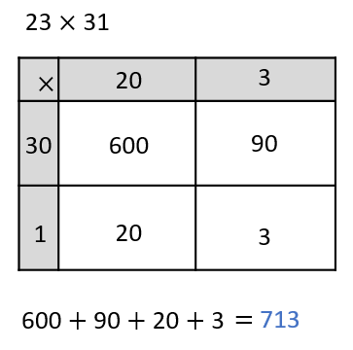  Then followed by the long column multiplication method as shown below:  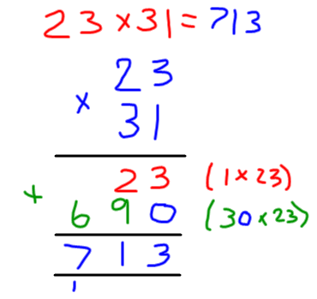  On Google Classroom, you will find a PowerPoint with a video explaining both grid method and long multiplication method.  Challenge Levels  1 Star – Complete the 2 x 2 digit questions 1-15  2 Star – Complete the 2 x 2 digit questions 1-30  3 – Complete the 2 star challenge and the reasoning problem |  | 4) | Lesson 14 – WALT: Write a closing paragraph for a non-chronological report about tigers.  For this final lesson on our tiger non-chronological report we will be writing our final, closing paragraph. For this lesson, you will need your notes from lesson 12 about a tiger’s habitat.  In this lesson we will:  - Recap the features of a non-chronological report  - Recap the tiger’s habitat research  - Complete a modelled write with Mrs Smart  - For the main task, write your own closing paragraph for your own non-chronological report.  The link for today’s video can be found here: https://classroom.thenational.academy/lessons/to-write-the-closing-paragraph-of-a-non-chronological-report-6gukec  To complete this work, you could log on to Google Classroom and use the Google Doc to write your own paragraph.  Challenge Levels  - Star - Write your own closing paragraph for a non-chronological report about tigers.  - Star - Write your own closing paragraph for a non-chronological report about tigers, using all of the features in Mrs Smart’s success criteria.  - Star - Write your two of your own closing paragraphs for a non-chronological report about tigers, using all of the features in Mrs Smart’s success criteria, including some of your own. To finish, you should colour code your writing to match your steps to success to check that you have included everything.  Completing without the video (Alternative activity)  If you cannot access the video, an alternative activity can be found later in this document. During the video, Mrs Smart works with you to create a “modelled paragraph”, which is a closing paragraph, which she has written during the completed the video. I have included the modelled paragraph later in this document, and the success criteria, which Mrs Smart has created. Your challenge is to use this to write your own closing paragraph for your non-chronological report
5) | WALT: Solve 3 by 2 digit multiplication problems  For the final multiplication challenge of this week, we will be looking at 3 x 2 digit multiplication. This is similar to yesterday’s method, but takes the difficult one step further.  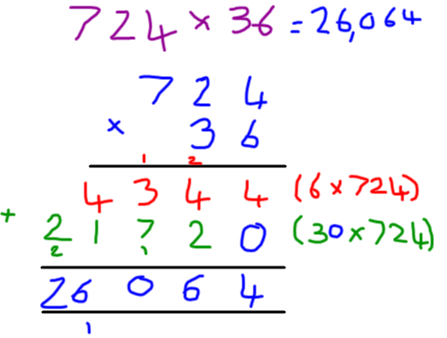  On Google Classroom, you will find a PowerPoint with a video explaining the long multiplication method for 3 by 2 digit numbers.  Challenge Levels  1 Star – Complete the 3 by 2 digit multiplication questions  2 Star – Complete the 1 star challenge and the reasoning problem  3 Star – Complete the 1 & 2 star challenge and the problem solving challenge. |  | 5) | Lesson 15 – WALT: Write our own non-chronological report about our own topic.  Over the last three weeks, you have developed your knowledge of how to write a Year 5 level non-chronological report. For the final lesson of this week, I would like you to think of your own topic which you could write a non-chronological report for. This could be for a different animal, a setting, or an alternative topic of your choice. Remember, a non-chronological report is a report which provides factual information about a subject.  There is no video link for this lesson, as I would like you to show me what you have learnt during our time out of school.  To complete this work, you could log on to Google Classroom and use the Google Doc to write your own non-chronological report.  Challenge Levels  1 Star – Write your own non-chronological report for your own topic.  2 Star – Write your own non-chronological report for your own topic using all of the success criteria which Mrs Smart provided you with during the last three weeks.  3 Star – Write your own non-chronological report using your own success criteria, including relative clauses and parenthesis.

Additional Subjects- To be completed anytime over next week
Science | Topic
Animals Including Humans – Reproductive and Life Cycles Lesson 1  WALT: Why do plants have flowers? Plants lifecycles.  For science, we will be starting with a lesson from one of our new Year 5 units this week. During the unit, we will think about the life cycles of different plants and animals, and how they are similar or different. We will learn about some of the different parts of a plant, and how these are important for their life cycles. We will also think about the role which animals can play in the reproductive process of a plant.  Reproduction is the production of offspring.  The main tasks for this lesson, will be to answer some questions about the life cycle of a plant. With your main, final task, to be to draw a diagram to represent the life cycle of a plant.  This lesson will be completed using Oak National Academy, just like our English lessons so far. The link for today’s lesson can be found here: https://classroom.thenational.academy/lessons/why-do-plants-have-flowers-70v3gc Today’s lesson includes a video, a worksheet and a final quiz. I would like you to complete your activity using the Google Doc on Google classrooms. You may find it easier to draw your own life cycle on paper, then take a photograph of your work, and upload it to Google classroom. A video explaining how to do this can be found on the home learning section of our school website.  Challenge Levels  1 Star – Learn about the life cycle of a plant and answer the questions provided in the video.  2 Star – Learn about the life cycle of a plant, answer the questions in the video and draw your own life cycle diagram for a plant.  3Star – Complete the 2 star challenge and the final quiz on Oak National Academy.  Alternative Paper Task  Complete the life cycle diagram which has been attached later in this document, using the explain cycle. | Climates and Biomes  WALT: Describe the climates and biomes of different areas across The Americas  In this lesson, we will be thinking about the difference between the weather in different areas, and climates. Climates show you what the weather is typically like. The world can be separated into different climate regions. We can also think about how parts of our world are different by describing biomes. Biomes are areas of our planet with similar Climates, landscapes, animals and plants. What lives in each biome depends on how warm or cold it is, how dry or wet it is, and how fertile the soil is.  On Google Classrooms, you will find a helpful map and information sheet which show you the different biomes and climates around the world. You will also find a PowerPoint presentation where I have recorded a video explaining these ideas to you.  If you would to learn more about biomes, this BBC Bitesize clip is very useful: https://www.bbc.co.uk/bitesize/topics/z849q6f/articles/zvsp92p  This oak national academy lesson can also be very helpful: https://classroom.thenational.academy/lessons/what-are-the-earths-biomes-6wrk2r?activity=video&step=1  For this task, I would like you to look at the information sheet which is on Google Classroom, then complete the climate research activity for The Americas.  Challenge Levels  1 star – Look at the climate and biomes map to investigate biomes, then complete the “What would I take in my suitcase” activity.  2 star – Complete the research activity for the climate of different locations in The Americas.  - star – Complete the research activity for the climate of different locations and also research some of your own locations in the Americas.  Alternative paper task:  An alternative paper task for this lesson can be found below.
Art | Computing
Frida Kahlo  Over the next few weeks, our art activities will relate to North and South American art to link with our topic activities.  This week, we will be looking at a famous artist called Frida Kahlo. I would like you to read through the information and pictures which can be found on Google Classroom within the PowerPoint, and find some information about her.  You can choose which task you would like to complete. The PowerPoint explains how to make clay monkeys. You may wish to do this, however I understand it may be difficult to find these materials at home. As an alternative task, could you either create your own drawing or piece of artwork inspired by the photos of Friday Kahlo’s work which I have provided, or could you create your own mood board (like we have in our art books for the Anglo-Saxons) to represent some of Frida’s work?  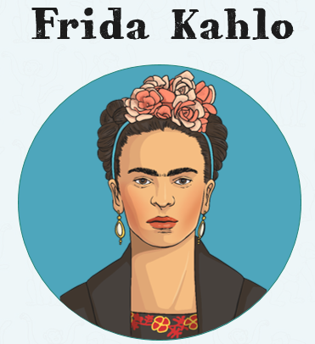 | Game Design  When we were in school, we used Purple Mash to create our own games with a story. I would like you to log onto Purple Mash and open the 2Do named My Digital Game. Can you create your own game which has a purpose?  As an extension challenge, can you and create an information levels to advertise your game, by completing the 2Do: DIY Game Magazine  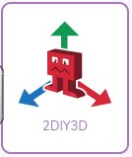
RE
Inspirational People – Father Damien
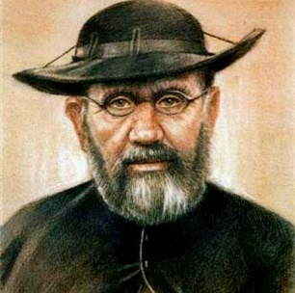
During our inspirational people topic, we will be learning about different inspirational people (such as Father Damien pictured above) and how we can learn from their actions.
On Google Classrooms, you will find the story of Father Damien’s life, I would like you to think about why people may think of him as an Inspirational Person. I would like you to respond to the story of Father Damien by completing one of the following three challenges:
Challenge Levels
1 Star – Answer the questions: Why was Father Damien an inspirational person? By writing a couple of short paragraphs with examples of his actions.
2 Star – Explain how Father Damien showed that he was a good Disciple of Jesus, by being an inspirational person. Then explain how you show that you can be a good follower of Jesus.
3 Star – Explain how religious beliefs and teaching influenced the moral values and behaviour of Father Damien. You could do this by linking Father Damien’s actions with some of the actions of Jesus.
 | Health and Wellbeing
P.E. – Keeping Active At Home

On our school website, there are a variety of daily, home exercise videos which Mr Allen has created. I wonder whether you could select one (or more) of Mr Allen’s daily challenges to try and complete?
The videos can be found at this link: http://www.st-pauls-hyde.tameside.sch.uk/page/home-exercise/65338

PSHE
Can You think about your feelings and your emotions and draw a picture which shows your inner and outer self? One side of the picture should show what you look like on the outside (like a self-portrait) The other side of your face should show what you are like on the inside. For example, what are your hobbies? How are you feeling? What are you looking forward to? An example of one of these pictures is shown later in this document.

Monday – Maths Lesson 6 Resources
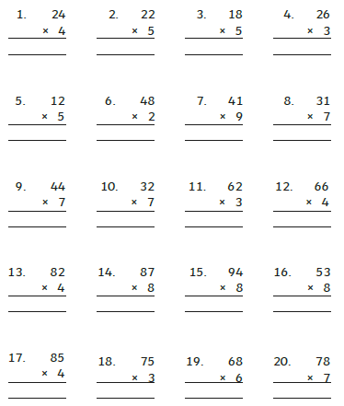

Monday Problem Solving Extension:
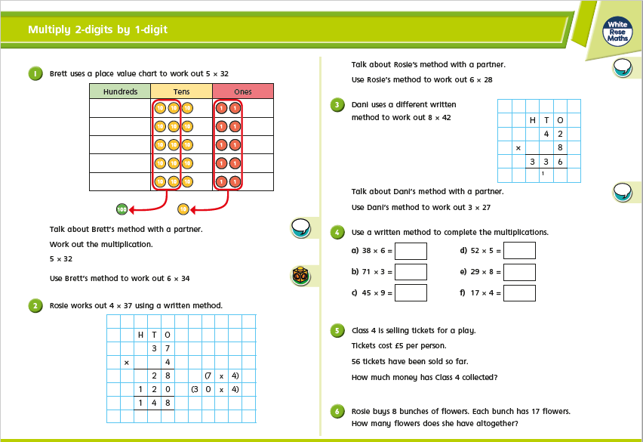

Tuesday – Maths Lesson 7 - Resources
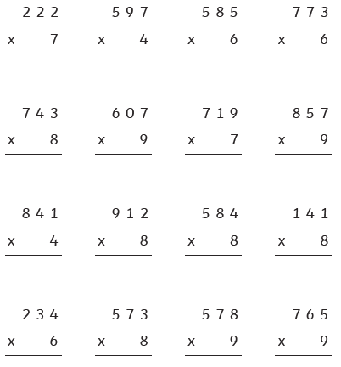
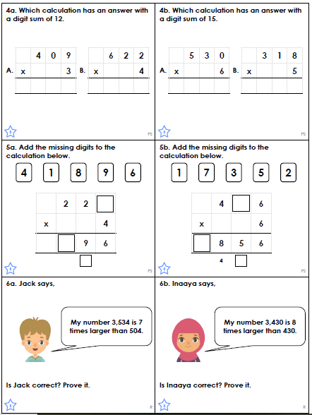

Wednesday – Maths Lesson 8 Resources
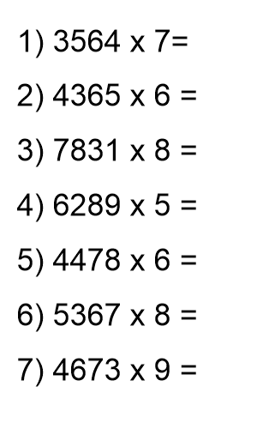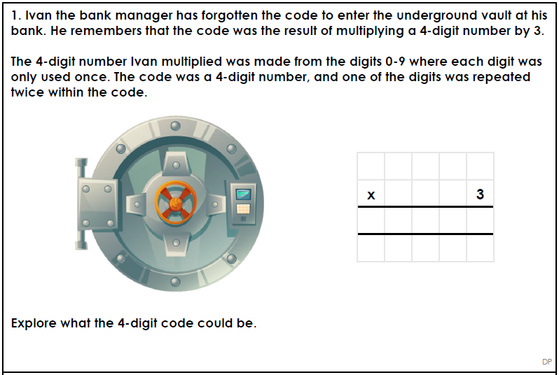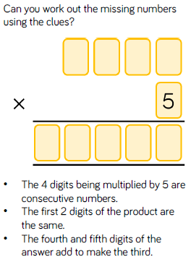
Thursday – Maths Lesson 9 Resources
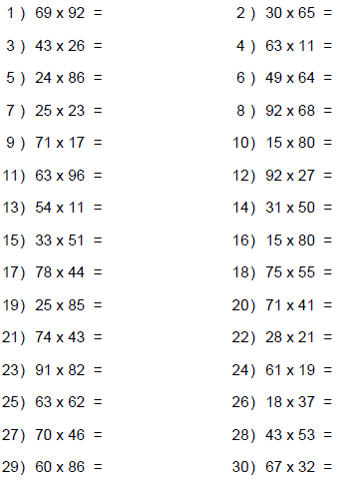
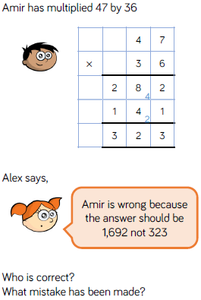

Friday – Maths Lesson 5 Resources
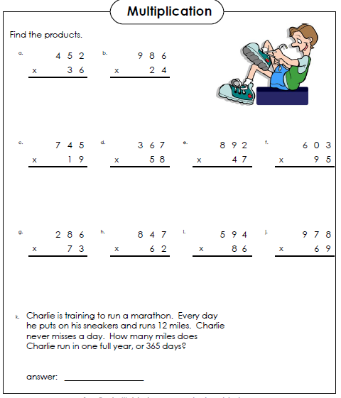
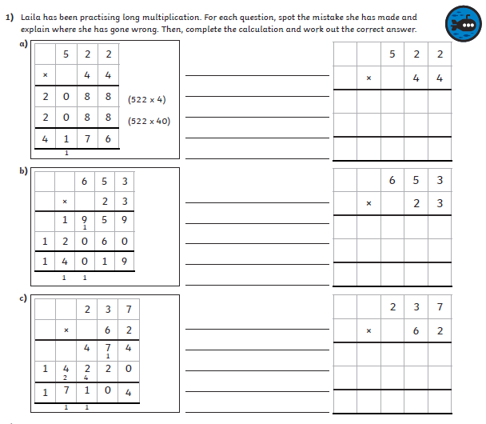
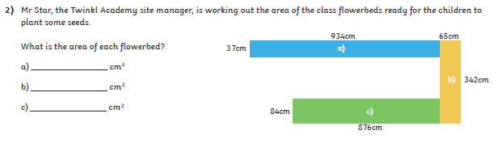

Monday – Alternative English Lesson 11 Resources
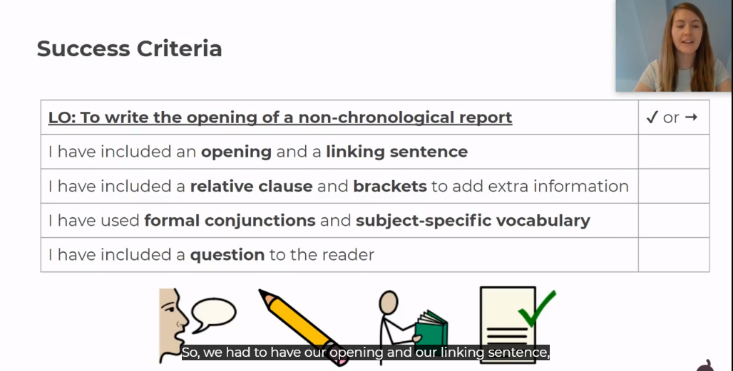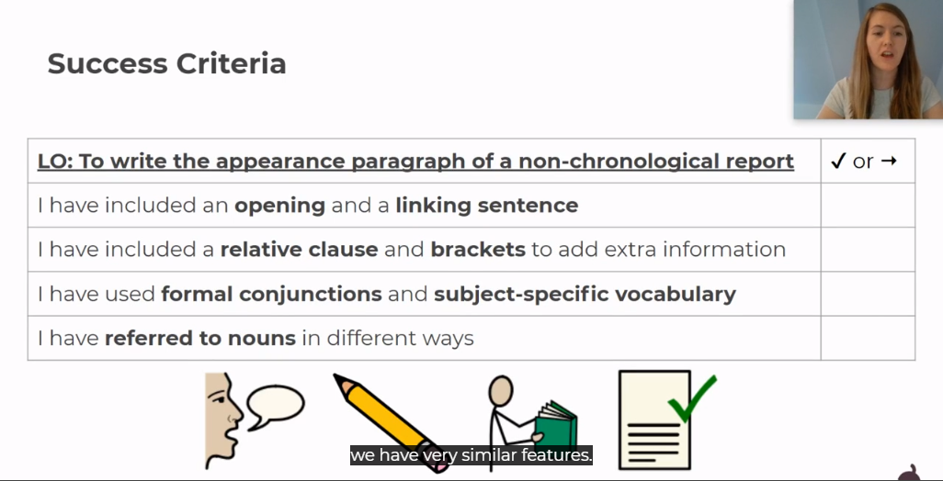
Tuesday – Alternative English lesson 2 Resources
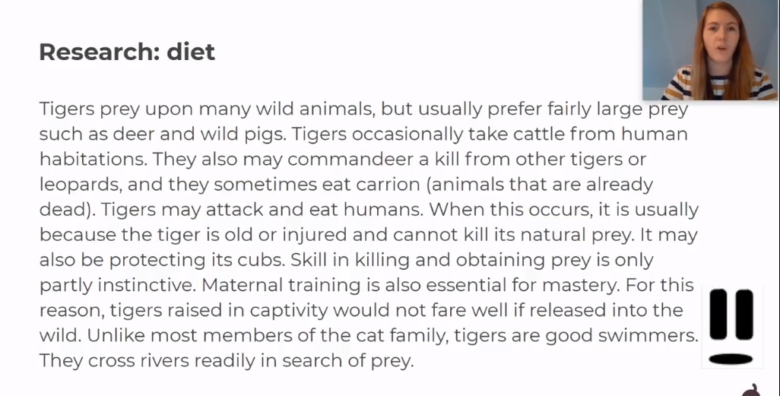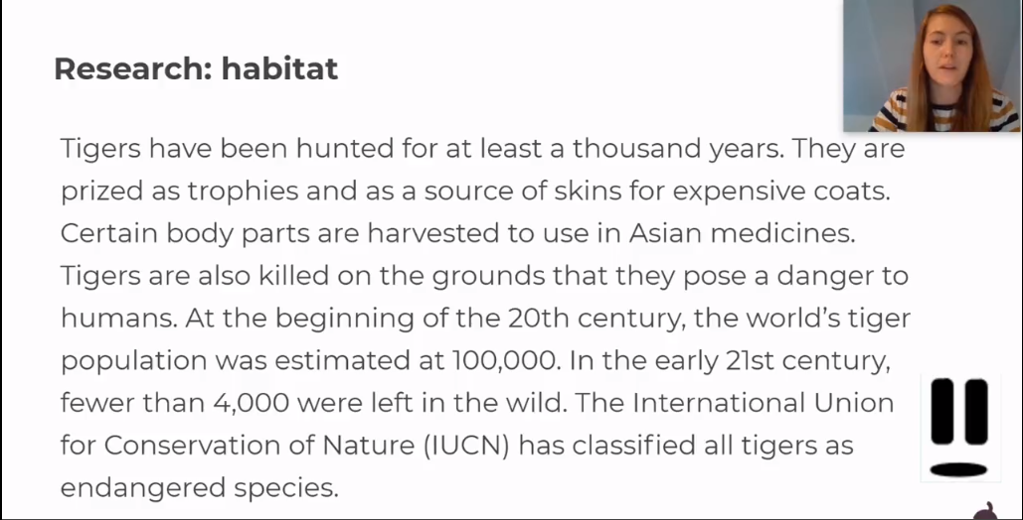
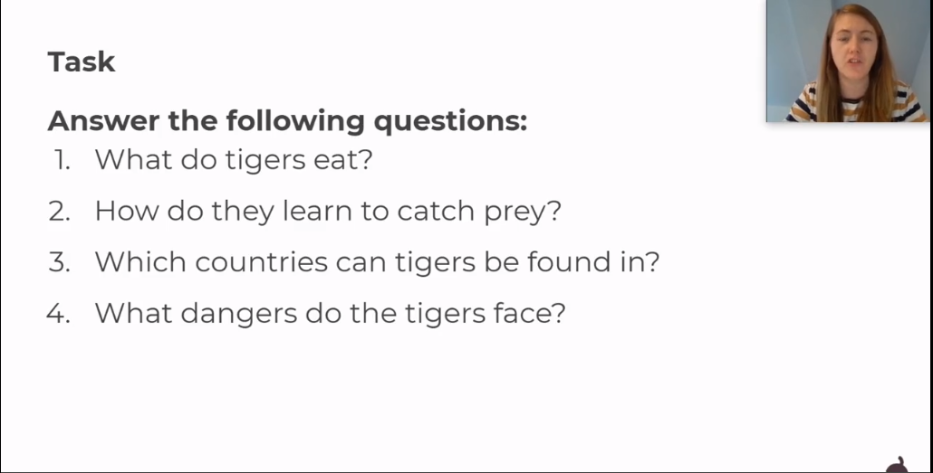
Wednesday – Alternative English Lesson 3 Resources
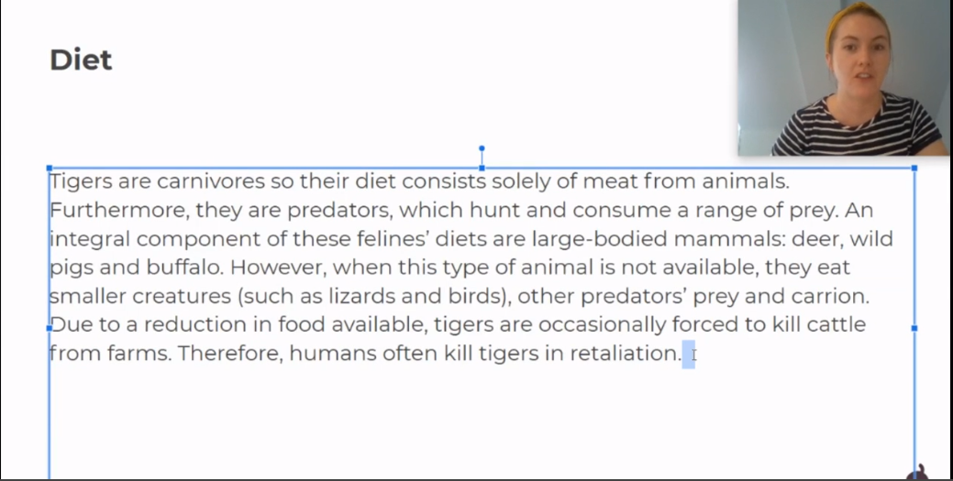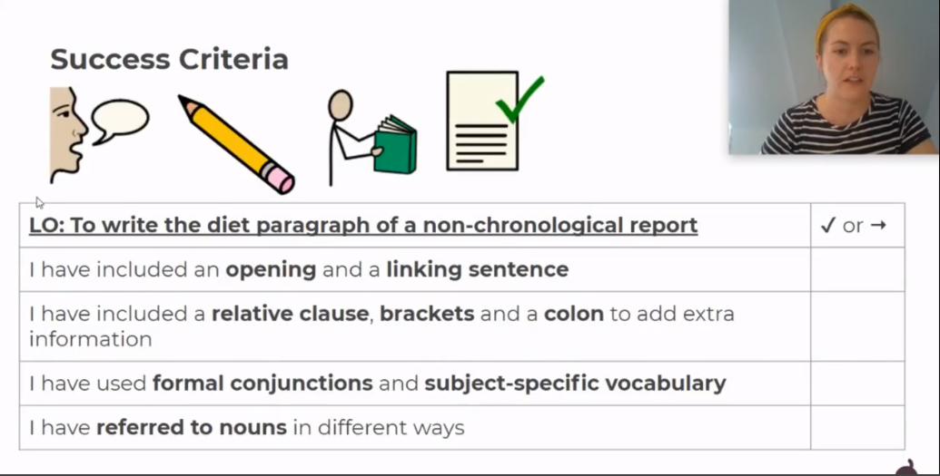

Thursday – Alternative English Lesson 4 Activities
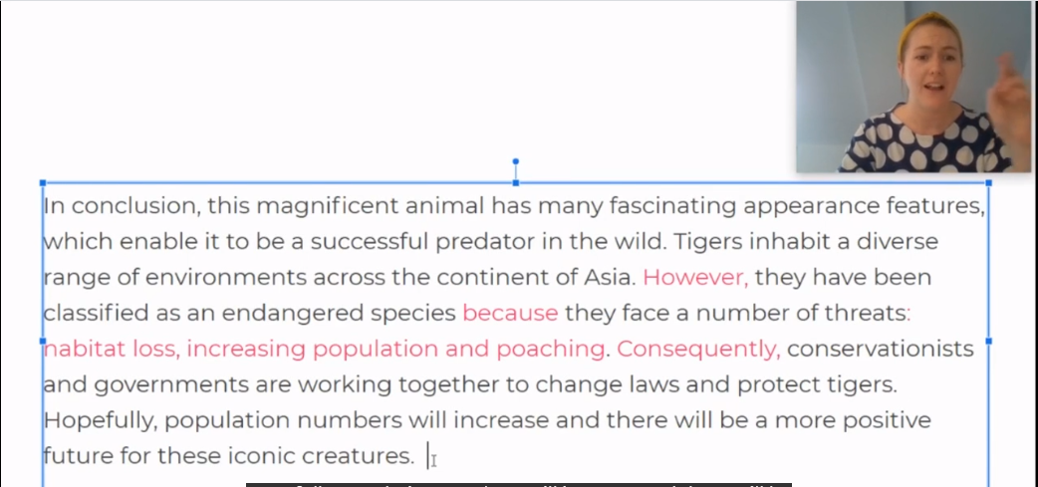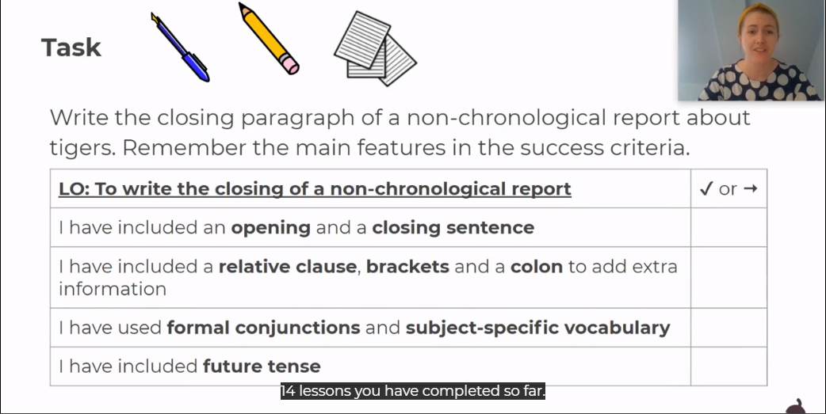

Monday – R.E. Resources
1 Star Challenge Question
2 Star Question
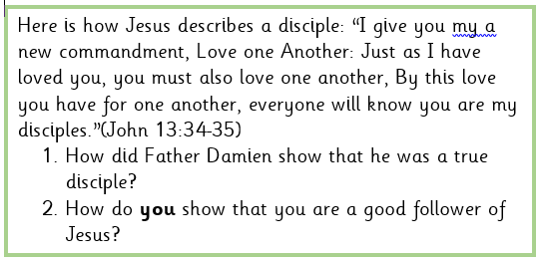
3 Star Question
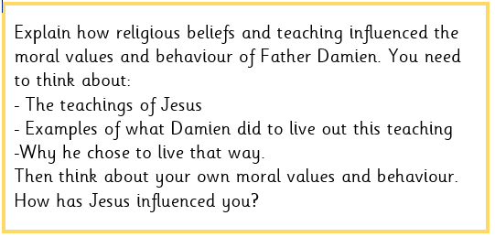

Tuesday – Art Resources
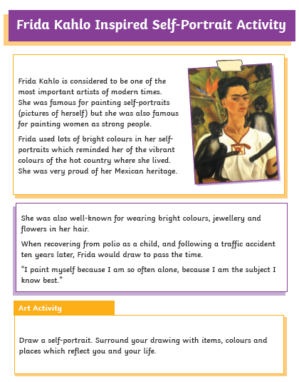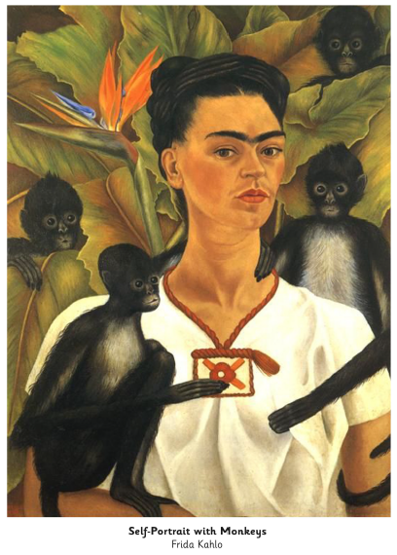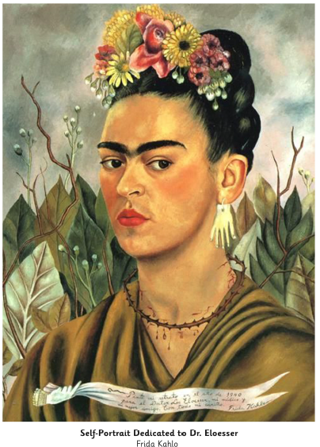

Wednesday – Geography Resources
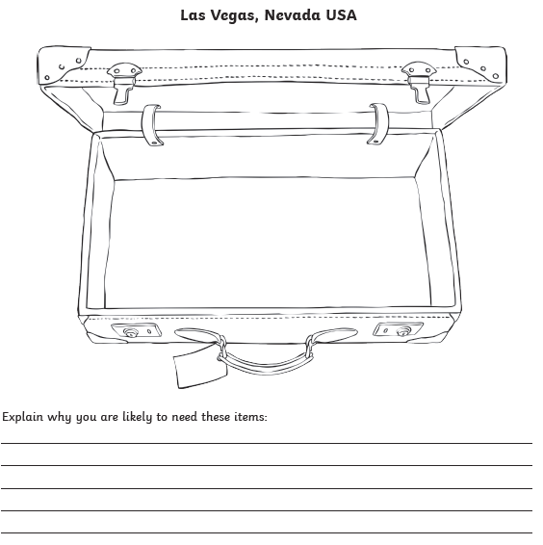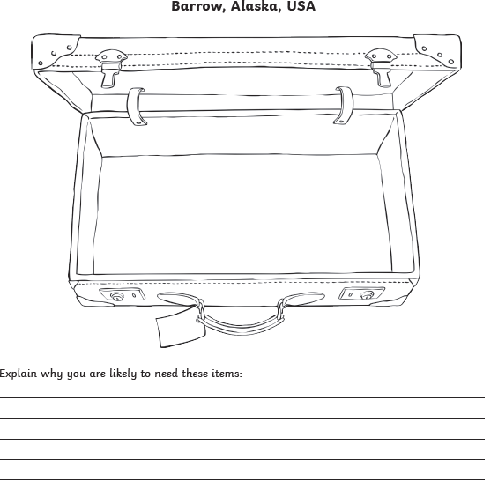
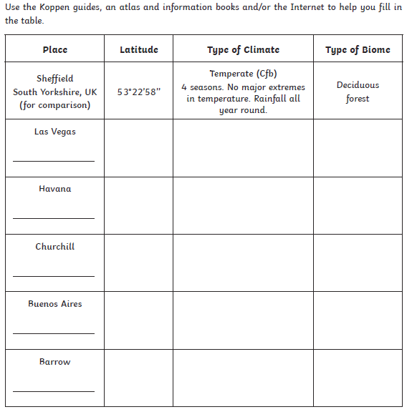

Thursday – Science Resources
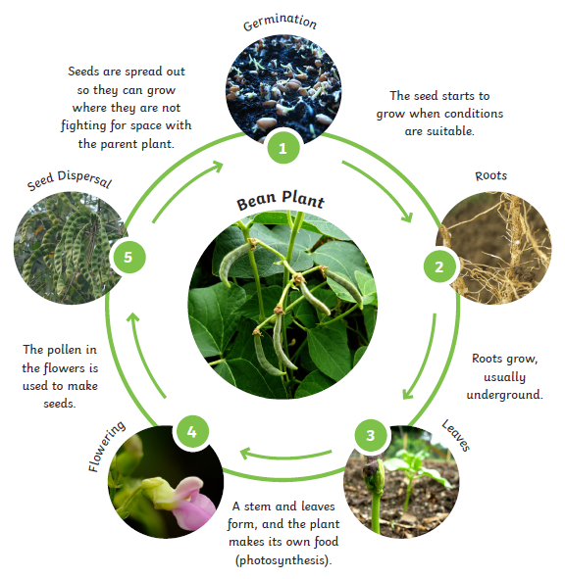

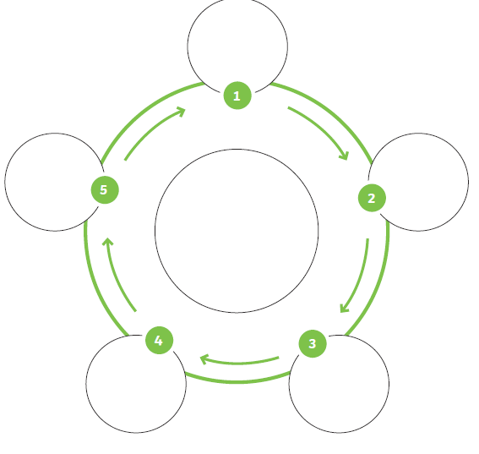
PSHE Resources
