Spelling Rule: When adding ‘ing’ to a word, if it ends in e, remove the e before adding ‘ing’.
Spelling Practise: Look, say, cover, write, check

 |  | Practise 1 |  | Practise 2 |  | Practise 3 |  | Practise 4 |  | Practise 5
Look | Say | Write |  | Write |  | Write |  | Write |  | Write
example |  | exampel |  | exampal |  | example |  | example |  | example
making
baking
loving
hoping
taking
liking
caring
sharing
scoring
escaping
Now choose four of the words to write in sentences.
1.
2.
3.
4.

Further Strategies to Practise Spellings
Here are some alternative ways to practise your spellings, if you would like to try something new other than look, say, cover, write, check.
Pyramid Words
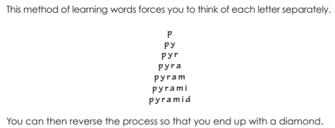
Write your spellings out starting with just the first letter, then the first 2 letters etc.

Rainbow Writing
Using coloured pencils in different ways can help to make parts of words memorable. You could highlight the tricky parts of the word or write the tricky part in a different colour. You could also write each letter in a different colour, or write the word in red, then overlay in orange, yellow and so on.

