Year 5 Home Learning |  | This document outlines the activities/lessons your child to complete at home during the bubble closure. Each activity is explained in detail here, including where to find the activities. There is a Maths and English lesson to complete each day, then a range of activities provided for additional subjects which can be completed at any time. WALT stands for We Are Learning To, which will give you a clear indication of the lesson objective. There will be different levels of challenge for the children to complete for most lessons (*** being the hardest level). The children do not need to complete all three levels. The children can work directly into their home learning book they have been given. Please feel free to email any work or pictures of the work and do not hesitate to email me on year5@st-pauls-hyde.tameside.sch.uk if you require any assistance. Thank you, Mr Titterington.  All of this week’s tasks have now also been uploaded onto Google Classroom, along with video links. You can complete your work using Google Classroom, and send your work back to me so that I can provide you with some feedback.
Week 2
Maths |  |  | English
Look in the table below to find the information about the lesson, which you need to complete. Once you have read the table, scroll down to the bottom of the document to find the tasks and questions, which you need to complete for each lesson. This week we will be focussing on Place Value, addition, subtraction and graphs. |  |  | Our topic and focus for our time outside of school will be writing non-chronological reports. Our topic will be called “Wild Cats – Non Chronological Reports”.  Each lesson, I have provide a link for an individual lesson, which will teach you the different learning focuses for each lesson. The videos will provide you with activities to complete. There will also be alternative paper activities similar to the videos, in case you are not able to follow along.  All of the weeks videos and activities can be located here: https://classroom.thenational.academy/units/wild-cats-non-chronological-reports-702c
1) | Lesson 6 – Negative Numbers  In this lesson, I would like you to think about negative numbers. You should remember that negative numbers are those numbers which are before, or less than, 0. In year 5, we should be able to identify where both negative and positive can be found on a number line, and also find the difference between two different numbers.  As a starter activity, you may want to ask someone you live with to use a blank positive and negative number line to ask you to find or draw an arrow to certain numbers. Someone you live with could also give you two different numbers which you need to find the difference between, by counting the amount between the two given numbers. For example: What is the difference between -5 and 7?  A link for a White Rose Hub video which may also help to explain Negative Numbers can be found below. Scroll down the page until you find the video for negative numbers.  https://whiterosemaths.com/homelearning/year-5/10672-2/  For your main task, see if you can complete the variety of negative number questions I have provided, including the reasoning and problem solving questions. Can you complete the Twinkl activity sheets, which are found later in this document?  - Complete page one of the negative number questions with this symbol:  - Complete page two of the negative number questions with this symbol:  Complete page three of the negative number questions with this symbol: |  | 1) | Lesson 6 – To learn about tigers and their appearance  During this lesson, and from watching today’s video, you will learn about how to gather some helpful information to help you to write your non-chronological reports at the end of this week. During the video, you will research about:  - Different tiger species  - Tiger’s fur and colouring  - Paws and claws  Once you have gathered your evidence, you should complete the main task, which is to draw your own tiger, and annotate your picture using the notes you have gathered about the tiger’s appearance. The link for today’s video is here: https://classroom.thenational.academy/lessons/to-learn-about-tigers-and-their-appearance-c5j3cc  Challenge levels  - Make notes about a tiger’s appearance using the bullet points above.  - Draw and annotate an image of a tiger using the notes you have made about the tiger’s appearance.  - Complete the two star challenge. Then also carry out your own research to gain unique notes and information for your final report.  Completing without the video (Alternative Activity)  Below you should find some images of the text which Mrs Smart is using for her research to find notes about tigers. Underline or write down some interesting facts or information which you can find inside the paragraphs. You might also want to find some of your own facts about tigers online using the search engine www.kiddle.co
2) | Lesson 7 – Column Addition  During Year 4 and continuing in Year 5, we learnt how to solve addition problems using a column addition method. In Year 5, we need to know how to add two numbers together which have more than 4 digits. If you are still unsure how to use the column addition method, I have created a video guide on the Year 5 home learning page of our school website. Although this was originally created in the beginning of March, the method is still relevant. The link and thumbnail for the video are here: http://www.st-pauls-hyde.tameside.sch.uk/page/year-5/65277  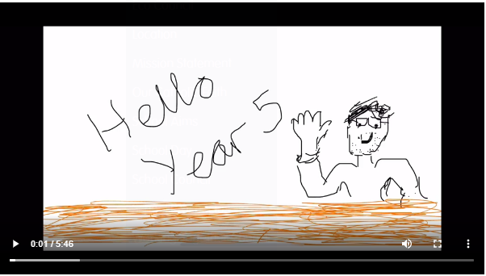  For today’s activity, I have provided a question sheet, containing a variety of 5 digit questions. If you complete this task, then there are some problem solving questions which you may wish to attempt.  - Complete the column addition question sheet.  Complete the column addition problem solving questions. |  | 2) | Lesson 7 – To practice and apply knowledge of the letter string –fer, including a test  During today’s lesson, we will be revisiting the spelling rule for –fer.  In today’s video you will think about:  - Key vocabulary (using –fer)  - Review spelling words using –fer  - Learn a new spelling strategy  - Spelling test for –fer  The link for today’s video can be found here: https://classroom.thenational.academy/lessons/to-practise-and-apply-knowledge-of-the-letter-string-fer-including-test-70rp8c  Challenge levels:  - Learn the spelling rules for –fer  - Complete the spelling test for –fer  - Construct your own sentences using words which use –fer  Completing without the video (alternative activity)  If you cannot access the online video, an alternative activity can be found later in this document. I have included a handwriting practice sheet which contains the words which use the spelling rule –fer. Practice these handwriting patterns and ensure that you have spelt the words correctly.
3) | Lesson 8 – Column Subtraction  During Year 4 and continuing in Year 5, we learnt how to solve subtraction problems using a column subtraction method. In Year 5, we need to know how to subtract two numbers which have more than 4 digits. We also need to know how to exchange/borrow from the next column when required. If you are still unsure how to use the column subtraction method, I have created a video guide on the Year 5 home learning page of our school website. Although this was originally created in the beginning of March, the method is still relevant. The link and thumbnail for the video are here: http://www.st-pauls-hyde.tameside.sch.uk/page/year-5/65277  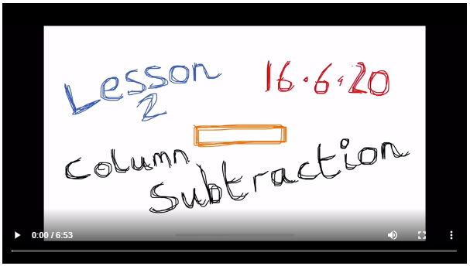  For today’s activity, I have provided a question sheet, containing a variety of 5 digit questions. If you complete this task, then there are some problem solving questions which you may wish to attempt.  - Complete the column subtraction question sheet.  - Complete the column subtraction problem solving questions. |  | 3) | Lesson 8 – To practice using formal conjunctions  Formal conjunctions are used in non-chronological reports to link ideas and paragraphs together professionally and effectively. In this lesson’s video, you will learn about:  - An introduction to formal conjunctions  - Identify types of formal conjunctions  - Practice using formal conjunctions  - Complete and independent task  Whilst watching the video, you will need to think about the different words which are identified as formal conjunctions, and try to put the correct one within a sentence to complete it. For your final main task, you will need to write your own sentences which uses the formal conjunctions which you have been given in the video. The link for today’s video can be found at: https://classroom.thenational.academy/lessons/to-practise-using-formal-conjunctions-chj3cr  Challenge levels:  - Recognise formal conjunctions and place the correct conjunction within a given sentence.  - Complete the first star challenge, then complete the main task at the end of the video to write your own sentences.  - Complete the 1 and 2 star challenges. Then write your own practice paragraph about tigers which uses formal conjunctions.  Completing without the video (Alternative Activity)  Below I have included an example paragraph, which Mrs Smart has shared within the video. In each paragraph, she has shown you how to correctly use some of the formal conjunction. Use these paragraphs to help you complete the main task, which is to write your own sentences which have formal conjunctions.
4) | Lesson 9 – Read and Interpret Graphs  In this lesson, I would like you to recap your understanding of interpreting graphs. In the activity, there are a variety of different types of graphs, including pictograms and bar charts. Read the keys and attempt to answer the relevant questions for each type of graph.  - Complete questions 1-3 in the activity sheet.  - Complete questions 1-4 in the activity sheet.  - Complete questions 1-5 in the activity sheet. Which includes the problem solving question.  A link for a White Rose Hub video which may also help to explain Reading and Interpret Charts AND Comparison, Sum and Difference questions can be found below. Scroll down the page until you find the video for Reading and interpret charts OR Comparison, Sum and Difference Questions. https://whiterosemaths.com/homelearning/year-5/week-6-statistics/ |  | 4) | Lesson 9 – Writing an opening paragraph for a non-chronological report about tigers  In this lesson, we will be bringing together and applying all of the skills, which we have learnt over the last two weeks in preparing for our non-chronological reports about tigers. For this lesson you will need to look back at your notes from the previous 8 lessons. It is strongly recommended that you watch the video as this lesson, as Mrs Smart’s tips are useful. A reminder that you can access the video on mobiles, laptops and tablets by typing the link into the internet.  The link for this lessons video is here: https://classroom.thenational.academy/lessons/to-write-the-opening-paragraph-of-a-non-chronological-report-6grp2e  In this lesson we will:  - Recap the features of a non-chronological report introduction  - Recap the features of an opening paragraph  - Complete a modelled write with Mrs Smart  - For the main task, write your own opening, introduction paragraph for your own non-chronological report.  Challenge levels  - Write your own introduction paragraph for a non-chronological report about tigers.  - Write your own introduction paragraph for a non-chronological report about tigers, using some of the features in Mrs Smart’s success criteria.  - Write your own introduction paragraph for a non-chronological report about tigers, using all of the features in Mrs Smart’s success criteria.  Completing without the video (Alternative activity)  If you cannot access the video, an alternative activity can be found later in this document. During the video, Mrs Smart works with you to create a “modelled paragraph”, which is an opening paragraph, which she has written during the completed the video. I have included the modelled paragraph later in this document, and the success criteria, which Mrs Smart has created. Your challenge is to use this to write your own opening paragraph for your non-chronological report.
5) | Lesson 10 – Line Graphs  In this lesson, I would like you to recap your understanding of interpreting line graphs. In the activity, there are a variety of different types of graphs, including pictograms and bar charts. Read the keys and attempt to answer the relevant questions for each type of graph.  - Complete questions 1-3 in the activity sheet.  - Complete questions 1-4 in the activity sheet.  - Complete questions 1-5 in the activity sheet. Which includes the problem solving question.  A link for a White Rose Hub video which may also help to explain Reading and interpreting line graphs can be found below. Scroll down the page until you find the video for Reading and Interpreting Line Graphs. https://whiterosemaths.com/homelearning/year-5/week-6-statistics/ |  | 5) | Lesson 10 – Writing an appearance paragraph for a non-chronological report about tigers  In this lesson, we will be bringing together and applying all of the skills, which we have learnt over the last two weeks in preparing for our non-chronological reports about tigers. For this lesson you will need to look back at your notes from the previous 8 lessons. It is strongly recommended that you watch the video as this lesson, as Mrs Smart’s tips are useful. A reminder that you can access the video on mobiles, laptops and tablets by typing the link into the internet.  The link for this lessons video is here: https://classroom.thenational.academy/lessons/to-write-the-appearance-paragraph-of-a-non-chronological-report-c5j3jd  In this lesson we will:  - Recap the features of a non-chronological report  - Recap the tiger’s appearance research  - Complete a modelled write with Mrs Smart  - For the main task, write your own appearance paragraph for your own non-chronological report.  Challenge levels  - Write your own appearance paragraph for a non-chronological report about tigers.  - Write your own appearance paragraph for a non-chronological report about tigers, using some of the features in Mrs Smart’s success criteria.  - Write your two of your own appearance paragraphs for a non-chronological report about tigers, using all of the features in Mrs Smart’s success criteria.  Completing without the video (Alternative activity)  If you cannot access the video, an alternative activity can be found later in this document. During the video, Mrs Smart works with you to create a “modelled paragraph”, which is an appearance paragraph, which she has written during the completed the video. I have included the modelled paragraph later in this document, and the success criteria, which Mrs Smart has created. Your challenge is to use this to write your own appearance paragraph for your non-chronological report

Additional Subjects- To be completed anytime over the 2 weeks.
Science | Topic
Science – Lesson 2 - Forces  In this lesson, I would like you to test and explore the two forces of gravity and air resistance. If you are unsure of what gravity is, then you could use this BBC bitesize clip here to learn about it: https://www.bbc.co.uk/bitesize/topics/z4brd2p/articles/zr3xh39  If you are unsure of what air resistance is, then you can use this BBC bitesize clip to learn about it: https://www.bbc.co.uk/bitesize/topics/zsxxsbk/articles/zxw6gdm  Later in this document, I have included the instructions for how to make a paper helicopter. You should attempt to make a helicopter using the instructions provided, and then write an explanation for how the two different forces are acting upon it. | Topic – Geography – The Americas – Lesson 2  Last lesson, you thought about the different countries and capital cities which are located in the Americas. In this lesson, I would like you to think about two or three specific locations, or cities in the Americas, and research about them.  You will need to think about:  - The Place name  - The state or country  - The coordinates of its latitude and longitude  - The hemisphere that it can be found in.  - The size of the city  - The natural (physical) features – such as mountain, rivers, coasts or forests  - The time zone it can be found in  - The typical weather (rainfall, summer and winter temperature)  If you are unsure of what the key terms hemisphere, latitude and longitude mean, then this bbc bitesize video may be useful: https://www.bbc.co.uk/bitesize/topics/zvsfr82/articles/zd4rmfr  Challenge levels:  - Complete the 1 star activity sheet, to research about Anchorage, Alaska and Rio De Janeiro in Brazil.  Complete the 3 star activity sheet, to research about 3 own locations of your own choice from either North or South America.
Art | Computing
Art – Anglo-Saxon & Viking Shields  This term we have been learning about the Anglo-Saxons. We know that they were strong warriors. They needed a variety of special equipment to achieve this.  Anglo-Saxons are famous for their shield designs, such as the ones below. Can you design your own with a pattern which has important meaning or represents yourself. You do not need to create the shield, but if you wanted to, then you could.  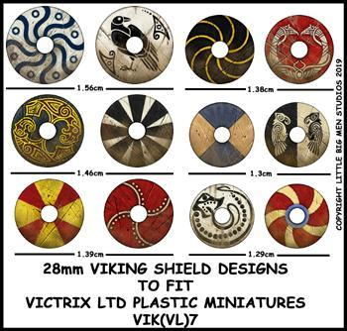 | Computing – Using If Commands  For this week’s computing activity, I would like you practice your use of If Commands when coding. When you log on to Purple Mash, search in the search bar for “Guard the Castle (Gibbon)”. Use the video guides and hints to try to complete the challenges using If Commands. The star level challenge will depend on how far you get through the challenge.  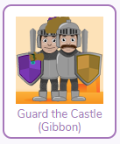
RE
R.E. Lesson 2 – Creation Art
Last week we thought about the creation story and the different ways that we can care for the Earth. Here is a piece of artwork which has been created to represent the Creation story.

Talk to someone at home about the different features of the artwork which have a particular meaning or represent the Creation Story.
For your task, can you create your own piece of artwork which represents the Creation story? You can be as creative as you like with this activity, you could simply create a drawing, or use different materials to create a 3D piece of work.
- Create a piece of artwork to represent the Creation story.
Create and label a piece of artwork to explain how it represents the Creation story.
 | Health and Wellbeing
P.E. – Keeping Active At Home

On our school website, there are a variety of daily, home exercise videos which Mr Allen has created. I wonder whether you could select one (or more) of Mr Allen’s daily challenges to try and complete?
The videos can be found at this link: http://www.st-pauls-hyde.tameside.sch.uk/page/home-exercise/65338

Monday – Maths Lesson 6 Resources
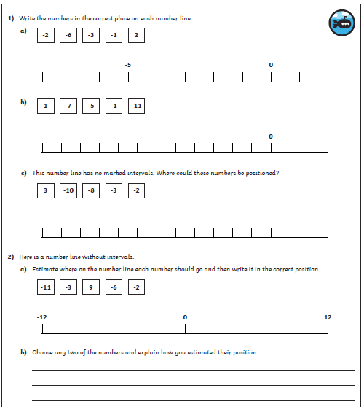
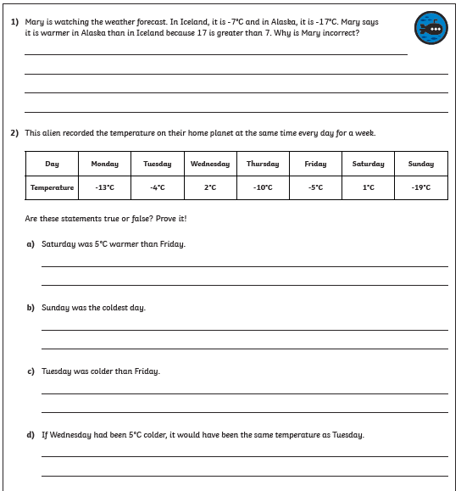
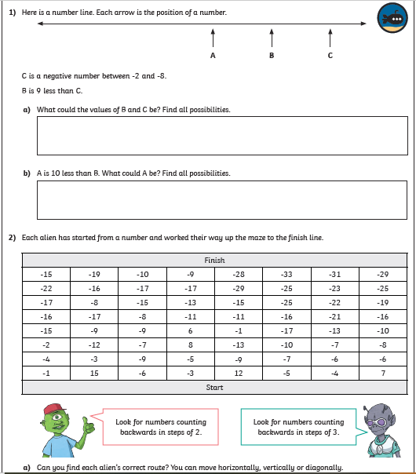

Tuesday – Maths Lesson 7 - Resources
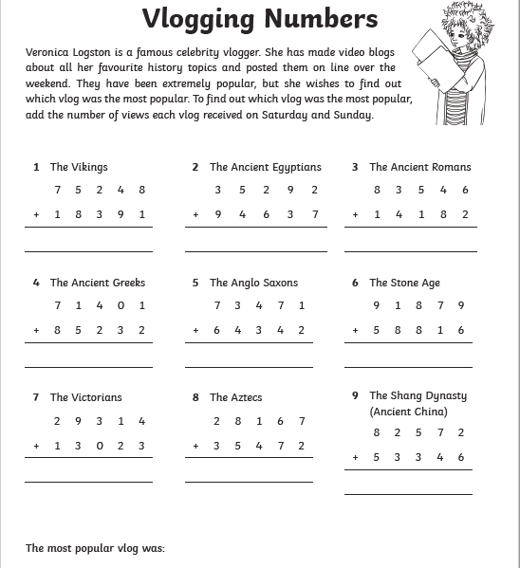
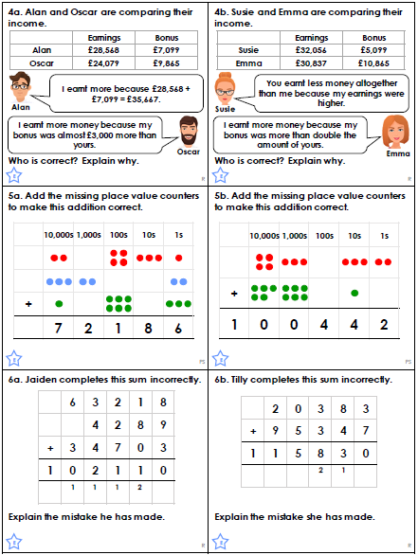

Wednesday – Maths Lesson 8 Resources
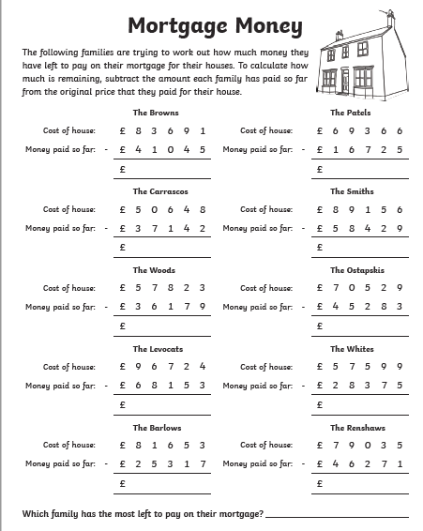
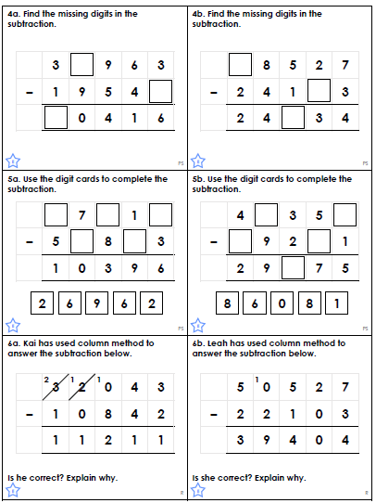

Thursday – Maths Lesson 9 Resources
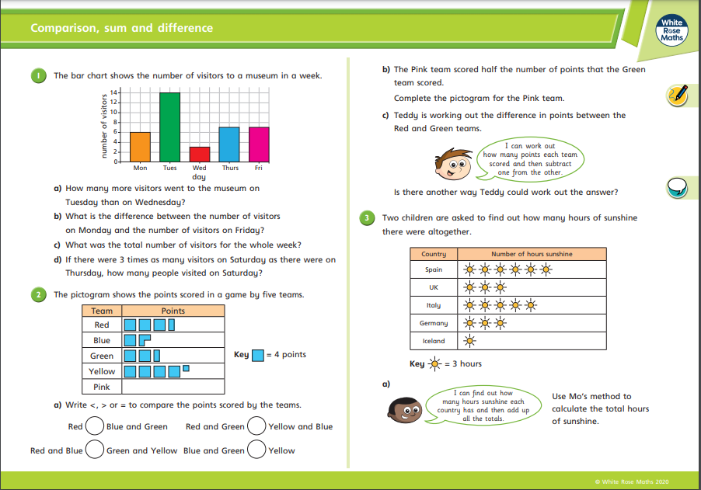

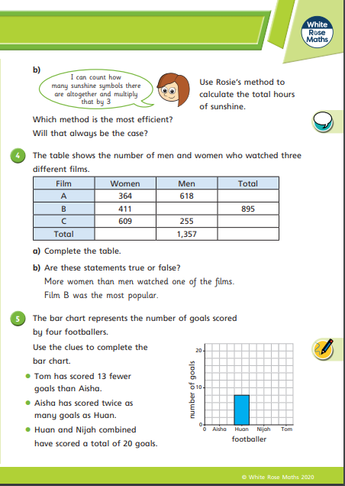

Friday – Maths Lesson 5 Resources
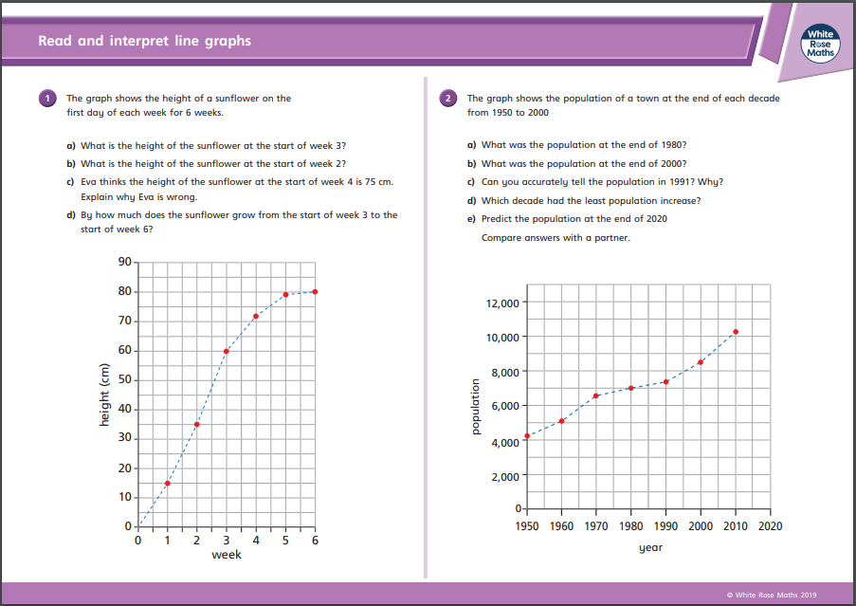

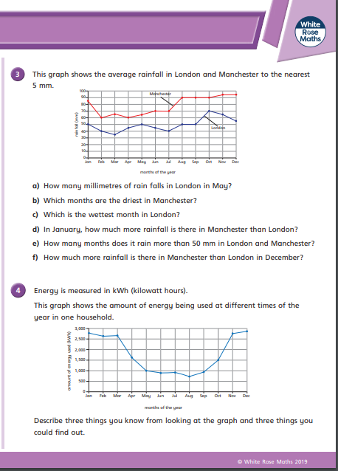

Monday – Alternative English Lesson 6 Resources
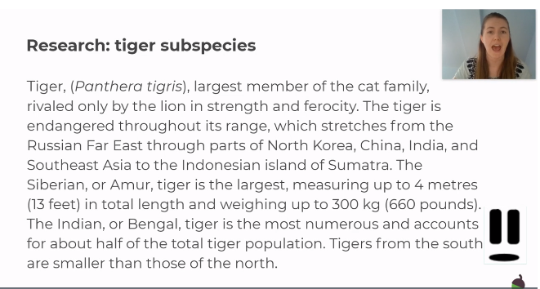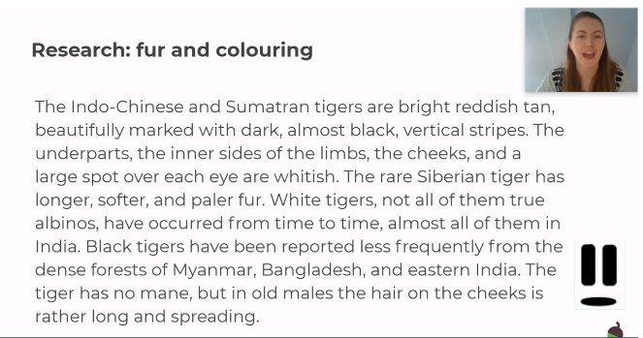
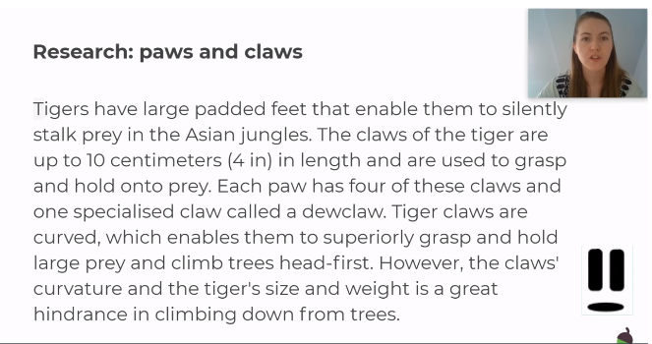

Tuesday – Alternative English lesson 2 Resources
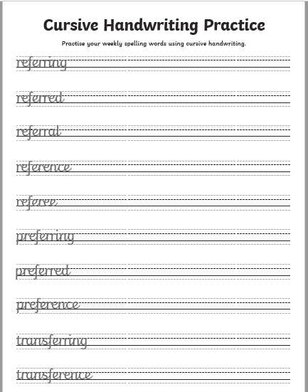

Wednesday – Alternative English Lesson 3 Resources
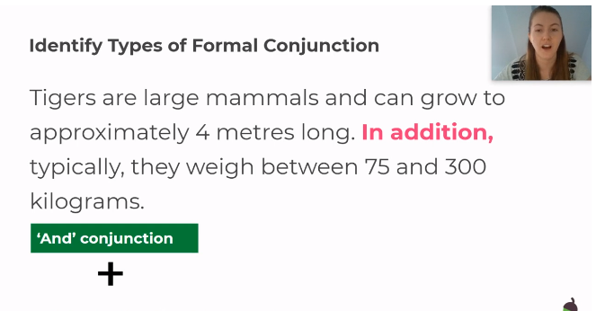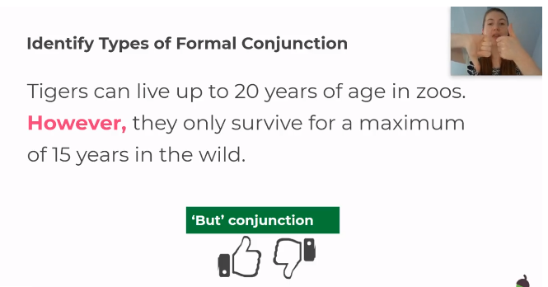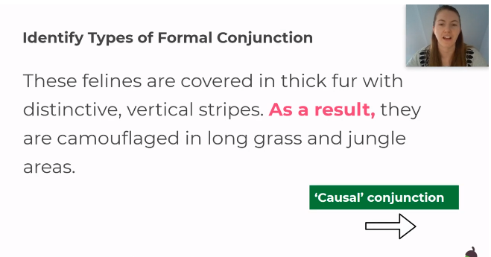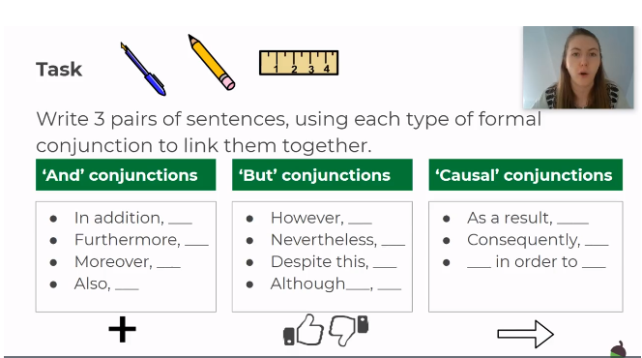

Thursday – Alternative English Lesson 4 Activities
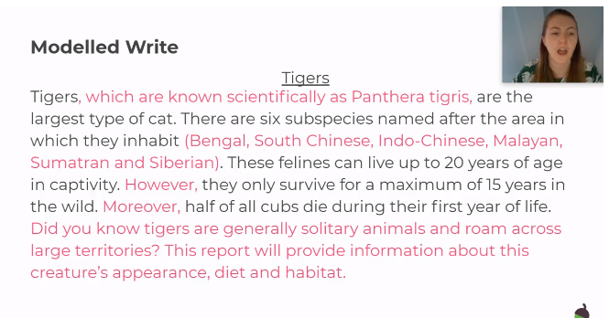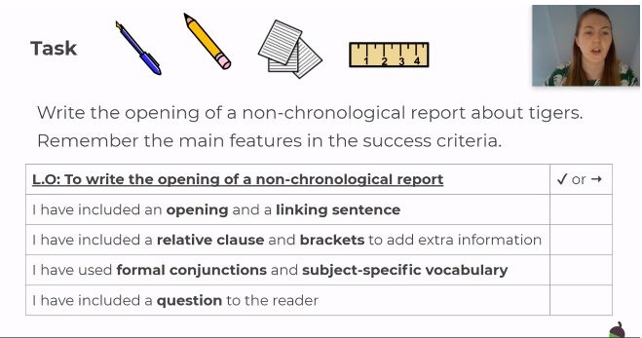

Friday – Alternative English Lesson 5 Activities
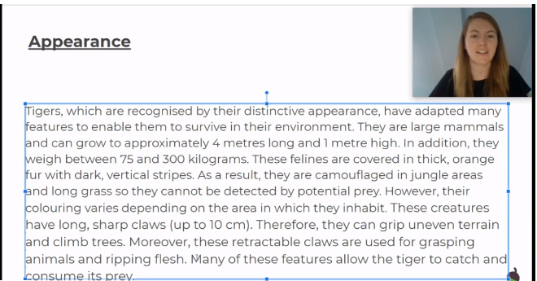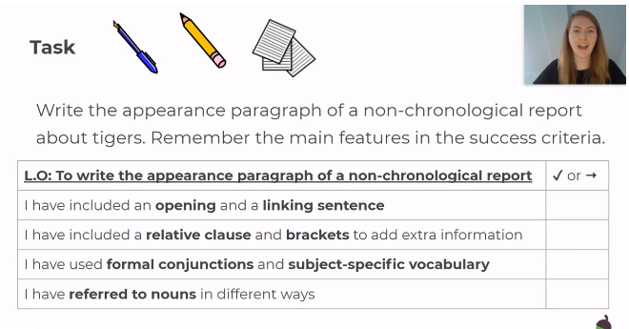

Monday – R.E. Resources

Wednesday – Geography Resources
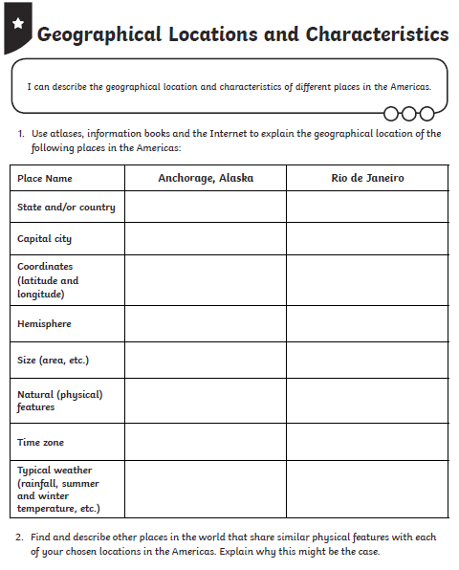
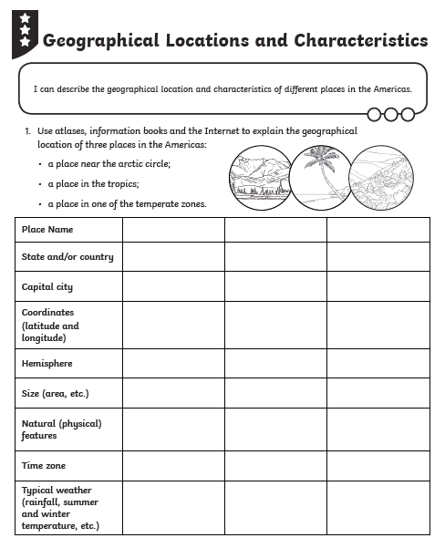

Thursday – Science Resources
