Year 5 - Home Learning Week 2 - Handwriting
 | Handwriting
Lettering Sets
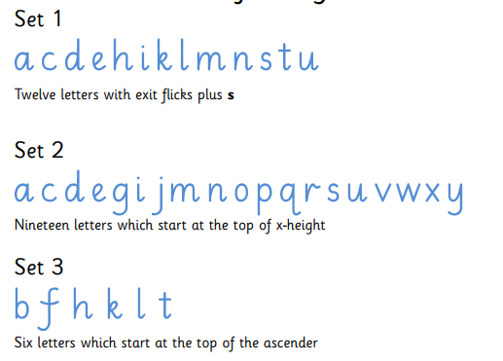
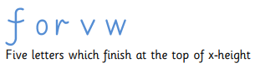

A useful website to use for practising and teaching handwriting is https://www.ictgames.com/mobilePage/writingRepeater/
This website should work on both ipads, mobiles and ipads, allowing you to record yourself writing and then play your recording back to help you to practice your handwriting on paper.

Monday | Lesson 6 – Practising the “third join.”  The third join is a curve join from any letter in set four to any letter in set 2. It is a curve join because it is x-height to x-height.  For this lesson can you practice joining the letters wo, wa, and ro.  Here is an example:  For a harder challenge, could you try to think of your own words using the letters which you have practiced in today’s lesson? Can you try to think of ten 5 or 6 letter words which use the letters from today’s activity.
Tuesday | Lesson 7 – Practising the “third join”  The third join is a curve join from any letter in set four to any letter in set 2. It is a curve join because it is x-height to x-height.  For this lesson, can you practice joining the letters fo, fa, and ra.  For a harder challenge, could you try to think of your own words using the letters which you have practiced in today’s lesson? Can you try to think of ten 5 or 6 letter words which use the letters from today’s activity.
Wednesday | Lesson 8 - Applying the “third join”  The third join is a curve join from any letter in set four to any letter in set 2. It is a curve join because it is x-height to x-height.  Can you use the Year 5 and 6 spelling list, which can be found on the next page. How many different words can you find which include a “third join”, linking a Set 4 letter to any Set 2 letter.  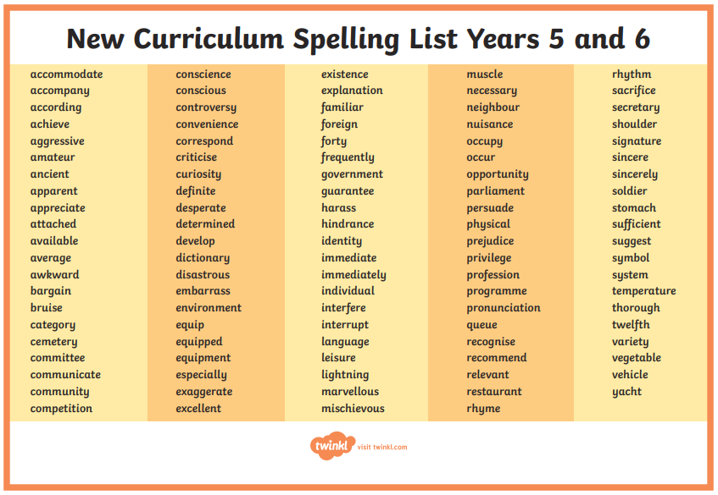  Write as many words as you can using accurate joins with your letters.
Thursday | Lesson 4 - Practicing the “fourth Join”  A fourth join is the join from any letter in set 4 to any letter in set 3. Same as the first join except that if goes from the x-height of one letter to the top of the ascender to the next  For this lesson, can you practice joining the letters wh, ob and ol.  For a harder challenge, could you try to think of your own words using the letters which you have practiced in today’s lesson? Can you try to think of ten 5 or 6 letter words which use the letters from today’s activity.
Friday | Lesson 5 - Practicing all of the joins.  For today’s activity, you could choose whichever of the joins you would like to work on/improve with the most. Think of some of your own words which use your chosen join.

