Year 4 Week 2
Group 3
Maths | Monday – 1s, 10s, 100s, 1000s  Complete the Maths page 1
Tuesday – Rounding
Complete Maths page 2

Wednesday – Addition
Complete the addition word problems
Thursday – Subtraction
Complete the subtraction word problems
Friday –
12 78 182 309 258 1829 3209 7921 6298 9999

- Multiply these numbers by 10 then 100
- Divide these numbers by 10 then 100

English | Monday  1) Read through the Impossibly Possible Bookshop again  Answer these questions:  - Why do you think the author used the word ‘rickety’ to describe the ladder?  - When Grandmama was in the post office, why do you think it seemed to Sammy like she had been a very long time?  - How do you think Sammy was feeling as he walked into the bookshop? How do you know?  - What do you think Sammy thought was going to happen when he opened the Tree Goblin book?  - Summarise the story in 50 words or less
Tuesday
- Create and draw your own goblins. For example - Cloud Goblin, Chocolate Goblin, Slime Goblin.
- Write 3-5 facts about your goblins. What do they eat? Where do they live? Do they have any special powers or skills? Do they have any enemies or other friends? What are they bad at?

Wednesday
- Write some expanded noun phrases to describe 1 of your goblins in more detail
- Write some expanded noun phrases to describe where 1 of your goblins live

Remember an expanded noun phrase gives more detail to something. Use 1 or 2 adjectives and a preposition to say where something is e.g. He had a bobbly, ugly wart on the end of his nose.

Use adverbs and verbs to write about how your goblin acts or what his personality is like, e.g. The Biscuit Goblin carefully creeps around the kitchen so as not to raise suspicion when stealthily stalking his next feast.

Thursday
Use your expanded noun phrases to write a character description about your chosen goblin. Use Fronted adverbials to start sentences and Include subordinate conjunctions to add more detail.
Can you Include information on how your goblin feels in different situations? For example, how he gets food, does he need to defend himself etc.

Friday
Design and draw a birthday cake for your goblin.
Write a set of instructions for how to make this cake.
Include useful fronted adverbial phrases, imperative verbs and precise adjectives. Don’t forget an introduction and final note of warning.

Science | Conduct a demonstration to explore the density of different liquids. Take a clear container and equal amounts of honey, milk, water, vegetable oil, golden syrup and washing up liquid. Colour the water and milk if you want to. Slowly pour the honey into the container making sure to pour it into the middle and not drip it down the side. Follow this with the golden syrup, washing up liquid, milk, water and finally vegetable oil.  Draw a diagram and write about what you notice about this demonstration. Which liquid do you think is most and least dense and why?
RE | 1) Find Colossians 3:13  Bearing with one another and, if one has a complaint against another, forgiving each other; as the Lord has forgiven you, so you also must forgive.  This is just one passage in the Bible that asks us to be forgiving to each other. Can you find and  copy some more?  Why do you think it is important to forgive others?  2) Why do you think that Jesus was followed and respected by so many people?  From everything that you have read in the Bible and learnt in your RE lessons think about what made him such a valuable leader?  Make a mind map and around the outside list words that you think best describe Jesus, some short phrases to give reasons why you think people followed him and use evidence from your knowledge of his actions to support your explanations.
Topic | South America  Choose 1 country from South America and create a fact file about it. Include facts about the people who live there, the landmarks, what the climate is like, the food people eat, any dances/sports etc. that are popular.
PE | Create a circuit in your back garden with at least 5 different exercises. You can use, sit ups, star jumps, use a bat and ball, dribble a football, sprints etc. Do each exercise for 1 minute then rest for a minute before moving onto the next. Don’t forget to do some stretches at the start and end to warm up and cool down
Art | Make a collage that might represent a volcano erupting. Use tissue paper, sweet wrappers, old material, felt tips, paint, anything in the colours that you think best represents a volcano. You can stick papers and materials on using tape, glue, paper clips – anything you have around the house.
French | Draw a picture of a picnic, include the following foods and label them on the picnic:  Le lait, le fromage, le pain, la glace, le poulet, le chocolat, le jus d‘orange, le jambon, le gateau, la pomme, les fraises
PSHE | Talk to your parents about your grandparents, aunts and uncles. What do they remember from when they were children? What were their favorite things to do? Did they go on any trips together?  Make a family tree to show at least 3 generations of your family, from you up to your grandparents or further. You could draw something like the one on page 4, draw a tree to place your family on or create a 3D effect with leaves to stick on and use collage materials to make the tree!

Maths page 1
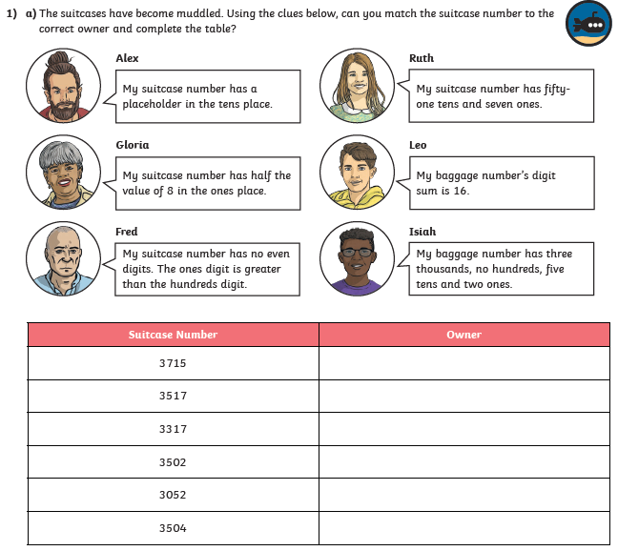
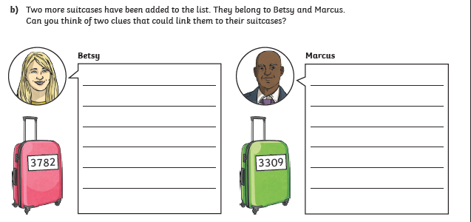

Maths page 2
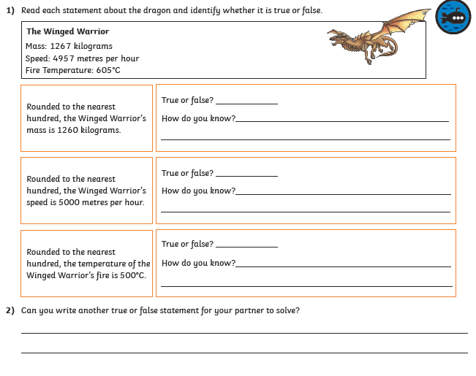

Addition word problems
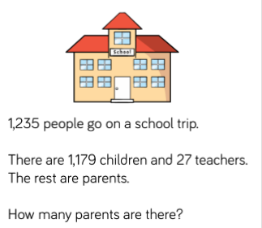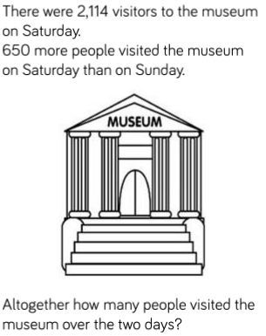

Last year, the school council raised £347 for charity. This year they raised £98 more. If a local business offers to double this year’s money, how much will they have in total?
Year 4 are collecting plastic bottles to recycle. So far, they have collected 4,285. If a local café donates another 129, how many more do they need to reach their target of 10,000?

Subtraction word problems
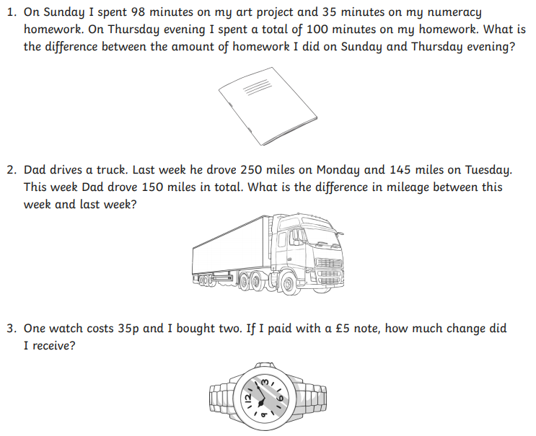
4. Lorenzo is looking over the photographs he took at his friend’s wedding. He took a total of 3,218 pictures but some of them were no good. 428 of them were blurred, he forgot the flash on 123 of them and could see part of his finger on 54 of them. How many pictures were good enough to go into the photo album?

