Year 5 - Home Learning Week 1 - Handwriting
 | Handwriting
Lettering Sets
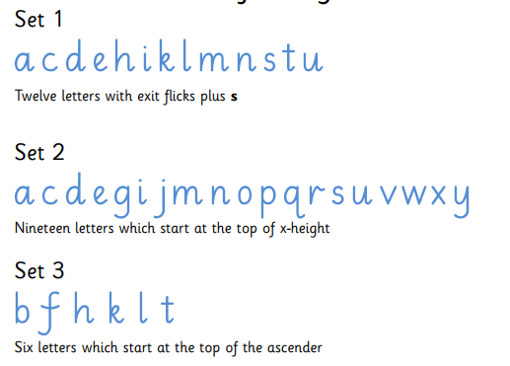

A useful website to use for practising and teaching handwriting is https://www.ictgames.com/mobilePage/writingRepeater/
This website should work on both ipads, mobiles and ipads, allowing you to record yourself writing and then play your recording back to help you to practice your handwriting on paper.

Monday | Lesson 1 – Practising the “first join.”  The first join is joining from any letter in Set 1 to any letter in Set 2.  For this lesson can you practice joining the letters am, an and ar.  Here is an example:  For a harder challenge, could you try to think of your own words using the letters which you have practiced in today’s lesson? Can you try to think of ten 5 or 6 letter words which use the letters from today’s activity.
Tuesday | Lesson 2 – Practising the “first join”  The first join is joining from any letter in Set 1 to any letter in Set 2.  For this lesson, can you practice joining the letters ig, ir and in.  For a harder challenge, could you try to think of your own words using the letters which you have practiced in today’s lesson? Can you try to think of ten 5 or 6 letter words which use the letters from today’s activity.
Wednesday | Lesson 3 - Applying the “first join”  The first join is joining from any letter in Set 1 to any letter in Set 2.  Can you use the Year 5 and 6 spelling list, which can be found on the next page. How many different words can you find which include a “first join”, linking a Set 1 letter to any Set 2 letter.  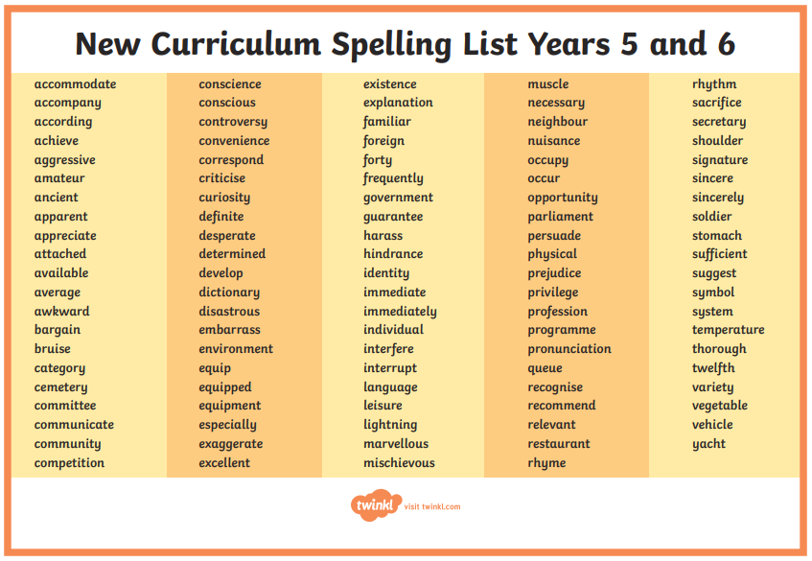  Write as many words as you can using accurate joins with your letters.
Thursday | Lesson 4 - Practicing the “Second Join”  A second join is the diagonal join from any letter in set 1 to any letter in set 3. The join meets the ascender half way up the letter and then continues up the ascender.  For this lesson, can you practice joining the letters ch, ct and at.  For a harder challenge, could you try to think of your own words using the letters which you have practiced in today’s lesson? Can you try to think of ten 5 or 6 letter words which use the letters from today’s activity.
Friday | Lesson 5 - Practicing the “Second Join”  A second join is the diagonal join from any letter in set 1 to any letter in set 3. The join meets the ascender half way up the letter and then continues up the ascender.  For this lesson, can you practice joining the letters ab, ib and il.  For a harder challenge, could you try to think of your own words using the letters which you have practiced in today’s lesson? Can you try to think of ten 5 or 6 letter words which use the letters from today’s activity.

