Year 5 Home Learning |  | This document outlines the activities/lessons your child to complete at home during the bubble closure. Each activity is explained in detail here, including where to find the activities. There is a Maths and English lesson to complete each day, then a range of activities provided for additional subjects which can be completed at any time. WALT stands for We Are Learning To, which will give you a clear indication of the lesson objective. There will be different levels of challenge for the children to complete for most lessons (*** being the hardest level). The children do not need to complete all three levels. The children can work directly into their home learning book they have been given. Please feel free to email any work or pictures of the work and do not hesitate to email me on year5@st-pauls-hyde.tameside.sch.uk if you require any assistance. Thank you, Mr Titterington.
Week 1
Maths |  |  | English
Look in the table below to find the information about the lesson, which you need to complete. Once you have read the table, scroll down to the bottom of the document to find the tasks and questions, which you need to complete for each lesson. This week we will be focussing on Place Value. |  |  | Our topic and focus for our time outside of school will be writing non-chronological reports. Our topic will be called “Wild Cats – Non Chronological Reports”.  Each lesson, I have provide a link for an individual lesson, which will teach you the different learning focuses for each lesson. The videos will provide you with activities to complete. There will also be alternative paper activities similar to the videos, in case you are not able to follow along.  All of the weeks videos and activities can be located here: https://classroom.thenational.academy/units/wild-cats-non-chronological-reports-702c
1) | Lesson 1 – Recognising numbers up to 1 million.  Earlier this year we learnt about numbers to 1 million, recognising how to order them and to recognise the value of the individual digits using place value headings.  The important place value headings which you need to remember for this topic are: M HTh TTH Th H T O  These headings stand for: Millions, Hundred Thousands, Ten Thousands, Thousands, Hundreds, Tens and Ones.  For your task, can you complete the White Rose Hub activity sheets which can be found later in this document?  - Complete questions 1-3 in the activity sheet.  - Complete questions 1-8 in the activity sheet.  Complete questions 1-8 in the activity sheet. Then complete the problem solving challenge in question 9. |  | 1) | Lesson 1 – Identifying the features of a Non-Chronological Report.  During this lesson, I would like you to learn about the key features of a non-chronological report. You will need to think about:  - The Purpose of a non-chronological report  - The Audience of a non-chronological report  - The Layout of a non-chronological report  - The Language used in a non-chronological report  You will need to watch the video which can be found by clicking “Start Lesson” at this link: https://classroom.thenational.academy/lessons/to-identify-the-features-of-a-non-chronological-report-6cwket  Watch the video in which Mrs Smart look at a non-chronological report about Gray Wolves. When you are shown each of the different parts or paragraphs of a non-chronological report, see if you can write some notes about the Purpose, Audience, Language and Layout which you can see. Mrs Smart has listed some of the features which you should try to find in the non-chronological report which she shows you, see if you can pause the video when asked, and write down some examples of the features inside the text.  Challenges  - Identify and talk about some of the features at home.  - Identify and write down an example of some of the features which Mrs Smart has asked you to look for within the video.  - Complete the two star challenge. Then write some of your own examples of the features which you could add into the non-chronological report.  Completing without the video (Alternative Activity)  Later in this document, you should find images of the Non-Chronological report, which Mrs Smart has written. At the side of the image, she has listed the different features, which you should try to find in each given paragraph. See if you can write down some of the examples of the features which she has asked you to find from the text.
2) | Lesson 2 – Comparing and ordering numbers up to 1 million  During lesson 1, you thought about the place value of numbers which went up to 1 million. In this lesson, I would like you to apply your knowledge of these numbers to compare and order them.  The important place value headings which you need to remember for this topic are: M HTh TTH Th H T O  These headings stand for: Millions, Hundred Thousands, Ten Thousands, Thousands, Hundreds, Tens and Ones.  In this lesson, I have provided you with some reasoning challenges. This means that you will need to answer the question and then explain why or how you have you have found your answer.  Remember to use the VAP rules:  V = Viewpoint (Is the answer correct or not)  A = Answer (What is the real answer if they are incorrect? What have they done wrong?)  P = Proof (Prove or explain why your answer is correct, or prove or explain why they have got the answer wrong)  For your task today, complete one of the Classroom Secret Activities, which have been provided later in this document. You can choose the challenge level, which suits you.  Challenge levels  - Complete the 1 star activity sheet.  - Complete the 2 star activity sheet.  Complete the 3 star activity sheet. |  | 2) | Lesson 2 – To investigate the spelling of –fer words.  During this lesson, I would like you to learn about the spelling of words which end with the suffix –fer. Some of these words have different spelling rules when we add the additional suffix –ed. Remember, a suffix comes at the end of the word.  You will need to watch the video which can be found by clicking “Start Lesson” at this link:  https://classroom.thenational.academy/lessons/to-investigate-the-letter-string-fer-64r3ce  Watch the video and learn with the teacher as they explain how to add the suffix –ed onto different –fer words. You will need a paper and pencil so that you can spell the given words, complete the sentences using the correct words and recognise the difference between the different spelling rules. This is because on some of the rules, you will need to double a consonant to ensure the word is spelt correctly. The teacher will tell you when to pause the video to complete a task.  - Spell some of the words correctly, which end with –fer.  - Add the suffix –ed onto the end of –fer rules correctly.  - Confidently recognise when we need and do not need to double a consonant when adding –ed onto the end of an –fer word.  Completing without a video (Alternative Activity).  If you cannot access the video, in the resources below, you will find a spelling list which includes a variety of words which use the spelling rule –fer. You should try to practice these 5 times using the “look, say, cover, write, check” method.
3) | Lesson 3 – Rounding to 1 million  During the autumn term, we have worked hard to round to a variety of different numbers. Today we will be answering questions with rounding numbers up to the nearest million.  You should remember that we have been following our rounding rhyme:  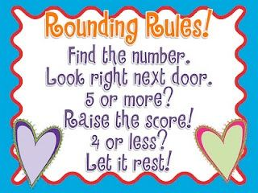  Remember that the place value headings are extremely important when rounding.  Here is an example:  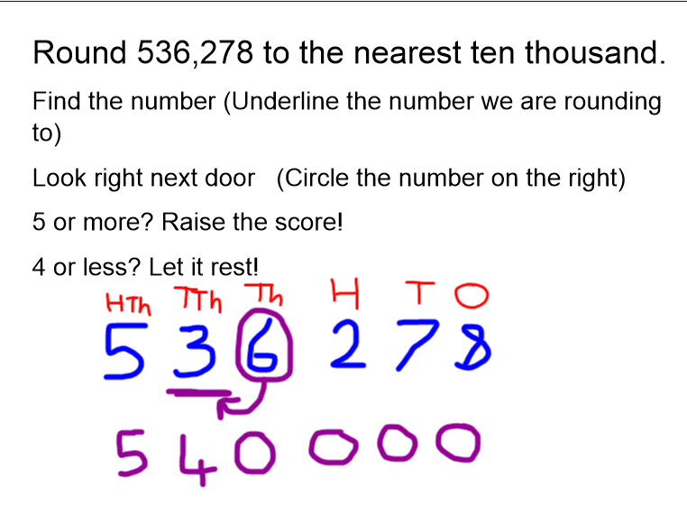  If you are still struggling with rounding to the nearest value, you may find some videos on BBC Bitesize helpful: https://www.bbc.co.uk/bitesize/articles/zjf492p  For your task, can you complete the second White Rose Hub activity sheets, which can be found later in this document?  Challenge levels:  - Complete questions 1-3 in the activity sheet.  - Complete questions 1-5 in the activity sheet.  Complete questions 1-6 in the activity sheet. Then complete the problem solving challenge in question 7. |  | 3) | Lesson 3 – To develop knowledge of relative clauses  During this lesson, I would like you to learn about how to use a relative clause in a sentence. You will need to think about carefully punctuating your sentences. You will also recap subordinate clause sentences in the video.  Here is an example, with the relevant clause highlighted:  Subordinate clause When Mr T is excited, he likes to dance around.  Relative clause Mr T, who likes to watch Ice Hockey, enjoys teaching Year 5.  Relative clause Australia is a hot country, which has a large desert in the middle.  You will need to watch the video for this lesson which can be found at this link: https://classroom.thenational.academy/lessons/to-develop-knowledge-of-relative-clauses-6mu6ae  For this lesson, you will need to find subordinate and relative clauses, and write some of your own. You will need a piece of paper and a pencil to complete the tasks which Mrs Smart asks you to complete each time you pause the video.  - Find some subordinate and relative clause sentences in the video.  - Write some of your own subordinate and relative clause sentences.  - Write some of your own subordinate and relative clause sentences using accurate punctuation.  Completing without the video (Alternative Activity)  If you cannot access the video, then you should try to complete the alternative paper activity, which can be found later in this document. Use the two following examples to help you to write a relative clause about the topic which you have been given:  Relative clause Mr T, who likes to watch Ice Hockey, enjoys teaching Year 5.  Relative clause Australia is a hot country, which has a large desert in the middle.
4) | Lesson 4 – Problem Solving and Reasoning when rounding up to the neatest 1 million.  In yesterday’s lesson (lesson 3), we thought about how to round to the nearest million. In today’s activties, I would like you to apply your understanding of how to round numbers using the rounding rhyme to problem solving and reasoning activities.  This means that you will need to answer the question and then explain why or how you have you have found your answer.  Remember to use the VAP rules:  V = Viewpoint (Is the answer correct or not)  A = Answer (What is the real answer if they are incorrect? What have they done wrong?)  P = Proof (Prove or explain why your answer is correct, or prove or explain why they have got the answer wrong)  For your task today, complete one of the Classroom Secret Activities, which have been provided later in this document. You can choose the challenge level, which suits you.  Challenge levels  - Complete the 1 star activity sheet.  - Complete the 2 star activity sheet.  Complete the 3 star activity sheet. |  | 4) | Lesson 4 – To generate subject-specific vocabulary  In this lesson, you will think and learn about important vocabulary and information which you can gather for a specific subject. The non-chronological report which you will be writing at the end of this unit will be about tigers. In today’s video, you will need to brainstorm and think of some important vocabulary for the tiger’s appearance, diet and habitat. In the video for today’s lesson, you will also be taught some important vocabulary for this topic by Mrs Smart. You will need to follow Mrs Smart’s instructions and think of some of your own keywords to describe the three words in bold. Your final main task, will be to write a paragraph about tigers, using the vocabulary which you have gatehred from watching the video. The video can be found at this link: https://classroom.thenational.academy/lessons/to-develop-and-generate-subject-specific-vocabulary-6mtp4e  - Listen to and understand some of the vocabulary, which Mrs Smart introduces in the video.  - Think of your own vocabulary and key words to describe a tiger’s appearance, diet and habitat.  - Use the vocabulary and keywords, which you have gathered to write your own paragraph about tigers.  Completing without the video (Alternative activity)  If you cannot access the video, then you should try to independently complete the alternative paper activity, which can be found later in this document. I would like you to create a mind map with as many ideas as possible to describe a tiger’s appearance, diet and habitat. You may need to use the internet to gather some research. Below you should find 3 different mind maps which you could either print out, or copy to complete.
5) | Lesson 5 – Rounding to Estimate  In this lesson, you will need to think about the rounding strategies which you have used in the previous two lessons. We are going to try to round to estimate.  When we are given a challenging addition question, such as adding numbers with 4 digits, we can round both numbers, and then add them together to find an approximate answer.  For example:  to work out 6237 + 2745, we can round both numbers to the nearest 1000, and then add them.  This would be 6000 + 3000. This is easier to work out in our head, so the estimated answer is 9000.  . If you are still unsure how to use the rounding to estimate method, I have created a video guide on the Year 5 home learning page of our school website. Although this was originally created in the beginning of March, the method is still relevant. The link and thumbnail for the video are here: http://www.st-pauls-hyde.tameside.sch.uk/page/year-5/65277  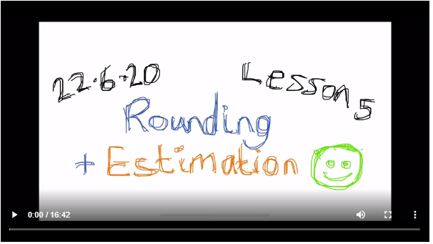  For your task, can you complete the second White Rose Hub activity sheets, which can be found later in this document?  Challenge levels:  - Complete questions 1-3 in the activity sheet.  - Complete questions 1-6 in the activity sheet.  Complete questions 1-7 in the activity sheet. Then complete the problem solving challenge in question 8 |  | 5) | Lesson 5 – To develop a rich understanding of words associated with eating  Tiger’s are often associated with being ferocious animals and are often associated with eating. In this lesson, our video will help you to think about synonyms (words which are different but have the same or similar meaning) for eating. In the video, the teacher will ask you to brainstorm some synonyms for eating. You will need to think about the meaning of the different words and write some of these ideas down. The link for today’s video is here: https://classroom.thenational.academy/lessons/to-develop-a-rich-understanding-of-words-associated-with-eating-6mtkec  - Understand what a synonym is.  - Think about different synonyms for eating and write the definitions of these words.  - Think of different synonyms for eating, write their definitions and include these in a sentence.  Completing without the video (Alternative Activity)  If you cannot access the video, then you should try to independently complete the alternative paper activity, which can be found later in this document. Can you think of different synonyms for the words which have been underlined?

Additional Subjects- To be completed anytime over the 2 weeks.
Science | Topic
Science – Lesson 1  During the Autumn term we learnt about Space and our Solar system. Although we learnt a lot about the different planets in our solar system, there are too many facts and pieces of information for us to cover in a few lessons! For this activity, I would like you to research the different planets in our solar system, to find as many interesting and unique facts as possible. Later in this document you will find a template which you may wish to use. However, you may want to produce your research in an exciting way, such as a poster or video. You could also use purple mash to complete this challenge, by searching “Planet Profile”. | Topic – Geography – The Americas – Lesson 1  In this lesson, I would like you to research the geography of the different countries of both North and South America. You will need to use either an atlas, or the internet (such as google maps/earth) to research the different countries, to find the capital cities and different information about them. Later in this document, you will find two activity sheets for these countries.  Challenge levels:  - Name and locate the different countries in the Americas.  - Name and locate the countries in the Americas, including their capital cities.  Name and locate the countries in the Americas, including their capital cities. Also, write a fact about each of the different countries using your research.
Art | Computing
Art – Viking Jewellery  With Mrs Taylor last term, you designed and created some of your own Anglo-Saxon Jewellery. Some people designed bracelets, others designed earrings, whilst others designed necklaces.  For this activity, I would like you to research the different styles of Viking jewellery which were available and design your own type of Viking jewellery, which is different to the Anglo-Saxon jewellery which you made in school.  Think about the patterns which you could use and the materials which would be used to make it. Remember to label your design to explain these.  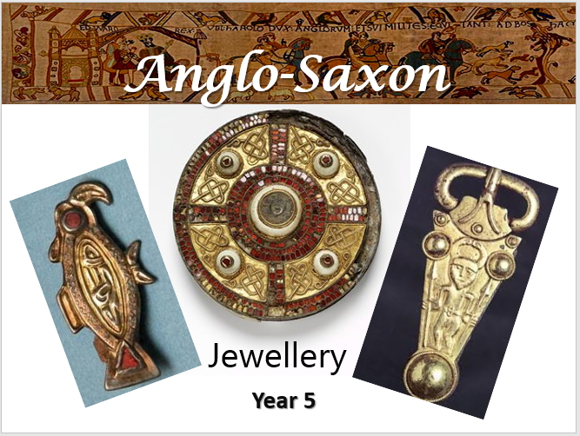 | Computing – Designing our own programme using timers  For this week’s computing activity, I would like you to design your own programme using timers. Remember, that in computing it is important that your programme and instructions have a purpose, and that you plan this carefully to ensure that your programme has a clear outcome. I would like you to draw and design your programme on a piece of paper, then log on to your purple mash account. When you are on Purple Mash, use the search bar to find “Free Code Gibbon”. Once you have finished your programme, remember to save it in your area so that I can see it.  Here is an example of a programme design, drawn by hand, which doesn’t use timers:  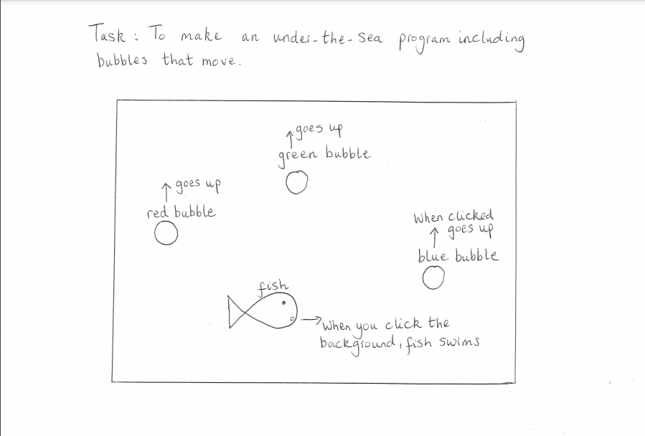
RE
During our topic of Creation, we thought about different beliefs, which many people have around the globe about how the world was created. We read the Creation Story in the Bible, which told us the different steps that God took to create the world in 7 days. If you have forgotten what happened in this story, you can recap this by watching a video here: https://www.youtube.com/watch?v=QJjzfXVdjGI
We have thought about some of the ways in which Christians care for the Earth, and some of the reasons why they do this, as a result of the Creation story in the Bible.

Now I want you to think about how you could care for God’s creation, and think of reasons why you do this. Below, you should find a blank template of a comic strip. I would like you to use this comic strip to show me 6 different ways that you would care for God’s Earth. You should draw a picture of these ways, and write a short explanation for what the picture represents. Think about our R.E. lessons after Christmas where we have talked about Inspirational People from the Bible, such as Jesus, and how they cared for the Earth. You might want to think about how their inspirational actions might help you to care for the Earth.

Challenges
- Draw and tell me 6 different ways which you would care for the Earth.
- Draw and tell me 6 different ways which you would care for the Earth. Also explain how your way for caring for the Earth is linked to God, the Creation story and inspirational people you might know. For example, One way that I would care for the Earth is to treat other people in kind way, in a way that I would like to be treated myself. I would do this because God created humans to care and to love one another, and I aim to show this through my actions. Jesus (who was an inspirational person) also showed how to act in a kind way when he healed a man who was suffering with leprosy.
Complete the challenges for stars 1 and 2. If you have time, you may want to create your own video, or artwork, which shows how we can care for God’s creation. You could email this to our class email address.

 | Health and Wellbeing
P.E. – Keeping Active At Home

It is important that even though we are at home, we are still receiving the right amount of exercise.

Watch and join in with this video created by Joe Wicks to help us to keep active at home.
https://www.youtube.com/watch?v=d3LPrhI0v-w

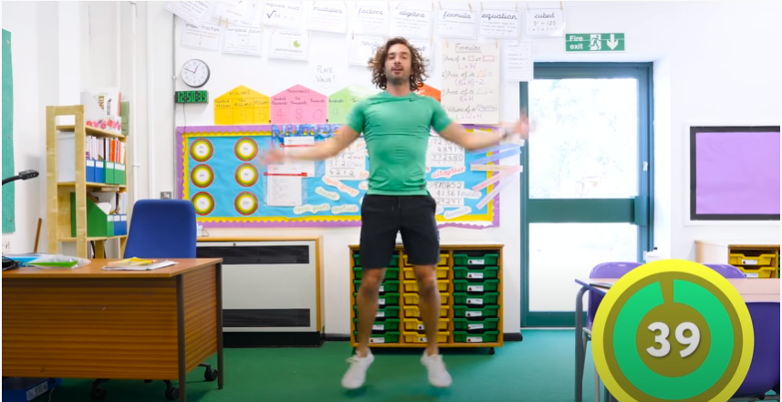

Monday – Maths Lesson 1 Resources
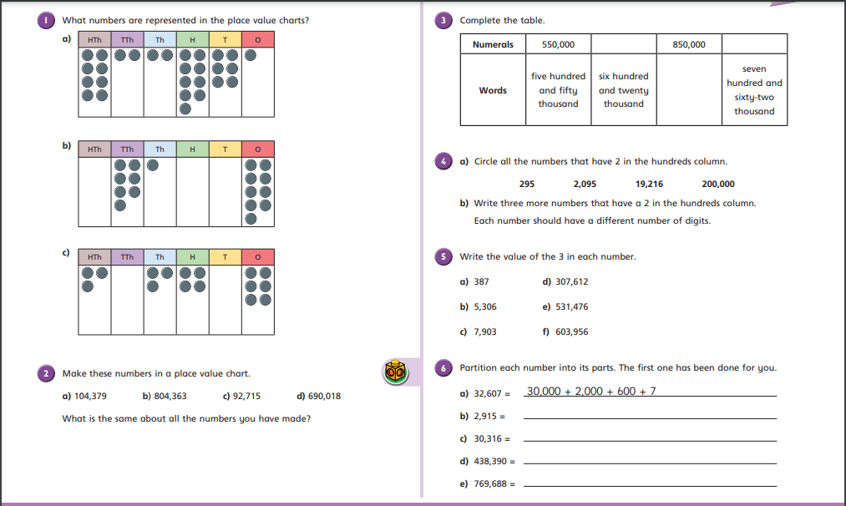
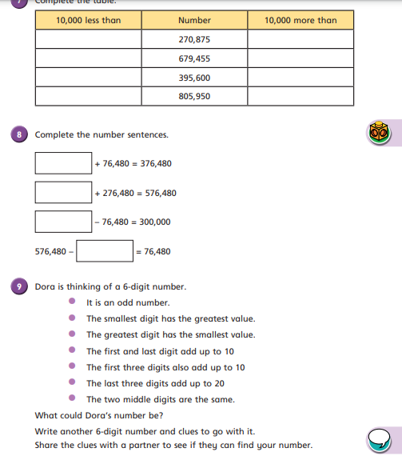

Tuesday – Maths Lesson 2 - Activity
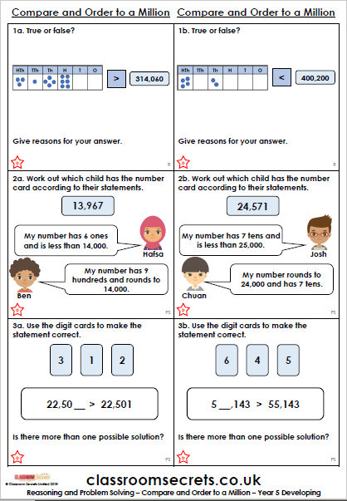

Tuesday – Maths Lesson 2 - Activity
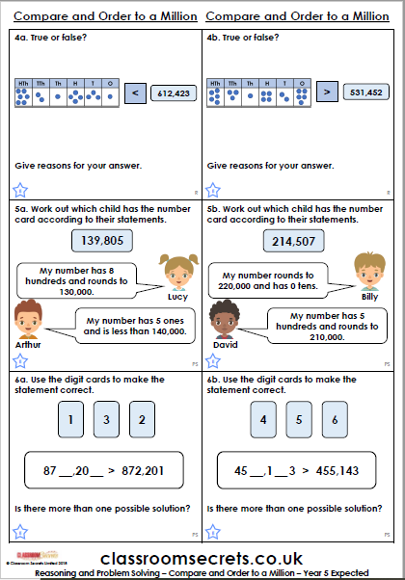
Tuesday – Maths Lesson 2 - Activity
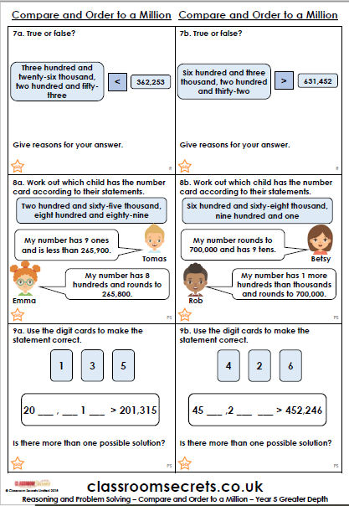

Wednesday – Maths Lesson 3 Resources
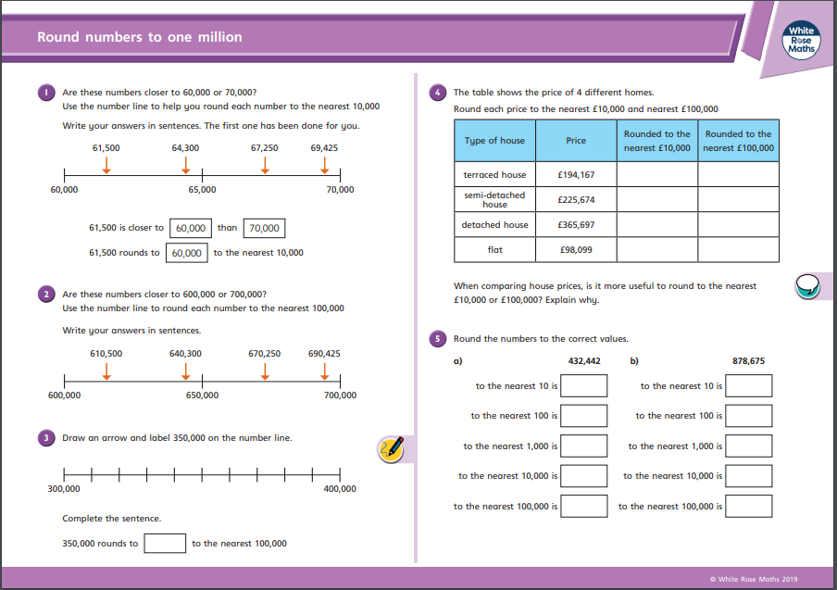
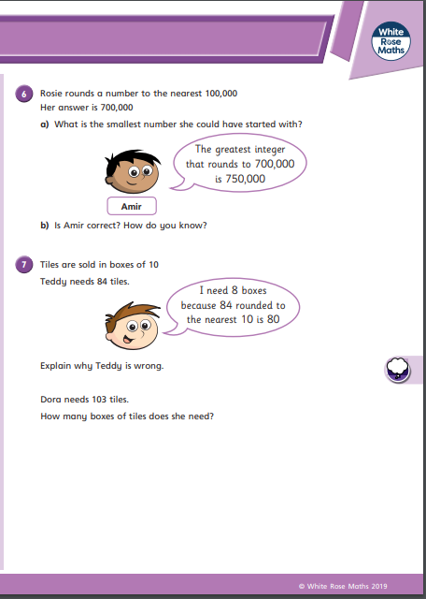
Thursday – Maths Lesson 3 - Activity
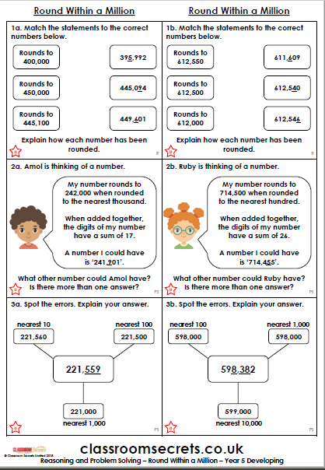

Thursday – Maths Lesson 3 - Activity
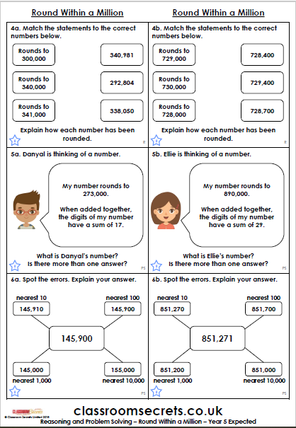
Thursday – Maths Lesson 3 - Activity
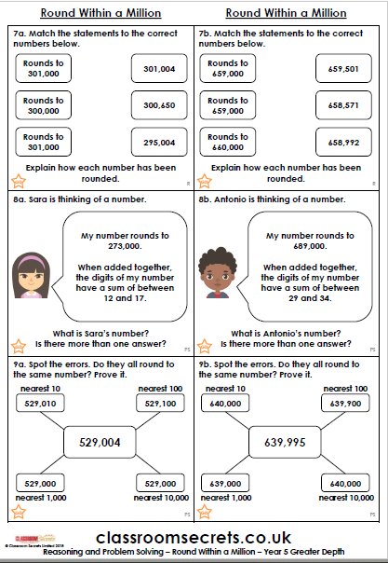
Friday – Maths Lesson 5 Resources
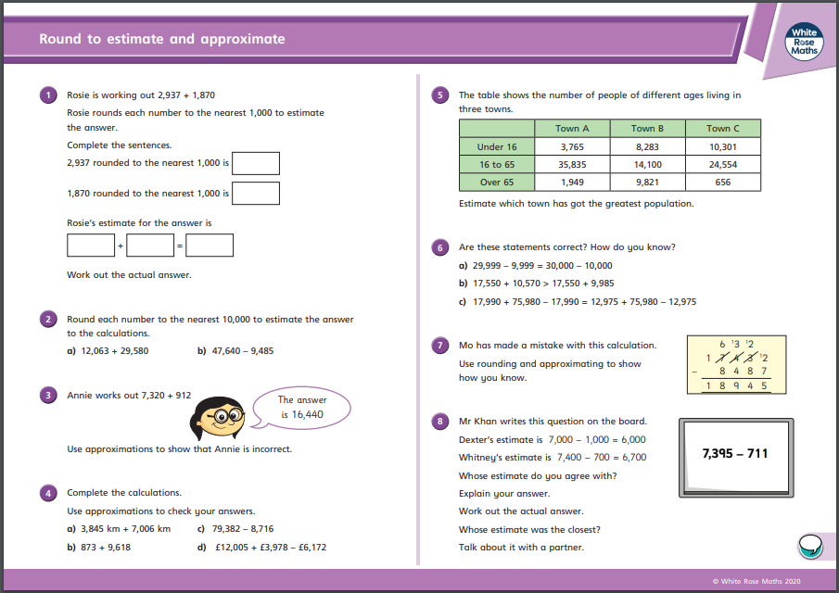

Monday – Alternative English Lesson 1 Resources
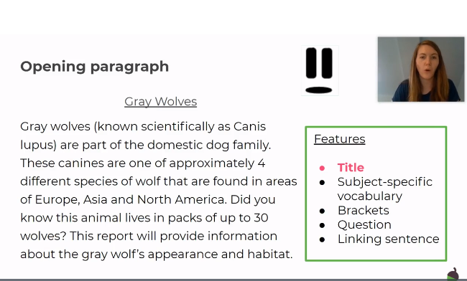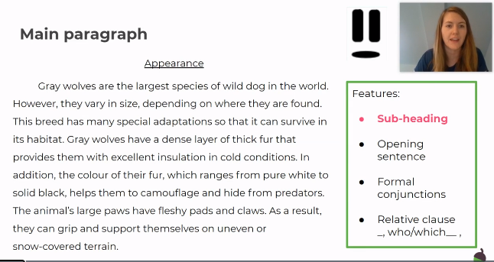

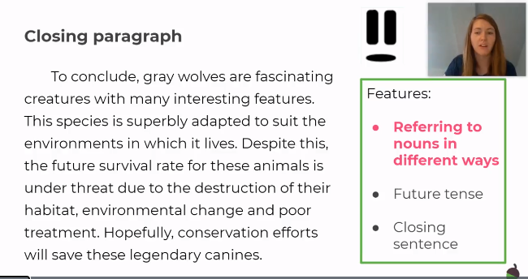

Tuesday – Alternative English lesson 2 Resources
 |  | Practise 1 |  | Practise 2 |  | Practise 3 |  | Practise 4 |  | Practise 5
Look | Say | Write |  | Write |  | Write |  | Write |  | Write
example |  | exampel |  | exampal |  | example |  | example |  | example
offered
suffered
different
difference
reference
preferred
transferred
referral
deterring
inferring

Wednesday – Alternative English Lesson 3 Resources
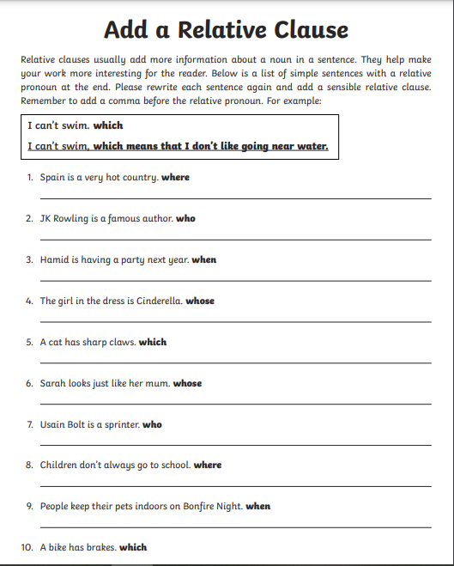

Thursday – Alternative English Lesson 4 Activities
Describe a tiger’s appearance

Describe a tiger’s habitat
Describe a tiger’s diet
Friday – Alternative English Lesson 5 Activities
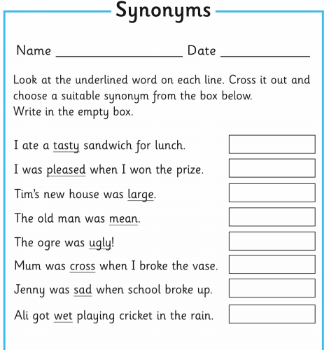

Monday – R.E. Resources

Wednesday – Geography Resources
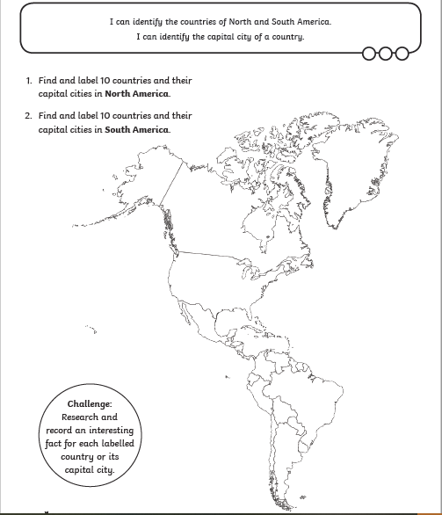

Thursday – Science Resources
