Year 5  2 Day Home Learning Pack |  | This document outlines the activities/lessons your child to complete at home for the first two days whilst self-isolating. Each activity is explained in detail here, including where to find the activities. There is a Maths and English lesson to complete each day, then a range of activities provided for additional subjects which can be completed at any time. WALT stands for We Are Learning To, which will give you a clear indication of the lesson objective. There will be different levels of challenge for the children to complete for most lessons (*** being the hardest level). The children do not need to complete all three levels. The children can work directly onto individual sheet of paper or on printed sheets. Please feel free to email any work or pictures of the work and do not hesitate to email me on year5@st-pauls-hyde.tameside.sch.uk if you require any assistance. Thank you, Mr Titterington
Maths |  |  | English
1) | WALT: Find multiples and factors of numbers  For this lesson, I would like you to recap your knowledge of finding multiples and factors.  A multiple is result of multiplying a number by another whole integer. For example, a multiple of 7 is 35, because 7 x 5 = 35.  Factors are two numbers which we can multiply together to create another number. For example: factors of 12 are 1 and 12, 2 and 6, 3 and 4.  For this lesson, I would like you to watch and complete the challenges on the Oak National Academy website. The link for the lesson can be found here: https://classroom.thenational.academy/lessons/multiples-and-factors-6gr32d?activity=video&step=1 Complete the challenges which Mr Ward sets for you.  Alternate Task  As an alternate task if you cannot access the video, you may wish to complete the worksheet which has been included below. The worksheet challenges you to use your knowledge of multiples.  Challenge Levels  1 Star – Complete questions 1 – 5  2 Star – Complete questions 1 – 7  3 Star – Complete questions 1 – 9 |  | 1) | WALT: Understand and use relative clauses in a sentence.  For this lesson, I would like you to recap your understanding of relative clauses, which we looked at in English during the Autumn Term.  To complete this lesson, you will need to watch the video at the following link, in which, the teacher explains what a relative clause looks like. She also gives example sentences and conjunctions which you can use. https://classroom.thenational.academy/lessons/to-explore-relative-clauses-65k30c?activity=video&step=1  Listen to her instructions, and help her to create the sentences which she needs using relative clauses.  What is a relative clause?  A relative clause can be used to give additional information for a noun. An embedded relative clause usually is placed in the middle of a sentence. For example:  The cake, which was waiting to be eaten by Mr T, was placed on the kitchen ledge.  The boys (who were 14 years old) were exercising at the playground.  The train station – which is in Birmingham – is extremely busy today.  For relative clauses, you could use commas, brackets or dashes.  Challenge Levels  1 Star – Can you write your own relative clause sentences for the picture and sentences the teacher in the video shows you, using punctuation in the correct place.  2 Star – Can you complete the one star challenge. Could you then write some of your own relative clause sentences with the correct punctuation.  3 Star – Could you complete the 1 star challenge, and write your own paragraph for your own topic which uses relative clauses and other grammar features too.  Alternative Paper Activity  I have also provided an alternate paper activity, which asks you to answer a variety of relative clause questions, which you may choose to complete as an alternative activity instead of watching the video.
2) | WALT: Understand how to find factor pairs.  For this lesson, I would like you to recap your knowledge of finding multiples and factors.  Factors are two numbers which we can multiply together to create another number. For example: factors of 12 are 1 and 12, 2 and 6, 3 and 4.  For this lesson, I would like you to watch and complete the challenges on the Oak National Academy website. The link for today’s video can be found here: https://classroom.thenational.academy/lessons/factor-pairs-61k3cd?activity=video&step=1  Alternative Challenge  As an alternate task if you cannot access the video, you may wish to complete the worksheet which has been included below. The worksheet challenges you to use your knowledge of factors.  Challenge Levels  1 Star – Complete Questions 1- 6  2 Star – Complete Questions 1 – 8  3 Star – Complete Questions 1 – 10 |  | 2) | WALT: Write a suspenseful setting description using a range of sentence structures.  During last term in English, we thought and wrote about different suspenseful settings, which were inspired by our Cogston House story. For this lesson, I would like you to write a suspenseful setting description for a different location. Remember, suspense means that you are building tension or excitement, gripping the reader making them want to continue reading.  Your setting could be somewhere that we discussed in the past, or it could be somewhere new. You might want to write a suspenseful setting description which is inspired by the Vikings, for example.  Challenge Levels  1 Star – Write a setting description for a picture of your choice, try to use subordinate conjunctions to create complex sentences.  2 Star – Write a setting description for a picture of your choice, which uses a mixture of subordinate conjunction sentences (complex) and relative clauses.  3 Star - Write a setting description for a picture of your choice, which uses a mixture subordinate conjunction sentences (complex) and relative clauses; in addition to another grammar feature of your choice.

Additional Subjects- To be completed anytime over the 2 days
Science | Topic
Forces  WALT: Identify forces which can be impacted by gears, levers and pulleys.  In this lesson, we will learn how the amount of force applied on an object can be changed through the use of levers, gears or pulleys. You should try the quiz, watch the video and finally, we will test our knowledge with some application questions.  I would like you to watch the following video from the Oak National Academy. In this video, the teacher will ask you to pause the video at various points to answer questions about your learning.  The link for the video can be found here: https://classroom.thenational.academy/lessons/what-impact-do-gears-levers-and-pulleys-have-on-forces-60w3cd  Alternative Science Paper Activity  Could you draw pictures of objects which represent or use pulleys, gears or levers. The activity gives you some examples of some objects, or you may want to think of some of your own. | Geography  WALT: Identify and compare human geographical features of South America and the UK.  In this lesson, you will recap our knowledge of the seven continents of the world, then you will zoom into the continent of South America. You will name and locate the countries of South America and then look at some of the human geographical features we can find on the continent. You must then compare these to the area of the UK where we live!  I would like you to watch the following video from the Oak National Academy. In this video, the teacher will show you a variety of physical geographical features for countries which are in South America.  The link for this lessons video can be found here: https://classroom.thenational.academy/lessons/what-are-some-of-south-americas-most-important-human-features-64rkje  Main Task  At the end of the video, the teacher will ask you to reflect and compare the different human geographical features in both South America and the UK.  1 Star – Identify and name a variety of human geographical features in South America.  2 Star – Identify and compare similarities and differences of human features between South America and the UK.  3 Star – Complete the 1 and 2 star challenges. Then use the internet, such as www.kiddle.co to research different South American geographical features and create your own travel poster to advertise one of these locations.  Alternative Paper Activity  Can you complete the paper map activity, can you use the map to answer the questions which you have been given?
Reading
Please continue to hear the children read their reading book or any current home reading book they have. Oxford Owl are offering free E-Books if you visit this website https://home.oxfordowl.co.uk/ You will have to create a free account.

Reading Activity 1 – Read and complete the questions for Plastic Pollution. Answer the questions which are also included in the document. Challenge levels: For this comprehension, you can select the 1, 2, or 3 star level text and questions.

Reading Activity 2 - Read and complete the questions for Anglo-Saxon Kings. Answer the questions which are also included in the document.

Maths Lesson 1
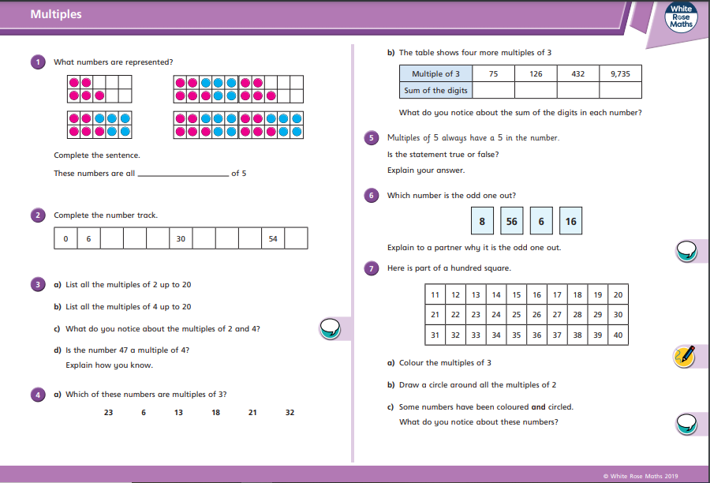
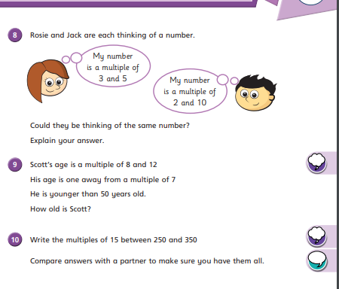

Maths Lesson 2
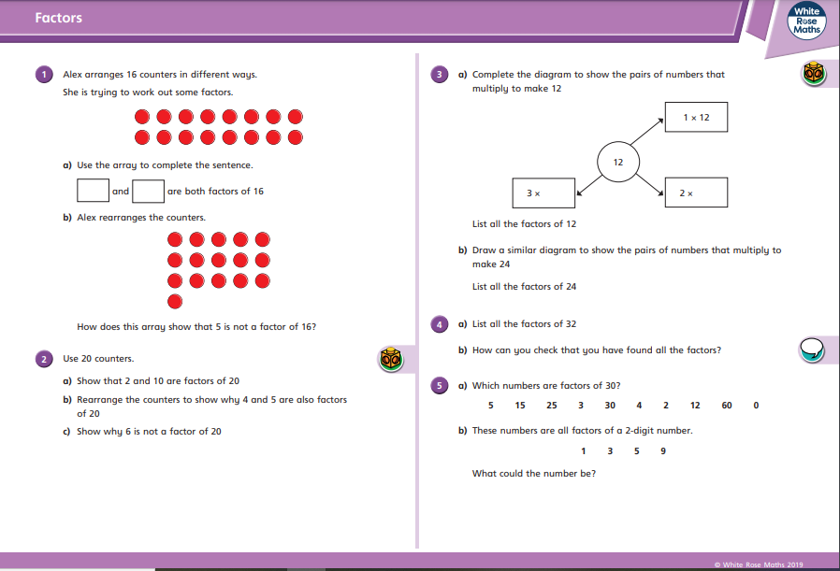
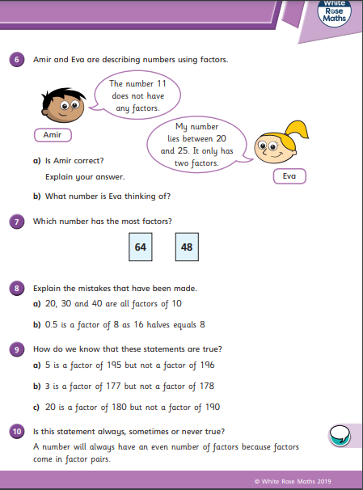
English Task Day 1
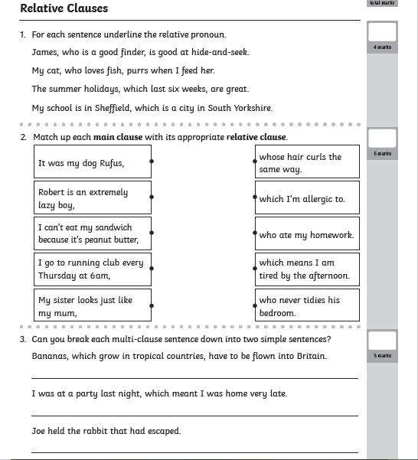
Science Activity
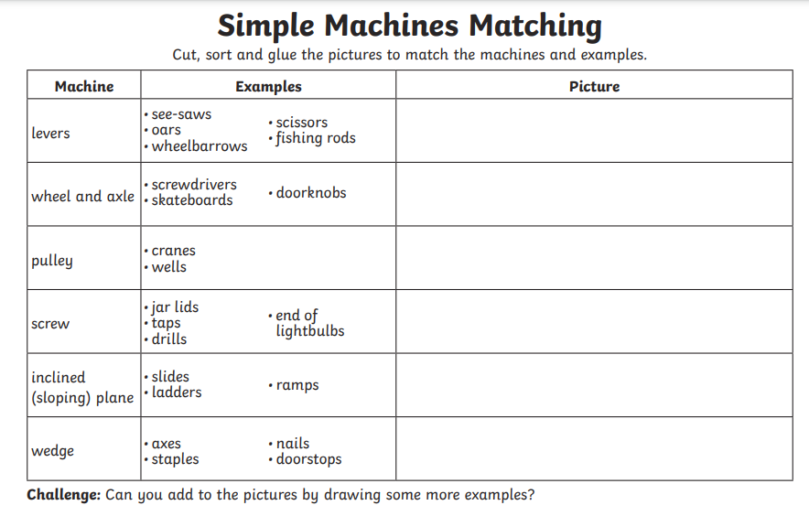

Topic – Geography Paper Activity
