Year 4 Week 2
Group 2
Maths | Monday – 1s, 10s, 100s, 1000s  Complete the Maths page 1
Tuesday – Rounding
Play the Rounding game with someone at home. Explain to them the rounding rhyme and how it works. If you can’t play the game, have a go at rounding as many numbers as you can.
Find the number, look next door, 5 or more raise the score, 4 or less let it rest

Wednesday – comparing calculations
Complete the Maths page 3

Thursday – word problems
Complete the Maths page 4

Friday –
12 78 182 309 258 1829 3209 7921 6298 9999

- Multiply each of the numbers by 10
- Divide each of the numbers by 10

English | Monday  1) Read through the Impossibly Possible Bookshop again (from week 1)  Answer these questions:  - How is the man in the bookshop described?  - Why do you think that the book that Sammy chose caught his eye?  - Was it light or dark in the bookshop? How do you know?  - How did Sammy know he was at a birthday party?  - Do you think Grandmama knew about the bookshop before Sammy went in? why?
Tuesday
- Create your own goblins. Draw 2 of your own goblins – Cloud Goblin, Chocolate Goblin or slime Goblin.
- Write 3 facts about your goblins. What do they eat? where do they live? Do they have any special powers or skills? Do they have any enemies or other friends? What are they bad at?

Wednesday
- Write 3 expanded noun phrases to describe 1 of your goblins in more detail.
- Write 3 expanded noun phrases to describe where 1 of your goblins lives.

Remember an expanded noun phrase gives more detail to something. Use 1 or 2 adjectives and a preposition is e.g. He had a bobbly, ugly wart on the end of his nose.

Thursday
Use your expanded noun phrases to write a character description about your chosen goblin. Use Fronted adverbials for when, where or how – to start sentences.

Friday
- Design and draw a birthday cake for your goblin.
- Write a set of instructions for how to make this cake

Science | Conduct a demonstration to explore the density of different liquids. Take a clear container and equal amounts of honey, milk, water, vegetable oil, golden syrup and washing up liquid. Colour the water and milk if you want to. Slowly pour the honey into the container making sure to pour it into the middle and not drip it down the side. Follow this with the golden syrup, washing up liquid, milk, water and finally vegetable oil.  Draw a picture of the demonstration. Can you write about what you notice about this demonstration. Which liquid do you think is most and least dense and why?
RE | 1) Find Colossians 3:13  Bearing with one another and, if one has a complaint against another, forgiving each other; as the Lord has forgiven you, so you also must forgive.  This is just one passage in the Bible that asks us to be forgiving to each other. Can you find and  copy some more?  Why do you think it is important to forgive others?  2) Why do you think that Jesus was followed and respected by so many people?  From everything that you have read in the Bible and learnt in your RE lessons think about what made him such a valuable leader?  Make a mind map and around the outside list words that you think best describe Jesus, some short phrases to give reasons why you think people followed him and use evidence from your knowledge of his actions to support your explanations.
Topic | South America  Choose a country in South America to research. Create a factfile for the country showing information about the people who live there and the main features of the country
PE | Create a circuit in your back garden with at least 5 different exercises. You can use, sit ups, star jumps, use a bat and ball, dribble a football, sprints etc. Do each exercise for 1 minute then rest for a minute before moving onto the next one. Don’t forget to do some stretches at the start and end to warm up and cool down
Art | Make a collage that might represent a volcano erupting. Use tissue paper, sweet wrappers, old material, felt tips, paint, anything in the colours that you think best represents a volcano. You can stick papers and materials on using tape, glue, paper clips – anything you have around the house.
French | Draw a picture of a picnic, include the following foods and label them on the picnic:  Le lait, le fromage, le pain, la glace, le poulet, le chocolat, le jus d‘orange, le jambon, le gateau, la pomme, les fraises
PSHE | Talk to your parents about your grandparents, aunts and uncles. What do they remember from when they were children? What were their favorite things to do? Did they go on any trips together?  Make a family tree to show at least 3 generations of your family, from you up to your grandparents or further. You could draw something like the one on page 4, draw a tree to place your family on or create a 3D effect with leaves to stick on and use collage materials to make the tree!

Maths page 1
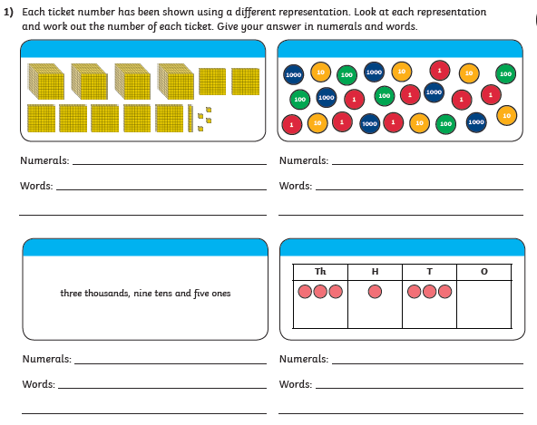
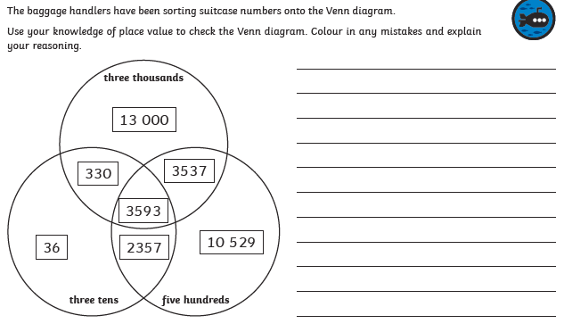
2)

Rounding game
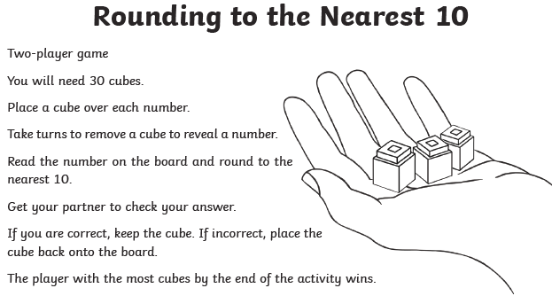
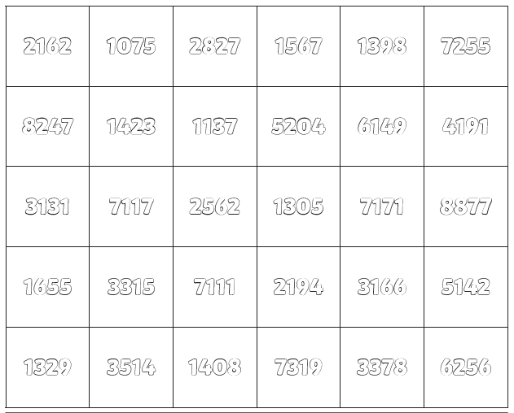

Maths page 3
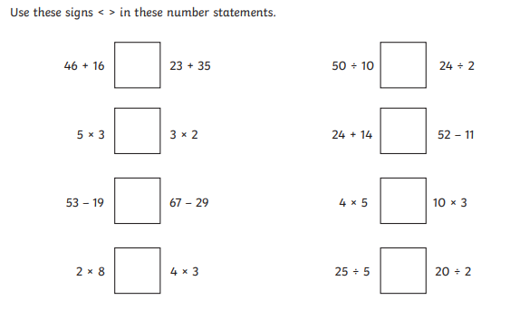

Maths page 4
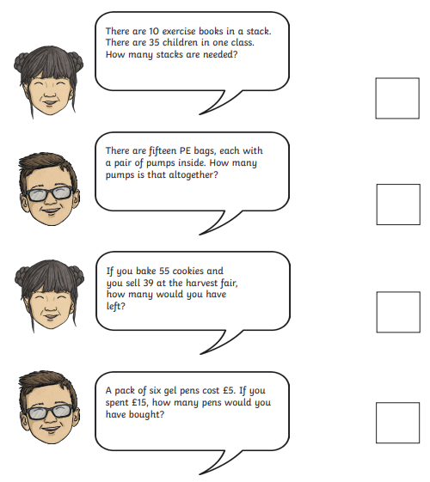

- Write some of your own word problems

