Year Two: 2 day block of work
This document outlines details of work which is to be completed for the first 2 days of your child’s isolation period. There are 2 lessons for Maths, English, Phonics and Reading and 2 additional lessons from various subjects to complete. For Maths and English, the * indicates the level of challenge. Allow you child to choose the level of challenge they feel most comfortable with. For most children, this will be the two-star option (**).
Maths | English
Activity 1  Make a 100 square. On a piece of paper, draw a grid of 10 squares x 10 squares. Alternatively, print out or copy the grid below. Starting with 1, fill in each square to make a 100 square. Ask an adult to cover up 5 different numbers and see if you can say what numbers are hiding.  Tasks  *Use your 100 square to choose a number and say what is 1 more than and 1 less than.  **Use your 100 square to choose a number and say what is 10 more than and 10 less than.  ***Use your 100 square to solve these additions and subtractions:  23+40=  76-30=  45+30=  92-70=  13+70=  100-60= | Activity 1  Look at the four different images below. There are 4 pictures of different settings. I would like you to choose a picture and describe the setting. Try and use rich, descriptive language so that I can tell which picture you are describing just by reading your writing. Choose your level of challenge:  * Write simple sentences using your senses e.g. I can hear…. I can smell…I can see… etc.  **Use expanded noun phrases to describe. remember, these are 2 adjectives used to describe a noun e.g. a tall, rough tree.  ***Write the setting description as if you are actually in that setting, like a story. For example, use sentences like ‘As I walked through the dark, spooky forest, I could feel the cold wind against my skin.’
Activity 2  Revise your number bonds to and within 20 by completing the number pyramids below. In a number pyramid, the two bricks below must add up to equal the brick above. Look at my example for more help with this.  *Change the top brick to 10 instead of 20.  ** Complete the 3 pyramids below.  ***Change the top bricks to any 2-digit number. | Activity 2  Think about your favourite story. Why is it your favourite? What do you like about it? What happens in your story?  Write a letter to me explaining what your favourite story is and why you like it. You could also tell me what happens in the story. Remember to begin and end your letter properly.
Phonics | Reading
Activity 1  Read the sentences on the activity below and draw a line to match the sentence to the appropriate picture. | Activity 1  Read your reading book from school. Tell an adult what happened in the story. Who were the main characters? What was the plot? Does it remind you of any other stories you have read? If you would like more books to read, log onto the Oxford Owl website and read the ebooks that match your book band.
Activity 2  Practise your most recent set of spellings by writing them out in pyramid form. Look on the back of your spelling sheet for help with this. | Activity 2  Complete the reading comprehension below by reading the text then answering the questions.
Geography | RE
Using the internet, any books you have or just your own knowledge, create a fact file about the United Kingdom. You could include what the 4 countries of the UK are, what their capital cities are, famous landmarks in each country and their human and physical features. You could do this as a poster or a leaflet. | Watch this clip to learn about Jesus choosing his first two disciples. https://www.bbc.co.uk/bitesize/clips/zbyr87h  Then, write the story in your own words. If this is too tricky, retell the story verbally to an adult.
Maths Activity 1

Maths Activity 2
20 is the number at the top of my pyramid, so the 2 bricks below have to add to equal 20. I chose 16+4=20. Now I need to make sure the bottom bricks equal the bricks above them. The first 2 bricks on the bottom row need to equal 16. There are lots of answers, but the middle brick on the bottom needs to add with the last brick to equal 4, so I’ve got to put a number in the middle smaller than 16 and 4. I chose 3. That means the first bottom brick is 13 because 13+3=16 and the last bottom brick is 1 because 3+1=4.
Example
1
13
3
4
16
20

Your turn:

20

20

20

English Activity 1
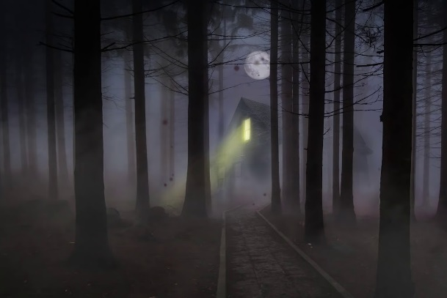
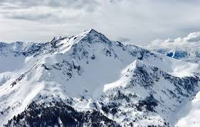

Choose one of these images and describe the setting (see details above).
Phonics Activity 1
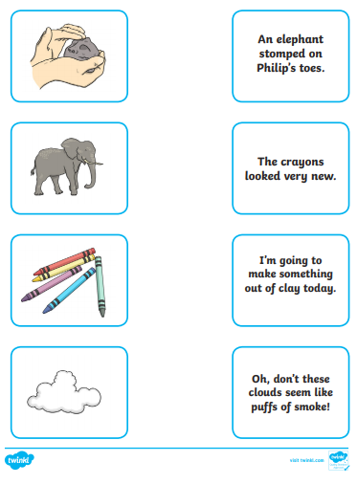

Reading Activity 2
