Year 4 Week 2
Group 1
Maths | Monday – Number Partitioning  Complete each question by filling in the values of the 1s, 10s and 100s in each number
Tuesday – 10 more or 10 less
Complete the maze

 | Wednesday – Complete the number bonds page
 | Thursday – Complete the 3 times table activity sheet
Friday –
Multiply each of these number by 10. Remember, each moves up one place in a place value grid.
12 53 72 85 91 142 287 421 736 768

English | Monday  1) Read through the Impossibly Possible Bookshop again  Answer these questions:  - Write 3 words that describe the man in the bookshop.  - Where did grandmama go before Sammy went into the bookshop?  - How did Sammy reach the book on the high shelf?  - Are the goblins kind? How do you know?  - What did grandmamma do when Sammy came out of the bookshop?
Tuesday
- Create and draw your own goblin. Choose from a Cloud Goblin, Chocolate Goblin or slime Goblin.
- Write 3 facts about your goblin. What do they eat? Where do they live? Do they have any special powers or skills? Do they have any enemies or other friends?

Wednesday
- Write some adjectives to describe 1 of your goblins in more detail
- Write some sentences with adjectives to describe where your goblin lives and what they like to do

Thursday
Use your adjectives to write a character description about your chosen goblin and where they live. Use the English page sheet and fill in the gaps.

Friday
Design a birthday cake that your goblin would love. Draw a picture of it and write a list of ingredients you might use to make it. Could you write some sentences to describe it too?
Science | Conduct a demonstration to explore the density of different liquids. Take a clear container and equal amounts of honey, milk, water, vegetable oil, golden syrup and washing up liquid. Colour the water and milk if you want to. Slowly pour the honey into the container making sure to pour it into the middle and not drip it down the side. Follow this with the golden syrup, washing up liquid, milk, water and finally vegetable oil.  Can you draw a diagram about this demonstration and write about what you notice about it. Which liquid do you think is most and least dense and why?
RE | 1) Find Colossians 3:13  Bearing with one another and, if one has a complaint against another, forgiving each other; as the Lord has forgiven you, so you also must forgive.  This is just one passage in the Bible that asks us to be forgiving to each other. Can you find and  copy some more?  Why do you think it is important to forgive others?  2) Why do you think that Jesus was followed and respected by so many people?  From everything that you have read in the Bible and learnt in your RE lessons think about what made him such a valuable leader?  Make a mind map and around the outside list words that you think best describe Jesus, some short phrases to give reasons why you think people followed him and use evidence from your knowledge of his actions to support your explanations.
Topic | South American  Can you look at Chile on a map. Try to draw it, and label the capital city on the country that you draw.
PE | Create a circuit in your back garden with at least 5 different exercises. You can use, sit ups, star jumps, use a bat and ball, dribble a football, sprints. Do each exercise for 1 minute then rest for a minute before moving onto the next one.  Don’t forget to do some stretches at the start and end to warm up and cool down.
Art | Make a collage that might represent a volcano erupting. Use tissue paper, sweet wrappers, old material, felt tips, paint, anything in the colours that you think best represents a volcano. You can stick papers and materials on using tape, glue, paper clips – anything you have around the house.
French | Draw a picture of a picnic, include the following foods and label them on the picnic:  Le lait, le fromage, le pain, la glace, le poulet, le chocolat, le jus d‘orange, le jambon, le gateau, la pomme, les fraises
PSHE | Talk to your parents about your grandparents, aunts and uncles. What do they remember from when they were children? What were their favorite things to do? Did they go on any trips together?  Make a family tree to show at least 3 generations of your family, from you up to your grandparents or further. You could draw something like the one on page 4, draw a tree to place your family on or create a 3D effect with leaves to stick on and use collage materials to make the tree!

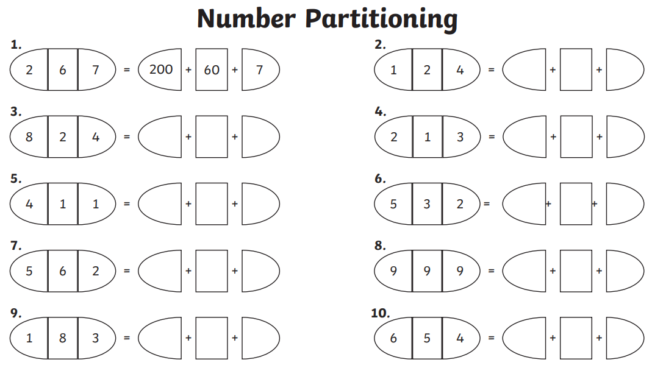

10 more or 10 less
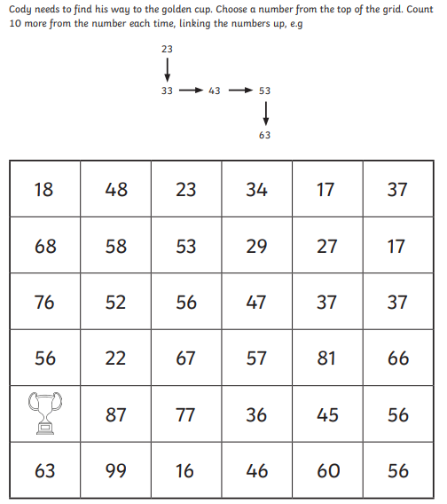

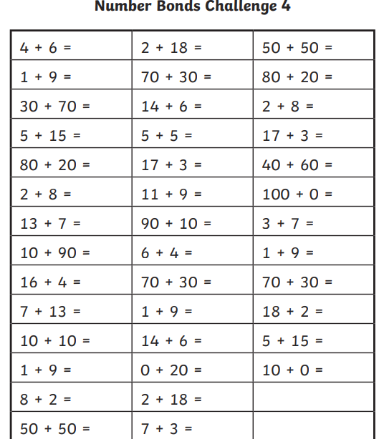

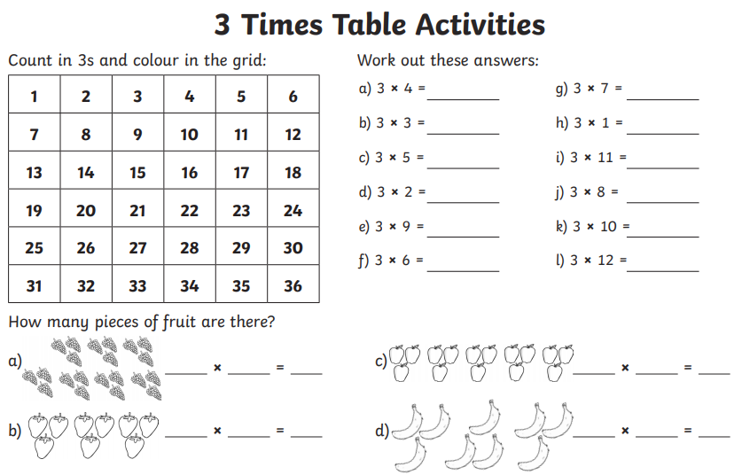

English page
The __________ goblin is _______________, it looks very ________________ and walk around really ________________.
This goblin lives __________________________, with their friends the _____________________________.
These goblins eat ______________________________ because _______________________________________.
They have enemies that are _______________________________________ and so they have to look out for them when they ________________________________________________________________________________________ .
You would like these goblins because ___________________________________________________________ but make sure that you don’t _________________________________________ because __________________________________ .

