Year 4 | Week 1
Group 3
Maths | Monday – 1s, 10s, 100s, 1000s  - What are the values of each of the underlined digits  268 190 2891 1723 8926 12,280 28,098  - Write each number out in words  - Multiply each of the numbers by 10, now what are the values of each of the underlined digits?
Tuesday – Rounding
Round these numbers to the nearest 10, 100 and 1000:
32 89 253 716 1823 3279 9935 12,521 27,102 30,791

Remember: Find the number, look next door, 5 or more raise the score, 4 or less let it rest.

 | Wednesday – Complete the addition questions
 | Thursday – Complete the subtraction questions
Friday – Real life maths
- Ask an adult for a receipt. How many combinations of items can you find that you could buy with £5.00 of £10.00?
- For each combination, how much change would you have?

English | Monday  1) Read through The Impossibly Possible Bookshop  2) Complete – Let’s chat about the story  3) Write a prediction for what you think might happen next
Tuesday
Write a diary entry for Sammy, for when he gets home that night. Don’t forget to use fronted adverbials for when and feelings for Sammy. Also include a part at the end for what Sammy might plan to do the next day.
Wednesday
1) Read the story again
2) Complete the Quiz. Underline or highlight the clues in the text that help you to answer
3) Complete the additional 4 questions on page 12

Thursday
- Complete a comic strip of the story by deciding on the 6 main parts. Draw a picture to illustrate what is happening and write 1 or 2 sentences to explain what is happening in each part of the story.
- Take a sentence from each part of the story and up-level it.

Friday
- Have a look at the table for vocabulary from the story. Write a definition for each word.
- Write each word in a sentence.
- Could you think of a synonym for each word as an alternative?

Science | A fair test is an experiment that only changes the variable that you are testing. Plan an experiment to see how the temperature of water affects how long it takes for a spoon of sugar to dissolve. Make a prediction for what might happen, write a list of equipment, a method, a table for the results and a conclusion to talk about what happened with the results.  If you don’t have a thermometer – use freshly boiled water, water that has been left for a short time and water from the cold tap. Present your findings in a table.
RE | 1) Plan a collective worship based on the theme of helping people. Think about a verse, reading, poem, prayer or video you might share and what you might ask our class to do in response to this. E.g. say a prayer, think about the message, do a craft activity.  2) The Bible references water many times. Look up the following bible verses and write them down. Include a note for each to show what the water represents.  Hebrews 10:22 Isaiah 12:3 Isaiah 43:2 John 3:5  Matthew 3:11 2 Samuel 22:17  Why do you think that the bible makes reference to water so often?
Topic | South America  - Use the map to locate and label the countries in South America  - Mark the capital cities of each country on the map and any main rivers or landmarks.
PE | Practice your triple jump technique.  Hop on one leg – leap to the next foot – jump with both feet. Do this 3 times and measure the length of your jump each time. Work out what your average length of jump is.  Don’t forget: land with a slight bend in your knees, swing your arms for extra momentum, measure your jump from start point to the back of your closest heel.
Art | Take a look around your house and sketch any plants, objects or pets that you have. Make labels or notes about the colours of the different objects or the materials they are made from. Add colour to your sketches with paints, crayons, or even by using cross hatching with your pencil.
French | Complete these calculations and write the answers in French:  e.g. dix + dix = vingt  - vingt + six =  - douze + douze =  - trente + un =  - dix + dix + dix =  - vingt + huit =  - trente – trois =  - vingt – quatre =  - dix – deux =  - quatorze – neuf =  - dix-huit – cinq =
PSHE | There are many things that happen that are out of our control, like not being able to see our loved ones at the moment or when a younger sibling spills juice on a favorite toy. This can sometimes feel a bit frustrating. However, there are definitely some things that we can control, such as making sure we call the people we love so we don’t miss them too much or keeping our things tidy so they don’t get lost or damaged.  Draw around your hand – on each finger, list something that is within your control. Around the outside, write things that are outside of your control and think about what you can do about them.
Computing | Meeting people online and meeting people face to face is definitely different. There are things that you know for certain when you can see someone face to face and there may be less that you know for certain when meeting a person online.  Do a comparison and write down what you can know for certain in each case.  Make a poster to include some dos and don’ts to help people to be safe online

Addition

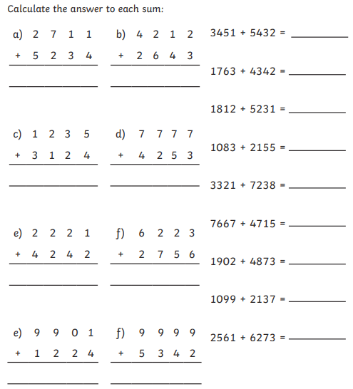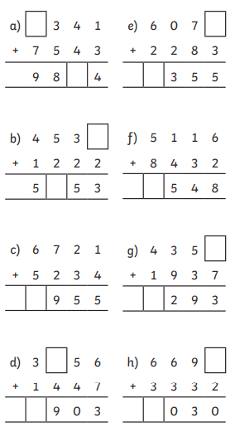

Subtraction
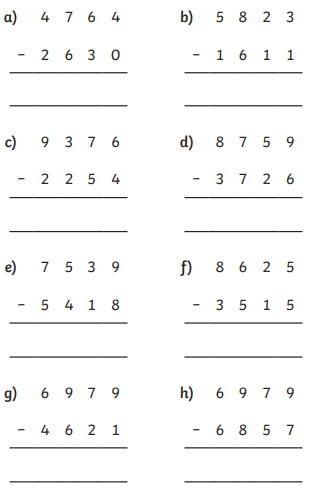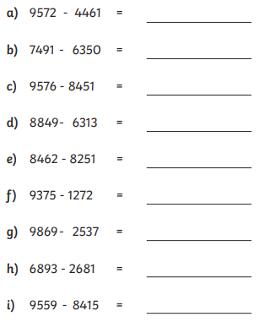

English

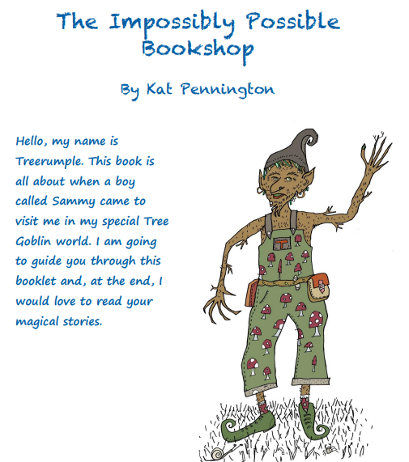

Listen to an audio recording of this story here: https://soundcloud.com/talkforwriting/bookshop/s-WQRn0LBZ1ho
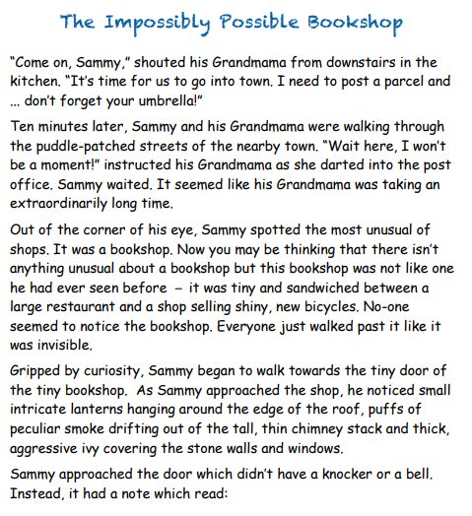

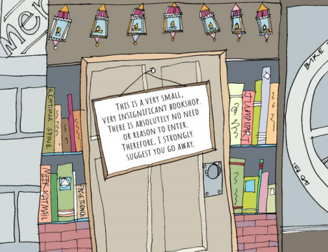
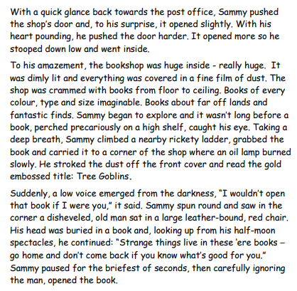

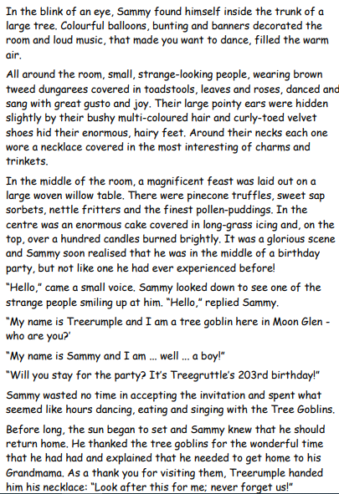

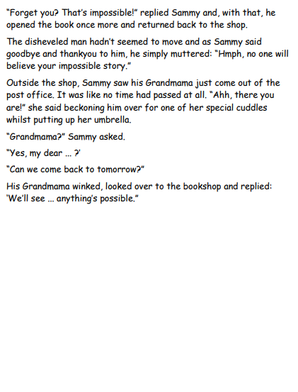
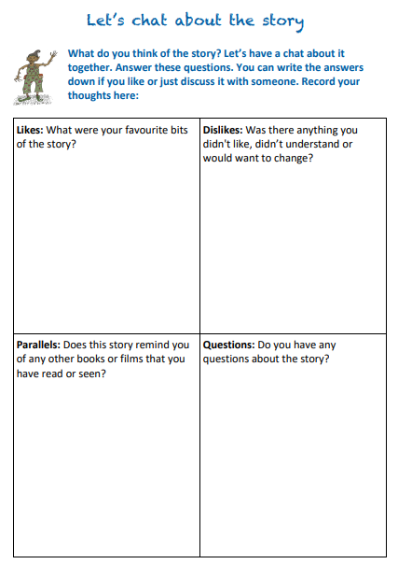

Quiz
Hello! Treerumple here again, fancy doing my quiz? It is all about the story that you have just read. I find it helpful to read the story a few times. Why not circle or highlight the story where you find the answer?
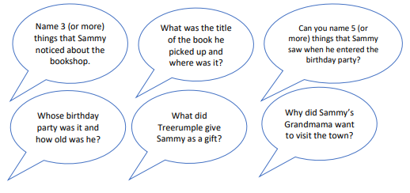
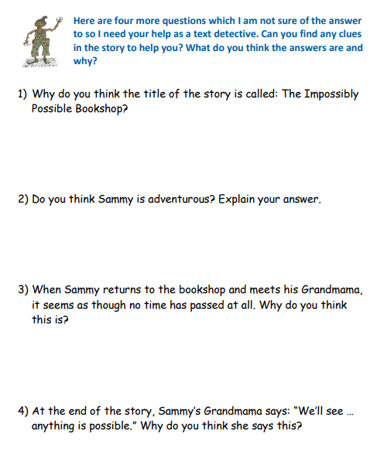

Comic strip
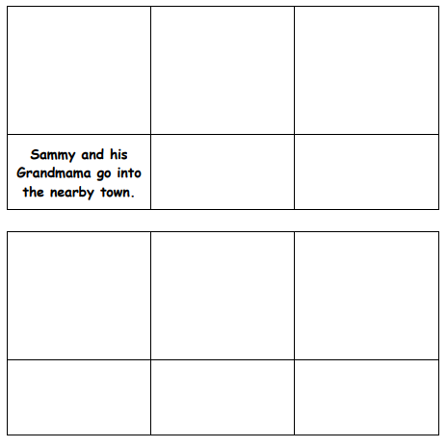

Definitions

Science
Prediction
__________________________________________________________________________________________
__________________________________________________________________________________________

Equipment
____________________________________
____________________________________
____________________________________
____________________________________
____________________________________

Diagram of the equipment
Method
__________________________________________________________________________________________
__________________________________________________________________________________________
__________________________________________________________________________________________
__________________________________________________________________________________________
__________________________________________________________________________________________
__________________________________________________________________________________________

 | Test 1 | Test 2 | Test 3
Time
Conclusion
__________________________________________________________________________________________
__________________________________________________________________________________________
__________________________________________________________________________________________

Topic


 

 

 

 

 

 

 

 

 

 

 

 

 

