Year 4 | Week 1
Group 2
Maths | Monday – 1s, 10s, 100s, 1000s  1) What are the values of each of the underlined digits  25 16 99 268 190 2891 1023 8926 1789  2) Write each number out in words.
Tuesday – Rounding
Round these numbers to the nearest 10, 100 and 1000:
32 99 852 253 716 1823 3279 8935

Remember: Find the number, look next door, 5 or more raise the score, 4 or less let it rest.

 | Wednesday – Complete the addition questions
 | Thursday – Complete the subtraction questions
Friday –
Ask an adult for a receipt. How many combinations of items can you find that you could buy with £5.00 of £10.00?

English | Monday  1) Read through The Impossibly Possible Bookshop  2) Complete page – Let’s chat about the story
Tuesday
Complete a text map for the story – remember only use 1 or 2 symbols or pictures for each sentence. Pick out the main points and keep drawings simple.
Rehearse the story until you know it off by heart

Wednesday
1) Read the story again
2) Complete the Quiz. Underline or highlight the clues in the text that help you to answer

Thursday
Complete a comic strip of the story by deciding on the 6 main parts, draw a picture to illustrate what is happening and write 1 or 2 sentences to explain what is happening in each part of the story.

Friday
Have a look at the table for vocabulary from the story.
1) Write a definition for each word.
2) Choose your 3 favourite words and write a sentence for each one.

Science | Plan an experiment to see how the temperature of water affects how long it takes for a spoon of sugar to dissolve. Make a prediction for what might happen, write a list of equipment, a method, a table for the results and a conclusion to talk about what happened with the results.  If you don’t have a thermometer – use freshly boiled water, water that has been left for a short time and water from the cold tap. Present your findings in a table.
RE | 1) Plan a collective worship based on the theme of helping people. Think about a verse, reading, poem, prayer or video you might share and what you might ask our class to do in response to this. E.g. say a prayer, think about the message, do a craft activity.  2) The Bible references water many times, it is a source of life and symbolism of faith and redemption. Look up the following bible verses and write them down. Include a note for each to show what the water represents.  Hebrews 10:22 Isaiah 12:3 Isaiah 43:2 John 3:5  Matthew 3:11 2 Samuel 22:17
Topic | South America  Use the map to locate and label the countries in South America  Could you also find out what the capital cities are for each country?
PE | Practice your triple jump technique. Hop on one leg – leap to the next foot – jump with both feet. Do this 3 times and measure the length of your jump each time.  Don’t forget: land with a slight bend in your knees, swing your arms for extra momentum, measure your jump from start point to the back of your closest heel.
Art | Take a look around your house and sketch any plants, objects or pets that you have. Make labels or notes about the colours of the different objects or the materials they are made from. Add colour to your sketches with paints, crayons, or even by using cross hatching with your pencil.
French | Complete these calculations and write the answers in French:  e.g. dix + dix = vingt  - vingt + six =  - douze + douze =  - trente + un =  - dix + dix + dix =  - vingt + huit =  - trente – trois =  - vingt – quatre =  - dix – deux =  - quatorze – neuf =  - dix-huit – cinq =
PSHE | There are many things that happen that are out of our control, like not being able to see our loved ones at the moment or when a younger sibling spills juice on a favorite toy. This can sometimes feel a bit frustrating. However, there are definitely some things that we can control, such as making sure we call the people we love so we don’t miss them too much or keeping our things tidy so they don’t get lost or damaged.  Draw around your hand – on each finger, list something that is within your control. Around the outside, write things that are outside of your control and think about what you can do about them.
Computing | Meeting people online and meeting people face to face is definitely different. There are things that you know for certain when you can see someone face to face and there may be less that you know for certain when meeting a person online.  Do a comparison and write down what you can know for certain in each case.

Addition

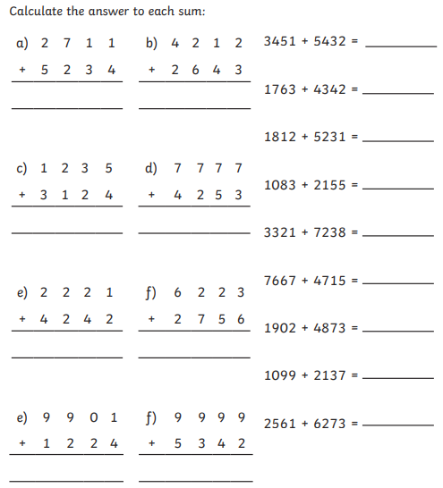

Subtraction

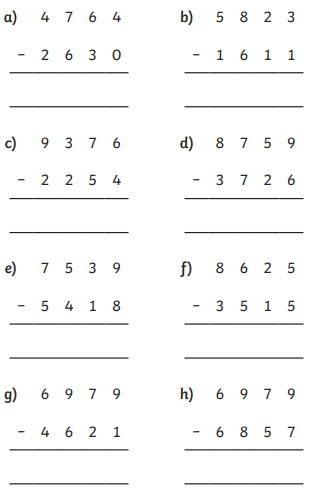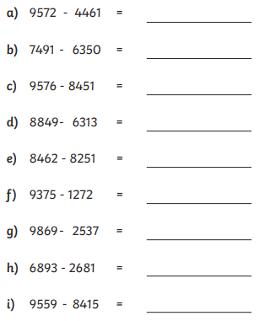

English

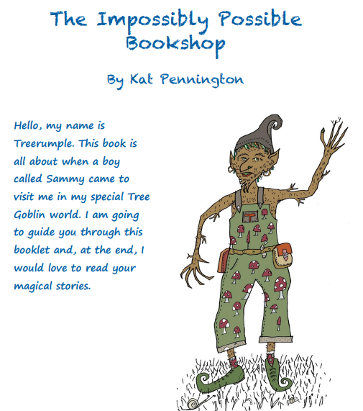

Listen to an audio recording of this story here: https://soundcloud.com/talkforwriting/bookshop/s-WQRn0LBZ1ho
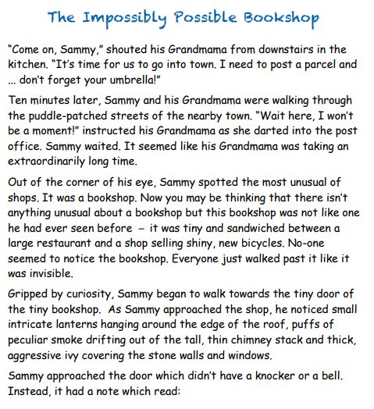

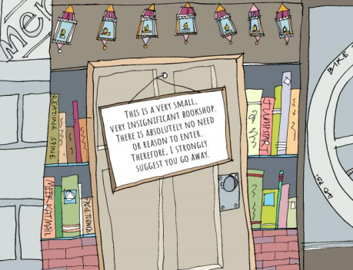

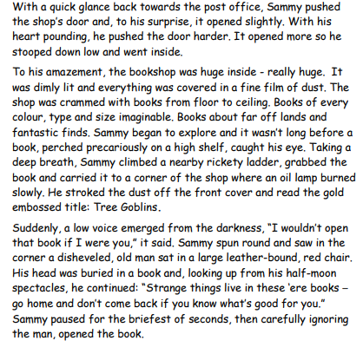

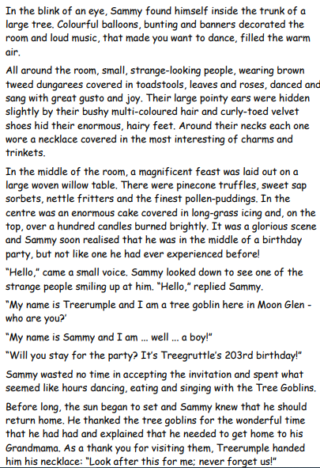

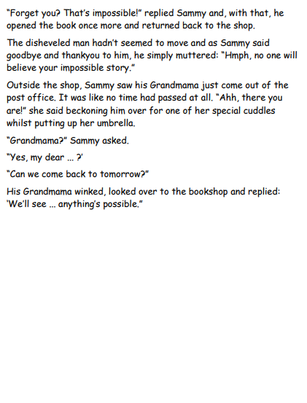
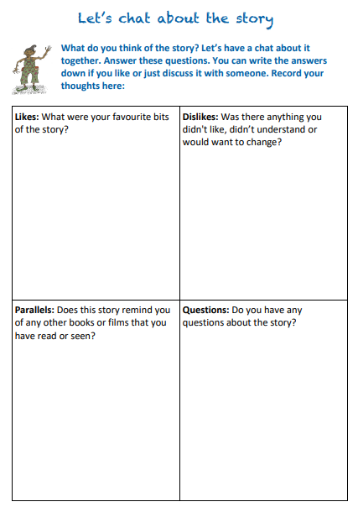

Quiz
Hello! Treerumple here again, fancy doing my quiz? It is all about the story that you have just read. I find it helpful to read the story a few times. Why not circle or highlight the story where you find the answer?
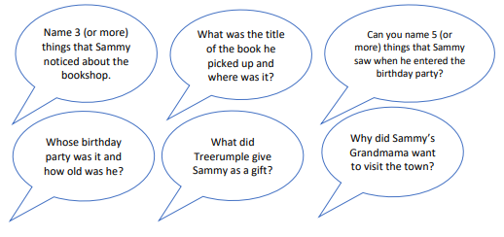

Comic Strip
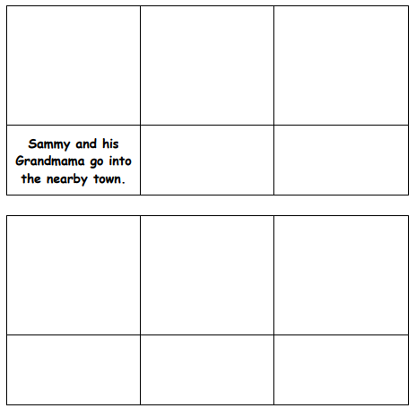

Definitions

Science
Prediction
__________________________________________________________________________________________
__________________________________________________________________________________________

Equipment
____________________________________
____________________________________
____________________________________
____________________________________
____________________________________

Diagram of the equipment
Method
__________________________________________________________________________________________
__________________________________________________________________________________________
__________________________________________________________________________________________
__________________________________________________________________________________________
__________________________________________________________________________________________
__________________________________________________________________________________________

 | Test 1 | Test 2 | Test 3
Time
Conclusion
__________________________________________________________________________________________
__________________________________________________________________________________________
__________________________________________________________________________________________

Topic


 

 

 

 

 

 

 

 

 

 

 

 

 

