Well we had hoped that we would not have to set home learning again! However, here we are. Now that you are in year 6, you may want to create your own table of home learning and treat this as a fresh start to becoming a home learning champion!

If you have any questions at all, or want to share your wonderful work, you can contact us on:
Miss Smith: year6Sm@st-pauls-hyde.tameside.sch.uk
Mrs Shackleton:year6Sh@st-pauls-hyde.tameside.sch.uk

 | This week, in English, we are using your knowledge of WW2 to write flashback narrative stories. They are great for showing action and emotion through language. Please find your daily lessons below.
Monday | WALT understand the structure of a flashback narrative  A flashback is where someone has vivid memories of something that has happened in the past. People thinking back to the past can create an interesting story structure indeed!  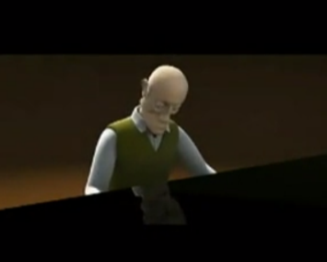  Watch this video: https://www.literacyshed.com/the-piano.html  as an example of showing a flashback.  Read A Veteran Never Forgets.  You are going to plan your own animation to show the story of A Veteran Never Forgets.  Use a storyboard to plan it out. In each box draw a picture to show the story. For example, in the first box, you might draw a man with children round his feet staring at a fire.  Scene 1 Scene 2 Scene 3  Scene 4 Scene 5 Scene 6  Extra Challenge: Can you write a descriptive sentence for each sentence?
Tuesday | WALT understand and use some of the vocabulary used in A Veteran Never Forgets  Can you write what you think the following words mean and then find a definition for the words?  After that, write some sentences that use the words. Write at least 5 sentences. If you write one sentence for each of the words, I will be very impressed!  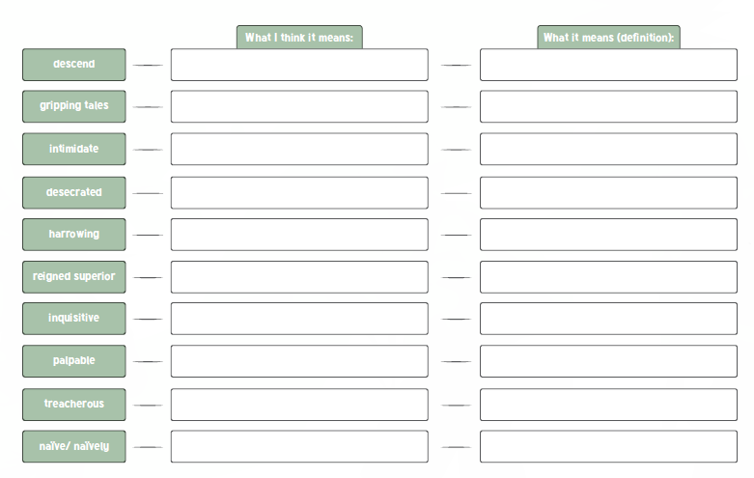  Descend, gripping tales, intimidate, desecrated, harrowing, reigned superior, inquisitive, palpable, treacherous, naïve/ naively
Wednesday | WALT understand the features of a Flashback Narrative.  Have a look at the Features Toolkit document. Find examples of all the features in A Veteran Never Forgets and write them down. You can either print the document to write them on, write them on a piece of paper or copy and paste  Features of a Flashback Narrative Examples Found in the Text.  Past tense narrative contrasting with modern tense narrative.  Varied sentences – longer, complex  and compound sentences mixed  with short sentences for impact  Alliteration on important verbs  and nouns  Personification to create atmosphere.  Fronted adverbials for when, how and where  Character emotion explaining how they feel at different times in the story.  Rhetorical questions.
Thursday | WALT write the start of a Flashback Narrative.  We are going to use the piano video that we watched on Monday to help us with the structure.  First paragraph. Introduce the elderly gentleman in the present My example starting sentence: Every evening, I sit down at my piano for practice. The cold ivory keys feel like a familiar friend to my fingertips.  Second paragraph Shift to how he used to feel when he sat there playing the piano with his wife. My example starting sentence: As the gentle song reaches the next note, I feel a feeling of warmth beside me.
Friday | WALT complete a Flashback narrative  Start by watching the video again. Plan out what the rest of the paragraphs will be (you might want to do a table like I have above).  Write the rest of the flashback narrative, thinking carefully about using language effectively to grip the reader.  If possible, email your finished product to your teacher! We can’t wait to see them!
Reading | WALT select key pieces of information and give an opinion.  Take a look at this website: https://www.bbc.co.uk/bitesize/articles/zbkbgwx  Watch the extracts from “To be a Cat” being read and complete activities 1,2 and 3
Maths | This week, in Maths, we are going to look at 2d shapes and symmetry—whoop!  This website has videos that you can watch and find out all about 2D shape and symmetry.  https://classroom.thenational.academy/units/fractions-8ae5  There are activities for you to complete each day. The activities can be found by pressing the green next at the bottom right-hand corner of the screen once you have watched the video  This week, you will need to complete lessons 1-5.
Computing | What makes a computer game?  https://www.bbc.co.uk/bitesize/topics/zs7s4wx/articles/zw96tfr  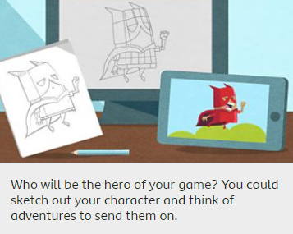  Take a look at this information on what makes a computer game on the left and  Complete the activity to the left.
Science | Who is Katherine Johnson?  In this lesson, we will learn about Katherine Johnson's main achievements and the story of her life. We will learn how she used maths to get rockets into space and back home safely. We will learn what trajectory is and draw the trajectory for different objects.  Click on the link below to find out more:  https://classroom.thenational.academy/lessons/who-is-katherine-johnson-61gpar
PHSE | Deforestation  In this lesson, you will investigate how deforestation impacts animals. You will also understand how human activity plays a major part.  Click on the link below to find out more:  https://classroom.thenational.academy/lessons/deforestation-70vk0c
RE | Gather How would you like people to come together? Is there any music that could be played that would link to your theme? Have you got a prayer focus?  Word of God Choose a passage from the Bible that links with your theme. This is a time to listen to God word and reflect.  Response to the Word May include symbolic action, silence, prayer Plan a small activity will help others reflect on the word of God.  Go forth- Mission What key message have you taken away from this collective worship session?  Collective worship  This week, I would like you to plan a collective worship session based on the kingdom values.  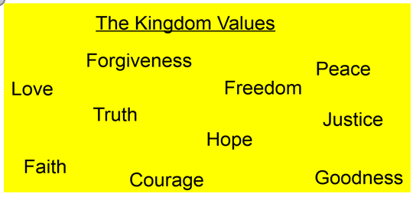
Design and Technology | This week you are going to be inventors and Designers!  Visit this website: https://www.bbc.co.uk/bitesize/articles/zdp9d6f  There are two videos for you to watch: the first, shows you how some designers get ideas; the second, shows you a design process challenge.  Your Activity can be found at the end of the website page. We cannot wait to see your sketches!
Topic | Mountains, Earthquakes and Volcanoes  This half term, we are starting an extremely exciting Geography Topic!  In this first lesson, we are going to be learning about the structure of the earth, what the earth is made of and where volcanoes and earthquakes occur and why.  https://classroom.thenational.academy/lessons/what-is-the-earth-made-of-6hk3ec
PE | This activity will help improve the accuracy of your overarm throw. Collect 6 old containers or cereal boxes. Place them in a line about two inches apart. Stand about 6 metres away and using rolled-up socks or a soft ball, try to hit the target with an overarm throw. Award 1 point for every correctly hit container. You could even move the containers further away or in different positions and more points could be awarded the more difficult the target.

