Year 4 – Day 1 Page 1 of 2
English
Watch this video to recap on compound sentences: https://teachers.thenational.academy/lessons/to-explore-compound-sentences-6wt3jt
Now, think back from Leon and the Place Between, write 2 sentences for each of the coordinating conjunctions discussed in the video: and, but, or
e.g. Leon disappears into the Place Between, but Abdul Kazam stays in the circus.
Here is the story, if you need to remind yourselves: https://www.youtube.com/watch?v=vpjAtvxA3xE
Challenge: Can you use a coordinated conjunction AND a subordinating conjunction in the same sentence to make a complex sentence: when, because, until e.g. Abdul Kazam stays in the circus, but Leon disappears into the Place Between until he gets callled back.
~~~~~~~~~~~~~~~~~~~~~~~~~~~~~~~~~~~~~~~~~~~~~~~
Maths
Watch the roman numerals song and join in! https://www.bing.com/videos/search?q=roman+numerals+song&&view=detail&mid=8B529DFC2164F114A7858B529DFC2164F114A785&&FORM=VRDGAR
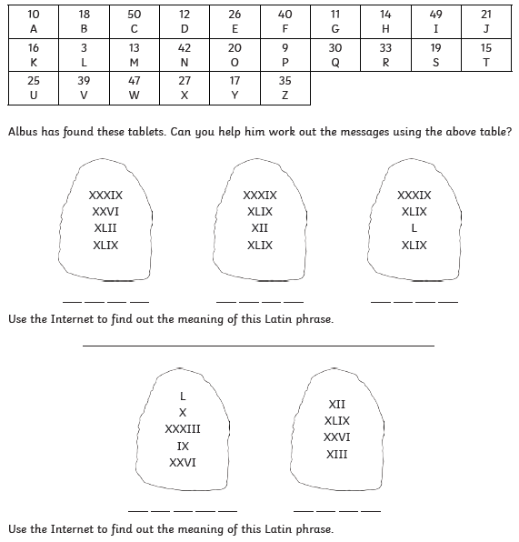

Year 4 – Day 1 Page 2 of 2

Guided Reading – read the Deep Sea Explorers guided reading text on the next page and complete the questions. Here Is a video where you can read along with me: https://vimeo.com/471404219 (password StPauls)
~~~~~~~~~~~~~~~~~~~~~~~~~~~~~~~~~~~~~~~~~~~~~~~

RE
Exodus 14:21-29
²¹ Then Moses stretched out his hand over the sea, and all that night the Lord drove the sea back with a strong east wind and turned it into dry land. The waters were divided, ²² and the Israelites went through the sea on dry ground, with a wall of water on their right and on their left.
²³ The Egyptians pursued them, and all Pharaoh’s horses and chariots and horsemen followed them into the sea. ²⁴ During the last watch of the night the Lord looked down from the pillar of fire and cloud at the Egyptian army and threw it into confusion. ²⁵ He jammed^{[a]} the wheels of their chariots so that they had difficulty driving. And the Egyptians said, “Let’s get away from the Israelites! The Lord is fighting for them against Egypt.”
²⁶ Then the Lord said to Moses, “Stretch out your hand over the sea so that the waters may flow back over the Egyptians and their chariots and horsemen.” ²⁷ Moses stretched out his hand over the sea, and at daybreak the sea went back to its place. The Egyptians were fleeing toward^{[b]} it, and the Lord swept them into the sea. ²⁸ The water flowed back and covered the chariots and horsemen—the entire army of Pharaoh that had followed the Israelites into the sea. Not one of them survived.
²⁹ But the Israelites went through the sea on dry ground, with a wall of water on their right and on their left.

- Draw a comic strip to illustrate this passage.
- What does this story tell us?

Year 4 – Day 2 Page 1 of 1

English
Watch this video to revise your knowledge about word classes: https://classroom.thenational.academy/lessons/to-revise-our-knowledge-of-word-class-c9k6ct?step=1&activity=video Make sure to pause the video when the teacher asks you to so that you can complete the tasks.
- Write at least 5 sentences about what happens in the Place Between using a verb, adverb, adjective and noun in each one. For example: Leon had a huge grin on his face as the carpet swiftly soared above the Place Between.
Challenge: Could you use similes (using like, or as) in your descriptions to make them really imaginative?

~~~~~~~~~~~~~~~~~~~~~~~~~~~~~~~~~~~~~~~~~~~~~~~

Maths
Watch this video about negative numbers and then complete the negative numbers worksheet attached.
https://www.bbc.co.uk/bitesize/topics/znwj6sg/articles/zxthnbk
The questions get trickier as you move through the sheets, just decide how many of the questions you would like to tackle!

~~~~~~~~~~~~~~~~~~~~~~~~~~~~~~~~~~~~~~~~~~~~~~~

Guided Reading – read the Alice in Wonderland guided reading text in the attached document and complete the questions. Here Is a video where you can read along with me: https://vimeo.com/471407093 (password StPauls)

~~~~~~~~~~~~~~~~~~~~~~~~~~~~~~~~~~~~~~~~~~~~~~~

Geography
Watch this video and learn along with the teacher: https://classroom.thenational.academy/lessons/where-are-the-worlds-natural-resources-6mu3et all you will need it a pencil/pen and paper.

