 | Day 1 | Day 2
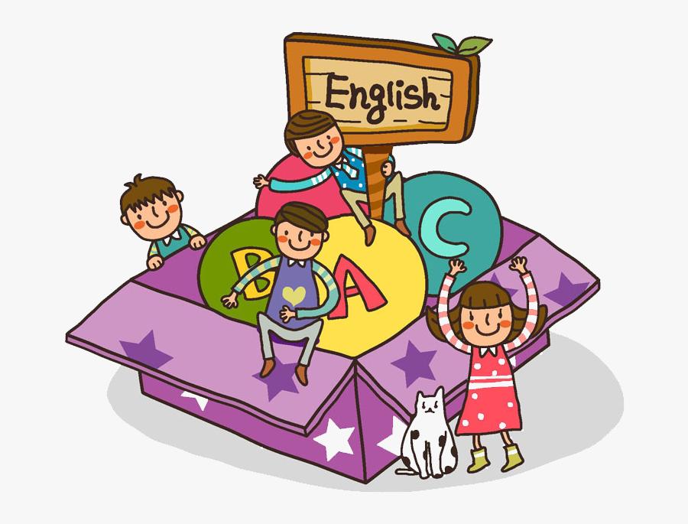  Don’t forget to read your book! | Writing:  If you could have a fantasy pet, what would it be and why? Discuss with your adult and write your answer.  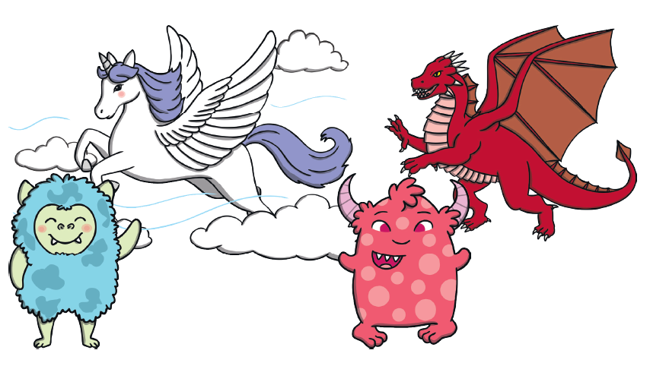  Don’t forget your capital letters and full stops. | Describing:  Draw a picture of your fantasy pet. Write all the adjective you can think of to describe this amazing creature.  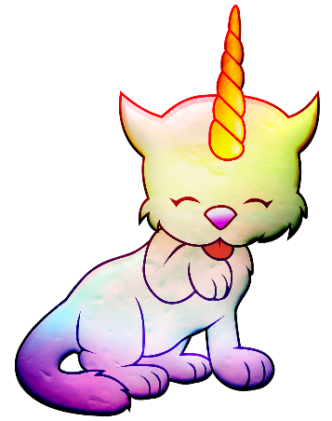  Use these adjectives and write a sentence to describe your pet.
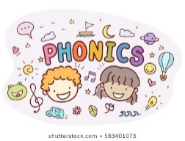 | Tricky words:  Watch the powerpoint- to be found on the year 1 page of the school website.  Read all the words on the bees.  Can you write them too?  Can you use them in a sentence? | Outside activity using chalk:  1. Choose as many words as you like from the phase 3 and 4 tricky word list.  2. Make a path of words using chalk.  3. Follow the path saying the words as you go.
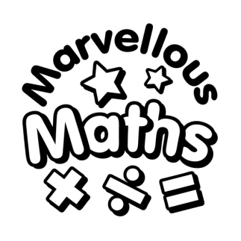 | Counting and comparing:  Fill a bag with beads, beans, bricks or other small items. The better you are at counting, the smaller the objects should be!  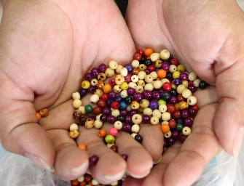  Now take it in turns to grab a handful and count them into a container. Write down how many each person has. Whoever has more wins a counter. The winner is the person with the most counters after 8 turns.  Challenge: play again and this time the person with fewer items gets the counter! | Counting and comparing:  Look at picture…  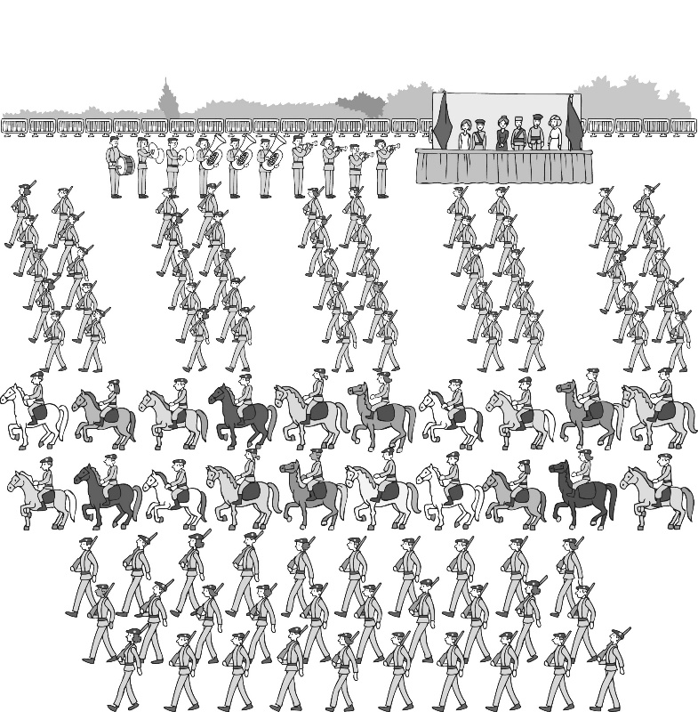  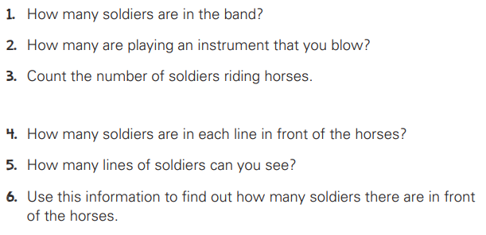
 | Me and My Body:  Lie on a large piece of paper (like wallpaper) and ask someone to draw around you. Now label all your body parts. If it’s a nice day, you could do this outside!  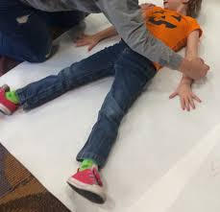  Challenge: Look at pictures of you and your friend, sister, brother, mum or dad. What is the same about you? What is different? You could also use a picture of two people from the newspaper or a magazine. | Me and My Body:  Time to get moving!  You will need to time yourself for 1 minute.  How many…  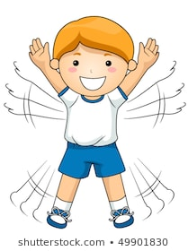  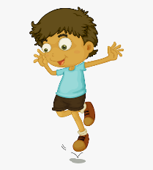  Hops? Star jumps?  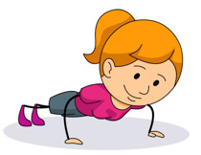  Press ups?  Can you beat your score?  Who is the best in your house?

