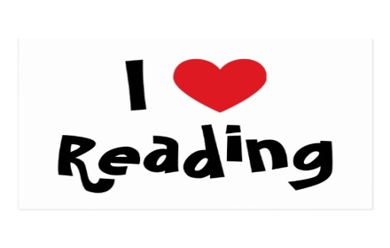
Non-Fiction Book Tasks

Challenge A  Can you find examples of different features of this text type (e.g a subheading, a caption, use of italic font) | Challenge B  What sort of person do you think would use this book? Why? | Challenge C  Find the most interesting 2 pages in the book. In no more than 4 sentences, can you summarise what those 2 pages are about?
Challenge D  Can you suggest ideas for other sections or chapters to go into the book? | Challenge E  Are there any features that it hasn’t got? Why do you think it doesn’t have them? | Challenge F  Can you write 3 questions for somebody else to answer when they read the book that you have just read?  .
Challenge G  Choose 3 sub-headings in the book and up-level them. If there are no sub-headings, can you create 3? | Challenge H  Can you share 5 interesting things that you found out about in the book. | Challenge I  List 5 technical words from the book and what they meant.

