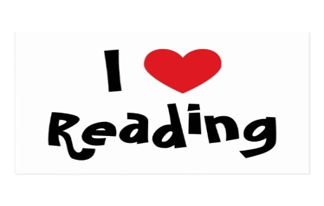
Fiction Book Tasks

Challenge A  Find a word in the text that you haven’t heard of before.  1)Use a dictionary to write a definition.  2)Use a Thesaurus to write three synonyms and three antonyms | Challenge B  How does the story hook you in at the beginning? Make a list of words and phrases that you feel are effective in making you want to read on. Explain why. | Challenge C  Think of 5 questions that you would like to ask one of the characters.
Challenge D  Is this book similar to the last book that you read? Explain why. Can you think of any books that you have read that it is similar to? | Challenge E  Compare two characters in this book. How are they the same? How are they different? | Challenge F  Find a word of which you weren’t sure of the meaning but worked it out. How did you use context to work it out? Write down your strategy.
Challenge G  Compare the main character in this book with the main character in another book you have read. What is the same and different? | Challenge H  If you could ask one question to help you understand the text better, what would it be? | Challenge I  Choose a part of the story and focus on the main character. Say what their thoughts and feelings are at this point and give evidence for your choices.

