Year 5 Home Learning |  | This document outlines the activities/lessons your child to complete at home during the bubble closure. Each activity is explained in detail here, including where to find the activities. There is a Maths and English lesson to complete each day, then a range of activities provided for additional subjects which can be completed at any time. WALT stands for We Are Learning To, which will give you a clear indication of the lesson objective. There will be different levels of challenge for the children to complete for most lessons (*** being the hardest level). The children do not need to complete all three levels. The children can work directly into their home learning book they have been given. Please feel free to email any work or pictures of the work and do not hesitate to email me on year5@st-pauls-hyde.tameside.sch.uk if you require any assistance. Thank you, Mr Titterington.
Week 8 (Spring 2 half term – Week 2)
Maths |  |  | English
Look in the table below to find the information about the lesson, which you need to complete. Once you have read the table, scroll down to the bottom of the document to find the tasks and questions, which you need to complete for each lesson. This week will be focussing on Fractions. It is important that you follow this plan carefully, as this is new learning for us, and is not a recap of learning which we have completed in school.  I will be uploading PowerPoints with videos included which explain the methods which you will need to use. |  |  | Poetry  As this is the final week before returning to school, and we have finished our historical narrative unit on The Saga of Ragnar, we will not start our next non-fiction unit until we are all back in school. During this week, I will set some poetry activities for you and your writing.
1) | Maths Lesson 36 – Adding Fractions  WALT: Add fractions where the answer is greater than 1.  So far this term, we have learnt a range of different techniques to be able to answer fraction questions. In this lesson, we will need to use our knowledge of:  - Finding the lowest common denominator  - Adding fractions when they have the same denominator  - Converting improper fractions into mixed numbers  If you are not feeling confident with any of the above methods, then you will need to look back through the previous weeks’ learning to find and complete those lessons.  In this lesson, we will be given two fractions, where the answer is greater than 1. We should know by now that a fraction that is greater than 1 is either a mixed number or an improper fraction.  To find these answers, you will need to first convert the fractions so that they have the same denominator, because, as we now know, we can’t add two fractions together if they have different denominators. Once the fractions have the same denominator, you add the two fractions, which will give you an improper fraction as an answer. In year 5, we should not leave our answer as an improper fraction, and should use our knowledge to convert our answer into a mixed number. An example of this method can be seen here:  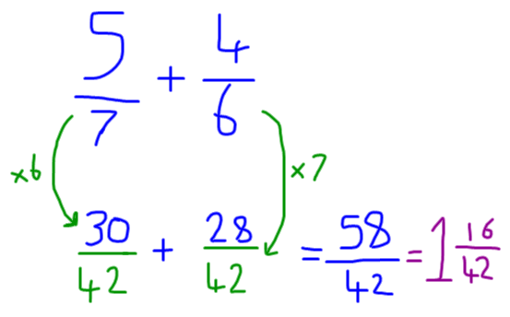  To make our answers even better, we can simplify our fractions to represent the fractions in their simplest form. To do this, we need to divide the numerator and denominator of our answer by the same number. For example: 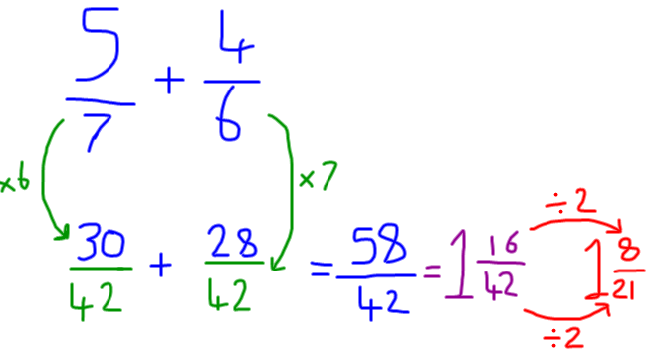  On Google Classroom, you will find a video explaining how to find the lowest common denominator and also how to convert improper fraction answers into mixed numbers.  Challenge Levels  1 Star – Complete the target maths questions, section A 1-8 and Section B 1-8. Section A’s fractions already have the same denominator, for section B you will need to find the common denominator.  2 Star – Complete questions 1 – 3 of the 2 Star Activity sheet.  3 Star – Complete questions 1-3 on the 2 Star worksheet, and the fraction pyramids in question 5. |  | 1) | English Lesson 36 – Poetry Lesson 1 – Repetition - The Mirrors of Wishes  WALT: Use repetition and similes to create a short poem.  In today’s lesson, we will be reading a short poem which uses a repetitive approach to add interest to the poem, and also has the opportunity to use Similes.  Because it is World Book Day this week (on Thursday) I would like you to try to think of some famous book characters, or types of people who you could include in your poem.  Later in this document, and on Google Classroom, you will find a poem written by a man named Pie Corbett, called The Mirrors of Wishes. In this poem, each stanza (paragraph) names a different person, and what they would hope to see in The Mirror of Wishes.  Read the poem and see if you can write your own inspired by Pie Corbett.  Challenge Levels  1 Star – Write a short poem about a range of different people using repetition and a range of people for each stanza.  2 Star – Write a short poem about a range of different people, using repetition and similes in some paragraphs. Similes tell you that something is like something else. For example:  The Teacher looked into the Mirror of wishes  And saw a class of hardworking children as quiet as mice.  3 Star – Write a short poem about a range of different people, using repetition, similes and rhymes.
2) | Maths Lesson 37 - Adding 3 fractions  WALT: Add 3 fractions together with different denominators.  In last week’s maths lesson, we looked at adding 3 different fractions together when they had different denominators. However, there were many people working at home who made mistakes.  The main mistake which people made was that they added fractions which had different denominators, was that they added fractions which had different denominators. When adding fractions, we never add the denominators together.  In this lesson, we will recap how to find the lowest common denominator, similar to how we did yesterday. A reminder that the lowest common denominator, is the number which is a multiple of both of the denominators. When we know what the lowest common denominator is, we can find an equivalent fraction by changing the denominator and numerator by multiplying. An example of this is here:  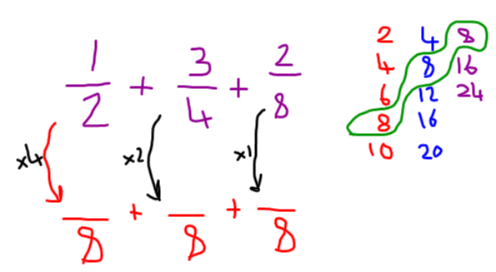  Once we have found the common denominator, we check what we have multiplied the denominator by to get to the common denominator, and then multiply the numerator by the same amount. Once we have done this, we can add the fraction’s numerators together to find the answer.  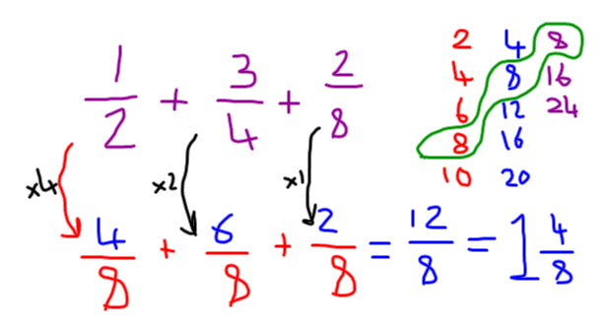  In this lesson, we will be doing this with 3 fractions as shown above, which means that we need to find a number which is in all 3 of the denominator’s times tables.  On Google Classroom, I have provided a video which explains this method in detail. In this lesson, we will be particularly thinking about making sure that we find the lowest common denominator accurately.  Challenge Levels  1 Star – Complete questions 1-3 on the worksheet.  2 Star – Complete questions 1-4 on the worksheet.  3 Star – Complete the 2 star challenge and either the problem solving square question, or the problem solving true or false questions. |  | 2) | English Lesson 37 – Poetry lesson 2 – Alliteration – The Cave of Curiosity  WALT: Write a poem using alliteration inspired by The Cave of Curiosity  Building on our learning from yesterday, we will be reading another poem written by Pie Corbett. In this poem, Pie uses a repetitive pattern and alliteration to create an effective and interesting poem.  Each stanza begins, and repeats, with In the cave of curiosity, I created…  Each stanza then uses alliteration to describe something new which might have been created inside the cave of curiosity. The author has used their imagination to think of unique and interesting items, and described them in different ways.  On Google Classroom, I have uploaded a video reading the poem and have explained the activity in more detail.  Your task is to write your own version of the Cave of Curiosity poem, thinking of your own ideas to create inside of the cave.  Challenge Levels  1 Star – Write your own poem for the cave of curiosity, using imaginative ideas.  2 Star - write your own poem for the cave of curiosity, using imaginative ideas and alliteration to describe the different items. Alliteration is when you use more than one word with the same starting letter or sound, for example: a terrified tarantula tickling a volcano.  3 Star – Complete the 2 star challenge, and similes.  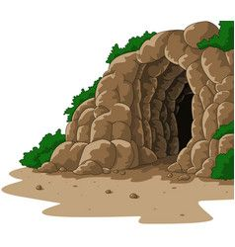
3) | Maths Lesson 38 – Adding mixed fractions  WALT: Add mixed fractions together.  In this lesson, we will be building on our knowledge from the last two days. We will still be finding common denominators of numbers, however this time, they will be mixed fractions, meaning they have a whole number before the fraction.  When we find a common denominator to add the two fractions, we do not need to change the whole number. Once we have found the common denominator, we add the two fractions together, and then add the two whole numbers together.  An example of this is shown here:  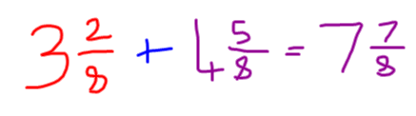  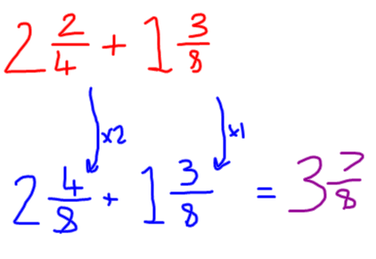  On Google Classroom, I have provided a video which explains this method in detail.  Challenge Levels  1 Star – Play the Mixed Fraction Connect 4 game with someone at home. With your team mate, choose a square, answer the question, and then check whether your partner got the answer correct. If they find the correct answer, then they can colour in the square. The winner is the first person who answers four questions in a line correctly.  2 Star – Answer questions 1-2 of the activity sheet  3 Star – Answer questions 1-5 of the activity sheet. |  | 3) | English Lesson 38 – Poetry Lesson 3 – Limericks  WALT: Write a limerick for a topic of my choice.  During this week, we have thought about different poetic techniques, such as repetition, similes and alliteration.  In this lesson, we will think about a different format for a poem. We will read a limerick poem, a short poem which follows a particular rhythm.  In a limerick, the first, second and 5 line follow the same rhythm and end with a word which rhymes.  Later in this document, and on Google Classroom, I have included an example of two limerick poems. Both follow a similar pattern and rhythm. This link from BBC Bitesize also includes a video and information about how to write an effective limerick: https://www.bbc.co.uk/bitesize/topics/z4mmn39/articles/zw3yw6f  For your task today, I would like you to think of your own topic, and write a limerick for it. Because it is the week of World Book Day, it might be that you think about a topic based on one of your favourite books that you have read during the lockdown period.  On Google Classroom, I have uploaded a video explaining this task in more detail.  Challenge Levels  1 Star – Write your own limerick for a topic of your choice.  2 Star – Write two of your own limericks, where one of them is based on World Book Day.  3 Star – Write three of your own limericks, where one of them is based on World Book Day.
4) | World Book Day  Take a look at the separate World Book Day planning sheet for today’s Maths Activity  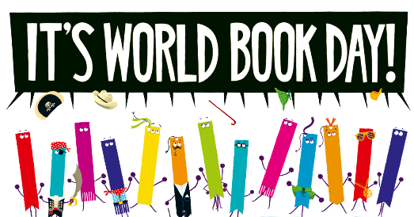 |  | 4) | World Book Day  Take a look at the separate World Book Day planning sheet for today’s English Activity
5) | Maths Lesson 40 – Subtracting Fractions  WALT: Find the common denominator to subtract fractions.  So far in the fraction unit, we have focussed mainly on adding fractions. Today, we will be completing our first lesson on subtracting fractions. In this lesson, we will be subtracting fractions which have different denominators. Because of this, we will need to use our knowledge of finding the lowest common denominator, just like we did in Monday and Tuesday’s lesson this week, in order to find the answer. Once we have found a lowest common denominator, we can subtract the numerators from one another to find our fraction answer.  An example of this method can be seen here:  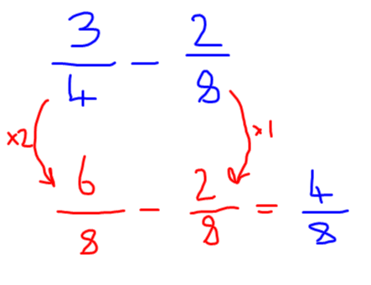  On Google Classroom, I have provided a video which explains this method in detail.  Challenge Levels  1 Star – Complete the subtracting fractions 1 star activity questions  2 Star – Complete the problem solving and reasoning problems on the 2 Star activity sheet.  3 Star – Complete the discussion problem with someone at home. |  | 5) | English Lesson 40 – Poetry Lesson 4 – Sonnets - Syllables  WALT: Write a Sonnet inspired by William Shakespeare, thinking about the number of syllables on each line.  In this lesson, we will be adding a little more challenge to our poetry learning. So far we have learnt about: repetition, rhyming, alliteration and similes. In this lesson, we will learn about the features of Sonnet. William Shakespeare was well known for writing Sonnets, which are a type of poem.  On Google Classroom, and later in this document, I have included a copy of Shakespeare’s Sonnet 18. This poem has some complicated language, however we will be focussing on the features of a sonnet today, and in particular, the syllables.  A Sonnet usually has 10 syllables on each line. For example, the first line in the Sonnet 18 is: Shall I compare thee to a summer’s day?  This line of the poem has 10 syllables.  A syllable helps to build rhythm in a poem, and is the beat of the words.  For example, the word laptop has 2 syllables: lap-top  The word temperature has 4 syllables: temp-er-a-ture  Each line should only have words with 10 syllables. In the poem, you should notice that each of the even numbered lines end with a word which rhymes.  For your task, I would like you to pick your own topic, it could be anything of your choice to write about, and then write your own Sonnet using syllables and rhymes.  Challenge Levels  1 Star – Practice using syllables by writing some of your own individual lines which have 10 syllables.  2 Star - Write a poem for a topic of your choice in the form of a Sonnet, thinking about syllables and rhyme.  3 Star - Write a poem for a topic of your choice in the form of a Sonnet, thinking about syllables and rhyme. Could you possibly use a simile in your poem?

Additional Subjects- To be completed anytime over next week
Science | Topic
Properties of Materials – Lesson 5  WALT: Identify and explain irreversible chemical changes.  Over the last few weeks, we have been thinking about how we could create new solutions by mixing different materials. In this lesson, we will think about some materials which, once they have been mixed together, cannot be separated.  Last week, we thought about how we could reverse the change we had made, and separate the different materials, today, we will think about those which we cannot separate once they have been mixed.  For your task, I would like you to look at the different pictures which I have given to you, and sort them into reversible changes and irreversible changes. With the irreversible changes, I would like you to see if you can explain why these different changes might be irreversible.  Furthermore, if you have the resources at home, you may which to experiment and try to create some of these irreversible changes. However, please make sure that you have parental supervision when doing so. In the video I have provided on Google Classroom, I have explained two of the irreversible changes you could create, using either vinegar and milk, or vinegar and bicarbonate soda.  Challenge Levels  1 Star – Sort the reversible and irreversible changes from the pictures which have been provided.  2 Star - Sort the reversible and irreversible changes from the pictures which have been provided, then carry out the experiments with adult supervision, if you have the resources available.  3 Star - Sort the reversible and irreversible changes from the pictures which have been provided, then carry out the experiments with adult supervision, if you have the resources available. Then explain your observations of what happens. | Topic – Viking Lesson 5 – Viking Life  WALT: Identify and explain key aspects of Viking life, recognising similarities and differences and changes throughout history.  During this half term, we have been learning about the Vikings and some of the important parts of their lifestyle and timeline. In this lesson, we will be focussing more specifically on the lives and actions of Vikings who lived in England and Denmark.  We will learn about their Social History, Religious History and Cultural History. We will find out about their clothes, jewellery, religious, gods, houses, food, writing, art and craft.  On Google classroom, I have provided a video and a powerpoint which explains each of these different areas.  For your main task, I would like you to create an information poster, which compares Viking Life, Anglo-Saxon Life, and our lives now. I would like you to think about how you could provide information and say how each of these different civilisations were similar or different.  Challenge Levels  1 Star – Create an information poster which gives information about Viking lives and compares their lives to our lives today.  2 Star – Create an information poster which gives information about Viking Lives, Anglo-Saxon Lives and our lives today, comparing the similarities and differences.  3 Star - Create an information poster which gives information about Viking Lives, Anglo-Saxon Lives and our lives today, comparing the similarities and differences, including your own research as well as watching the video on Google Classroom.  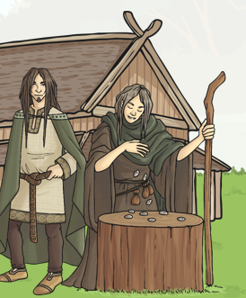
Art | Computing
Creating a Book front cover for World Book Day  This week, for the final week before returning to school, I would like you to think about all of the skills and artwork which we have gathered so far this year, and apply this to today’s task.  For World Book Day, (which is on Thursday this week), I would like you to choose one of the following two options:  - Create a new book cover for one of your favourite books, think about all of the different techniques which we have learnt this year, such as with Mrs Taylor, and try to apply this to your work. You could use pencil crayons, collage, or any other type of art form which could make your book cover spectacular.  - Recreate one of the scenes from one of your favourite stories in a creative way of your choice. An example could be, creating a shoe box scene such as the one below, this will depend on the resources which you have available at home:  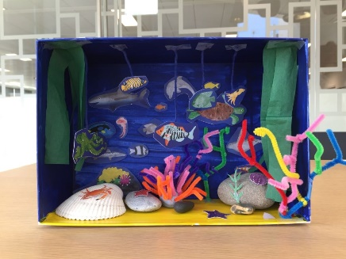  Try to be as creative as possible with your activity. | Computing – Spreadsheet Lesson 5  During this half term, we have worked on using spreadsheets and you have been doing a great job with this! In this lesson, Class 4 have been collecting data for the temperature of the playground. In this lesson, I would like you to try and use a spreadsheet to create a line graph to represent the data. The data which they have gathered can be seen here:  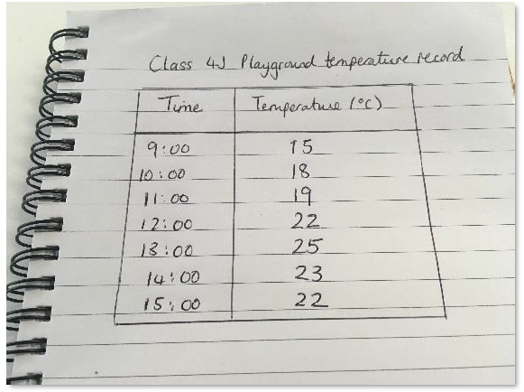  On Google Classroom, I have provided a video explaining how to complete this activity.
RE | Music
R.E. Reconciliation Lesson 2 – Knots of disobedience  In this lesson, we will learn about The ‘Knot’ of Disobedience. Pope Francis helps us to understand what sin can do to us and others. He said that when young people disobey their parents, “We can say that a little ‘knot’ is created. The young person acts with an awareness of what he or she is doing, and often there is a lie involved. At that moment, they break trust with their parents. You know how frequently this happens! Then the relationship with their parents needs to be healed; the young person has to ask for forgiveness so that harmony can be restored.”  On Google Classroom, and later in this document, I have provided an outline of a knot, which I would like you to use to write your work on, if possible. It would be good to see if you could draw a line to write on inside of the knot, and then do your writing inside so that we can use them on our display in school.  If you cannot write inside of the knot, then you can write your ideas in a Google Doc or draw your own knot.  “Many knots can form a tangle which gets more and more painful to undo.”  The challenge levels below explain your task. Most people should aim to complete the 2 star challenge.  Challenge Levels  1 Star – Explain “What is the knot of disobedience?”  2 Star – Explain “What is the knot of disobedience?” Then, explain Who might be affected by or create knots of disobedience? Can you make a link to someone you know, or have learnt about in the Bible? (Write about 3 examples, yourself [when you have created a knot], someone else, and someone from the Bible).  3 Star – Explain, what advice could we give, or does Pope Francis give to prevent knots of disobedience from happening.  As a challenge, see if you can explain how your beliefs about sin and sorrow can affect our behaviour? | Charanga  Last week, many of you got involved with the Pans Percussion activity provided by the Tameside Music Service, it was great to see so many of your pictures and videos from the activity!  This week, I have provided a link to an online learning resource called Charanga. This is a resource which we began using last year, and you should have received log in information from Miss Holland last year. If you cannot find your log in, you can ask your parents to send me an email to ask for this, and I can try to find it for you.  Log on to Charanga using the link which can be found below, explore the website and get involved in some of the music activities!  https://charanga.com/yumu/login
 | Health and Wellbeing
P.E. & Dance
Mr Allen has started to upload P.E. and dance sessions with videos onto our Google Classroom page. See if you can join in with his activities, and remember to leave a comment if you do! It is important to continue to exercise at home, especially during extended time inside. Mr T might even make a guest appearance!!
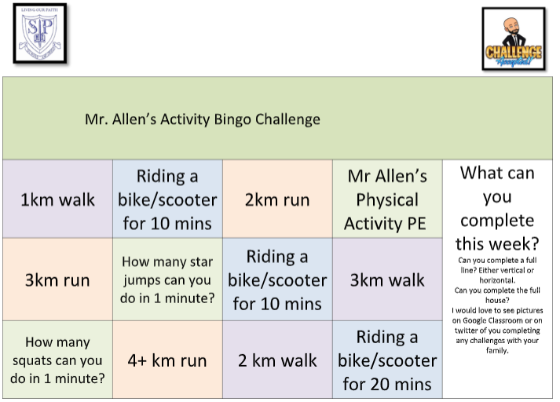

PSHE – Wellbeing Journal
For this week’s PSHE activity, I have provided wellbeing journal. This journal will help you to reflect on your day, to think about what you are proud of, what has worried you, or things we are grateful for. You may wish to just complete this once, for one day, or you could complete the journal each day for the whole week.
Let me know in your comments how you feel about this activity, and we may be able to repeat it next week!

Monday – Maths Lesson 36 Resources – 1 Star Challenge

Monday – Maths Lesson 36 Resources – 2 and 3 Star Challenge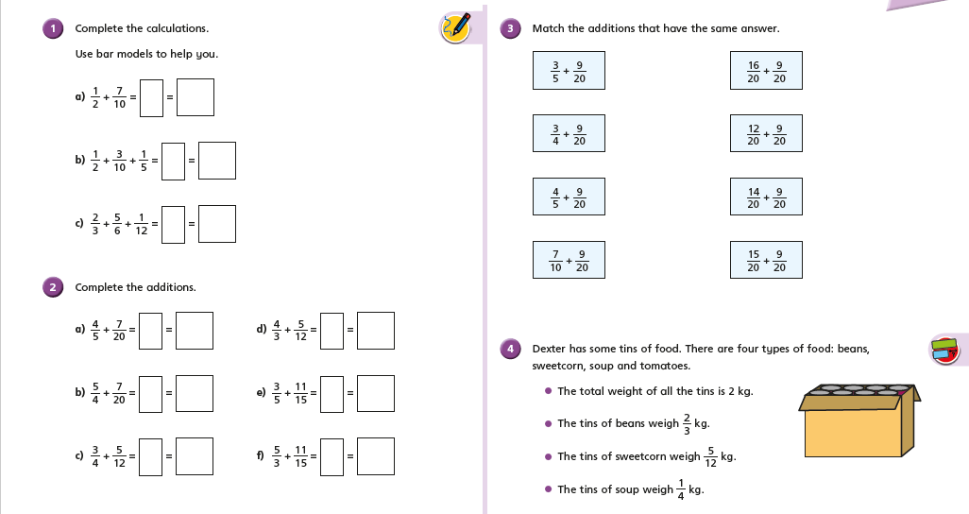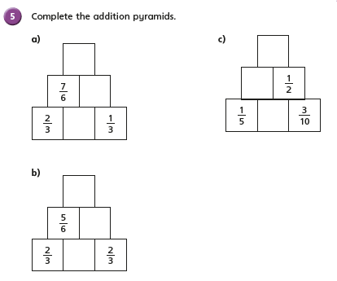

Tuesday – Maths Lesson 36 - Resources – 1 and 2 Star Activity – Question Sheet
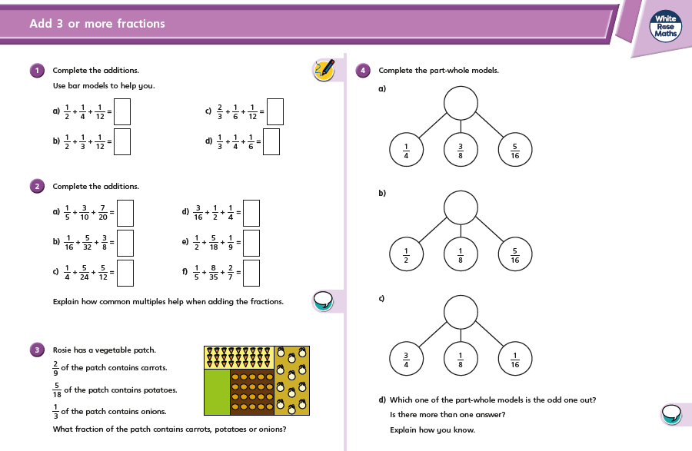

Tuesday – Maths Lesson 36 – 3 Star Reasoning and Problem Solving Sheet
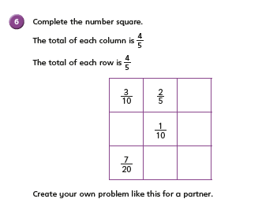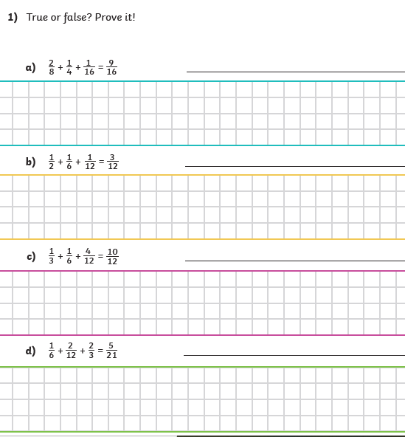

Wednesday – Maths Lesson 38 Resources – 1 Star 4 in a row game
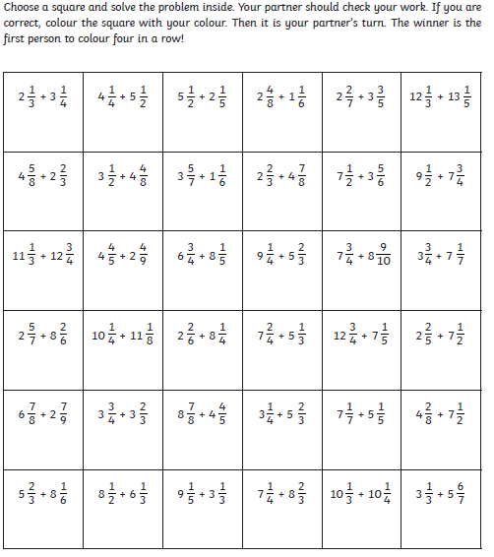

Wednesday – Maths Lesson 38 Resources – 2 and 3 Star Activity
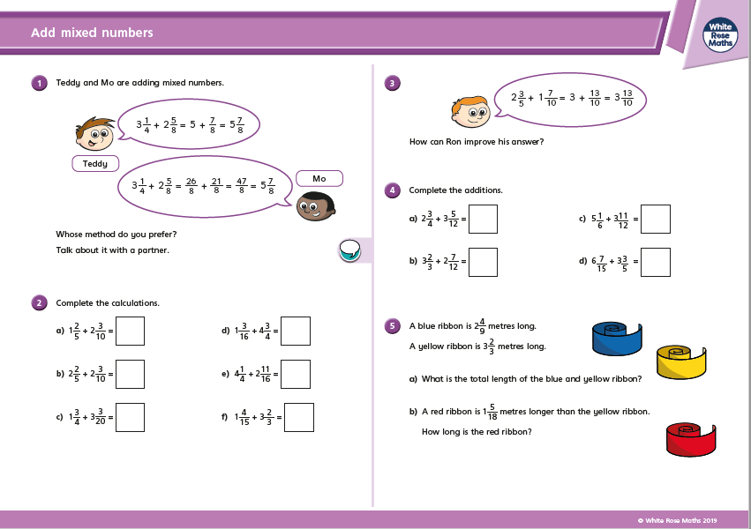

Friday – Maths Lesson 40 Resources – Subtracting Fractions - 1 Star Activity
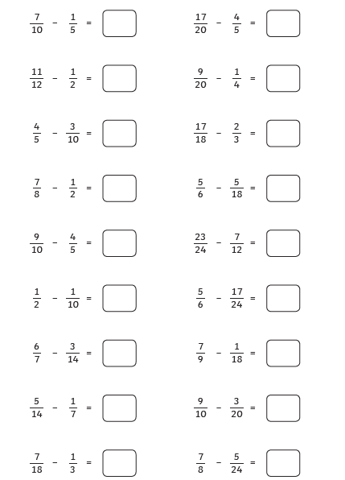

Friday – Maths Lesson 40 Resources – Subtracting Fractions – 2 Star Reasoning Problems
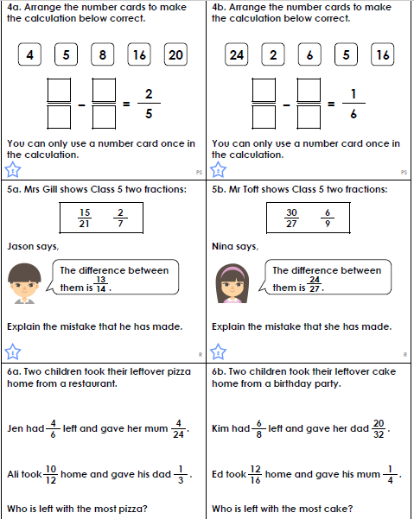

Friday – Maths Lesson 40 – 3 Star Activity
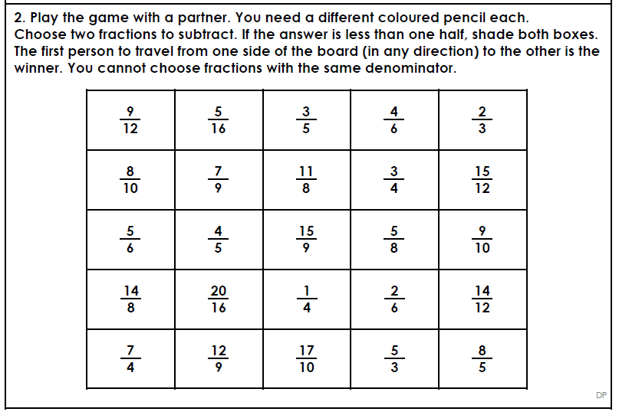

Monday –English Lesson 36 Resources – The Mirror of Wishes
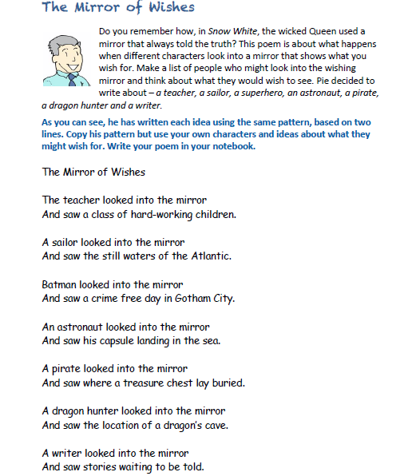

Tuesday – English Lesson 37– The Cave of Curiosity Poem
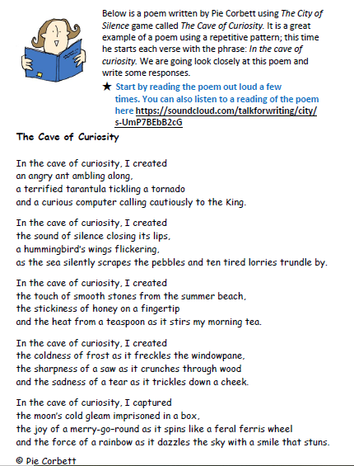

English Lesson 39 – Limericks
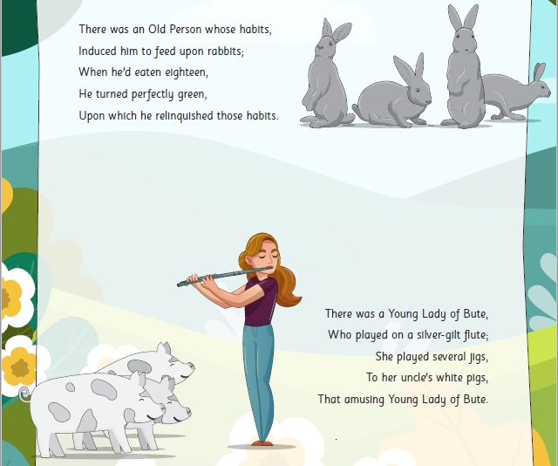

English Lesson 40 – Sonnet 18
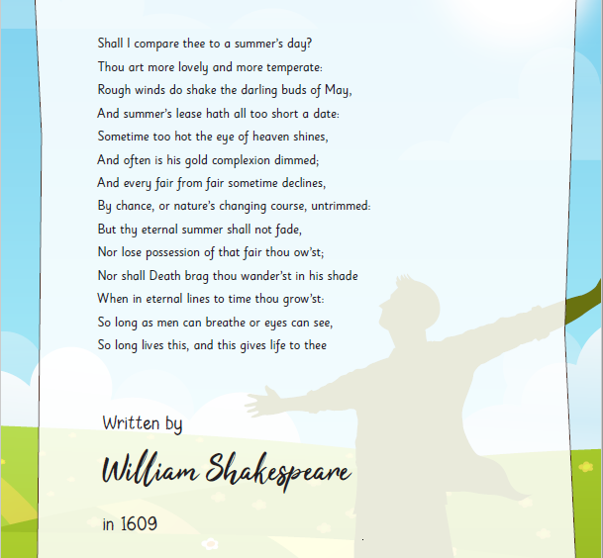

Monday – R.E. Resources – Reconciliation – The ‘Knot’ of Disobedience

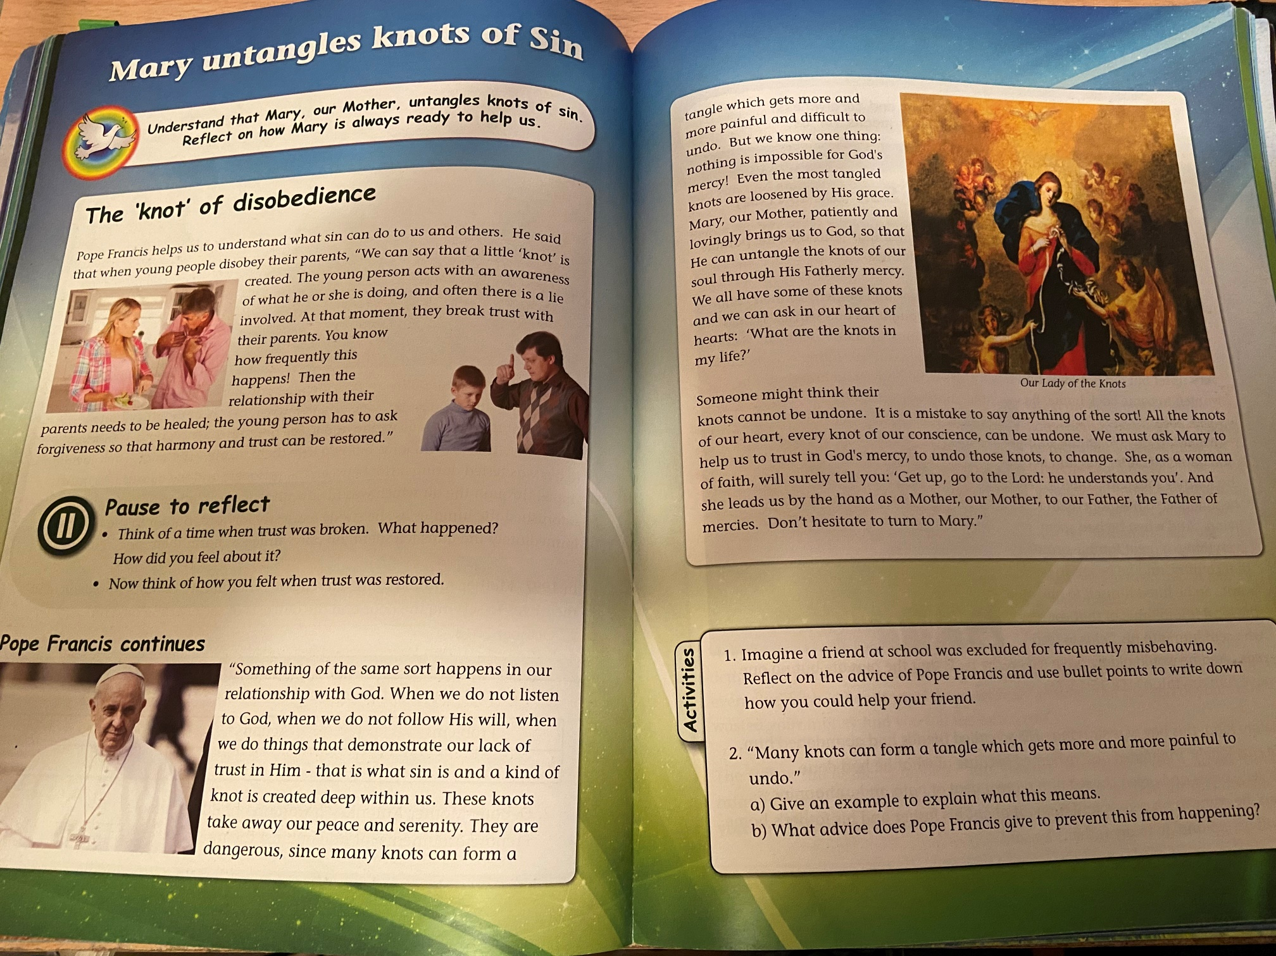
PSHE Resources
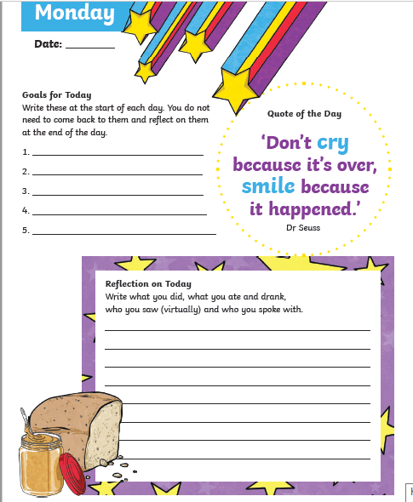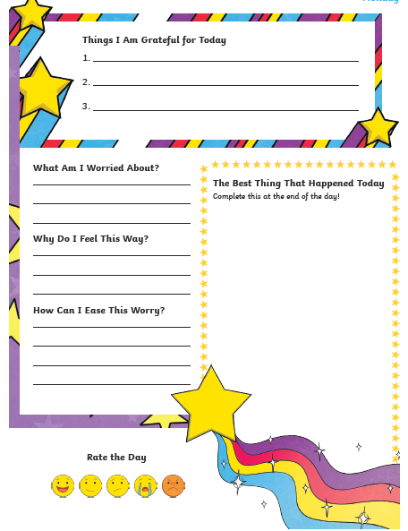

Topic resources – Viking Life
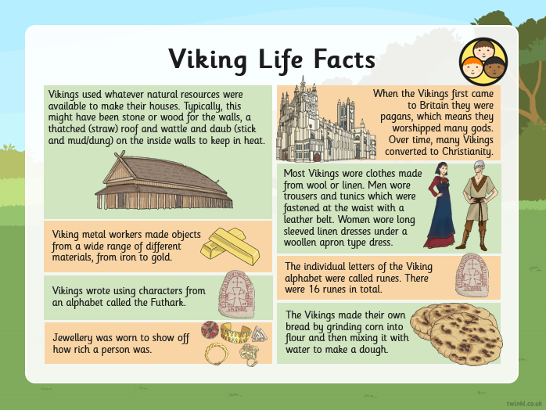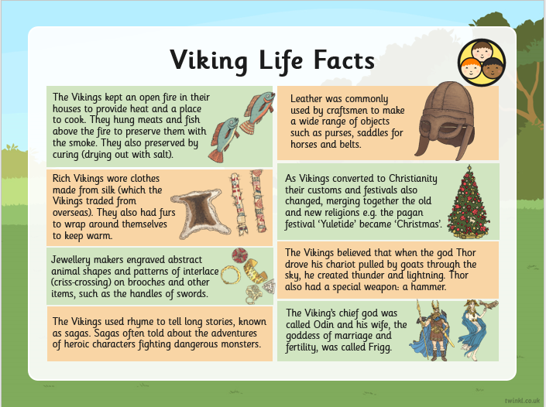
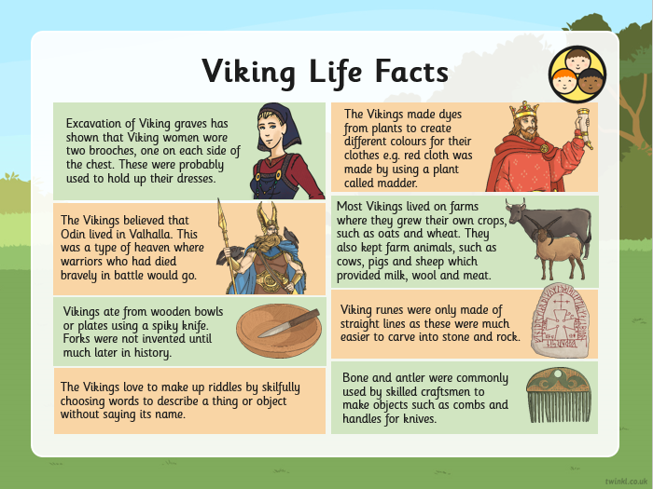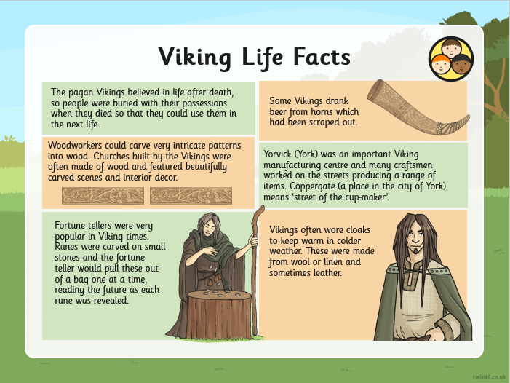

Science Resources
