Year 1 Home learning menu- Spring 2 week 2
See daily videos and worksheets on our Google Classroom to support this plan
The Rainbow Fish  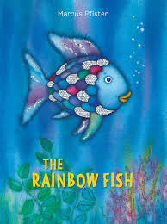 | Write speech bubbles for two characters.  Retell the story again.  Think about the two main characters- what would they say to each other?  Write a sentence for each character in their speech bubble. | Write a letter.  Think about how the little blue fish feels after he receives a shiny scale.  Write a thank you letter from the blue fish to the rainbow fish. |  | Have-a-go!  Retell the story.  Using the story map and actions you have learnt, write the story. Try to do this all on your own- it’s have-a-go day! |  | 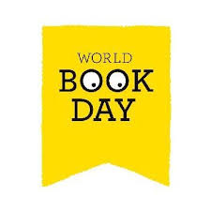 |  | Edit and improve your writing.  Look at the story you have written.  Read it again.  Have you included all the capital letters and full stops?  Can you improve it?  Make any changes you require.
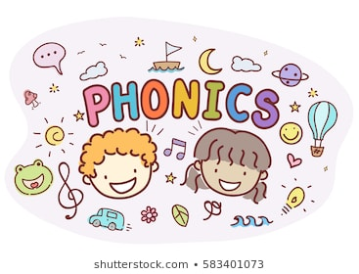 | Read sentences and find the words with the /oa/ phoneme.  Read the sentences in the phoneme spotter and recognise which words have the /oa/ phoneme. How is that phoneme made? | Sort the ways to make the /oa/ phoneme.  Read all the words and sort them according to how the /oa/ phoneme is made. |  | Read sentences and find the words with the /oa/ phoneme.  Read the sentences and recognise which words have the /oa/ phoneme. How is that phoneme made? |  | Read sentences and find the words with the alternative spellings for the /m/ phonemes.  Read the sentences and recognise which words have the /m/ phoneme. How is that phoneme made? |  | Read sentences and find the words with the /oa/ phonemes.  Read the sentences and recognise which words have the /oa/ phoneme. How is that phoneme made?
RE  Families and celebrations | WALT- Have the opportunity to hear the story of the Good Samaritan and reflect on the message it has for us.  Watch the video on our Google classroom.  Listen to the story of The Good Samaritan.  What happened to the injured man?  Who saw the injured man?  Did everyone help the man?  Who helped the man?  Why was this surprising?  Write two acts of kindness from the story.  What could we learn from the story?
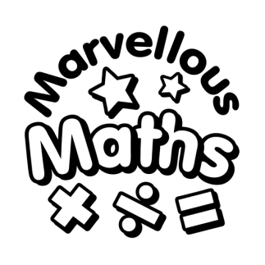 | WALT- Compare lengths.  Using the correct vocabulary, compare the lengths of objects. |  | WALT- Compare heights.  Using the correct vocabulary, compare the heights of objects. |  | WALT- Compare lengths and heights.  Using the correct vocabulary, compare the lengths and heights of objects. |  | 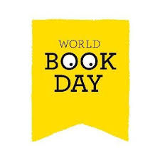 |  | WALT- Measure length using non standard measure.  Measure length using cubes, paper clips and other objects.
Awesome Oceans  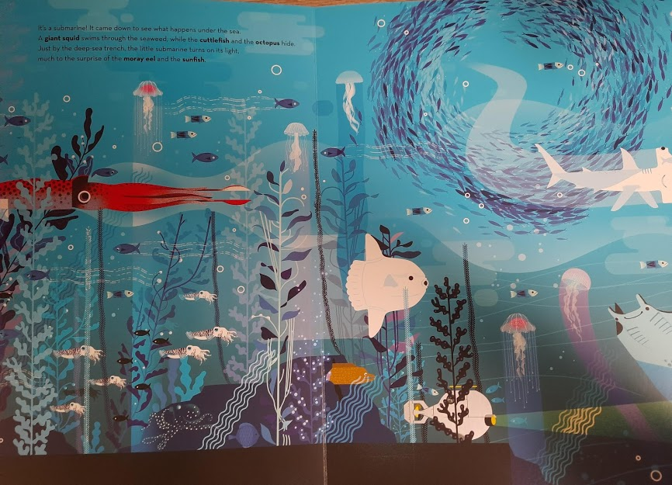 | Challenge 1:  Revise the continents and learn the names of all the oceans on the world.  Label a world map with the continents and oceans.  Challenge 2:  Listen to extra information about all the oceans- add details to your world map from yesterday.  Challenge 3:  Plot a route around the world.  If you were going to travel around the world like Phileas Fogg, where would you go and what transport would you use?  Plan your route using a compass to show direction.  Challenge 4:  Carry out a science experiment.  Which items float and which items sink?  Can you predict whether an item will float or sink?

